SEC Form 3
FORM 3 | UNITED STATES SECURITIES AND EXCHANGE COMMISSION  Washington, D.C. 20549  INITIAL STATEMENT OF BENEFICIAL OWNERSHIP OF SECURITIES  Filed pursuant to Section 16(a) of the Securities Exchange Act of 1934  or Section 30(h) of the Investment Company Act of 1940
  OMB APPROVAL
  OMB Number: | 3235-0104
  Estimated average burden
  hours per response: | 0.5
1. Name and Address of Reporting Person*  (Street) | 2. Date of Event Requiring Statement (Month/Day/Year)  08/18/2026 | 3. Issuer Name and Ticker or Trading Symbol  CONDUENT Inc [ CNDT ]  Foreign Trading Symbol
  Novoseletsky Anna Rose
  (Last) | (First) | (Middle)
  100 CAMPUS DRIVE
  SUITE 200
  FLORHAM PARK | NJ | 07932
  (City) | (State) | (Zip)
 |  | 4. Relationship of Reporting Person(s) to Issuer  (Check all applicable) | 5. If Amendment, Date of Original Filed (Month/Day/Year)
   | Director |  | 10% Owner
   | Officer (give title below) |  | Other (specify below)
  EVP, GC & Secretary
6. Individual or Joint/Group Filing (Check Applicable Line)
Form filed by One Reporting Person
Form filed by More than One Reporting Person

Table I - Non-Derivative Securities Beneficially Owned
1. Title of Security (Instr. 4) | 2. Amount of Securities Beneficially Owned (Instr. 4) | 3. Ownership Form: Direct (D) or Indirect (I) (Instr. 5) | 4. Nature of Indirect Beneficial Ownership (Instr. 5)
Common Stock | 0 | D
Table II - Derivative Securities Beneficially Owned
(e.g., puts, calls, warrants, options, convertible securities)
1. Title of Derivative Security (Instr. 4) | 2. Date Exercisable and Expiration Date (Month/Day/Year) |  | 3. Title and Amount of Securities Underlying Derivative Security (Instr. 4) |  | 4. Conversion or Exercise Price of Derivative Security | 5. Ownership Form: Direct (D) or Indirect (I) (Instr. 5) | 6. Nature of Indirect Beneficial Ownership (Instr. 5)
1. Title of Derivative Security (Instr. 4) | Date Exercisable | Expiration Date | Title | Amount or Number of Shares | 4. Conversion or Exercise Price of Derivative Security | 5. Ownership Form: Direct (D) or Indirect (I) (Instr. 5) | 6. Nature of Indirect Beneficial Ownership (Instr. 5)
Explanation of Responses:
Remarks:
 | /s/ Mike Fisherman, attorney-in-fact | 08/18/2026
 | ** Signature of Reporting Person | Date
Reminder: Report on a separate line for each class of securities beneficially owned directly or indirectly.
* If the form is filed by more than one reporting person, see Instruction 5 (b)(v).
** Intentional misstatements or omissions of facts constitute Federal Criminal Violations See 18 U.S.C. 1001 and 15 U.S.C. 78ff(a).
Note: File three copies of this Form, one of which must be manually signed. If space is insufficient, see Instruction 6 for procedure.
Persons who respond to the collection of information contained in this form are not required to respond unless the form displays a currently valid OMB Number.
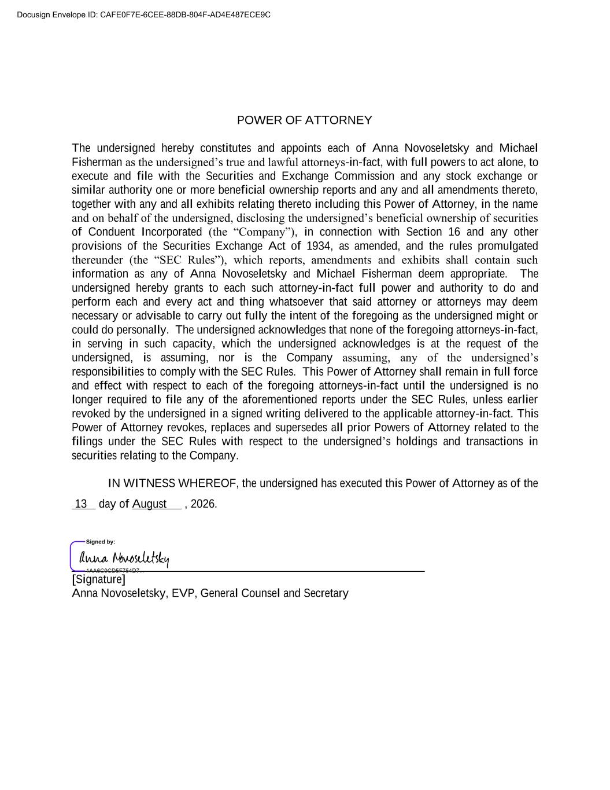
POWER OF ATTORNEY The undersigned hereby constitutes and appoints each of Anna Novoseletsky and Michael Fisherman as the undersigned’s true and lawful attorneys-in-fact, with full powers to act alone, to execute and file with the Securities and Exchange Commission and any stock exchange or similar authority one or more beneficial ownership reports and any and all amendments thereto, together with any and all exhibits relating thereto including this Power of Attorney, in the name and on behalf of the undersigned, disclosing the undersigned’s beneficial ownership of securities of Conduent Incorporated (the “Company”), in connection with Section 16 and any other provisions of the Securities Exchange Act of 1934, as amended, and the rules promulgated thereunder (the “SEC Rules”), which reports, amendments and exhibits shall contain such information as any of Anna Novoseletsky and Michael Fisherman deem appropriate. The undersigned hereby grants to each such attorney-in-fact full power and authority to do and perform each and every act and thing whatsoever that said attorney or attorneys may deem necessary or advisable to carry out fully the intent of the foregoing as the undersigned might or could do personally. The undersigned acknowledges that none of the foregoing attorneys-in-fact, in serving in such capacity, which the undersigned acknowledges is at the request of the undersigned, is assuming, nor is the Company assuming, any of the undersigned’s responsibilities to comply with the SEC Rules. This Power of Attorney shall remain in full force and effect with respect to each of the foregoing attorneys-in-fact until the undersigned is no longer required to file any of the aforementioned reports under the SEC Rules, unless earlier revoked by the undersigned in a signed writing delivered to the applicable attorney-in-fact. This Power of Attorney revokes, replaces and supersedes all prior Powers of Attorney related to the filings under the SEC Rules with respect to the undersigned’s holdings and transactions in securities relating to the Company. IN WITNESS WHEREOF, the undersigned has executed this Power of Attorney as of the 13 day of August , 2026. ___________________________________________________________ [Signature] Anna Novoseletsky, EVP, General Counsel and Secretary Docusign Envelope ID: CAFE0F7E-6CEE-88DB-804F-AD4E487ECE9C



