UNITED STATES
SECURITIES AND EXCHANGE COMMISSION
Washington, D.C. 20549
FORM 8-K

CURRENT REPORT
Pursuant to Section 13 or 15(d)
of the Securities Exchange Act of 1934

Date of Report (date of earliest event reported): August 10, 2026

CONDUENT INCORPORATED
(Exact name of registrant as specified in its charter)
New York |  |  |  |  |  | 001-37817 |  |  |  |  |  | 81-2983623
(State or other jurisdiction of  incorporation or organization) |  |  |  |  |  | (Commission  File Number) |  |  |  |  |  | (IRS Employer  Identification No.)
100 Campus Drive, |  |  |  |  |  | Suite 200,
Florham Park, |  |  | New Jersey
07932
(Address of principal executive offices) (Zip Code)

Registrant’s telephone number, including area code: (844) 663-2638
Not Applicable
(Former name or former address, if changed since last report)
Check the appropriate box below if the Form 8-K filing is intended to simultaneously satisfy the filing obligation of the registrant under any of the following provisions (see General Instruction A.2. below):

☐ |  |  | Written communications pursuant to Rule 425 under the Securities Act (17 CFR 230.425)
☐ |  |  | Soliciting material pursuant to Rule 14a-12 under the Exchange Act (17 CFR 240.14a-12)
☐ |  |  | Pre-commencement communications pursuant to Rule 14d-2(b) under the Exchange Act (17 CFR 240.14d-2(b))
☐ |  |  | Pre-commencement communications pursuant to Rule 13e-4(c) under the Exchange Act (17 CFR 240.13e-4(c))

Securities registered pursuant to Section 12(b) of the Act:
Title of each class |  |  | Trading Symbol(s) |  |  | Name of each exchange on which registered
Common Stock, $0.01 par value |  |  | CNDT |  |  | NASDAQ Global Select Market

Indicate by check mark whether the registrant is an emerging growth company as defined in Rule 405 of the Securities Act of 1933 (CFR 230.405) or Rule 12b-2 of the Securities Exchange Act of 1934 (CFR 240.12b-2).☐ Emerging growth company

If an emerging growth company, indicate by check mark if the registrant has elected not to use the extended transition period for complying with any new or revised financial accounting standards provided pursuant to Section 13(a) of the Exchange Act. ☐

Item 2.02. Results of Operations and Financial Condition.
On August 10, 2026, Conduent Incorporated (the "Company") released its second quarter 2026 financial results and is furnishing to the Securities and Exchange Commission (the "Commission") a copy of the financial results press release as Exhibit 99.1 to this Current Report on Form 8-K (this "Report") under Item 2.02 of Form 8-K.
The information contained in Item 2.02 of this Report and in Exhibit 99.1 shall not be deemed “filed” with the Commission for purposes of Section 18 of the Exchange Act of 1934, as amended, or otherwise subject to the liability of that section.
Item 7.01. Regulation FD Disclosure.
On August 10, 2026, the Company conducted a financial results call regarding its 2026 second quarter results and is furnishing to the Commission a copy of the presentation used during the financial results call as Exhibit 99.2 to this Report under Item 7.01 of Form 8-K.
The information contained in Item 7.01 of this Report and in Exhibit 99.2 to this Report shall not be deemed “filed” with the Commission for purposes of Section 18 of the Exchange Act of 1934, as amended, or otherwise subject to the liability of that section.
Item 9.01. Financial Statements and Exhibits.
(d) Exhibits.
Exhibit No. |  |  |  |  |  | Description
99.1 |  |  |  |  |  | Registrant’s second quarter 2026 financial results press release dated August 10, 2026
99.2 |  |  |  |  |  | Registrant’s investor presentation dated August 10, 2026
104 |  |  |  |  |  | Cover Page Interactive Data File (embedded within the Inline XBRL document)

Forward-Looking Statements
This Report and any exhibits to this Report may contain "forward-looking statements" as defined in the Private Securities Litigation Reform Act of 1995, as amended (the "Litigation Reform Act"). The words “anticipate,” “believe,” “estimate,” “expect,” "plan," “intend,” “will,” “aim,” “should,” “could,” “forecast,” “target,” “may,” "continue to," "endeavor," "if,” “growing,” “projected,” “potential,” “likely,” "see," "ahead," "further," "going forward," "on the horizon," "as we progress," "going to," "path from here forward," "think," "path to deliver," "from here," “on track”, “remain” and similar expressions (including the negative and plural forms of such words and phrases), as they relate to us, are intended to identify forward-looking statements, but the absence of these words does not mean that a statement is not forward-looking. These statements reflect our current views with respect to future events and are subject to certain risks, uncertainties and assumptions, many of which are outside of our control. Should one or more of these risks or uncertainties materialize, or should underlying assumptions prove incorrect, actual results may vary materially from those expressed or implied in this Report, any exhibits to this Report and other public statements we make.
Important factors and uncertainties that could cause our actual results to differ materially from those in our forward-looking statements include, but are not limited to: risks related to recently announced divestitures including the sale of the Company’s (i) Public Transit business and (ii) Tolling business, including but not limited to our ability to realize the benefits anticipated from such transactions, as well as unexpected costs, liabilities or delays associated with such transactions; competitive restrictions applicable to the Company and its affiliates under the definitive transaction agreements; risks related to the equity interest in Quarterhill Inc. to be received as partial consideration in the Tolling transaction, including fluctuations in the value of such interest; government appropriations and termination rights contained in our government contracts; the impact of changes in government spending levels, budget priorities or efficiency initiatives, including federal cost-reduction programs, on demand for our government solutions and services; the competitiveness of the markets in which we operate and our ability to renew commercial and government contracts, including contracts awarded through competitive bidding processes; our ability to recover capital and other investments in connection with our contracts; the impact of geopolitical events and geopolitical tensions (such as the war in Ukraine and conflict in the Middle East), macroeconomic conditions, natural disasters and other factors in a particular country or region on our workforce, customers and vendors; the impact of changes in trade policies, tariffs or export controls on our cost structure, supply chain and business operations; our reliance on third-party providers; our ability to deliver on our contractual obligations properly and on time; changes in continued interest in outsourced business process services; the adverse effect of claims of infringement of third-party intellectual property rights; our ability to estimate the scope of work or the costs of performance in our contracts; the loss of key senior management and our ability to attract and retain necessary technical personnel and qualified subcontractors; our failure to develop new service offerings and protect our intellectual property rights; our ability to modernize our information technology infrastructure and consolidate data centers; expectations relating to environmental, social and governance considerations; utilization of our stock repurchase program; the effects related to our use of artificial intelligence ("AI") on our business; the failure to comply with laws relating to individually identifiable information and personal health information; the failure to comply with laws relating to processing certain financial transactions, including payment card transactions and debit or credit card transactions; breaches of our information systems or security systems or any service interruptions; risks related to hacking or other cybersecurity threats to our data systems, information systems and network infrastructure and other service interruptions, including relating to the previously disclosed cyber event that took place in January 2025 (the "January 2025 Cyber Event"), including our investigation of such incident and mitigation and remediation efforts, the nature and extent of such incident, the potential disruption to our business or operations, the potential impact on our reputation, and our assessments of the likely financial and operational impacts of such incident; our ability to comply with data security standards; developments in various contingent liabilities that are not reflected on our balance sheet, including those arising as a result of being involved in a variety of claims, lawsuits, investigations and proceedings; the impact of potential goodwill and other asset impairments on our results of operations; our significant indebtedness and the terms of such indebtedness; our failure to obtain or maintain a satisfactory credit rating and financial performance; our ability to obtain adequate pricing for our services and to improve our cost structure; our ability to collect our receivables, including those for unbilled services; a decline in revenues from, or a loss of, or a reduction in business from or failure of significant clients; fluctuations in our non-recurring revenue; increases in the cost of voice and data services or significant interruptions in such services; our ability to receive dividends or other payments from our subsidiaries; and other factors that are set forth in the “Risk Factors” section, the “Legal Proceedings” section, the “Management's Discussion and Analysis of Financial Condition and Results of Operations” section and other sections in our Annual Reports on Form 10-K, as well as in our Quarterly Reports on Form 10-Q and Current Reports on Form 8-K filed with or furnished to the Commission. Any forward-looking statements made by us in this Report speak only as of the date on which they are made. We are under no

obligation to, and expressly disclaim any obligation to, update or alter our forward-looking statements, whether because of new information, subsequent events or otherwise, except as required by law.

SIGNATURES
Pursuant to the requirements of the Securities Exchange Act of 1934, registrant has duly authorized this report to be signed on its behalf by the undersigned hereunto duly authorized.
Date: August 10, 2026

CONDUENT INCORPORATED
By: |  |  | /s/ GEORGE ABATE
 |  |  | George Abate
 |  |  | Vice President and Chief Accounting Officer

EXHIBIT 99.1

News from Conduent

Conduent Reports Second Quarter 2026 Results and Advances Transformation Priorities

Key Q2 2026 Highlights
•Signed divestitures expected to generate $234M in gross proceeds
•Revenue: $531M from Continuing Operations
•Pre-tax Income (Loss) from Continuing Operations: $(57)M
•Adj. EBITDA from Continuing Operations(1) : $16M
•Adj. EBITDA Margin from Continuing Operations(1): 3.0%
•New Business Signings ACV from Continuing Operations(2): $99M

FLORHAM PARK, NJ, August 10, 2026 - Conduent Incorporated (Nasdaq: CNDT), a global technology-driven business process solutions and services company, today announced its second quarter 2026 financial results.
Harsha V. Agadi, Chief Executive Officer, stated: “Six months into our transformation, we are making significant progress against the priorities we established at the beginning of the year. We are simplifying the organization, strengthening financial discipline and taking structural costs out of the business, while making good progress against our approximately $100 million annualized cost-savings program.
We also took significant steps this quarter to reshape our portfolio and sharpen our focus on the markets where we believe Conduent is best positioned to compete and grow. The announced sales of our Transit and Tolling businesses are expected to generate approximately $234 million in gross proceeds, plus a 7% equity interest in the Tolling buyer, exceeding the commitment we made in the first quarter to generate at least $200 million through portfolio actions. We intend to use the majority of these proceeds to reduce debt and further strengthen our balance sheet."

“At the same time, we are seeing encouraging momentum in our go-to-market execution. Our qualified new business pipeline continues to grow, supported by new wins and expansions across both Commercial and Government. We are also investing in our go-forward portfolio and differentiated technology capabilities, including AI, to help clients modernize complex, mission-critical operations and position Conduent to capture opportunities in the large and growing markets we serve."

“While our second-quarter financial results do not yet reflect the full impact of the actions underway, we are building a simpler, more focused and higher-performing Conduent. We remain focused on disciplined
EXHIBIT 99.1
1
execution, converting our pipeline into profitable growth, and building a stronger cost structure. I am confident that the actions we are taking today position us to improve financial performance and create sustainable, long-term value for our clients and shareholders.”

Key Financial Q2 2026 Results
($ in millions, except margin and per share data) |  |  | Q2 2026 |  |  | Q2 2025 |  |  | Current Quarter Y/Y B/(W)
Revenue |  |  | $531 |  |  | $603 |  |  | (11.9)%
GAAP Net Income (Loss) |  |  | $(116) |  |  | $(40) |  |  | (190.0)%
Adjusted EBITDA from Continuing Operations(1) |  |  | $16 |  |  | $23 |  |  | (30.4)%
Adjusted EBITDA Margin from Continuing Operations(1) |  |  | 3.0% |  |  | 3.8% |  |  | -80 bps
GAAP Income (Loss) Before Income Tax from Continuing Operations |  |  | $(57) |  |  | $(43) |  |  | (32.6)%
GAAP Diluted EPS from Continuing Operations |  |  | $(0.46) |  |  | $(0.27) |  |  | $(0.19)
Adjusted Diluted EPS from Continuing Operations(1) |  |  | $(0.18) |  |  | $(0.16) |  |  | $(0.02)
Cash Flow from Operating Activities |  |  | $7 |  |  | $(15) |  |  | 146.7%
Adjusted Free Cash Flow(1) |  |  | $(8) |  |  | $(30) |  |  | 73.3%
Performance Commentary
Cash flow from operating activities improved by $22 million year-over-year, primarily due to favorable working capital results, which included, among other things, the effects of the realization of some of our long-term projects in the Government and former Transportation segments.
Q2 2026 pre-tax income (loss) from continuing operations was $(57) million versus $(43) million in the prior year period. This unfavorable variance was primarily caused by higher restructuring-related costs in the current year related to our transformation plan.
Q2 2026 Adjusted EBITDA of $16 million and Adjusted EBITDA margin of 3.0% decreased, respectively, versus the prior year, due to lower profitability in our Government segment.
Key Achievements and Industry Accolades
Portfolio Optimization & Strategic Transformation
•Entered into agreements to sell the Public Transit business to Modaxo for $164 million and the Tolling business to Quarterhill Inc. for $70 million, plus a 7% equity interest in Quarterhill, further simplifying Conduent's portfolio, strengthening financial flexibility and increasing focus on core growth opportunities.
Business Execution & Contract Wins
•Signed a pension risk transfer administration engagement with Securian, expanding Conduent's retirement administration capabilities.
EXHIBIT 99.1
2
•Selected by Trillium Health Resources to deploy the Health Services Plus platform for claims processing, provider data management, and member services.
•Implemented a modernized Medicaid platform for the State of New Mexico, replacing a 24-year-old legacy system and supporting approximately 900,000 Medicaid members.
•Awarded a multi-year contract renewal by the Commonwealth of Virginia to continue operating and modernizing its Medicaid platform, serving approximately 1.6 million members.
•Expanded the EBT EMV implementation following the Alabama rollout, with four states expected to be live with chip-enabled EBT cards by year-end 2026, helping strengthen payment security and protect beneficiaries from card fraud.

Innovation & Technology Investment
•Introduced an AI-powered next-generation Customer Experience platform featuring real-time translation, AI-assisted training, and voice enhancement capabilities to improve customer experiences and agent performance.
•Investing in next-generation Medicaid technology to modernize provider enrollment and management, with the first client implementation planned for a U.S. state, expanding Conduent's Government Healthcare capabilities and supporting continued modernization of state Medicaid programs.

Leadership & Governance
•Appointed Adam Demuyakor to the Board of Directors, adding expertise in artificial intelligence, digital transformation, innovation and enterprise technology.

EXHIBIT 99.1
3
FY 2026 Outlook(3)
FY 2026
Outlook(3)
Revenue |  |  |  |  |  | $2,150M - $2,250M
Adj. EBITDA from Continuing Operations(1) |  |  |  |  |  | $140M - $170M

(1) Refer to the Appendix for definition and complete non-GAAP reconciliations of Adjusted EBITDA, Adjusted EBITDA Margin, Adjusted Diluted EPS and Adjusted Free Cash Flow.
(2) Refer to the Appendix for definition.
(3) Refer to the Appendix for additional information regarding non-GAAP outlook.
EXHIBIT 99.1
4
Conference Call
Management will present the results during a conference call and webcast on August 10, 2026 at 9:00 a.m. ET.

The call will be available by live audio webcast along with the news release and online presentation slides at https://investor.conduent.com/.

The conference call will also be available by calling 877-407-4019 toll-free. If requested, the conference ID for this call is 13761624.

The international dial-in is 1-201-689-8337. The international conference ID is also 13761624.

A recording of the conference call will be available by calling 1-877-660-6853 three hours after the conference call concludes. The replay ID is 13761624.

The telephone recording will be available until Aug 24, 2026.

About Conduent
Conduent delivers digital business solutions and services spanning the commercial, government and transportation spectrum – creating valuable outcomes for its clients and the millions of people who count on them. The Company leverages cloud computing, artificial intelligence, machine learning, automation and advanced analytics to deliver mission-critical solutions. Through a dedicated global team of approximately 46,000(1) associates, process expertise and advanced technologies, Conduent’s solutions and services digitally transform its clients’ operations to enhance customer experiences, improve performance, increase efficiencies and reduce costs. Conduent adds momentum to its clients’ missions in many ways including disbursing approximately $80 billion in government payments annually, enabling approximately 2.0 billion customer service interactions annually, empowering millions of employees through HR services every year and processing over 14 million tolling transactions every day. Learn more at www.conduent.com.

(1) Approximately 46,000 employees globally, including approximately 3,500 within the Transportation business.
EXHIBIT 99.1
5
Non-GAAP Financial Measures
We have reported our financial results in accordance with accounting principles generally accepted in the U.S. (U.S. GAAP). In addition, we have discussed our financial results using non-GAAP measures from our Continuing Operations only, unless otherwise noted. We believe these non-GAAP measures allow investors to better understand the trends in our business and to better understand and compare our results. Accordingly, we believe it is necessary to adjust several reported amounts, determined in accordance with U.S. GAAP, to exclude the effects of certain items as well as their related tax effects. Management believes that these non-GAAP financial measures provide an additional means of analyzing the results of the current period against the corresponding prior period. However, these non-GAAP financial measures should be viewed in addition to, and not as a substitute for, our reported results prepared in accordance with U.S. GAAP. Our non-GAAP financial measures are not meant to be considered in isolation or as a substitute for comparable U.S. GAAP measures and should be read only in conjunction with our Consolidated Financial Statements prepared in accordance with U.S. GAAP. Our management regularly uses our non-GAAP financial measures internally to understand, manage and evaluate our business and make operating decisions. Providing such non-GAAP financial measures to investors allows for a further level of transparency as to how management reviews and evaluates our business results and trends. These non-GAAP measures are among the primary factors management uses in planning for and forecasting future periods. Compensation of our executives is based in part on the performance of our business based on certain of these non-GAAP measures. Refer to the "Non-GAAP Financial Measures" and "Non-GAAP Reconciliations" sections attached to this release for a discussion of these non-GAAP measures and their reconciliation to the reported U.S. GAAP measures.

EXHIBIT 99.1
6
Forward-Looking Statements

This press release, any exhibits or attachments to this release, and other public statements we make may contain "forward-looking statements" as defined in the Private Securities Litigation Reform Act of 1995. The words “anticipate,” “believe,” “estimate,” “expect,” "expectations," "in front of us," "plan," “intend,” “will,” “aim,” “should,” “could,” “forecast,” “target,” “may,” "continue to," "looking to continue," “endeavor,” "if,” “growing,” “projected,” “potential,” “likely,” "see," "ahead," "further," "going forward," "on the horizon," "as we progress," "going to," "path from here forward," "think," "path to deliver," "from here," "on track," "remain" and similar expressions (including the negative and plural forms of such words and phrases), as they relate to us, are intended to identify forward-looking statements, but the absence of these words does not mean that a statement is not forward-looking. All statements other than statements of historical fact included in this press release or any attachment to this press release are forward-looking statements, including, but not limited to, statements regarding our financial results, condition and outlook; changes in our operating results; general and market and economic conditions; and our projected financial performance, including all statements made under the section captioned “FY 2026 Outlook” within this release. Unless otherwise noted, the discussion of our results is on a continuing operations basis and does not include discontinued operations. These statements are based on our beliefs and reflect our current views with respect to future events using currently available information and are subject to certain risks, uncertainties and assumptions, many of which are outside of our control, that could cause actual results to differ materially from those expected or implied by such forward-looking statements contained in this press release, any exhibits to this press release and other public statements we make.

Important factors and uncertainties that could cause our actual results to differ materially from those in our forward-looking statements include, but are not limited to: risks related to recently announced divestitures including the sale of the Company’s (i) Public Transit business and (ii) Tolling business, including but not limited to our ability to realize the benefits anticipated from such transactions, as well as unexpected costs, liabilities or delays associated with such transactions; competitive restrictions applicable to the Company and its affiliates under the definitive transaction agreements; risks related to the equity interest in Quarterhill Inc. to be received as partial consideration in the Tolling transaction, including fluctuations in the value of such interest; government appropriations and termination rights contained in our government contracts; the impact of changes in government spending levels, budget priorities or efficiency initiatives, including federal cost-reduction programs, on demand for our government solutions and services; the competitiveness of the markets in which we operate and our ability to renew commercial and government contracts, including contracts awarded through competitive bidding processes; our ability to recover capital and other investments in connection with our contracts; the impact of geopolitical events and geopolitical tensions (such as the war in Ukraine and conflict in the Middle East), macroeconomic conditions, natural disasters and other factors in a particular country or region on our workforce, customers and vendors; the impact of changes in trade policies, tariffs or export controls on our cost structure, supply chain and business operations; our reliance on third-party providers; our ability to deliver on our contractual obligations properly and on time; changes in continued
EXHIBIT 99.1
7
interest in outsourced business process services; the adverse effect of claims of infringement of third-party intellectual property rights; our ability to estimate the scope of work or the costs of performance in our contracts; the loss of key senior management and our ability to attract and retain necessary technical personnel and qualified subcontractors; our failure to develop new service offerings and protect our intellectual property rights; our ability to modernize our information technology infrastructure and consolidate data centers; expectations relating to environmental, social and governance considerations; utilization of our stock repurchase program; the effects related to our use of artificial intelligence on our business; the failure to comply with laws relating to individually identifiable information and personal health information; the failure to comply with laws relating to processing certain financial transactions, including payment card transactions and debit or credit card transactions; breaches of our information systems or security systems or any service interruptions; risks related to hacking or other cybersecurity threats to our data systems, information systems and network infrastructure and other service interruptions, including relating to the previously disclosed cyber event that took place in January 2025 (the “January 2025 Cyber Event”), including Conduent’s investigation of such incident and mitigation and remediation efforts, the nature and extent of such incident, the potential disruption to our business or operations, the potential impact on Conduent’s reputation, and Conduent’s assessments of the likely financial and operational impacts of such incident; our ability to comply with data security standards; developments in various contingent liabilities that are not reflected on our balance sheet, including those arising as a result of being involved in a variety of claims, lawsuits, investigations and proceedings; the impact of potential goodwill and other asset impairments on our results of operations; our significant indebtedness and the terms of such indebtedness; our failure to obtain or maintain a satisfactory credit rating and financial performance; our ability to obtain adequate pricing for our services and to improve our cost structure; our ability to collect our receivables, including those for unbilled services; a decline in revenues from, or a loss of, or a reduction in business from or failure of significant clients; fluctuations in our non-recurring revenue; increases in the cost of voice and data services or significant interruptions in such services; our ability to receive dividends or other payments from our subsidiaries; and other factors that are set forth in the “Risk Factors” section, the “Legal Proceedings” section, the “Management's Discussion and Analysis of Financial Condition and Results of Operations” section and other sections in our 2025 Annual Report on Form 10-K, as well as in our Quarterly Reports on Form 10-Q and Current Reports on Form 8-K filed with or furnished to the Securities and Exchange Commission. Any forward-looking statements made by us in this release speak only as of the date on which they are made. We are under no obligation to, and expressly disclaim any obligation to, update or alter our forward-looking statements, whether because of new information, subsequent events or otherwise, except as required by law.

EXHIBIT 99.1
8
# # #

Media Contacts:
Remy Kaul, Conduent, remy.kaul@conduent.com

Investor Contacts:
Nick Goel, ir@conduent.com
Conduent Incorporated
100 Campus Drive, Suite 200
Florham Park, NJ 07932
www.conduent.com

EXHIBIT 99.1
9
CONDUENT INCORPORATED
CONDENSED CONSOLIDATED STATEMENTS OF INCOME (LOSS) (UNAUDITED)
 |  |  |  |  |  | Three Months Ended  June 30, |  |  |  |  |  |  |  |  |  |  |  | Six Months Ended  June 30,
(in millions, except per share data) |  |  |  |  |  | 2026 |  |  |  |  |  | 2025 |  |  |  |  |  | 2026 |  |  |  |  |  | 2025
Revenue |  |  |  |  |  | $ | 531 |  |  |  |  | $ | 603 |  |  |  |  | $ | 1,118 |  |  |  |  | $ | 1,221
Operating Costs and Expenses
Cost of services (excluding depreciation and amortization) |  |  |  |  |  | 435 |  |  |  |  |  | 489 |  |  |  |  |  | 897 |  |  |  |  |  | 995
Selling, general and administrative (excluding depreciation and amortization) |  |  |  |  |  | 80 |  |  |  |  |  | 90 |  |  |  |  |  | 158 |  |  |  |  |  | 201
Research and development (excluding depreciation and amortization) |  |  |  |  |  | — |  |  |  |  |  | 1 |  |  |  |  |  | 1 |  |  |  |  |  | 2
Depreciation and amortization |  |  |  |  |  | 37 |  |  |  |  |  | 41 |  |  |  |  |  | 78 |  |  |  |  |  | 82
Restructuring and related costs |  |  |  |  |  | 20 |  |  |  |  |  | 8 |  |  |  |  |  | 28 |  |  |  |  |  | 12
Interest expense |  |  |  |  |  | 13 |  |  |  |  |  | 12 |  |  |  |  |  | 25 |  |  |  |  |  | 24
(Gain) loss on divestitures and transaction costs, net |  |  |  |  |  | 2 |  |  |  |  |  | 4 |  |  |  |  |  | 3 |  |  |  |  |  | 6
Litigation settlements (recoveries), net |  |  |  |  |  | 1 |  |  |  |  |  | — |  |  |  |  |  | 1 |  |  |  |  |  | 2
Other (income) expenses, net |  |  |  |  |  | — |  |  |  |  |  | 1 |  |  |  |  |  | 3 |  |  |  |  |  | 2
Total Operating Costs and Expenses |  |  |  |  |  | 588 |  |  |  |  |  | 646 |  |  |  |  |  | 1,194 |  |  |  |  |  | 1,326
Income (Loss) Before Income Taxes from Continuing Operations |  |  |  |  |  | (57) |  |  |  |  |  | (43) |  |  |  |  |  | (76) |  |  |  |  |  | (105)
Income tax expense (benefit) from continuing operations |  |  |  |  |  | 12 |  |  |  |  |  | (1) |  |  |  |  |  | 15 |  |  |  |  |  | (7)
Net Income (Loss) from Continuing Operations |  |  |  |  |  | $ | (69) |  |  |  |  | $ | (42) |  |  |  |  | $ | (91) |  |  |  |  | $ | (98)
Income (Loss) from Discontinued Operations, Net of Tax |  |  |  |  |  | $ | (47) |  |  |  |  | $ | 2 |  |  |  |  | $ | (58) |  |  |  |  | $ | 7
Net Income (Loss) |  |  |  |  |  | $ | (116) |  |  |  |  | $ | (40) |  |  |  |  | $ | (149) |  |  |  |  | $ | (91)
Net Income (Loss) per Share:
Basic:
Continuing operations |  |  |  |  |  | $ | (0.46) |  |  |  |  | $ | (0.27) |  |  |  |  | $ | (0.62) |  |  |  |  | $ | (0.63)
Discontinued operations |  |  |  |  |  | (0.30) |  |  |  |  |  | 0.01 |  |  |  |  |  | (0.37) |  |  |  |  |  | 0.04
Basic net income (loss) per share |  |  |  |  |  | $ | (0.76) |  |  |  |  | $ | (0.26) |  |  |  |  | $ | (0.99) |  |  |  |  | $ | (0.59)
Diluted:
Continuing operations |  |  |  |  |  | $ | (0.46) |  |  |  |  | $ | (0.27) |  |  |  |  | $ | (0.62) |  |  |  |  | $ | (0.63)
Discontinued operations |  |  |  |  |  | (0.30) |  |  |  |  |  | 0.01 |  |  |  |  |  | (0.37) |  |  |  |  |  | 0.04
Diluted net income (loss) per share |  |  |  |  |  | $ | (0.76) |  |  |  |  | $ | (0.26) |  |  |  |  | $ | (0.99) |  |  |  |  | $ | (0.59)

EXHIBIT 99.1
10
CONDUENT INCORPORATED
CONDENSED CONSOLIDATED STATEMENTS OF COMPREHENSIVE INCOME (LOSS) (UNAUDITED)
 |  |  |  |  |  | Three Months Ended  June 30, |  |  |  |  |  |  |  |  |  |  |  | Six Months Ended  June 30,
(in millions) |  |  |  |  |  | 2026 |  |  |  |  |  | 2025 |  |  |  |  |  | 2026 |  |  |  |  |  | 2025
Net Income (Loss) |  |  |  |  |  | $ | (116) |  |  |  |  | $ | (40) |  |  |  |  | $ | (149) |  |  |  |  | $ | (91)
Other Comprehensive Income (Loss), Net(1)
Currency translation adjustments, net |  |  |  |  |  | 2 |  |  |  |  |  | 24 |  |  |  |  |  | (5) |  |  |  |  |  | 33
Unrecognized gains (losses), net |  |  |  |  |  | 1 |  |  |  |  |  | — |  |  |  |  |  | (1) |  |  |  |  |  | 2
Other Comprehensive Income (Loss), Net |  |  |  |  |  | 3 |  |  |  |  |  | 24 |  |  |  |  |  | (6) |  |  |  |  |  | 35
Comprehensive Income (Loss), Net |  |  |  |  |  | $ | (113) |  |  |  |  | $ | (16) |  |  |  |  | $ | (155) |  |  |  |  | $ | (56)

(1)All amounts are net of tax. Tax effects were immaterial.

EXHIBIT 99.1
11
CONDUENT INCORPORATED
CONDENSED CONSOLIDATED BALANCE SHEETS (UNAUDITED)
(in millions, except share data in thousands) |  |  |  |  |  | June 30, 2026 |  |  |  |  |  | December 31, 2025
Assets
Cash and cash equivalents |  |  |  |  |  | $ | 228 |  |  |  |  | $ | 233
Accounts receivable, net |  |  |  |  |  | 337 |  |  |  |  |  | 341
Contract assets |  |  |  |  |  | 10 |  |  |  |  |  | 53
Other current assets |  |  |  |  |  | 136 |  |  |  |  |  | 125
Assets of discontinued operations held for sale |  |  |  |  |  | 386 |  |  |  |  |  | 452
Total current assets |  |  |  |  |  | 1,097 |  |  |  |  |  | 1,204
Land, buildings and equipment, net |  |  |  |  |  | 152 |  |  |  |  |  | 167
Operating lease right-of-use assets |  |  |  |  |  | 110 |  |  |  |  |  | 112
Deferred contract costs, net |  |  |  |  |  | 72 |  |  |  |  |  | 74
Goodwill |  |  |  |  |  | 614 |  |  |  |  |  | 617
Other long-term assets |  |  |  |  |  | 200 |  |  |  |  |  | 223
Total Assets |  |  |  |  |  | $ | 2,245 |  |  |  |  | $ | 2,397
Liabilities and Equity
Current portion of long-term debt |  |  |  |  |  | $ | 21 |  |  |  |  | $ | 22
Accounts payable |  |  |  |  |  | 95 |  |  |  |  |  | 108
Accrued compensation and benefits costs |  |  |  |  |  | 127 |  |  |  |  |  | 136
Contract liabilities |  |  |  |  |  | 46 |  |  |  |  |  | 44
Other current liabilities |  |  |  |  |  | 212 |  |  |  |  |  | 201
Liabilities of discontinued operations held for sale |  |  |  |  |  | 206 |  |  |  |  |  | 217
Total current liabilities |  |  |  |  |  | 707 |  |  |  |  |  | 728
Long-term debt |  |  |  |  |  | 697 |  |  |  |  |  | 665
Deferred taxes |  |  |  |  |  | 16 |  |  |  |  |  | 19
Operating lease liabilities |  |  |  |  |  | 83 |  |  |  |  |  | 83
Other long-term liabilities |  |  |  |  |  | 74 |  |  |  |  |  | 75
Total Liabilities |  |  |  |  |  | 1,577 |  |  |  |  |  | 1,570
Series A convertible preferred stock |  |  |  |  |  | 142 |  |  |  |  |  | 142
Common stock |  |  |  |  |  | 2 |  |  |  |  |  | 2
Treasury stock, at cost |  |  |  |  |  | (235) |  |  |  |  |  | (235)
Additional paid-in capital |  |  |  |  |  | 3,969 |  |  |  |  |  | 3,968
Retained earnings (deficit) |  |  |  |  |  | (2,767) |  |  |  |  |  | (2,613)
Accumulated other comprehensive loss |  |  |  |  |  | (443) |  |  |  |  |  | (437)
Total Equity |  |  |  |  |  | 526 |  |  |  |  |  | 685
Total Liabilities and Equity |  |  |  |  |  | $ | 2,245 |  |  |  |  | $ | 2,397
Shares of common stock issued and outstanding |  |  |  |  |  | 155,521 |  |  |  |  |  | 154,709
Shares of series A convertible preferred stock issued and outstanding |  |  |  |  |  | 120 |  |  |  |  |  | 120
Shares of common stock held in treasury |  |  |  |  |  | 70,097 |  |  |  |  |  | 70,097

EXHIBIT 99.1
12
CONDUENT INCORPORATED
CONDENSED CONSOLIDATED STATEMENTS OF CASH FLOWS (UNAUDITED)
 |  |  |  |  |  | Three Months Ended  June 30, |  |  |  |  |  |  |  |  |  |  |  | Six Months Ended  June 30,
(in millions) |  |  |  |  |  | 2026 |  |  |  |  |  | 2025 |  |  |  |  |  | 2026 |  |  |  |  |  | 2025
Cash Flows from Operating Activities:
Net income (loss) |  |  |  |  |  | $ | (116) |  |  |  |  | $ | (40) |  |  |  |  | $ | (149) |  |  |  |  | $ | (91)
Adjustments required to reconcile net income (loss) to cash flows from operating activities:
Depreciation and amortization |  |  |  |  |  | 43 |  |  |  |  |  | 48 |  |  |  |  |  | 90 |  |  |  |  |  | 96
Contract inducement amortization |  |  |  |  |  | — |  |  |  |  |  | 1 |  |  |  |  |  | 1 |  |  |  |  |  | 1
Deferred income taxes |  |  |  |  |  | 2 |  |  |  |  |  | 1 |  |  |  |  |  | — |  |  |  |  |  | (7)
Amortization of debt financing costs |  |  |  |  |  | 1 |  |  |  |  |  | 1 |  |  |  |  |  | 1 |  |  |  |  |  | 1
(Gain) loss on divestitures and sales of fixed assets, net |  |  |  |  |  | 30 |  |  |  |  |  | 2 |  |  |  |  |  | 30 |  |  |  |  |  | 2
Stock-based compensation |  |  |  |  |  | 2 |  |  |  |  |  | 5 |  |  |  |  |  | 2 |  |  |  |  |  | 8
Changes in operating assets and liabilities |  |  |  |  |  | 48 |  |  |  |  |  | (23) |  |  |  |  |  | 22 |  |  |  |  |  | (71)
Net change in income tax assets and liabilities |  |  |  |  |  | (3) |  |  |  |  |  | (10) |  |  |  |  |  | 2 |  |  |  |  |  | (12)
Net cash provided by (used in) operating activities |  |  |  |  |  | 7 |  |  |  |  |  | (15) |  |  |  |  |  | (1) |  |  |  |  |  | (73)
Cash Flows from Investing Activities:
Cost of additions to land, buildings and equipment |  |  |  |  |  | (9) |  |  |  |  |  | (15) |  |  |  |  |  | (18) |  |  |  |  |  | (29)
Cost of additions to internal use software |  |  |  |  |  | (6) |  |  |  |  |  | (5) |  |  |  |  |  | (11) |  |  |  |  |  | (9)
Proceeds from divestitures |  |  |  |  |  | 3 |  |  |  |  |  | 52 |  |  |  |  |  | 3 |  |  |  |  |  | 53
Net cash provided by (used in) investing activities |  |  |  |  |  | (12) |  |  |  |  |  | 32 |  |  |  |  |  | (26) |  |  |  |  |  | 15
Cash Flows from Financing Activities:
Proceeds from revolving credit facility |  |  |  |  |  | — |  |  |  |  |  | 75 |  |  |  |  |  | 60 |  |  |  |  |  | 125
Proceeds from the issuance of debt, net |  |  |  |  |  | — |  |  |  |  |  | 4 |  |  |  |  |  | — |  |  |  |  |  | 4
Payments of revolving credit facility |  |  |  |  |  | — |  |  |  |  |  | (75) |  |  |  |  |  | (25) |  |  |  |  |  | (125)
Payments of debt |  |  |  |  |  | (5) |  |  |  |  |  | (7) |  |  |  |  |  | (10) |  |  |  |  |  | (15)
Treasury stock purchases |  |  |  |  |  | — |  |  |  |  |  | (7) |  |  |  |  |  | — |  |  |  |  |  | (7)
Excise tax payment on treasury stock purchases |  |  |  |  |  | — |  |  |  |  |  | (2) |  |  |  |  |  | — |  |  |  |  |  | (2)
Dividends paid on preferred stock |  |  |  |  |  | (2) |  |  |  |  |  | (3) |  |  |  |  |  | (2) |  |  |  |  |  | (5)
(Repurchase of) contribution from noncontrolling interest |  |  |  |  |  | — |  |  |  |  |  | (5) |  |  |  |  |  | — |  |  |  |  |  | (5)
Net cash provided by (used in) financing activities |  |  |  |  |  | (7) |  |  |  |  |  | (20) |  |  |  |  |  | 23 |  |  |  |  |  | (30)
Effect of exchange rate changes on cash, cash equivalents and restricted cash |  |  |  |  |  | 1 |  |  |  |  |  | 4 |  |  |  |  |  | 1 |  |  |  |  |  | 5
Increase (decrease) in cash, cash equivalents and restricted cash |  |  |  |  |  | (11) |  |  |  |  |  | 1 |  |  |  |  |  | (3) |  |  |  |  |  | (83)
Cash, Cash Equivalents and Restricted Cash at Beginning of Period |  |  |  |  |  | 251 |  |  |  |  |  | 293 |  |  |  |  |  | 243 |  |  |  |  |  | 377
Cash, Cash Equivalents and Restricted Cash at End of period(1) |  |  |  |  |  | $ | 240 |  |  |  |  | $ | 294 |  |  |  |  | $ | 240 |  |  |  |  | $ | 294
___________
(1)Includes $12 million and $19 million restricted cash as of June 30, 2026 and 2025, respectively, that were included in Other current assets on the respective Consolidated Balance Sheets.

Appendix

Definitions

New Business Annual Contract Value (ACV): (New Business TCV / contract term) multiplied by 12.

New Business Total Contract Value (TCV): Estimated total future revenues from contracts signed during the period related to new logo, new service line or expansion with existing customers.
EXHIBIT 99.1
13

TTM: Trailing twelve months.

PBT: Profit before tax.
Non-GAAP Financial Measures
We have reported our financial results in accordance with accounting principles generally accepted in the U.S. (U.S. GAAP). In addition, we have discussed our financial results using non-GAAP measures for our Continuing Operations only, unless otherwise noted.

We believe these non-GAAP measures allow investors to better understand the trends in our business and to better understand and compare our results. Accordingly, we believe it is necessary to adjust several reported amounts, determined in accordance with U.S. GAAP, to exclude the effects of certain items as well as their related tax effects. Management believes that these non-GAAP financial measures provide an additional means of analyzing the results of the current period against the corresponding prior period. However, these non-GAAP financial measures should be viewed in addition to, and not as a substitute for, the Company’s reported results prepared in accordance with U.S. GAAP. Our non-GAAP financial measures are not meant to be considered in isolation or as a substitute for comparable U.S. GAAP measures and should be read only in conjunction with our Consolidated Financial Statements prepared in accordance with U.S. GAAP. Our management regularly uses our non-GAAP financial measures internally to understand, manage and evaluate our business and make operating decisions. Providing such non-GAAP financial measures to investors allows for a further level of transparency as to how management reviews and evaluates our business results and trends. These non-GAAP measures are among the primary factors management uses in planning for and forecasting future periods. Compensation of our executives is based in part on the performance of our business based on certain of these non-GAAP measures.

Management cautions that amounts presented in accordance with Conduent's definition of non-GAAP financial measures may not be comparable to similar measures disclosed by other companies because not all companies calculate non-GAAP measures in the same manner.
A reconciliation of the non-GAAP financial measures to the most directly comparable financial measures calculated and presented in accordance with U.S. GAAP are provided below.
These reconciliations also include the income tax effects for our non-GAAP performance measures in total, to the extent applicable. The income tax effects are calculated under the same accounting principles as applied to our reported pre-tax performance measures under Accounting Standards Codification 740, which employs an annual effective tax rate method. The noted income tax effect for our non-GAAP performance measures is effectively the difference in income taxes for reported and adjusted pre-tax income calculated under the annual effective tax rate method. The tax effect of the non-GAAP adjustments was calculated based upon evaluation of the statutory tax treatment and the applicable statutory tax rate in the jurisdictions in which such charges were incurred.
Discontinued Operations
We have announced the pending sales of our Public Transit and Tolling businesses. These two pending transactions collectively represent an exit from the Transportation business, a strategic shift that will have a major effect on our operations and financial results. As such, these transactions qualify under applicable accounting guidance for reporting as discontinued operations and we reported these businesses as discontinued operations and reclassified their results from our former Transportation segment to Discontinued Operations and no longer report results for a Transportation segment. Additionally, the related assets and liabilities associated with the discontinued operations are classified as held for sale in our condensed consolidated balance sheet for the periods presented.
Unless otherwise noted, the discussion of our results is on a continuing operations basis and does not include discontinued operations.

EXHIBIT 99.1
14
Adjusted Revenue, Adjusted Profit Before Tax from Continuing Operations, Adjusted Net Income (Loss) from Continuing Operations, Adjusted Diluted Earnings per Share from Continuing Operations, Adjusted Weighted Average Common Shares Outstanding, and Adjusted Effective Tax Rate from Continuing Operations

We make adjustments to Revenue, Net Income (Loss) before Income Taxes from Continuing Operations for the following items, as applicable, to the particular financial measure, for the purpose of calculating Adjusted Revenue, Adjusted Profit Before Tax from Continuing Operations, Adjusted Net Income (Loss) from Continuing Operations, Adjusted Diluted Earnings per Share from Continuing Operations, Adjusted Weighted Average Common Shares Outstanding, and Adjusted Effective Tax Rate from Continuing Operations:

•Amortization of acquired intangible assets. This is driven by acquisition activity, which can vary in size, nature and timing as compared to other companies within our industry and from period to period.
•Restructuring and related costs. This includes restructuring and asset impairment charges as well as costs associated with our strategic transformation program.
•Goodwill impairment. This represents goodwill impairment charges arising from annual or interim goodwill testing.
•(Gain) loss on divestitures and transaction costs, net. Represents (gain) loss on divested businesses and transaction costs.
•Litigation settlements (recoveries), net represents settlements or recoveries for various matters subject to litigation.
•Loss on extinguishment of debt. This represents write-off related debt issuance costs related to prepayments of debt.
•Direct response costs - cyber event. This represents costs related to investigating, remediating and responding to the January 2025 Cyber Event.
•Other charges (credits). This includes Other (income) expenses, net on the Consolidated Statements of Income (Loss) and other adjustments, including former CEO separation costs of approximately $4 million in Q1 2026.
•Divestitures. Revenue and Adjusted EBITDA of divested businesses, which are not reported as discontinued operations, are excluded.

We provide adjusted net income and adjusted EPS financial measures from continuing operations to assist our investors in evaluating our ongoing operating performance for the current reporting period and, where provided, over different reporting periods, by adjusting for certain items which may be recurring or non-recurring and which in our view do not necessarily reflect ongoing performance. We also internally use these measures to assess our operating performance, both absolutely and in comparison to other companies, and in evaluating or making selected compensation decisions.

Management believes that the adjusted effective tax rate from continuing operations, provided as supplemental information, facilitates a comparison by investors of our actual effective tax rate from continuing operations with an adjusted effective tax rate from continuing operations which reflects the impact of the items which are excluded in providing adjusted net income and certain other identified items, and may provide added insight into our underlying business results and how effective tax rates impact our ongoing business.
EXHIBIT 99.1
15

Adjusted Revenue, Adjusted Operating Income from Continuing Operations and Adjusted Operating Margin from Continuing Operations

We make adjustments to Revenue, Costs and Expenses and Operating Margin from Continuing Operations for the following items, as applicable, for the purpose of calculating Adjusted Revenue from Continuing Operations, Adjusted Operating Income from Continuing Operations and Adjusted Operating Margin from Continuing Operations:

•Amortization of acquired intangible assets.
•Restructuring and related costs.
•Interest expense. Interest expense includes interest on long-term debt and amortization of debt issuance costs.
•Goodwill impairment.
•(Gain) loss on divestitures and transaction costs, net.
•Litigation settlements (recoveries), net.
•Loss on extinguishment of debt.
•Direct response costs - cyber event.
•Other charges (credits).
•Divestitures.

We provide our investors with adjusted revenue, adjusted operating income from Continuing Operations and adjusted operating margin from Continuing Operations information, as supplemental information, because we believe it offers added insight, by itself and for comparability between periods, by adjusting for certain non-cash items as well as certain other identified items which we do not believe are indicative of our ongoing business, and may also provide added insight on trends in our ongoing business.

Adjusted EBITDA from Continuing Operations and EBITDA Margin from Continuing Operations

We use Adjusted EBITDA from Continuing Operations and Adjusted EBITDA Margin from Continuing Operations as an additional way of assessing certain aspects of our operations that, when viewed with the U.S. GAAP results and the accompanying reconciliations to corresponding U.S. GAAP financial measures, provide a more complete understanding of our on-going business. Adjusted EBITDA from Continuing Operations represents income (loss) before interest, income taxes, depreciation and amortization and contract inducement amortization adjusted for the following items. Adjusted EBITDA Margin from Continuing Operations is Adjusted EBITDA from Continuing Operations divided by revenue or adjusted revenue, as applicable.

•Restructuring and related costs.
•Goodwill impairment.
•(Gain) loss on divestitures and transaction costs, net.
•Litigation settlements (recoveries), net.
•Loss on extinguishment of debt.
•Direct response costs - cyber event.
•Other charges (credits).
•Divestitures.

Adjusted EBITDA from Continuing Operations is not intended to represent cash flows from operations, operating income (loss) or net income (loss) as defined by U.S. GAAP as indicators of operating performance.

EXHIBIT 99.1
16
Free Cash Flow

Free Cash Flow is defined as cash flows from operating activities as reported on the consolidated statement of cash flows, less cost of additions to land, buildings and equipment, cost of additions to internal use software, and proceeds from sales of land, buildings and equipment, as applicable. We use the non-GAAP measure of Free Cash Flow as a criterion of liquidity. We use Free Cash Flow as a measure of liquidity to determine amounts we can reinvest in our core businesses, such as amounts available to make acquisitions and invest in land, buildings and equipment and internal use software, after required payments on debt. In order to provide a meaningful basis for comparison, we are providing information with respect to our Free Cash Flow reconciled to cash flow provided by operating activities, which we believe to be the most directly comparable measure under U.S. GAAP.

Adjusted Free Cash Flow

Adjusted Free Cash Flow is defined as Free Cash Flow from above plus adjustments for litigation insurance recoveries, transaction costs, taxes paid on gains from divestitures and litigation recoveries, proceeds from failed sale-leaseback transactions and certain other identified adjustments, as applicable. We use Adjusted Free Cash Flow, in addition to Free Cash Flow, to provide supplemental information to our investors concerning our ability to generate cash from our ongoing operating activities; by excluding these items, we believe we provide useful additional information to our investors to help them further understand our ability to generate cash period-over-period as well as added information on comparability to our competitors. Such as with Free Cash Flow information, as so adjusted, it is specifically not intended to provide amounts available for discretionary spending. We have added certain adjustments to account for items which we do not believe reflect our core business or operating performance, and we computed all periods with such adjusted costs.

Revenue at Constant Currency

To better understand trends in our business, we believe that it is helpful to adjust revenue to exclude the impact of changes in the translation of foreign currencies into U.S. Dollars. We refer to this adjusted revenue as “constant currency.” Currency impact is determined as the difference between actual growth rates and constant currency growth rates. This currency impact is calculated by translating the current period activity in local currency using the comparable prior-year period's currency translation rate.

Non-GAAP Outlook

In providing the Full Year 2026 Outlook for Adjusted EBITDA and Adjusted EBITDA Margin, we exclude certain items which are otherwise included in determining the comparable U.S. GAAP financial measure. A description of the adjustments which historically have been applicable in determining Adjusted EBITDA and Adjusted EBITDA Margin is reflected in the table below. We are providing such outlook only on a non-GAAP basis because we are unable without unreasonable efforts to predict with reasonable certainty the totality or ultimate outcome or occurrence of these adjustments for the forward-looking period, which can be dependent on future events that may not be reliably predicted. Based on past reported results, where one or more of these items have been applicable, such excluded items could be material, individually or in the aggregate, to reported results. We have provided an outlook for Adjusted Revenue only on a non-GAAP basis using foreign currency translation rates as of fiscal year end due to the inability to, without unreasonable efforts, accurately predict foreign currency impact on revenues. In addition, the outlook is on a continuing operations basis.

EXHIBIT 99.1
17
Non-GAAP Reconciliations: Revenue at Constant Currency, Adjusted Net Income (Loss) from Continuing Operations, Adjusted Effective Tax from Continuing Operations, Adjusted Operating Income (Loss) from Continuing Operations and Adjusted EBITDA from Continuing Operations were as follows (see footnotes on last page of Non-GAAP reconciliations):
 |  |  |  |  |  | Three Months Ended  June 30, |  |  |  |  |  |  |  |  |  |  |  | Six Months Ended  June 30,
(in millions) |  |  |  |  |  | 2026 |  |  |  |  |  | 2025 |  |  |  |  |  | 2026 |  |  |  |  |  | 2025
REVENUE AT CONSTANT CURRENCY
Revenue |  |  |  |  |  | $ | 531 |  |  |  |  | $ | 603 |  |  |  |  | $ | 1,118 |  |  |  |  | $ | 1,221
Foreign currency impact |  |  |  |  |  | (1) |  |  |  |  |  | (1) |  |  |  |  |  | (5) |  |  |  |  |  | 1
Revenue at Constant Currency |  |  |  |  |  | $ | 530 |  |  |  |  | $ | 602 |  |  |  |  | $ | 1,113 |  |  |  |  | $ | 1,222
Adjusted Net Income (Loss) from Continuing Operations calculated from Net Income (Loss) from Continuing Operations
Net Income (Loss) from Continuing Operations |  |  |  |  |  | $ | (69) |  |  |  |  | $ | (42) |  |  |  |  | $ | (91) |  |  |  |  | $ | (98)
Adjustments:
Amortization of acquired intangible assets(2) |  |  |  |  |  | 1 |  |  |  |  |  | 1 |  |  |  |  |  | 1 |  |  |  |  |  | 1
Restructuring and related costs |  |  |  |  |  | 20 |  |  |  |  |  | 8 |  |  |  |  |  | 28 |  |  |  |  |  | 12
(Gain) loss on divestitures and transaction costs, net |  |  |  |  |  | 2 |  |  |  |  |  | 4 |  |  |  |  |  | 3 |  |  |  |  |  | 6
Litigation settlements (recoveries), net |  |  |  |  |  | 1 |  |  |  |  |  | — |  |  |  |  |  | 1 |  |  |  |  |  | 2
Direct response costs - cyber event |  |  |  |  |  | — |  |  |  |  |  | — |  |  |  |  |  | — |  |  |  |  |  | 25
Other charges (credits) |  |  |  |  |  | — |  |  |  |  |  | 1 |  |  |  |  |  | 7 |  |  |  |  |  | 2
Total Non-GAAP Adjustments |  |  |  |  |  | 24 |  |  |  |  |  | 14 |  |  |  |  |  | 40 |  |  |  |  |  | 48
Income tax adjustments(3) |  |  |  |  |  | 19 |  |  |  |  |  | 5 |  |  |  |  |  | 24 |  |  |  |  |  | 7
Adjusted Net Income (Loss) from Continuing Operations |  |  |  |  |  | $ | (26) |  |  |  |  | $ | (23) |  |  |  |  | $ | (27) |  |  |  |  | $ | (43)
Adjusted Net Income (Loss) from Continuing Operations calculated from Income (Loss) before Income Taxes from Continuing Operations
Income (Loss) Before Income Taxes from Continuing Operations |  |  |  |  |  | $ | (57) |  |  |  |  | $ | (43) |  |  |  |  | $ | (76) |  |  |  |  | $ | (105)
Adjustments:
Total Non-GAAP Adjustments |  |  |  |  |  | 24 |  |  |  |  |  | 14 |  |  |  |  |  | 40 |  |  |  |  |  | 48
Adjusted PBT from Continuing Operations |  |  |  |  |  | $ | (33) |  |  |  |  | $ | (29) |  |  |  |  | $ | (36) |  |  |  |  | $ | (57)
Adjustments:
Income tax expense (benefit) from continuing operations |  |  |  |  |  | $ | 12 |  |  |  |  | $ | (1) |  |  |  |  | $ | 15 |  |  |  |  | $ | (7)
Income tax adjustments(3) |  |  |  |  |  | (19) |  |  |  |  |  | (5) |  |  |  |  |  | (24) |  |  |  |  |  | (7)
Adjusted Income Tax Expense (Benefit) from Continuing Operations |  |  |  |  |  | (7) |  |  |  |  |  | (6) |  |  |  |  |  | (9) |  |  |  |  |  | (14)
Adjusted Net Income (Loss) from Continuing Operations |  |  |  |  |  | $ | (26) |  |  |  |  | $ | (23) |  |  |  |  | $ | (27) |  |  |  |  | $ | (43)

EXHIBIT 99.1
18
CONTINUED |  |  |  |  |  | Three Months Ended  June 30, |  |  |  |  |  |  |  |  |  |  |  | Six Months Ended  June 30,
(in millions) |  |  |  |  |  | 2026 |  |  |  |  |  | 2025 |  |  |  |  |  | 2026 |  |  |  |  |  | 2025
Adjusted Operating Income (Loss) from Continuing Operations
Income (Loss) Before Income Taxes from Continuing Operations |  |  |  |  |  | $ | (57) |  |  |  |  | $ | (43) |  |  |  |  | $ | (76) |  |  |  |  | $ | (105)
Adjustments:
Total non-GAAP adjustments |  |  |  |  |  | 24 |  |  |  |  |  | 14 |  |  |  |  |  | 40 |  |  |  |  |  | 48
Interest expense |  |  |  |  |  | 13 |  |  |  |  |  | 12 |  |  |  |  |  | 25 |  |  |  |  |  | 24
Adjusted Operating Income (Loss) from Continuing Operations |  |  |  |  |  | $ | (20) |  |  |  |  | $ | (17) |  |  |  |  | $ | (11) |  |  |  |  | $ | (33)
ADJUSTED EBITDA FROM CONTINUING OPERATIONS
Net Income (Loss) from Continuing Operations |  |  |  |  |  | $ | (69) |  |  |  |  | $ | (42) |  |  |  |  | $ | (91) |  |  |  |  | $ | (98)
Income tax expense (benefit) from continuing operations |  |  |  |  |  | 12 |  |  |  |  |  | (1) |  |  |  |  |  | 15 |  |  |  |  |  | (7)
Depreciation and amortization |  |  |  |  |  | 37 |  |  |  |  |  | 41 |  |  |  |  |  | 78 |  |  |  |  |  | 82
Interest expense |  |  |  |  |  | 13 |  |  |  |  |  | 12 |  |  |  |  |  | 25 |  |  |  |  |  | 24
EBITDA FROM CONTINUING OPERATIONS |  |  |  |  |  | (7) |  |  |  |  |  | 10 |  |  |  |  |  | 27 |  |  |  |  |  | 1
Adjustments:
Restructuring and related costs |  |  |  |  |  | 20 |  |  |  |  |  | 8 |  |  |  |  |  | 28 |  |  |  |  |  | 12
(Gain) loss on divestitures and transaction costs, net |  |  |  |  |  | 2 |  |  |  |  |  | 4 |  |  |  |  |  | 3 |  |  |  |  |  | 6
Litigation settlements (recoveries), net |  |  |  |  |  | 1 |  |  |  |  |  | — |  |  |  |  |  | 1 |  |  |  |  |  | 2
Direct response costs - cyber event |  |  |  |  |  | — |  |  |  |  |  | — |  |  |  |  |  | — |  |  |  |  |  | 25
Other charges (credits) |  |  |  |  |  | — |  |  |  |  |  | 1 |  |  |  |  |  | 7 |  |  |  |  |  | 2
Adjusted EBITDA from Continuing Operations |  |  |  |  |  | $ | 16 |  |  |  |  | $ | 23 |  |  |  |  | $ | 66 |  |  |  |  | $ | 48

EXHIBIT 99.1
19
Non-GAAP Reconciliations: Adjusted Weighted Average Shares Outstanding, Adjusted Diluted EPS from Continuing Operations, Adjusted Effective Tax Rate from Continuing Operations, Adjusted Operating Margin from Continuing Operations and Adjusted EBITDA Margin from Continuing Operations were as follows:
 |  |  |  |  |  | Three Months Ended  June 30, |  |  |  |  |  |  |  |  |  |  |  | Six Months Ended  June 30,
(Amounts are in whole dollars, shares are in thousands and margins and rates are in %) |  |  |  |  |  | 2026 |  |  |  |  |  | 2025 |  |  |  |  |  | 2026 |  |  |  |  |  | 2025
ADJUSTED DILUTED EPS FROM CONTINUING OPERATIONS(4)
Weighted Average Common Shares Outstanding |  |  |  |  |  | 155,288 |  |  |  |  |  | 161,162 |  |  |  |  |  | 155,095 |  |  |  |  |  | 161,448
Adjustments:
Restricted stock and performance units / shares |  |  |  |  |  | — |  |  |  |  |  | — |  |  |  |  |  | — |  |  |  |  |  | —
Adjusted Weighted Average Common Shares Outstanding |  |  |  |  |  | 155,288 |  |  |  |  |  | 161,162 |  |  |  |  |  | 155,095 |  |  |  |  |  | 161,448
Diluted EPS from Continuing Operations |  |  |  |  |  | $ | (0.46) |  |  |  |  | $ | (0.27) |  |  |  |  | $ | (0.62) |  |  |  |  | $ | (0.63)
Adjustments:
Total non-GAAP adjustments |  |  |  |  |  | 0.16 |  |  |  |  |  | 0.08 |  |  |  |  |  | 0.26 |  |  |  |  |  | 0.29
Income tax adjustments(3) |  |  |  |  |  | 0.12 |  |  |  |  |  | 0.03 |  |  |  |  |  | 0.15 |  |  |  |  |  | 0.04
Adjusted Diluted EPS from Continuing Operations |  |  |  |  |  | $ | (0.18) |  |  |  |  | $ | (0.16) |  |  |  |  | $ | (0.21) |  |  |  |  | $ | (0.30)
ADJUSTED EFFECTIVE TAX RATE FROM CONTINUING OPERATIONS
Effective tax rate |  |  |  |  |  | (20.8) |  | % |  |  |  | 2.7 |  | % |  |  |  | (20.2) |  | % |  |  |  | 6.8 |  | %
Adjustments:
Total non-GAAP adjustments |  |  |  |  |  | 41.3 |  | % |  |  |  | 19.2 |  | % |  |  |  | 44.2 |  | % |  |  |  | 18.1 |  | %
Adjusted Effective Tax Rate from Continuing Operations(3) |  |  |  |  |  | 20.5 |  | % |  |  |  | 21.9 |  | % |  |  |  | 24.0 |  | % |  |  |  | 24.9 |  | %
ADJUSTED OPERATING MARGIN FROM CONTINUING OPERATIONS
Income (Loss) Before Income Taxes from Continuing Operations Margin |  |  |  |  |  | (10.7) |  | % |  |  |  | (7.1) |  | % |  |  |  | (6.8) |  | % |  |  |  | (8.6) |  | %
Adjustments:
Total non-GAAP adjustments |  |  |  |  |  | 4.5 |  | % |  |  |  | 2.3 |  | % |  |  |  | 3.6 |  | % |  |  |  | 3.9 |  | %
Interest expense |  |  |  |  |  | 2.4 |  | % |  |  |  | 2.0 |  | % |  |  |  | 2.2 |  | % |  |  |  | 2.0 |  | %
Margin for Adjusted Operating Income from Continuing Operations |  |  |  |  |  | (3.8) |  | % |  |  |  | (2.8) |  | % |  |  |  | (1.0) |  | % |  |  |  | (2.7) |  | %
ADJUSTED EBITDA MARGIN FROM CONTINUING OPERATIONS
EBITDA Margin from Continuing Operations |  |  |  |  |  | (1.3) |  | % |  |  |  | 1.7 |  | % |  |  |  | 2.4 |  | % |  |  |  | 0.1 |  | %
Total non-GAAP adjustments |  |  |  |  |  | 4.3 |  | % |  |  |  | 2.1 |  | % |  |  |  | 3.5 |  | % |  |  |  | 3.8 |  | %
Adjusted EBITDA from Continuing Operations Margin |  |  |  |  |  | 3.0 |  | % |  |  |  | 3.8 |  | % |  |  |  | 5.9 |  | % |  |  |  | 3.9 |  | %
EXHIBIT 99.1
20

Free Cash Flow and Adjusted Free Cash Flow Reconciliation:
 |  |  |  |  |  | Three Months Ended  June 30, |  |  |  |  |  |  |  |  |  |  |  | Six Months Ended  June 30,
(in millions) |  |  |  |  |  | 2026 |  |  |  |  |  | 2025 |  |  |  |  |  | 2026 |  |  |  |  |  | 2025
Operating Cash Flow |  |  |  |  |  | $ | 7 |  |  |  |  | $ | (15) |  |  |  |  | $ | (1) |  |  |  |  | $ | (73)
Cost of additions to land, buildings and equipment |  |  |  |  |  | (9) |  |  |  |  |  | (15) |  |  |  |  |  | (18) |  |  |  |  |  | (29)
Cost of additions to internal use software |  |  |  |  |  | (6) |  |  |  |  |  | (5) |  |  |  |  |  | (11) |  |  |  |  |  | (9)
Free Cash Flow |  |  |  |  |  | $ | (8) |  |  |  |  | $ | (35) |  |  |  |  | $ | (30) |  |  |  |  | $ | (111)
Free Cash Flow |  |  |  |  |  | $ | (8) |  |  |  |  | $ | (35) |  |  |  |  | $ | (30) |  |  |  |  | $ | (111)
Transaction costs |  |  |  |  |  | 3 |  |  |  |  |  | 3 |  |  |  |  |  | 6 |  |  |  |  |  | 7
Direct response costs - cyber event payments |  |  |  |  |  | 1 |  |  |  |  |  | — |  |  |  |  |  | 8 |  |  |  |  |  | 2
Vendor finance lease payments |  |  |  |  |  | (4) |  |  |  |  |  | (3) |  |  |  |  |  | (7) |  |  |  |  |  | (7)
Adjusted Free Cash Flow |  |  |  |  |  | $ | (8) |  |  |  |  | $ | (30) |  |  |  |  | $ | (23) |  |  |  |  | $ | (104)
__________
(1)Reserved for future use.
(2)Included in Depreciation and amortization on the Consolidated Statements of Income (Loss).
(3)The tax impact of Adjusted Pre-tax income (loss) was calculated under the same accounting principles applied to the 'As Reported' pre-tax income (loss), which employs an annual effective tax rate method to the results and without regard to the Total Non-GAAP adjustments.
(4)Average shares for the 2026 and 2025 calculation of adjusted EPS excludes 5.4 million shares associated with our Series A convertible preferred stock and includes the impact of preferred stock dividends of approximately $3 million each quarter.
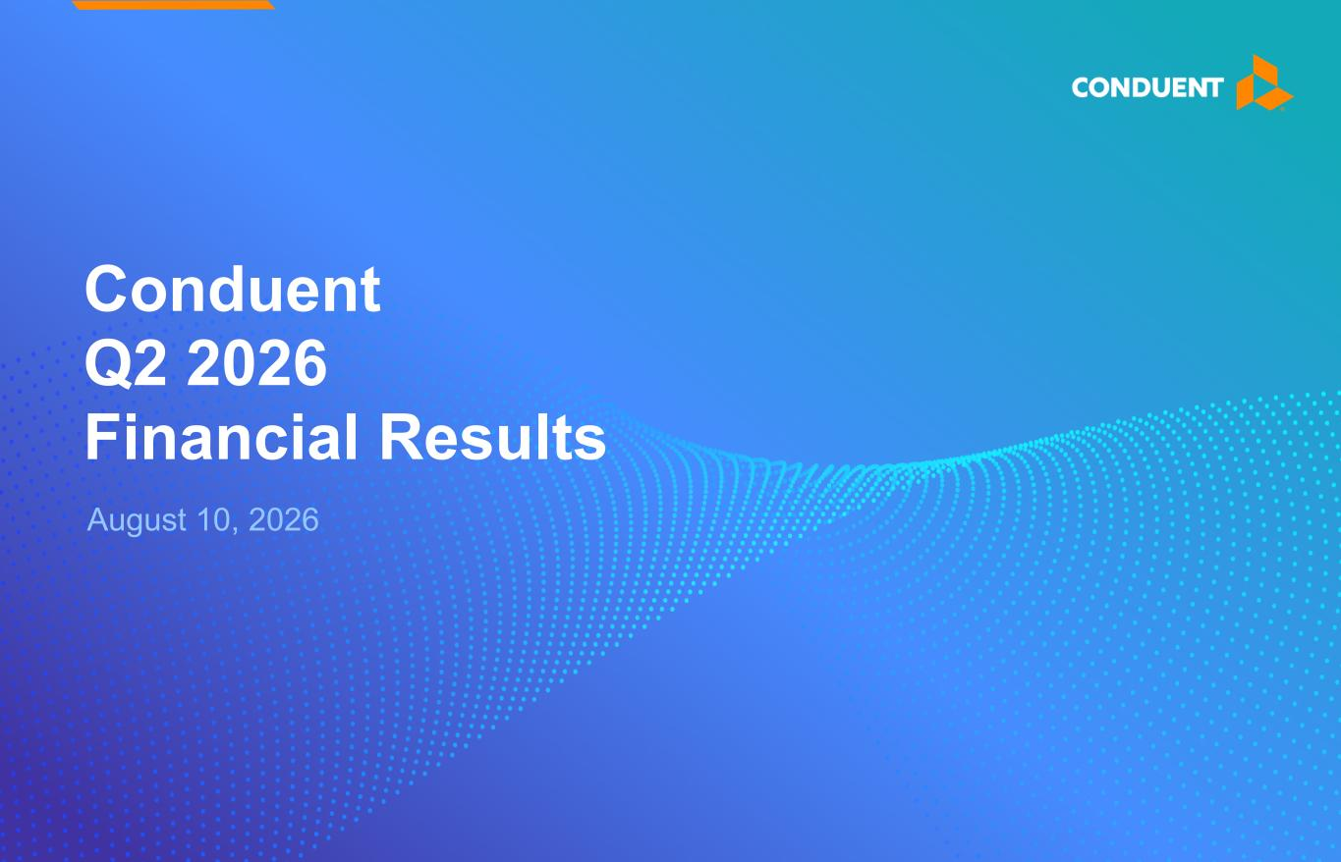
21
August 10, 2026 Conduent Q2 2026 Financial Results

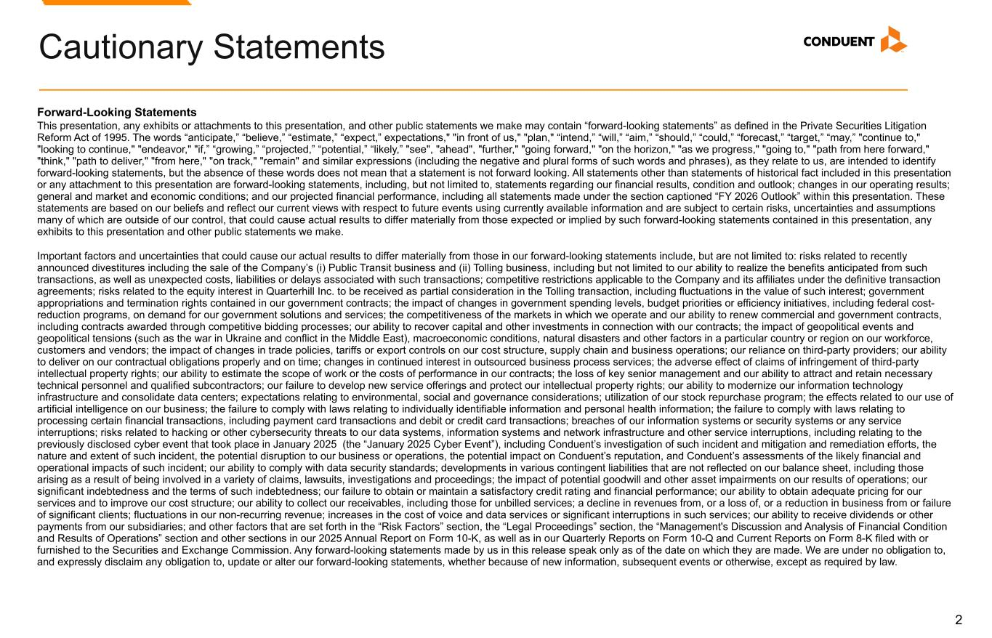
2 Forward-Looking Statements This presentation, any exhibits or attachments to this presentation, and other public statements we make may contain “forward-looking statements” as defined in the Private Securities Litigation Reform Act of 1995. The words “anticipate,” “believe,” “estimate,” “expect,” expectations," "in front of us," "plan," “intend,” “will,” “aim,” “should,” “could,” “forecast,” “target,” “may,” "continue to," "looking to continue," "endeavor," "if,” “growing,” “projected,” “potential,” “likely,” "see", "ahead", "further," "going forward," "on the horizon," "as we progress," "going to," "path from here forward," "think," "path to deliver," "from here," "on track," "remain" and similar expressions (including the negative and plural forms of such words and phrases), as they relate to us, are intended to identify forward-looking statements, but the absence of these words does not mean that a statement is not forward looking. All statements other than statements of historical fact included in this presentation or any attachment to this presentation are forward-looking statements, including, but not limited to, statements regarding our financial results, condition and outlook; changes in our operating results; general and market and economic conditions; and our projected financial performance, including all statements made under the section captioned “FY 2026 Outlook” within this presentation. These statements are based on our beliefs and reflect our current views with respect to future events using currently available information and are subject to certain risks, uncertainties and assumptions many of which are outside of our control, that could cause actual results to differ materially from those expected or implied by such forward-looking statements contained in this presentation, any exhibits to this presentation and other public statements we make. Important factors and uncertainties that could cause our actual results to differ materially from those in our forward-looking statements include, but are not limited to: risks related to recently announced divestitures including the sale of the Company’s (i) Public Transit business and (ii) Tolling business, including but not limited to our ability to realize the benefits anticipated from such transactions, as well as unexpected costs, liabilities or delays associated with such transactions; competitive restrictions applicable to the Company and its affiliates under the definitive transaction agreements; risks related to the equity interest in Quarterhill Inc. to be received as partial consideration in the Tolling transaction, including fluctuations in the value of such interest; government appropriations and termination rights contained in our government contracts; the impact of changes in government spending levels, budget priorities or efficiency initiatives, including federal cost- reduction programs, on demand for our government solutions and services; the competitiveness of the markets in which we operate and our ability to renew commercial and government contracts, including contracts awarded through competitive bidding processes; our ability to recover capital and other investments in connection with our contracts; the impact of geopolitical events and geopolitical tensions (such as the war in Ukraine and conflict in the Middle East), macroeconomic conditions, natural disasters and other factors in a particular country or region on our workforce, customers and vendors; the impact of changes in trade policies, tariffs or export controls on our cost structure, supply chain and business operations; our reliance on third-party providers; our ability to deliver on our contractual obligations properly and on time; changes in continued interest in outsourced business process services; the adverse effect of claims of infringement of third-party intellectual property rights; our ability to estimate the scope of work or the costs of performance in our contracts; the loss of key senior management and our ability to attract and retain necessary technical personnel and qualified subcontractors; our failure to develop new service offerings and protect our intellectual property rights; our ability to modernize our information technology infrastructure and consolidate data centers; expectations relating to environmental, social and governance considerations; utilization of our stock repurchase program; the effects related to our use of artificial intelligence on our business; the failure to comply with laws relating to individually identifiable information and personal health information; the failure to comply with laws relating to processing certain financial transactions, including payment card transactions and debit or credit card transactions; breaches of our information systems or security systems or any service interruptions; risks related to hacking or other cybersecurity threats to our data systems, information systems and network infrastructure and other service interruptions, including relating to the previously disclosed cyber event that took place in January 2025 (the “January 2025 Cyber Event”), including Conduent’s investigation of such incident and mitigation and remediation efforts, the nature and extent of such incident, the potential disruption to our business or operations, the potential impact on Conduent’s reputation, and Conduent’s assessments of the likely financial and operational impacts of such incident; our ability to comply with data security standards; developments in various contingent liabilities that are not reflected on our balance sheet, including those arising as a result of being involved in a variety of claims, lawsuits, investigations and proceedings; the impact of potential goodwill and other asset impairments on our results of operations; our significant indebtedness and the terms of such indebtedness; our failure to obtain or maintain a satisfactory credit rating and financial performance; our ability to obtain adequate pricing for our services and to improve our cost structure; our ability to collect our receivables, including those for unbilled services; a decline in revenues from, or a loss of, or a reduction in business from or failure of significant clients; fluctuations in our non-recurring revenue; increases in the cost of voice and data services or significant interruptions in such services; our ability to receive dividends or other payments from our subsidiaries; and other factors that are set forth in the “Risk Factors” section, the “Legal Proceedings” section, the “Management's Discussion and Analysis of Financial Condition and Results of Operations” section and other sections in our 2025 Annual Report on Form 10-K, as well as in our Quarterly Reports on Form 10-Q and Current Reports on Form 8-K filed with or furnished to the Securities and Exchange Commission. Any forward-looking statements made by us in this release speak only as of the date on which they are made. We are under no obligation to, and expressly disclaim any obligation to, update or alter our forward-looking statements, whether because of new information, subsequent events or otherwise, except as required by law. Cautionary Statements

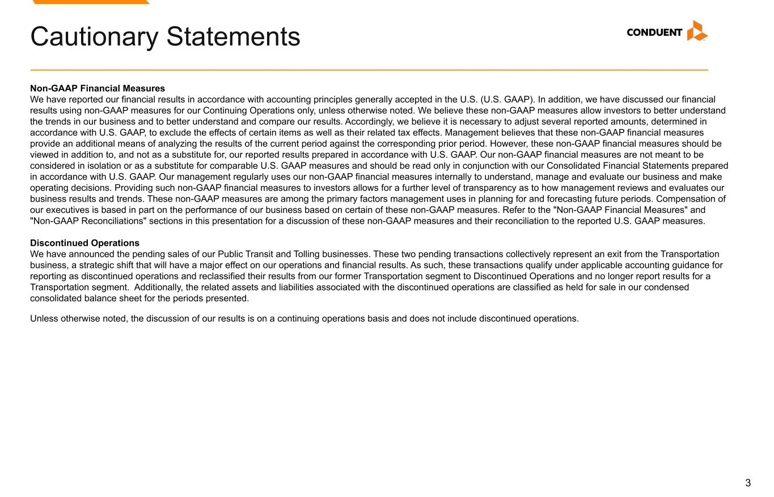
3 Non-GAAP Financial Measures We have reported our financial results in accordance with accounting principles generally accepted in the U.S. (U.S. GAAP). In addition, we have discussed our financial results using non-GAAP measures for our Continuing Operations only, unless otherwise noted. We believe these non-GAAP measures allow investors to better understand the trends in our business and to better understand and compare our results. Accordingly, we believe it is necessary to adjust several reported amounts, determined in accordance with U.S. GAAP, to exclude the effects of certain items as well as their related tax effects. Management believes that these non-GAAP financial measures provide an additional means of analyzing the results of the current period against the corresponding prior period. However, these non-GAAP financial measures should be viewed in addition to, and not as a substitute for, our reported results prepared in accordance with U.S. GAAP. Our non-GAAP financial measures are not meant to be considered in isolation or as a substitute for comparable U.S. GAAP measures and should be read only in conjunction with our Consolidated Financial Statements prepared in accordance with U.S. GAAP. Our management regularly uses our non-GAAP financial measures internally to understand, manage and evaluate our business and make operating decisions. Providing such non-GAAP financial measures to investors allows for a further level of transparency as to how management reviews and evaluates our business results and trends. These non-GAAP measures are among the primary factors management uses in planning for and forecasting future periods. Compensation of our executives is based in part on the performance of our business based on certain of these non-GAAP measures. Refer to the "Non-GAAP Financial Measures" and "Non-GAAP Reconciliations" sections in this presentation for a discussion of these non-GAAP measures and their reconciliation to the reported U.S. GAAP measures. Discontinued Operations We have announced the pending sales of our Public Transit and Tolling businesses. These two pending transactions collectively represent an exit from the Transportation business, a strategic shift that will have a major effect on our operations and financial results. As such, these transactions qualify under applicable accounting guidance for reporting as discontinued operations and reclassified their results from our former Transportation segment to Discontinued Operations and no longer report results for a Transportation segment. Additionally, the related assets and liabilities associated with the discontinued operations are classified as held for sale in our condensed consolidated balance sheet for the periods presented. Unless otherwise noted, the discussion of our results is on a continuing operations basis and does not include discontinued operations. Cautionary Statements

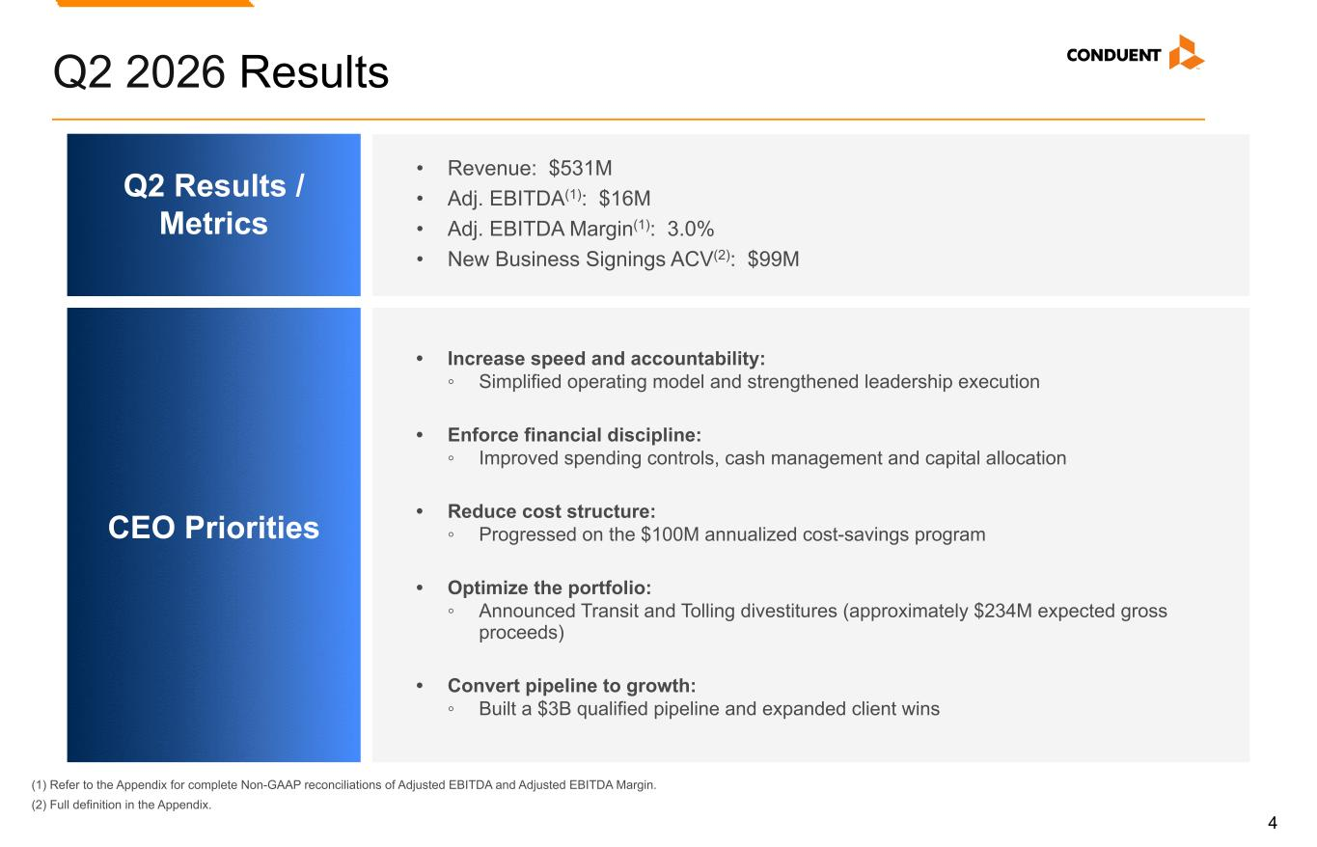
4 Q2 2026 Results (1) Refer to the Appendix for complete Non-GAAP reconciliations of Adjusted EBITDA and Adjusted EBITDA Margin. (2) Full definition in the Appendix. Q2 Results / Metrics CEO Priorities • Revenue: $531M • Adj. EBITDA(1): $16M • Adj. EBITDA Margin(1): 3.0% • New Business Signings ACV(2): $99M • Increase speed and accountability: ◦ Simplified operating model and strengthened leadership execution • Enforce financial discipline: ◦ Improved spending controls, cash management and capital allocation • Reduce cost structure: ◦ Progressed on the $100M annualized cost-savings program • Optimize the portfolio: ◦ Announced Transit and Tolling divestitures (approximately $234M expected gross proceeds) • Convert pipeline to growth: ◦ Built a $3B qualified pipeline and expanded client wins

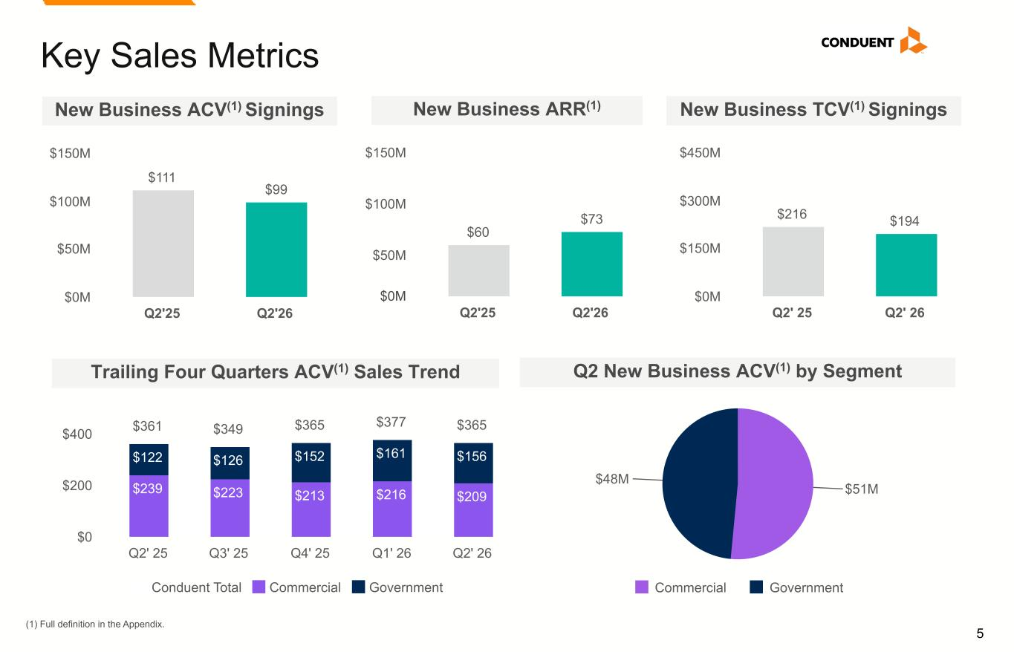
5 Key Sales Metrics New Business ACV(1) Signings Q2 New Business ACV(1) by Segment (1) Full definition in the Appendix. $216 $194 Q2' 25 Q2' 26 $0M $150M $300M $450M New Business TCV(1) Signings $60 $73 Q2'25 Q2'26 $50M $100M $150M $51M $48M Commercial Government $111 $99 Q2'25 Q2'26 $0M $50M $100M $150M New Business ARR(1) Trailing Four Quarters ACV(1) Sales Trend $361 $349 $365 $377 $365 $239 $223 $213 $216 $209 $122 $126 $152 $161 $156 Conduent Total Commercial Government Q2' 25 Q3' 25 Q4' 25 Q1' 26 Q2' 26 $0 $200 $400 $0M

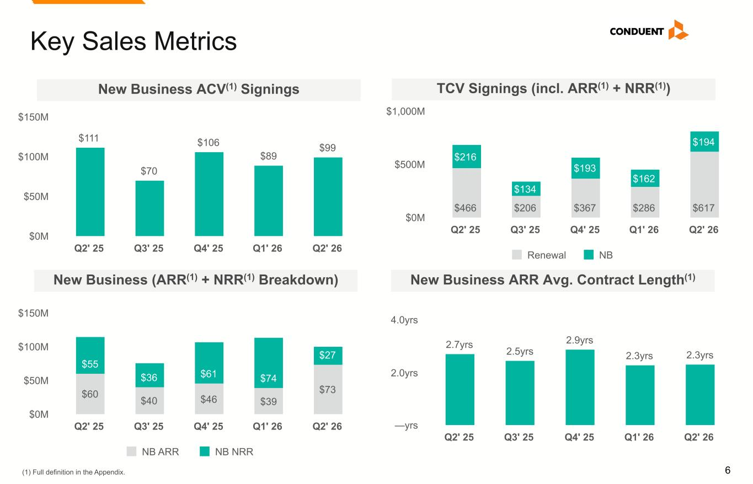
6 Key Sales Metrics TCV Signings (incl. ARR(1) + NRR(1)) $466 $206 $367 $286 $617 $216 $134 $193 $162 $194 Renewal NB Q2' 25 Q3' 25 Q4' 25 Q1' 26 Q2' 26 $0M $500M $1,000M New Business (ARR(1) + NRR(1) Breakdown) $60 $40 $46 $39 $73 $55 $36 $61 $74 $27 NB ARR NB NRR Q2' 25 Q3' 25 Q4' 25 Q1' 26 Q2' 26 $0M $50M $100M $150M New Business ARR Avg. Contract Length(1) $111 $70 $106 $89 $99 Q2' 25 Q3' 25 Q4' 25 Q1' 26 Q2' 26 $0M $50M $100M $150M New Business ACV(1) Signings 2.7yrs 2.5yrs 2.9yrs 2.3yrs 2.3yrs Q2' 25 Q3' 25 Q4' 25 Q1' 26 Q2' 26 —yrs 2.0yrs 4.0yrs (1) Full definition in the Appendix.

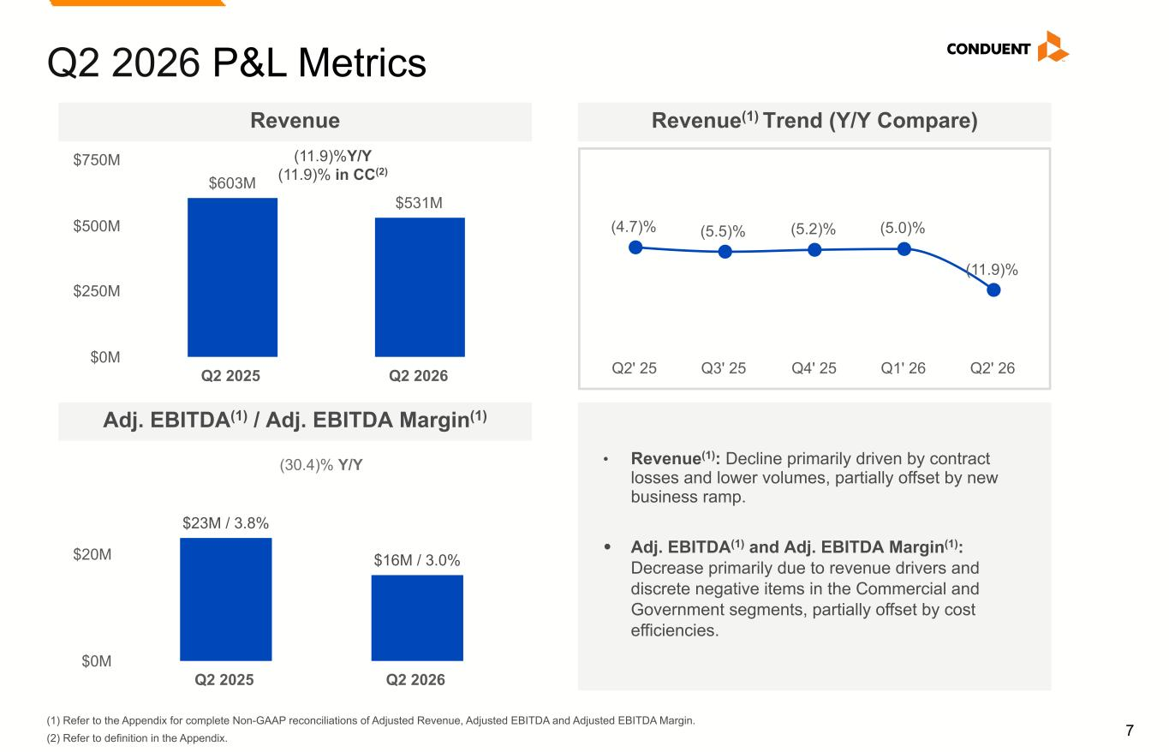
7 Q2 2026 P&L Metrics $603M $531M Q2 2025 Q2 2026 $0M $250M $500M $750M (11.9)%Y/Y (11.9)% in CC(2) Revenue $23M / 3.8% $16M / 3.0% Q2 2025 Q2 2026 $0M $20M Adj. EBITDA(1) / Adj. EBITDA Margin(1) (30.4)% Y/Y • Revenue(1): Decline primarily driven by contract losses and lower volumes, partially offset by new business ramp. • Adj. EBITDA(1) and Adj. EBITDA Margin(1): Decrease primarily due to revenue drivers and discrete negative items in the Commercial and Government segments, partially offset by cost efficiencies. (4.7)% (5.5)% (5.2)% (5.0)% (11.9)% Q2' 25 Q3' 25 Q4' 25 Q1' 26 Q2' 26 Revenue(1) Trend (Y/Y Compare) (1) Refer to the Appendix for complete Non-GAAP reconciliations of Adjusted Revenue, Adjusted EBITDA and Adjusted EBITDA Margin. (2) Refer to definition in the Appendix.

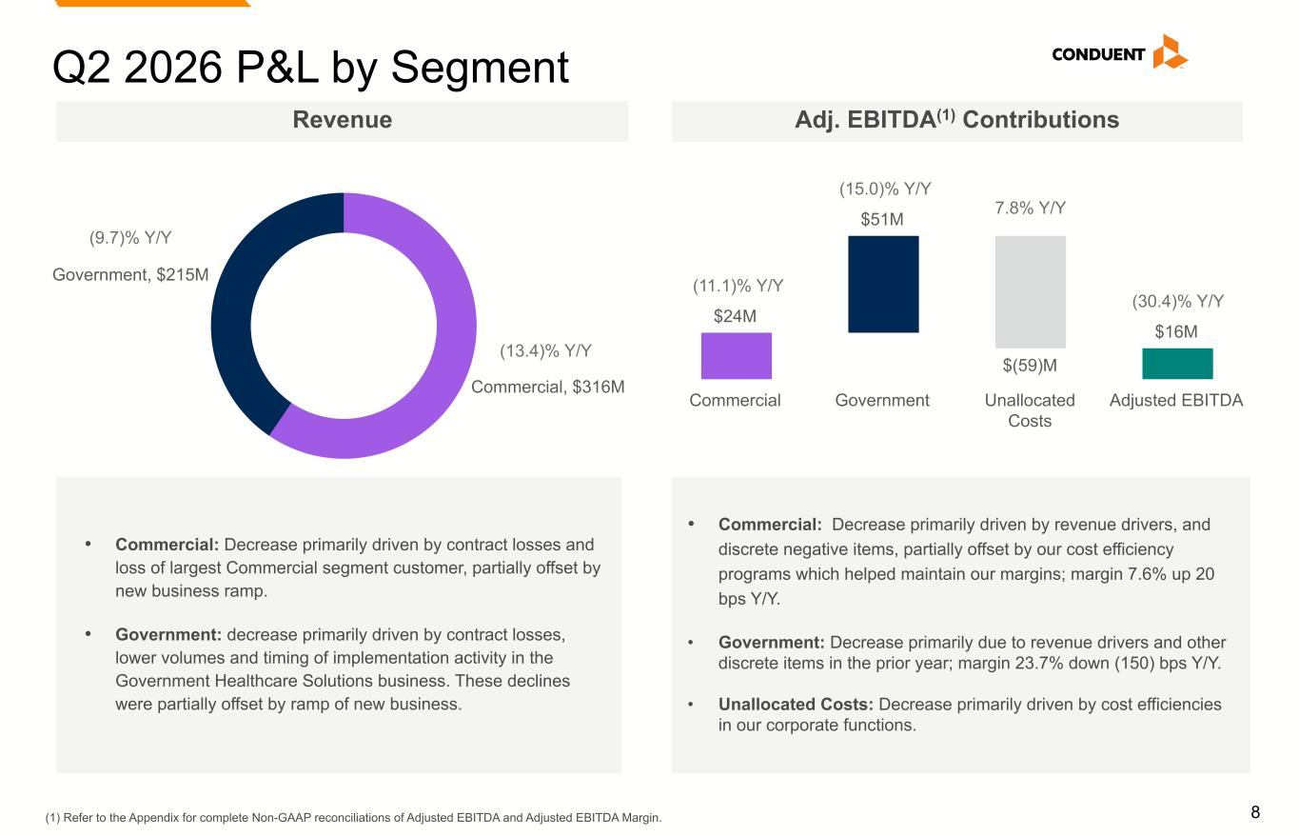
8 $24M $51M $(59)M $16M Commercial Government Unallocated Costs Adjusted EBITDA Commercial, $316M Government, $215M Q2 2026 P&L by Segment (1) Refer to the Appendix for complete Non-GAAP reconciliations of Adjusted EBITDA and Adjusted EBITDA Margin. (9.7)% Y/Y (13.4)% Y/Y (15.0)% Y/Y (11.1)% Y/Y Revenue Adj. EBITDA(1) Contributions (30.4)% Y/Y 7.8% Y/Y • Commercial: Decrease primarily driven by contract losses and loss of largest Commercial segment customer, partially offset by new business ramp. • Government: decrease primarily driven by contract losses, lower volumes and timing of implementation activity in the Government Healthcare Solutions business. These declines were partially offset by ramp of new business. • Commercial: Decrease primarily driven by revenue drivers, and discrete negative items, partially offset by our cost efficiency programs which helped maintain our margins; margin 7.6% up 20 bps Y/Y. • Government: Decrease primarily due to revenue drivers and other discrete items in the prior year; margin 23.7% down (150) bps Y/Y. • Unallocated Costs: Decrease primarily driven by cost efficiencies in our corporate functions.

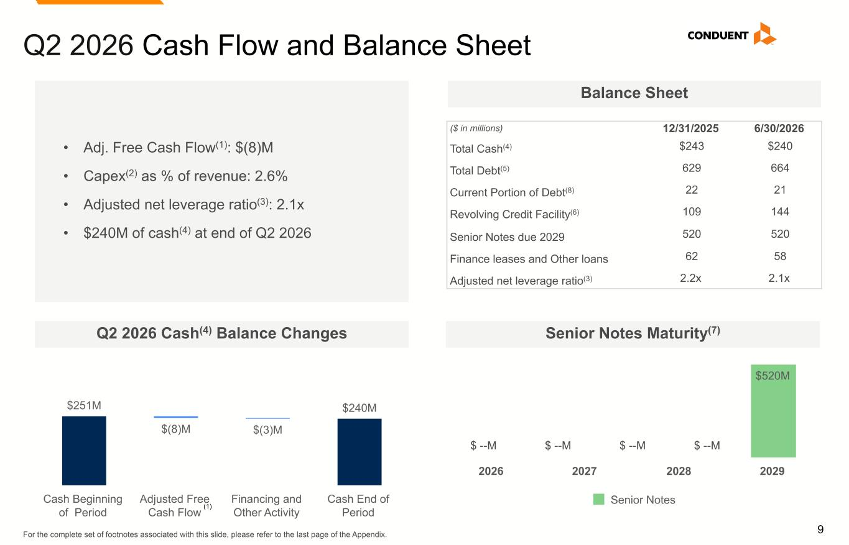
9 $520M Senior Notes 2026 2027 2028 2029 Q2 2026 Cash Flow and Balance Sheet Q2 2026 Cash(4) Balance Changes Balance Sheet For the complete set of footnotes associated with this slide, please refer to the last page of the Appendix. ($ in millions) 12/31/2025 6/30/2026 Total Cash(4) $243 $240 Total Debt(5) 629 664 Current Portion of Debt(8) 22 21 Revolving Credit Facility(6) 109 144 Senior Notes due 2029 520 520 Finance leases and Other loans 62 58 Adjusted net leverage ratio(3) 2.2x 2.1x Senior Notes Maturity(7) $251M $(8)M $(3)M $240M Cash Beginning of Period Adjusted Free Cash Flow Financing and Other Activity Cash End of Period • Adj. Free Cash Flow(1): $(8)M • Capex(2) as % of revenue: 2.6% • Adjusted net leverage ratio(3): 2.1x • $240M of cash(4) at end of Q2 2026 (1) $ --M $ --M$ --M $ --M

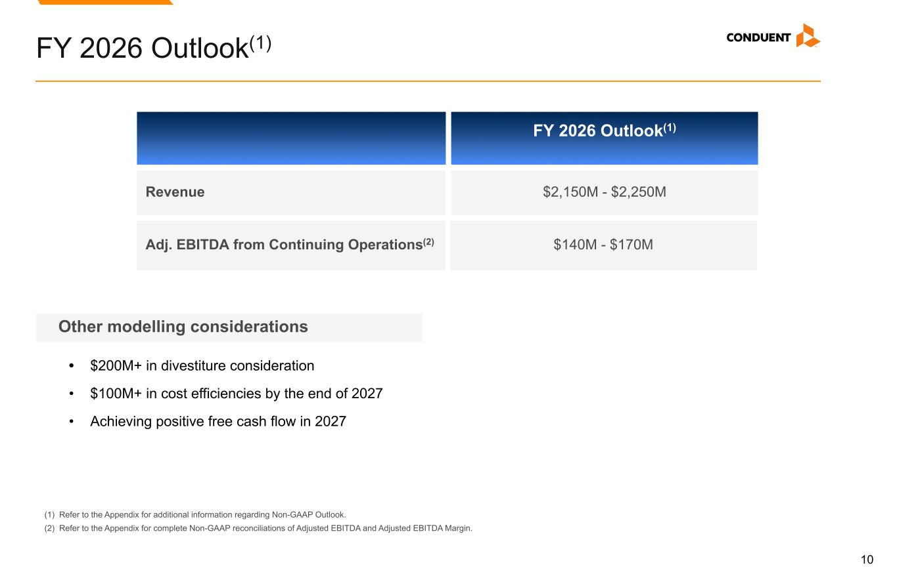
10 FY 2026 Outlook(1) (1) Refer to the Appendix for additional information regarding Non-GAAP Outlook. (2) Refer to the Appendix for complete Non-GAAP reconciliations of Adjusted EBITDA and Adjusted EBITDA Margin. $2,150M - $2,250MRevenue Adj. EBITDA from Continuing Operations(2) $140M - $170M FY 2026 Outlook(1) • $200M+ in divestiture consideration • $100M+ in cost efficiencies by the end of 2027 • Achieving positive free cash flow in 2027 Other modelling considerations


Appendix

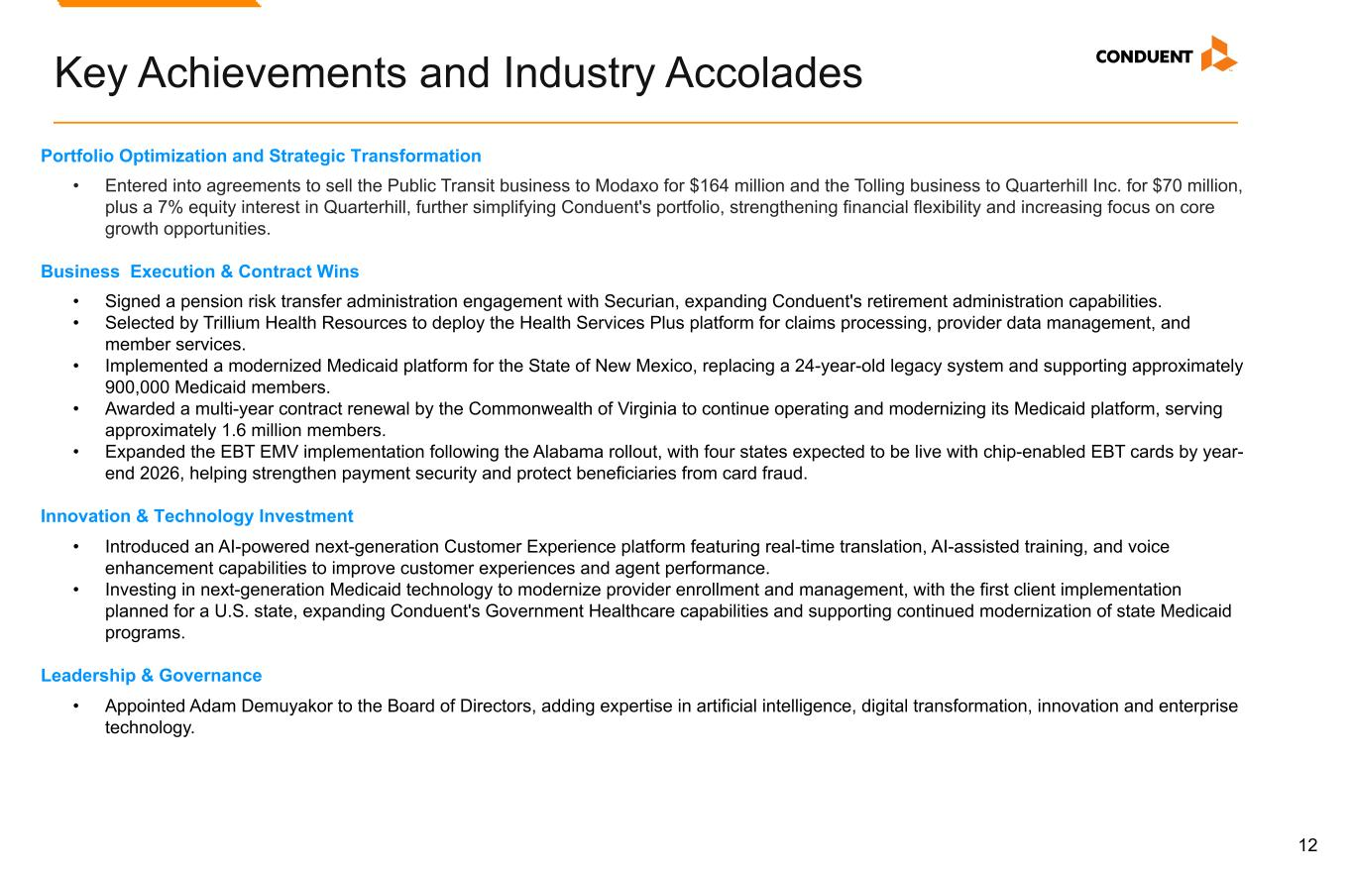
12 Key Achievements and Industry Accolades Portfolio Optimization and Strategic Transformation • Entered into agreements to sell the Public Transit business to Modaxo for $164 million and the Tolling business to Quarterhill Inc. for $70 million, plus a 7% equity interest in Quarterhill, further simplifying Conduent's portfolio, strengthening financial flexibility and increasing focus on core growth opportunities. Business Execution & Contract Wins • Signed a pension risk transfer administration engagement with Securian, expanding Conduent's retirement administration capabilities. • Selected by Trillium Health Resources to deploy the Health Services Plus platform for claims processing, provider data management, and member services. • Implemented a modernized Medicaid platform for the State of New Mexico, replacing a 24-year-old legacy system and supporting approximately 900,000 Medicaid members. • Awarded a multi-year contract renewal by the Commonwealth of Virginia to continue operating and modernizing its Medicaid platform, serving approximately 1.6 million members. • Expanded the EBT EMV implementation following the Alabama rollout, with four states expected to be live with chip-enabled EBT cards by year- end 2026, helping strengthen payment security and protect beneficiaries from card fraud. Innovation & Technology Investment • Introduced an AI-powered next-generation Customer Experience platform featuring real-time translation, AI-assisted training, and voice enhancement capabilities to improve customer experiences and agent performance. • Investing in next-generation Medicaid technology to modernize provider enrollment and management, with the first client implementation planned for a U.S. state, expanding Conduent's Government Healthcare capabilities and supporting continued modernization of state Medicaid programs. Leadership & Governance • Appointed Adam Demuyakor to the Board of Directors, adding expertise in artificial intelligence, digital transformation, innovation and enterprise technology.

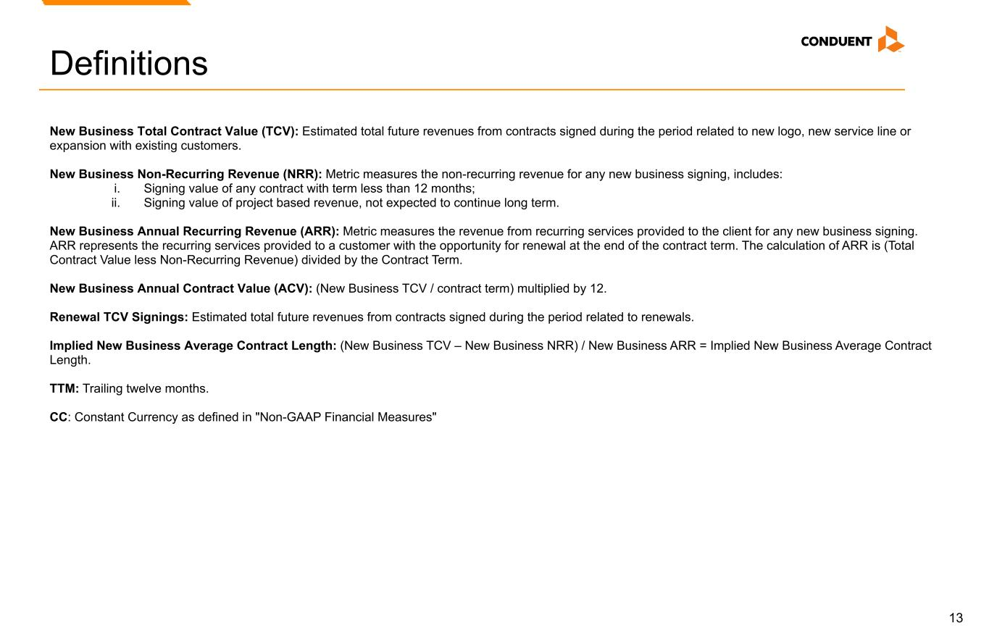
13 Definitions New Business Total Contract Value (TCV): Estimated total future revenues from contracts signed during the period related to new logo, new service line or expansion with existing customers. New Business Non-Recurring Revenue (NRR): Metric measures the non-recurring revenue for any new business signing, includes: i. Signing value of any contract with term less than 12 months; ii. Signing value of project based revenue, not expected to continue long term. New Business Annual Recurring Revenue (ARR): Metric measures the revenue from recurring services provided to the client for any new business signing. ARR represents the recurring services provided to a customer with the opportunity for renewal at the end of the contract term. The calculation of ARR is (Total Contract Value less Non-Recurring Revenue) divided by the Contract Term. New Business Annual Contract Value (ACV): (New Business TCV / contract term) multiplied by 12. Renewal TCV Signings: Estimated total future revenues from contracts signed during the period related to renewals. Implied New Business Average Contract Length: (New Business TCV – New Business NRR) / New Business ARR = Implied New Business Average Contract Length. TTM: Trailing twelve months. CC: Constant Currency as defined in "Non-GAAP Financial Measures"

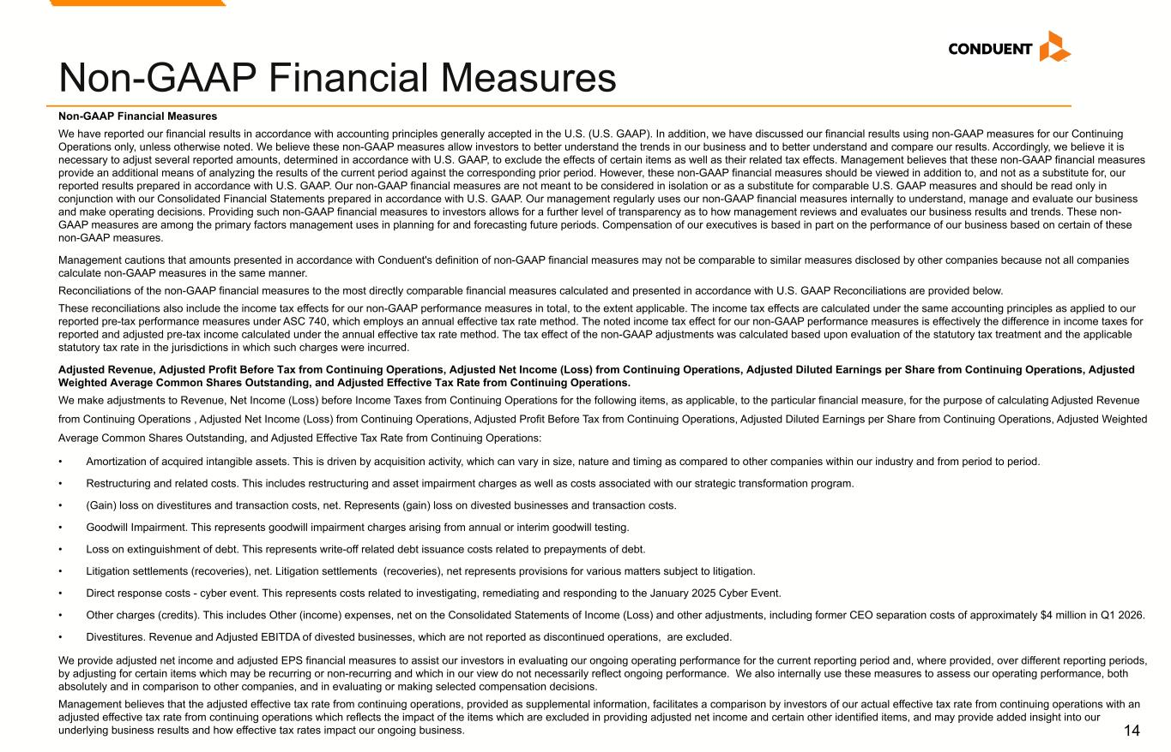
14 Non-GAAP Financial Measures We have reported our financial results in accordance with accounting principles generally accepted in the U.S. (U.S. GAAP). In addition, we have discussed our financial results using non-GAAP measures for our Continuing Operations only, unless otherwise noted. We believe these non-GAAP measures allow investors to better understand the trends in our business and to better understand and compare our results. Accordingly, we believe it is necessary to adjust several reported amounts, determined in accordance with U.S. GAAP, to exclude the effects of certain items as well as their related tax effects. Management believes that these non-GAAP financial measures provide an additional means of analyzing the results of the current period against the corresponding prior period. However, these non-GAAP financial measures should be viewed in addition to, and not as a substitute for, our reported results prepared in accordance with U.S. GAAP. Our non-GAAP financial measures are not meant to be considered in isolation or as a substitute for comparable U.S. GAAP measures and should be read only in conjunction with our Consolidated Financial Statements prepared in accordance with U.S. GAAP. Our management regularly uses our non-GAAP financial measures internally to understand, manage and evaluate our business and make operating decisions. Providing such non-GAAP financial measures to investors allows for a further level of transparency as to how management reviews and evaluates our business results and trends. These non- GAAP measures are among the primary factors management uses in planning for and forecasting future periods. Compensation of our executives is based in part on the performance of our business based on certain of these non-GAAP measures. Management cautions that amounts presented in accordance with Conduent's definition of non-GAAP financial measures may not be comparable to similar measures disclosed by other companies because not all companies calculate non-GAAP measures in the same manner. Reconciliations of the non-GAAP financial measures to the most directly comparable financial measures calculated and presented in accordance with U.S. GAAP Reconciliations are provided below. These reconciliations also include the income tax effects for our non-GAAP performance measures in total, to the extent applicable. The income tax effects are calculated under the same accounting principles as applied to our reported pre-tax performance measures under ASC 740, which employs an annual effective tax rate method. The noted income tax effect for our non-GAAP performance measures is effectively the difference in income taxes for reported and adjusted pre-tax income calculated under the annual effective tax rate method. The tax effect of the non-GAAP adjustments was calculated based upon evaluation of the statutory tax treatment and the applicable statutory tax rate in the jurisdictions in which such charges were incurred. Adjusted Revenue, Adjusted Profit Before Tax from Continuing Operations, Adjusted Net Income (Loss) from Continuing Operations, Adjusted Diluted Earnings per Share from Continuing Operations, Adjusted Weighted Average Common Shares Outstanding, and Adjusted Effective Tax Rate from Continuing Operations. We make adjustments to Revenue, Net Income (Loss) before Income Taxes from Continuing Operations for the following items, as applicable, to the particular financial measure, for the purpose of calculating Adjusted Revenue from Continuing Operations , Adjusted Net Income (Loss) from Continuing Operations, Adjusted Profit Before Tax from Continuing Operations, Adjusted Diluted Earnings per Share from Continuing Operations, Adjusted Weighted Average Common Shares Outstanding, and Adjusted Effective Tax Rate from Continuing Operations: • Amortization of acquired intangible assets. This is driven by acquisition activity, which can vary in size, nature and timing as compared to other companies within our industry and from period to period. • Restructuring and related costs. This includes restructuring and asset impairment charges as well as costs associated with our strategic transformation program. • (Gain) loss on divestitures and transaction costs, net. Represents (gain) loss on divested businesses and transaction costs. • Goodwill Impairment. This represents goodwill impairment charges arising from annual or interim goodwill testing. • Loss on extinguishment of debt. This represents write-off related debt issuance costs related to prepayments of debt. • Litigation settlements (recoveries), net. Litigation settlements (recoveries), net represents provisions for various matters subject to litigation. • Direct response costs - cyber event. This represents costs related to investigating, remediating and responding to the January 2025 Cyber Event. • Other charges (credits). This includes Other (income) expenses, net on the Consolidated Statements of Income (Loss) and other adjustments, including former CEO separation costs of approximately $4 million in Q1 2026. • Divestitures. Revenue and Adjusted EBITDA of divested businesses, which are not reported as discontinued operations, are excluded. We provide adjusted net income and adjusted EPS financial measures to assist our investors in evaluating our ongoing operating performance for the current reporting period and, where provided, over different reporting periods, by adjusting for certain items which may be recurring or non-recurring and which in our view do not necessarily reflect ongoing performance. We also internally use these measures to assess our operating performance, both absolutely and in comparison to other companies, and in evaluating or making selected compensation decisions. Management believes that the adjusted effective tax rate from continuing operations, provided as supplemental information, facilitates a comparison by investors of our actual effective tax rate from continuing operations with an adjusted effective tax rate from continuing operations which reflects the impact of the items which are excluded in providing adjusted net income and certain other identified items, and may provide added insight into our underlying business results and how effective tax rates impact our ongoing business. Non-GAAP Financial Measures

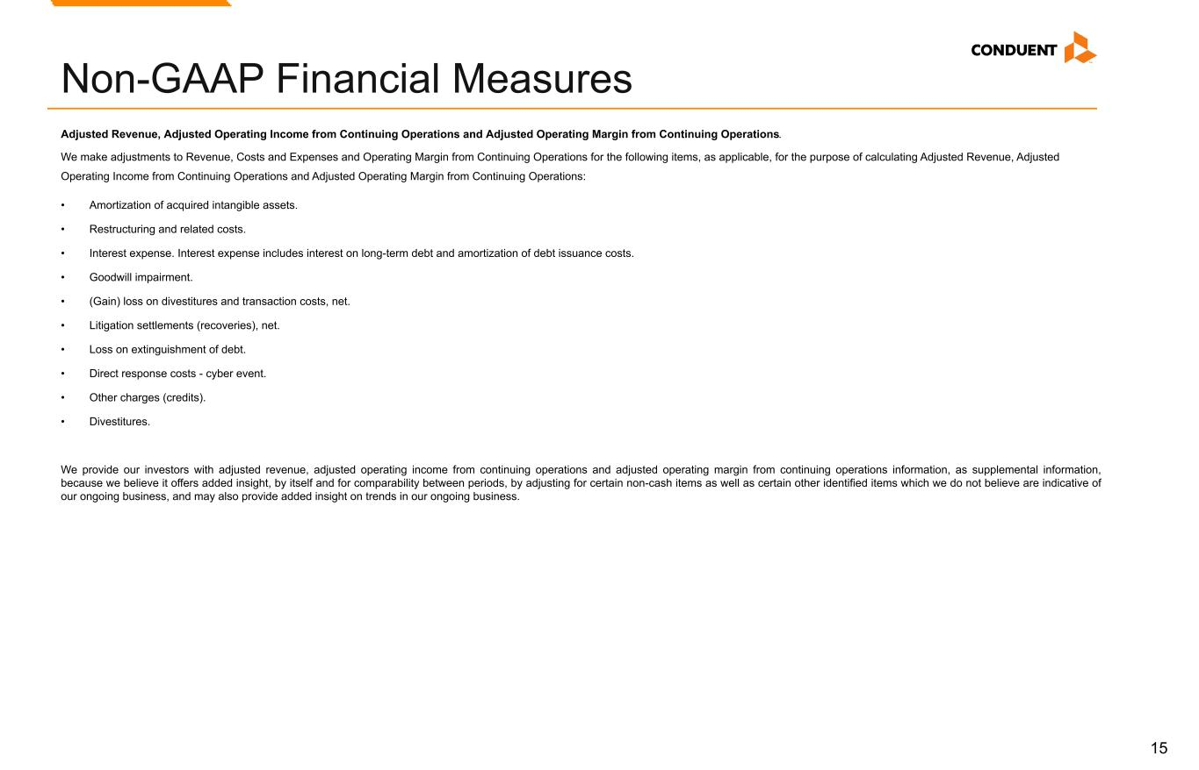
15 Adjusted Revenue, Adjusted Operating Income from Continuing Operations and Adjusted Operating Margin from Continuing Operations. We make adjustments to Revenue, Costs and Expenses and Operating Margin from Continuing Operations for the following items, as applicable, for the purpose of calculating Adjusted Revenue, Adjusted Operating Income from Continuing Operations and Adjusted Operating Margin from Continuing Operations: • Amortization of acquired intangible assets. • Restructuring and related costs. • Interest expense. Interest expense includes interest on long-term debt and amortization of debt issuance costs. • Goodwill impairment. • (Gain) loss on divestitures and transaction costs, net. • Litigation settlements (recoveries), net. • Loss on extinguishment of debt. • Direct response costs - cyber event. • Other charges (credits). • Divestitures. We provide our investors with adjusted revenue, adjusted operating income from continuing operations and adjusted operating margin from continuing operations information, as supplemental information, because we believe it offers added insight, by itself and for comparability between periods, by adjusting for certain non-cash items as well as certain other identified items which we do not believe are indicative of our ongoing business, and may also provide added insight on trends in our ongoing business. Non-GAAP Financial Measures

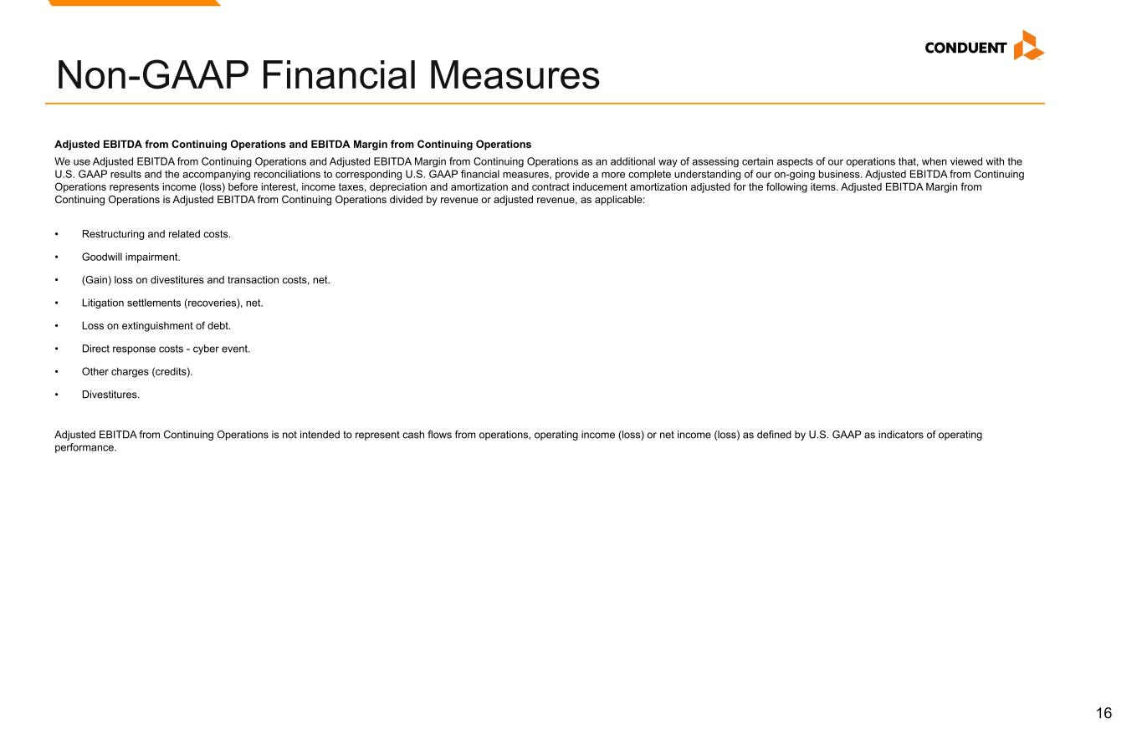
16 Adjusted EBITDA from Continuing Operations and EBITDA Margin from Continuing Operations We use Adjusted EBITDA from Continuing Operations and Adjusted EBITDA Margin from Continuing Operations as an additional way of assessing certain aspects of our operations that, when viewed with the U.S. GAAP results and the accompanying reconciliations to corresponding U.S. GAAP financial measures, provide a more complete understanding of our on-going business. Adjusted EBITDA from Continuing Operations represents income (loss) before interest, income taxes, depreciation and amortization and contract inducement amortization adjusted for the following items. Adjusted EBITDA Margin from Continuing Operations is Adjusted EBITDA from Continuing Operations divided by revenue or adjusted revenue, as applicable: • Restructuring and related costs. • Goodwill impairment. • (Gain) loss on divestitures and transaction costs, net. • Litigation settlements (recoveries), net. • Loss on extinguishment of debt. • Direct response costs - cyber event. • Other charges (credits). • Divestitures. Adjusted EBITDA from Continuing Operations is not intended to represent cash flows from operations, operating income (loss) or net income (loss) as defined by U.S. GAAP as indicators of operating performance. Non-GAAP Financial Measures

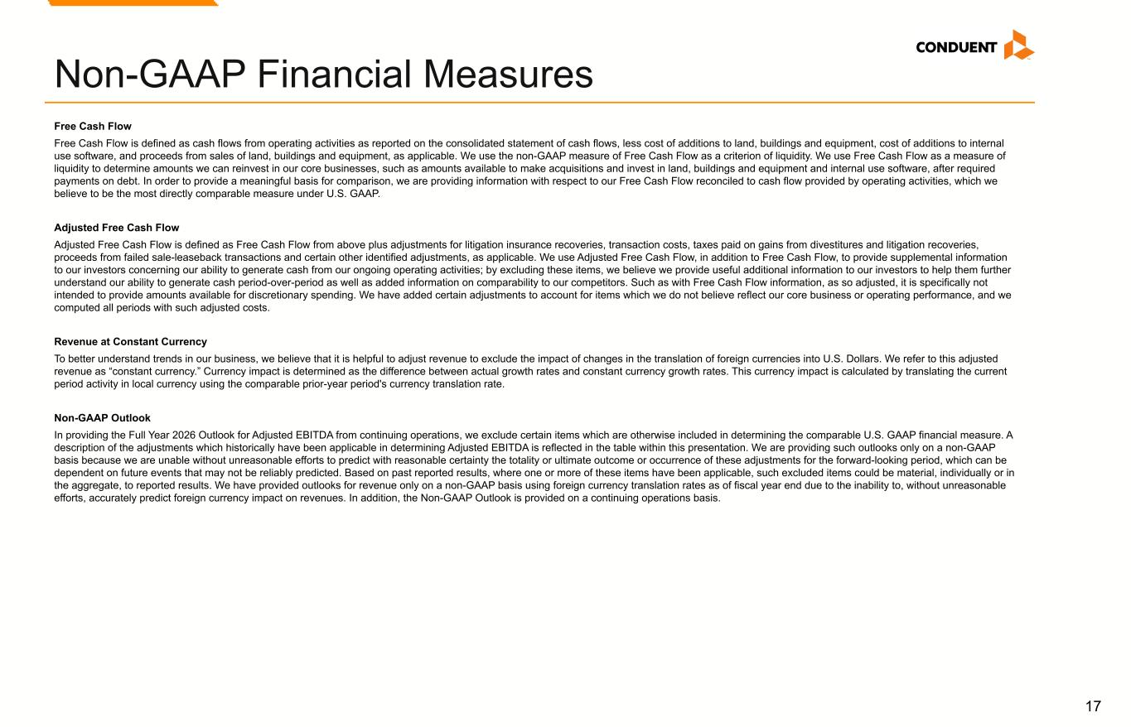
17 Free Cash Flow Free Cash Flow is defined as cash flows from operating activities as reported on the consolidated statement of cash flows, less cost of additions to land, buildings and equipment, cost of additions to internal use software, and proceeds from sales of land, buildings and equipment, as applicable. We use the non-GAAP measure of Free Cash Flow as a criterion of liquidity. We use Free Cash Flow as a measure of liquidity to determine amounts we can reinvest in our core businesses, such as amounts available to make acquisitions and invest in land, buildings and equipment and internal use software, after required payments on debt. In order to provide a meaningful basis for comparison, we are providing information with respect to our Free Cash Flow reconciled to cash flow provided by operating activities, which we believe to be the most directly comparable measure under U.S. GAAP. Adjusted Free Cash Flow Adjusted Free Cash Flow is defined as Free Cash Flow from above plus adjustments for litigation insurance recoveries, transaction costs, taxes paid on gains from divestitures and litigation recoveries, proceeds from failed sale-leaseback transactions and certain other identified adjustments, as applicable. We use Adjusted Free Cash Flow, in addition to Free Cash Flow, to provide supplemental information to our investors concerning our ability to generate cash from our ongoing operating activities; by excluding these items, we believe we provide useful additional information to our investors to help them further understand our ability to generate cash period-over-period as well as added information on comparability to our competitors. Such as with Free Cash Flow information, as so adjusted, it is specifically not intended to provide amounts available for discretionary spending. We have added certain adjustments to account for items which we do not believe reflect our core business or operating performance, and we computed all periods with such adjusted costs. Revenue at Constant Currency To better understand trends in our business, we believe that it is helpful to adjust revenue to exclude the impact of changes in the translation of foreign currencies into U.S. Dollars. We refer to this adjusted revenue as “constant currency.” Currency impact is determined as the difference between actual growth rates and constant currency growth rates. This currency impact is calculated by translating the current period activity in local currency using the comparable prior-year period's currency translation rate. Non-GAAP Outlook In providing the Full Year 2026 Outlook for Adjusted EBITDA from continuing operations, we exclude certain items which are otherwise included in determining the comparable U.S. GAAP financial measure. A description of the adjustments which historically have been applicable in determining Adjusted EBITDA is reflected in the table within this presentation. We are providing such outlooks only on a non-GAAP basis because we are unable without unreasonable efforts to predict with reasonable certainty the totality or ultimate outcome or occurrence of these adjustments for the forward-looking period, which can be dependent on future events that may not be reliably predicted. Based on past reported results, where one or more of these items have been applicable, such excluded items could be material, individually or in the aggregate, to reported results. We have provided outlooks for revenue only on a non-GAAP basis using foreign currency translation rates as of fiscal year end due to the inability to, without unreasonable efforts, accurately predict foreign currency impact on revenues. In addition, the Non-GAAP Outlook is provided on a continuing operations basis. Non-GAAP Financial Measures

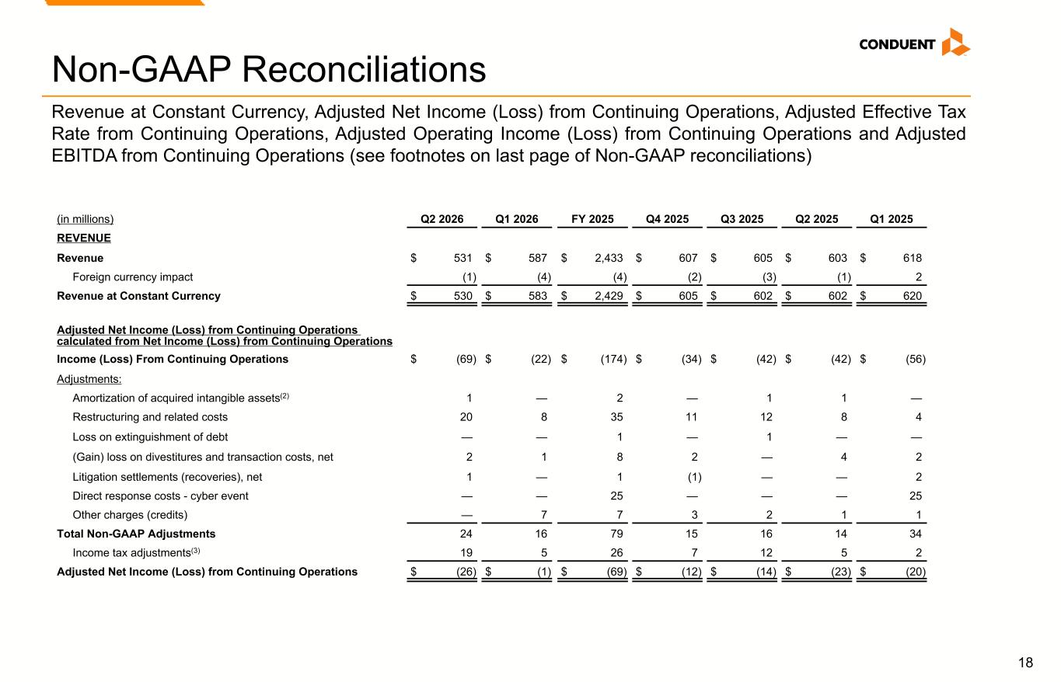
18 Non-GAAP Reconciliations (in millions) Q2 2026 Q1 2026 FY 2025 Q4 2025 Q3 2025 Q2 2025 Q1 2025 REVENUE Revenue $ 531 $ 587 $ 2,433 $ 607 $ 605 $ 603 $ 618 Foreign currency impact (1) (4) (4) (2) (3) (1) 2 Revenue at Constant Currency $ 530 $ 583 $ 2,429 $ 605 $ 602 $ 602 $ 620 Adjusted Net Income (Loss) from Continuing Operations calculated from Net Income (Loss) from Continuing Operations Income (Loss) From Continuing Operations $ (69) $ (22) $ (174) $ (34) $ (42) $ (42) $ (56) Adjustments: Amortization of acquired intangible assets(2) 1 — 2 — 1 1 — Restructuring and related costs 20 8 35 11 12 8 4 Loss on extinguishment of debt — — 1 — 1 — — (Gain) loss on divestitures and transaction costs, net 2 1 8 2 — 4 2 Litigation settlements (recoveries), net 1 — 1 (1) — — 2 Direct response costs - cyber event — — 25 — — — 25 Other charges (credits) — 7 7 3 2 1 1 Total Non-GAAP Adjustments 24 16 79 15 16 14 34 Income tax adjustments(3) 19 5 26 7 12 5 2 Adjusted Net Income (Loss) from Continuing Operations $ (26) $ (1) $ (69) $ (12) $ (14) $ (23) $ (20) Revenue at Constant Currency, Adjusted Net Income (Loss) from Continuing Operations, Adjusted Effective Tax Rate from Continuing Operations, Adjusted Operating Income (Loss) from Continuing Operations and Adjusted EBITDA from Continuing Operations (see footnotes on last page of Non-GAAP reconciliations)

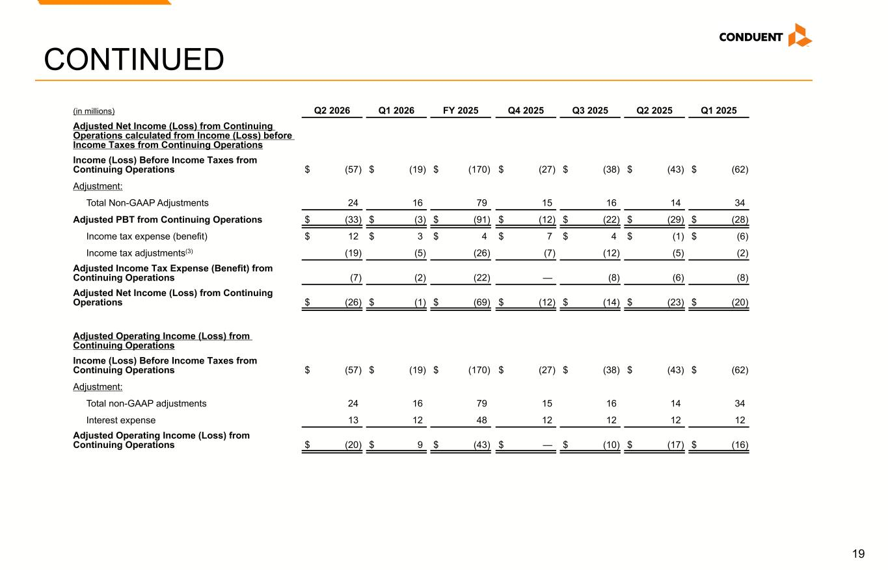
19 CONTINUED (in millions) Q2 2026 Q1 2026 FY 2025 Q4 2025 Q3 2025 Q2 2025 Q1 2025 Adjusted Net Income (Loss) from Continuing Operations calculated from Income (Loss) before Income Taxes from Continuing Operations Income (Loss) Before Income Taxes from Continuing Operations $ (57) $ (19) $ (170) $ (27) $ (38) $ (43) $ (62) Adjustment: Total Non-GAAP Adjustments 24 16 79 15 16 14 34 Adjusted PBT from Continuing Operations $ (33) $ (3) $ (91) $ (12) $ (22) $ (29) $ (28) Income tax expense (benefit) $ 12 $ 3 $ 4 $ 7 $ 4 $ (1) $ (6) Income tax adjustments(3) (19) (5) (26) (7) (12) (5) (2) Adjusted Income Tax Expense (Benefit) from Continuing Operations (7) (2) (22) — (8) (6) (8) Adjusted Net Income (Loss) from Continuing Operations $ (26) $ (1) $ (69) $ (12) $ (14) $ (23) $ (20) Adjusted Operating Income (Loss) from Continuing Operations Income (Loss) Before Income Taxes from Continuing Operations $ (57) $ (19) $ (170) $ (27) $ (38) $ (43) $ (62) Adjustment: Total non-GAAP adjustments 24 16 79 15 16 14 34 Interest expense 13 12 48 12 12 12 12 Adjusted Operating Income (Loss) from Continuing Operations $ (20) $ 9 $ (43) $ — $ (10) $ (17) $ (16)

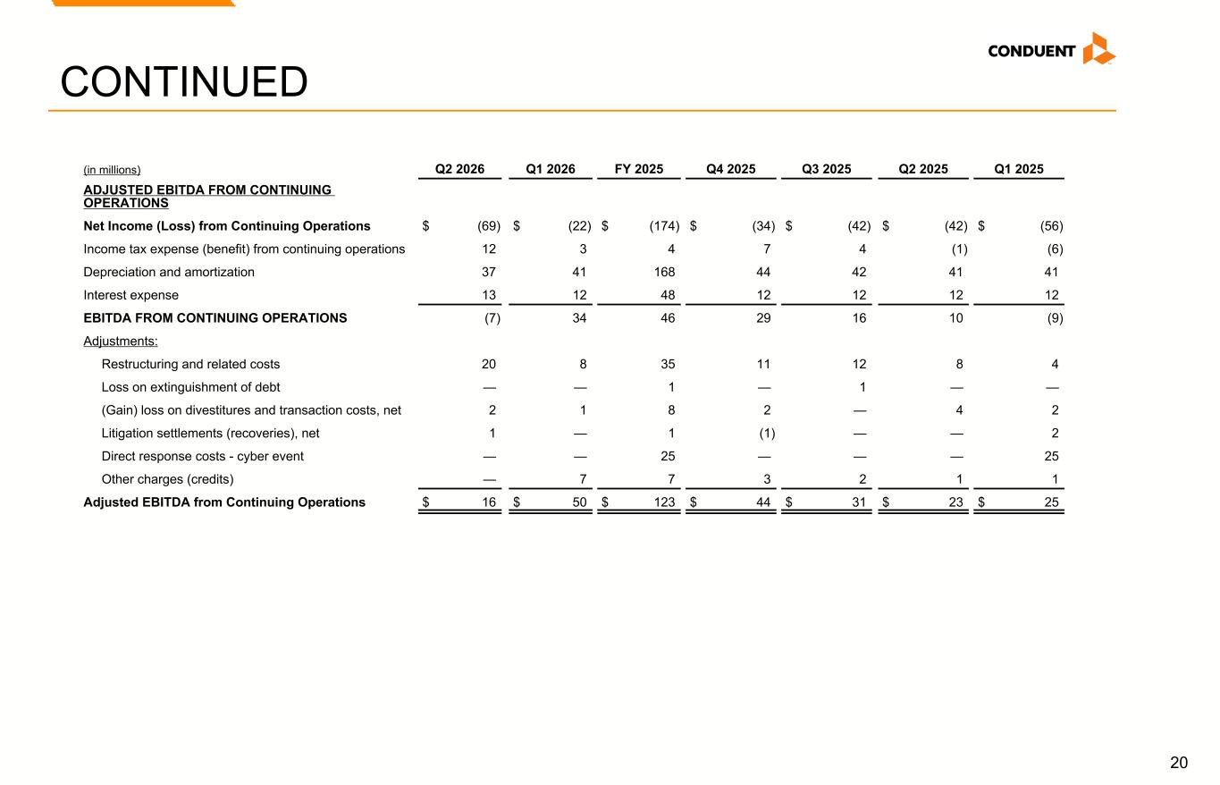
20 (in millions) Q2 2026 Q1 2026 FY 2025 Q4 2025 Q3 2025 Q2 2025 Q1 2025 ADJUSTED EBITDA FROM CONTINUING OPERATIONS Net Income (Loss) from Continuing Operations $ (69) $ (22) $ (174) $ (34) $ (42) $ (42) $ (56) Income tax expense (benefit) from continuing operations 12 3 4 7 4 (1) (6) Depreciation and amortization 37 41 168 44 42 41 41 Interest expense 13 12 48 12 12 12 12 EBITDA FROM CONTINUING OPERATIONS (7) 34 46 29 16 10 (9) Adjustments: Restructuring and related costs 20 8 35 11 12 8 4 Loss on extinguishment of debt — — 1 — 1 — — (Gain) loss on divestitures and transaction costs, net 2 1 8 2 — 4 2 Litigation settlements (recoveries), net 1 — 1 (1) — — 2 Direct response costs - cyber event — — 25 — — — 25 Other charges (credits) — 7 7 3 2 1 1 Adjusted EBITDA from Continuing Operations $ 16 $ 50 $ 123 $ 44 $ 31 $ 23 $ 25 CONTINUED

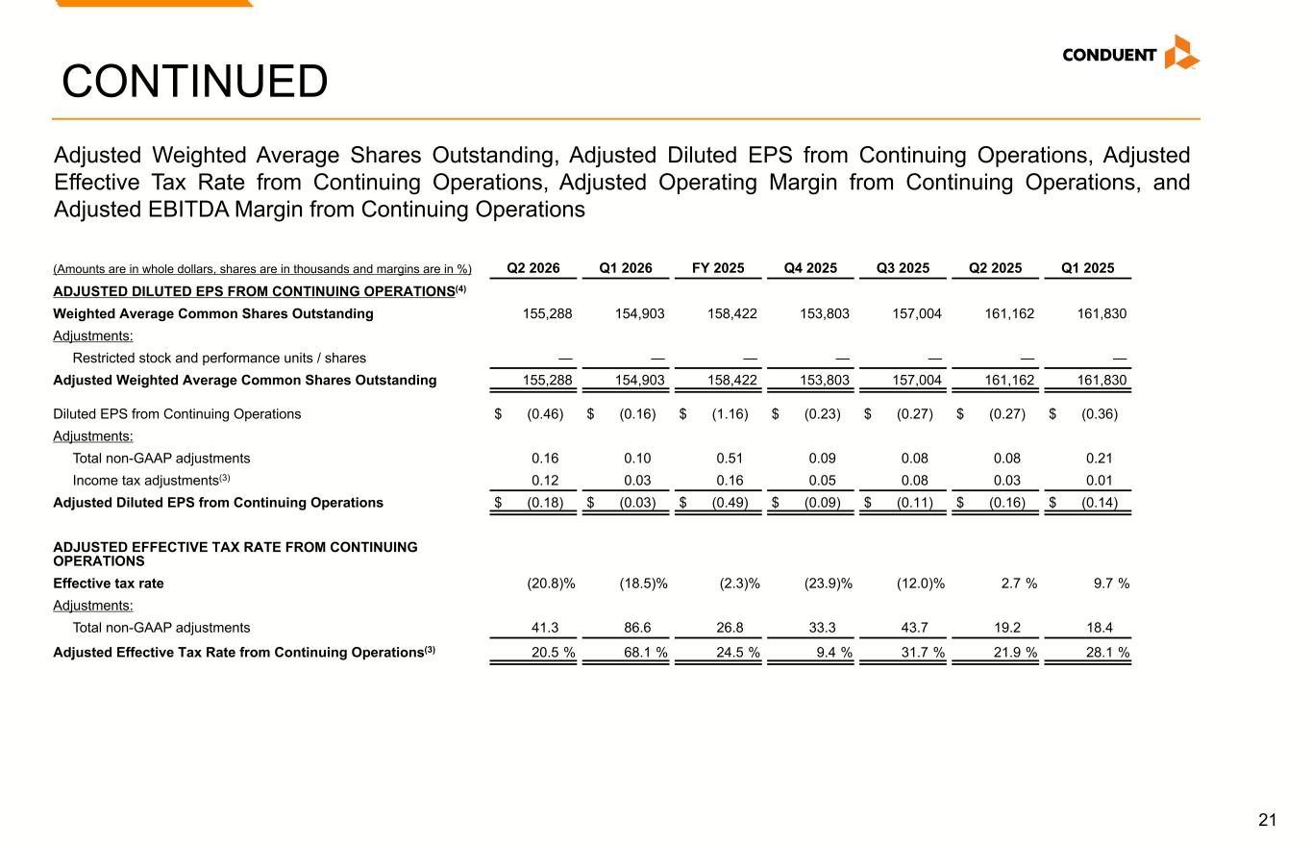
21 CONTINUED (Amounts are in whole dollars, shares are in thousands and margins are in %) Q2 2026 Q1 2026 FY 2025 Q4 2025 Q3 2025 Q2 2025 Q1 2025 ADJUSTED DILUTED EPS FROM CONTINUING OPERATIONS(4) Weighted Average Common Shares Outstanding 155,288 154,903 158,422 153,803 157,004 161,162 161,830 Adjustments: Restricted stock and performance units / shares — — — — — — — Adjusted Weighted Average Common Shares Outstanding 155,288 154,903 158,422 153,803 157,004 161,162 161,830 Diluted EPS from Continuing Operations $ (0.46) $ (0.16) $ (1.16) $ (0.23) $ (0.27) $ (0.27) $ (0.36) Adjustments: Total non-GAAP adjustments 0.16 0.10 0.51 0.09 0.08 0.08 0.21 Income tax adjustments(3) 0.12 0.03 0.16 0.05 0.08 0.03 0.01 Adjusted Diluted EPS from Continuing Operations $ (0.18) $ (0.03) $ (0.49) $ (0.09) $ (0.11) $ (0.16) $ (0.14) ADJUSTED EFFECTIVE TAX RATE FROM CONTINUING OPERATIONS Effective tax rate (20.8) % (18.5) % (2.3) % (23.9) % (12.0) % 2.7 % 9.7 % Adjustments: Total non-GAAP adjustments 41.3 86.6 26.8 33.3 43.7 19.2 18.4 Adjusted Effective Tax Rate from Continuing Operations(3) 20.5 % 68.1 % 24.5 % 9.4 % 31.7 % 21.9 % 28.1 % Adjusted Weighted Average Shares Outstanding, Adjusted Diluted EPS from Continuing Operations, Adjusted Effective Tax Rate from Continuing Operations, Adjusted Operating Margin from Continuing Operations, and Adjusted EBITDA Margin from Continuing Operations

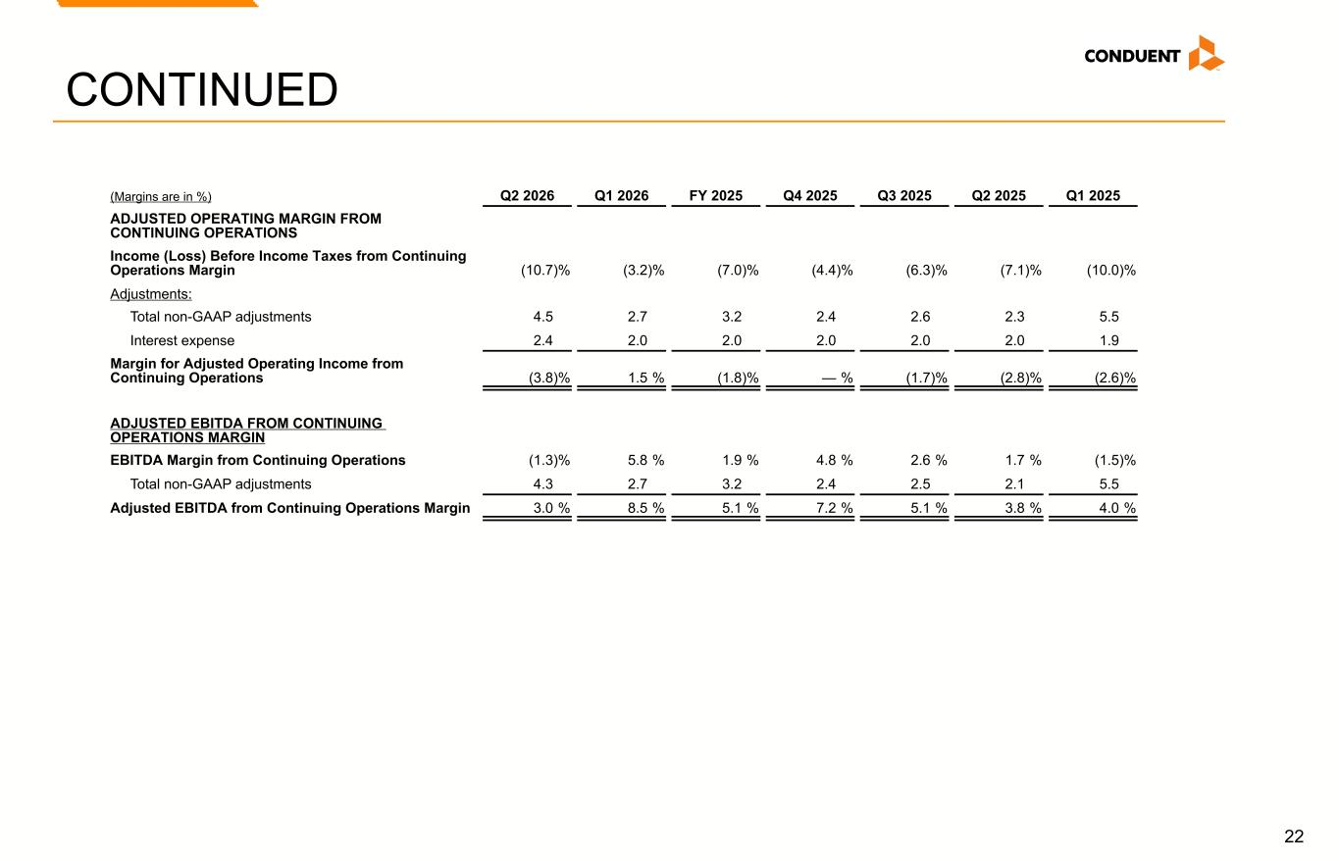
22 (Margins are in %) Q2 2026 Q1 2026 FY 2025 Q4 2025 Q3 2025 Q2 2025 Q1 2025 ADJUSTED OPERATING MARGIN FROM CONTINUING OPERATIONS Income (Loss) Before Income Taxes from Continuing Operations Margin (10.7) % (3.2) % (7.0) % (4.4) % (6.3) % (7.1) % (10.0) % Adjustments: Total non-GAAP adjustments 4.5 2.7 3.2 2.4 2.6 2.3 5.5 Interest expense 2.4 2.0 2.0 2.0 2.0 2.0 1.9 Margin for Adjusted Operating Income from Continuing Operations (3.8) % 1.5 % (1.8) % — % (1.7) % (2.8) % (2.6) % ADJUSTED EBITDA FROM CONTINUING OPERATIONS MARGIN EBITDA Margin from Continuing Operations (1.3) % 5.8 % 1.9 % 4.8 % 2.6 % 1.7 % (1.5) % Total non-GAAP adjustments 4.3 2.7 3.2 2.4 2.5 2.1 5.5 Adjusted EBITDA from Continuing Operations Margin 3.0 % 8.5 % 5.1 % 7.2 % 5.1 % 3.8 % 4.0 % CONTINUED

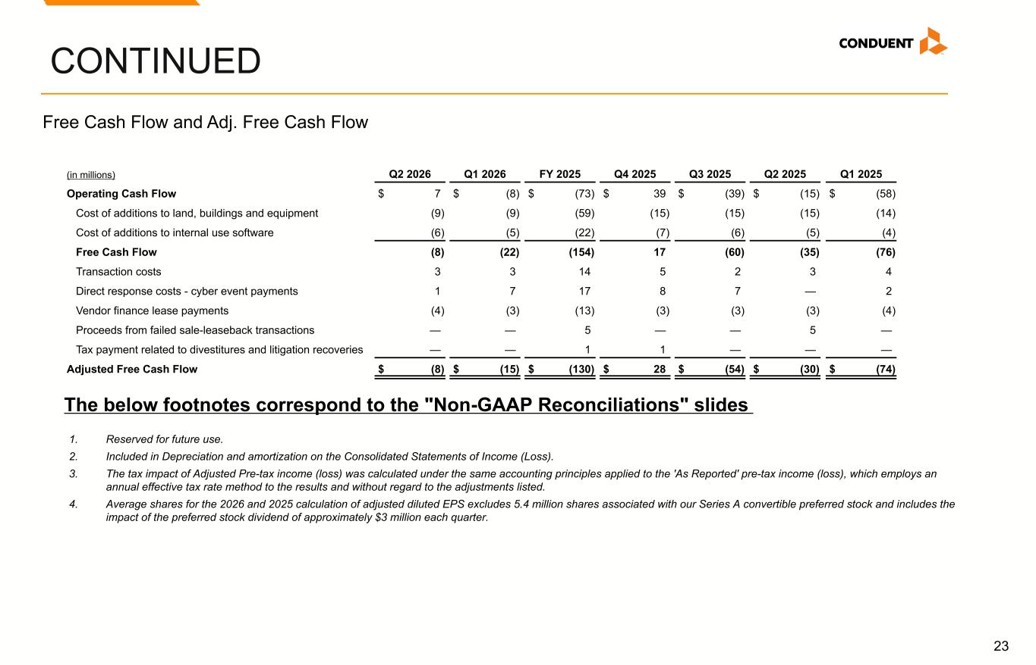
23 CONTINUED (in millions) Q2 2026 Q1 2026 FY 2025 Q4 2025 Q3 2025 Q2 2025 Q1 2025 Operating Cash Flow $ 7 $ (8) $ (73) $ 39 $ (39) $ (15) $ (58) Cost of additions to land, buildings and equipment (9) (9) (59) (15) (15) (15) (14) Cost of additions to internal use software (6) (5) (22) (7) (6) (5) (4) Free Cash Flow (8) (22) (154) 17 (60) (35) (76) Transaction costs 3 3 14 5 2 3 4 Direct response costs - cyber event payments 1 7 17 8 7 — 2 Vendor finance lease payments (4) (3) (13) (3) (3) (3) (4) Proceeds from failed sale-leaseback transactions — — 5 — — 5 — Tax payment related to divestitures and litigation recoveries — — 1 1 — — — Adjusted Free Cash Flow $ (8) $ (15) $ (130) $ 28 $ (54) $ (30) $ (74) Free Cash Flow and Adj. Free Cash Flow The below footnotes correspond to the "Non-GAAP Reconciliations" slides 1. Reserved for future use. 2. Included in Depreciation and amortization on the Consolidated Statements of Income (Loss). 3. The tax impact of Adjusted Pre-tax income (loss) was calculated under the same accounting principles applied to the 'As Reported' pre-tax income (loss), which employs an annual effective tax rate method to the results and without regard to the adjustments listed. 4. Average shares for the 2026 and 2025 calculation of adjusted diluted EPS excludes 5.4 million shares associated with our Series A convertible preferred stock and includes the impact of the preferred stock dividend of approximately $3 million each quarter.

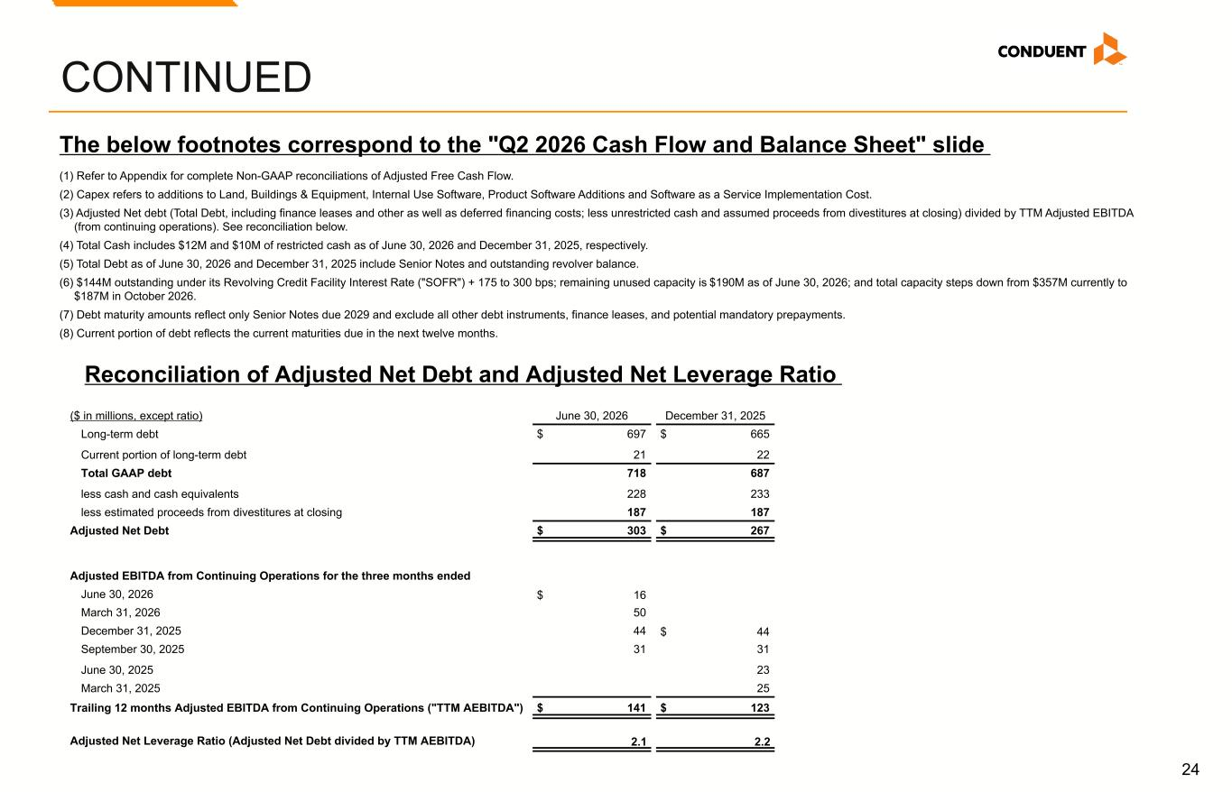
24 CONTINUED ($ in millions, except ratio) June 30, 2026 December 31, 2025 Long-term debt $ 697 $ 665 Current portion of long-term debt 21 22 Total GAAP debt 718 687 less cash and cash equivalents 228 233 less estimated proceeds from divestitures at closing 187 187 Adjusted Net Debt $ 303 $ 267 Adjusted EBITDA from Continuing Operations for the three months ended June 30, 2026 $ 16 March 31, 2026 50 December 31, 2025 44 $ 44 September 30, 2025 31 31 June 30, 2025 23 March 31, 2025 25 Trailing 12 months Adjusted EBITDA from Continuing Operations ("TTM AEBITDA") $ 141 $ 123 Adjusted Net Leverage Ratio (Adjusted Net Debt divided by TTM AEBITDA) 2.1 2.2 (1) Refer to Appendix for complete Non-GAAP reconciliations of Adjusted Free Cash Flow. (2) Capex refers to additions to Land, Buildings & Equipment, Internal Use Software, Product Software Additions and Software as a Service Implementation Cost. (3) Adjusted Net debt (Total Debt, including finance leases and other as well as deferred financing costs; less unrestricted cash and assumed proceeds from divestitures at closing) divided by TTM Adjusted EBITDA (from continuing operations). See reconciliation below. (4) Total Cash includes $12M and $10M of restricted cash as of June 30, 2026 and December 31, 2025, respectively. (5) Total Debt as of June 30, 2026 and December 31, 2025 include Senior Notes and outstanding revolver balance. (6) $144M outstanding under its Revolving Credit Facility Interest Rate ("SOFR") + 175 to 300 bps; remaining unused capacity is $190M as of June 30, 2026; and total capacity steps down from $357M currently to $187M in October 2026. (7) Debt maturity amounts reflect only Senior Notes due 2029 and exclude all other debt instruments, finance leases, and potential mandatory prepayments. (8) Current portion of debt reflects the current maturities due in the next twelve months. The below footnotes correspond to the "Q2 2026 Cash Flow and Balance Sheet" slide Reconciliation of Adjusted Net Debt and Adjusted Net Leverage Ratio


© 2025 Conduent, Inc. All rights reserved. Conduent and Conduent Agile Star are trademarks of Conduent, Inc. and/or its subsidiaries in the United States and/or other countries.© 2026 Conduent, Inc. All rights reserved. Conduent and Conduent Agile Star are trademarks of Conduent, Inc. and/or its subsidiaries in the United States and/or other countries.

