UNITED STATES
SECURITIES AND EXCHANGE COMMISSION
Washington, D.C. 20549
FORM 8-K

CURRENT REPORT
Pursuant to Section 13 or 15(d)
of the Securities Exchange Act of 1934

Date of Report (date of earliest event reported): October 16, 2026

CONDUENT INCORPORATED
(Exact name of registrant as specified in its charter)
New York |  |  |  |  |  | 001-37817 |  |  |  |  |  | 81-2983623
(State or other jurisdiction of  incorporation or organization) |  |  |  |  |  | (Commission  File Number) |  |  |  |  |  | (IRS Employer  Identification No.)
100 Campus Drive, |  |  |  |  |  | Suite 200,
Florham Park, |  |  | New Jersey
07932
(Address of principal executive offices) (Zip Code)

Registrant’s telephone number, including area code: (844) 663-2638
Not Applicable
(Former name or former address, if changed since last report)
Check the appropriate box below if the Form 8-K filing is intended to simultaneously satisfy the filing obligation of the registrant under any of the following provisions (see General Instruction A.2. below):

☐ |  |  | Written communications pursuant to Rule 425 under the Securities Act (17 CFR 230.425)
☐ |  |  | Soliciting material pursuant to Rule 14a-12 under the Exchange Act (17 CFR 240.14a-12)
☐ |  |  | Pre-commencement communications pursuant to Rule 14d-2(b) under the Exchange Act (17 CFR 240.14d-2(b))
☐ |  |  | Pre-commencement communications pursuant to Rule 13e-4(c) under the Exchange Act (17 CFR 240.13e-4(c))

Securities registered pursuant to Section 12(b) of the Act:
Title of each class |  |  | Trading Symbol(s) |  |  | Name of each exchange on which registered
Common Stock, $0.01 par value |  |  | CNDT |  |  | NASDAQ Global Select Market
Indicate by check mark whether the registrant is an emerging growth company as defined in Rule 405 of the Securities Act of 1933 (CFR 230.405) or Rule 12b-2 of the Securities Exchange Act of 1934 (CFR 240.12b-2).
Emerging Growth Company ☐
If an emerging growth company, indicate by check mark if the registrant has elected not to use the extended transition period for complying with any new or revised financial accounting standards provided pursuant to Section 13(a) of the Exchange Act. ☐

Item 1.01. Entry into a Material Definitive Agreement.
On October 16, 2026, Conduent Incorporated, Conduent Business Services, LLC and Conduent State & Local Solutions, Inc. (collectively, the "Company") entered into a Class Action Settlement Agreement and Release (the "Settlement Agreement") with the plaintiffs to the previously disclosed consolidated class action lawsuit (In re: Conduent Business Services Data Breach Litigation) pending in the U.S. District Court for the District of New Jersey (the "Court"), which arises from the Company's previously disclosed January 2025 cybersecurity incident (the "cyber incident"), and, if approved by the Court, will resolve such lawsuit.
Under the Settlement Agreement, the Company will fund $80 million into a non-reversionary settlement fund, which amount will be inclusive of the recovery amount for class members, costs of credit and medical data monitoring, fees for the plaintiffs’ counsel, and the costs of administering the settlement, and is the Company's total monetary obligation under the Settlement Agreement. Upon final approval, the Settlement Agreement releases the Company, the Company's affected clients, and such clients’ affected customers, from claims arising out of or relating to the cyber incident. The Settlement Agreement is not an admission of fault or liability, which the Company denies, and remains subject to Court approval.
As previously disclosed, the Company maintains cyber insurance and does not expect this settlement to have a material impact on its financial position, results of operations or cash flows.
The foregoing description is not complete and is qualified in its entirety by reference to the Settlement Agreement, filed as Exhibit 10.1 to this Current Report on Form 8-K (this “Report”) and incorporated herein by reference.
Item 9.01. Financial Statements and Exhibits.
(d) Exhibits.
Exhibit No. |  |  |  |  |  | Description
10.1 |  |  |  |  |  | Class Action Settlement Agreement and Release, dated October 16, 2026, among the Company and the plaintiffs, on behalf of themselves and the proposed settlement class.
104 |  |  |  |  |  | Cover Page Interactive Data File (embedded within the Inline XBRL document)

Forward-Looking Statements
This Report and any exhibits to this Report may contain "forward-looking statements" as defined in the Private Securities Litigation Reform Act of 1995, as amended. The words "anticipate," "believe," "estimate," "expect," "plan," "intend," "will," "aim," "should," "could," "forecast," "target," "may," "continue to," "endeavor," "if," "growing," "projected," "potential," "likely," "see," "ahead," "further," "going forward," "on the horizon," and similar expressions (including the negative and plural forms of such words and phrases), as they relate to us, are intended to identify forward-looking statements, but the absence of these words does not mean that a statement is not forward-looking. These statements include, but may not be limited to, statements regarding the cyber incident and the Settlement Agreement, including the expected impacts of the Settlement Agreement on the Company’s financial position, results of operations or cash flows. These statements reflect our current views with respect to future events and are subject to certain risks, uncertainties and assumptions, many of which are outside of our control, that could cause actual results to differ materially from those expected or implied by such forward-looking statements contained in this Report, any exhibits to this Report and other public statements we make. Important factors and uncertainties that could cause our actual results to differ materially from those in our forward-looking statements include, but are not limited to: the possibility that the Court may materially alter or fail to approve the Settlement Agreement; uncertainties regarding the outcome of other legal proceedings or government investigations related to the cyber incident; unexpected costs or liabilities in connection with the Settlement Agreement and cyber incident; the risk of litigation or regulatory actions related to the cyber incident; availability and timing of cyber insurance recovery; and other factors that are set forth in the "Risk Factors" and other sections of our Annual Report on Form 10-K, as well as in our Quarterly Reports on Form 10-Q and Current Reports on Form 8-K filed with or furnished to the Securities and Exchange Commission. Any forward-looking statements made by us in this Report speak only as of the date on which they are made. We are under no obligation to, and expressly disclaim any obligation to, update or alter our forward-looking statements, whether because of new information, subsequent events or otherwise, except as required by law.

SIGNATURES
Pursuant to the requirements of the Securities Exchange Act of 1934, Registrant has duly authorized this report to be signed on its behalf by the undersigned duly authorized.
Date: October 16, 2026

CONDUENT INCORPORATED
By: |  |  |  |  |  | /s/ ANNA NOVOSELETSKY
 |  |  |  |  |  | Anna Novoseletsky
 |  |  |  |  |  | Executive Vice President, General Counsel and Secretary



EXHIBIT A Case 2:25-cv-16953-MEF-ADS Document 173-2 Filed 10/16/26 Page 1 of 109 PageID: 1540

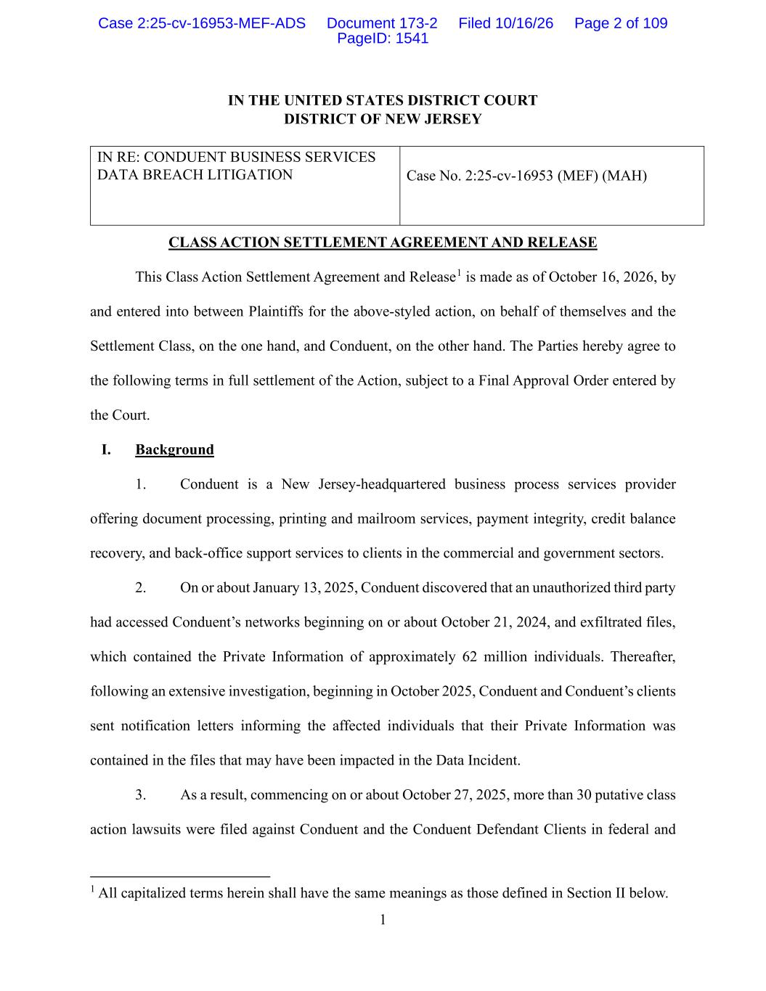
1 IN THE UNITED STATES DISTRICT COURT DISTRICT OF NEW JERSEY IN RE: CONDUENT BUSINESS SERVICES DATA BREACH LITIGATION Case No. 2:25-cv-16953 (MEF) (MAH) CLASS ACTION SETTLEMENT AGREEMENT AND RELEASE This Class Action Settlement Agreement and Release1 is made as of October 16, 2026, by and entered into between Plaintiffs for the above-styled action, on behalf of themselves and the Settlement Class, on the one hand, and Conduent, on the other hand. The Parties hereby agree to the following terms in full settlement of the Action, subject to a Final Approval Order entered by the Court. I. Background 1. Conduent is a New Jersey-headquartered business process services provider offering document processing, printing and mailroom services, payment integrity, credit balance recovery, and back-office support services to clients in the commercial and government sectors. 2. On or about January 13, 2025, Conduent discovered that an unauthorized third party had accessed Conduent’s networks beginning on or about October 21, 2024, and exfiltrated files, which contained the Private Information of approximately 62 million individuals. Thereafter, following an extensive investigation, beginning in October 2025, Conduent and Conduent’s clients sent notification letters informing the affected individuals that their Private Information was contained in the files that may have been impacted in the Data Incident. 3. As a result, commencing on or about October 27, 2025, more than 30 putative class action lawsuits were filed against Conduent and the Conduent Defendant Clients in federal and 1 All capitalized terms herein shall have the same meanings as those defined in Section II below. Case 2:25-cv-16953-MEF-ADS Document 173-2 Filed 10/16/26 Page 2 of 109 PageID: 1541

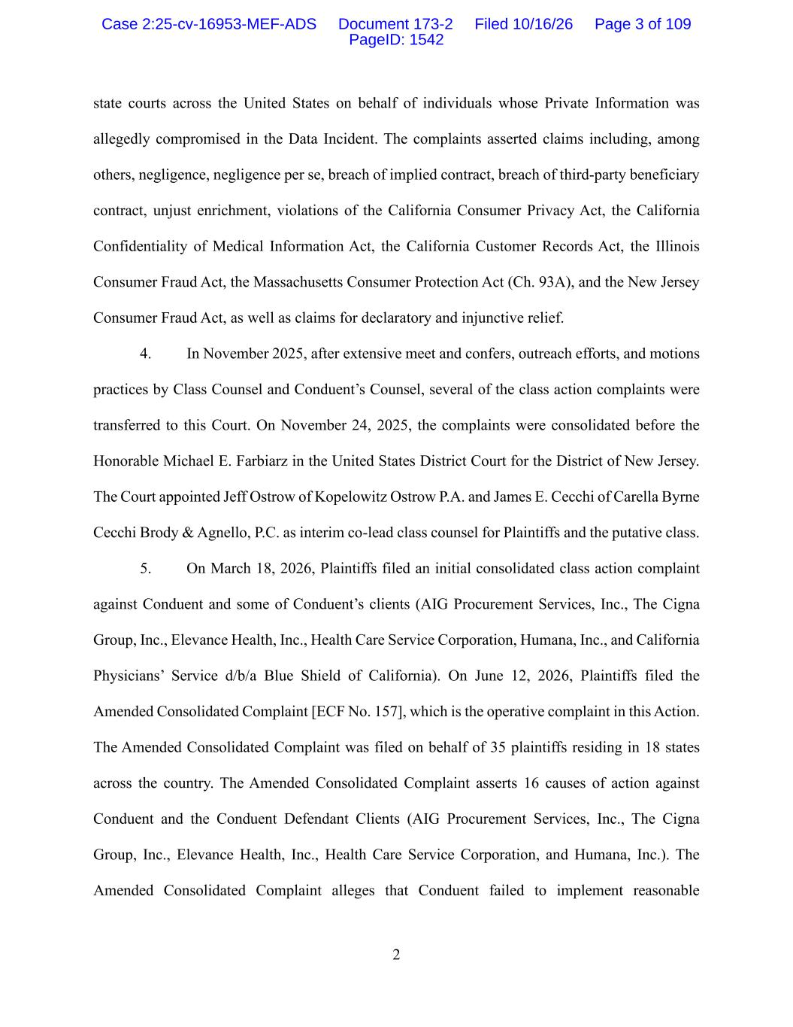
2 state courts across the United States on behalf of individuals whose Private Information was allegedly compromised in the Data Incident. The complaints asserted claims including, among others, negligence, negligence per se, breach of implied contract, breach of third-party beneficiary contract, unjust enrichment, violations of the California Consumer Privacy Act, the California Confidentiality of Medical Information Act, the California Customer Records Act, the Illinois Consumer Fraud Act, the Massachusetts Consumer Protection Act (Ch. 93A), and the New Jersey Consumer Fraud Act, as well as claims for declaratory and injunctive relief. 4. In November 2025, after extensive meet and confers, outreach efforts, and motions practices by Class Counsel and Conduent’s Counsel, several of the class action complaints were transferred to this Court. On November 24, 2025, the complaints were consolidated before the Honorable Michael E. Farbiarz in the United States District Court for the District of New Jersey. The Court appointed Jeff Ostrow of Kopelowitz Ostrow P.A. and James E. Cecchi of Carella Byrne Cecchi Brody & Agnello, P.C. as interim co-lead class counsel for Plaintiffs and the putative class. 5. On March 18, 2026, Plaintiffs filed an initial consolidated class action complaint against Conduent and some of Conduent’s clients (AIG Procurement Services, Inc., The Cigna Group, Inc., Elevance Health, Inc., Health Care Service Corporation, Humana, Inc., and California Physicians’ Service d/b/a Blue Shield of California). On June 12, 2026, Plaintiffs filed the Amended Consolidated Complaint [ECF No. 157], which is the operative complaint in this Action. The Amended Consolidated Complaint was filed on behalf of 35 plaintiffs residing in 18 states across the country. The Amended Consolidated Complaint asserts 16 causes of action against Conduent and the Conduent Defendant Clients (AIG Procurement Services, Inc., The Cigna Group, Inc., Elevance Health, Inc., Health Care Service Corporation, and Humana, Inc.). The Amended Consolidated Complaint alleges that Conduent failed to implement reasonable Case 2:25-cv-16953-MEF-ADS Document 173-2 Filed 10/16/26 Page 3 of 109 PageID: 1542

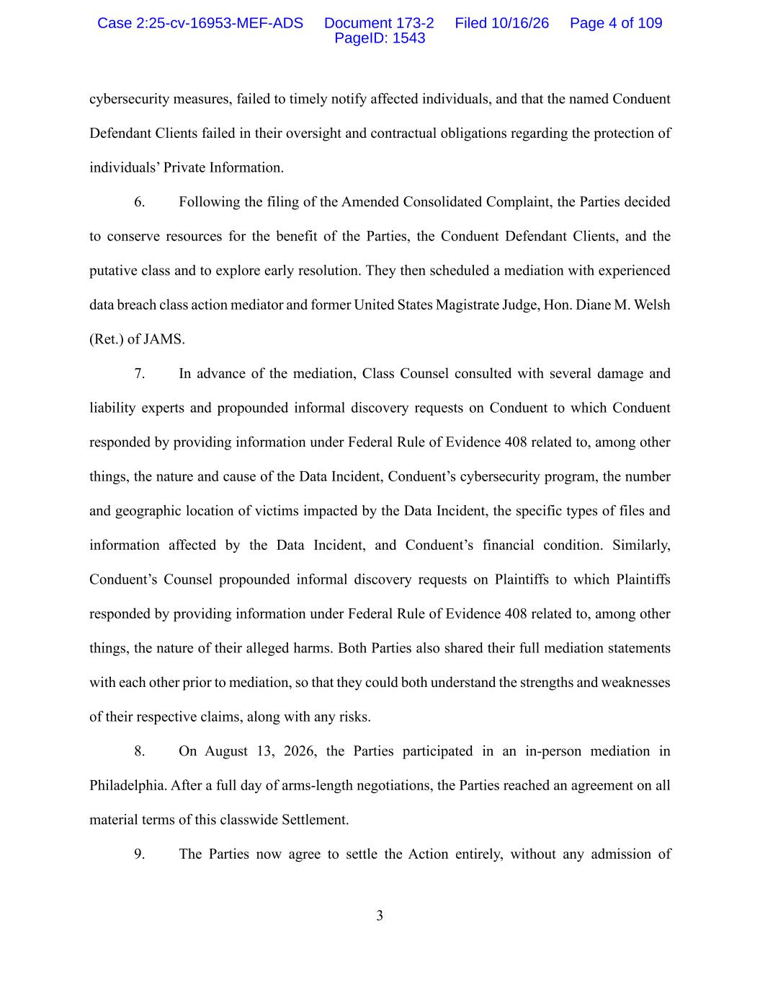
3 cybersecurity measures, failed to timely notify affected individuals, and that the named Conduent Defendant Clients failed in their oversight and contractual obligations regarding the protection of individuals’ Private Information. 6. Following the filing of the Amended Consolidated Complaint, the Parties decided to conserve resources for the benefit of the Parties, the Conduent Defendant Clients, and the putative class and to explore early resolution. They then scheduled a mediation with experienced data breach class action mediator and former United States Magistrate Judge, Hon. Diane M. Welsh (Ret.) of JAMS. 7. In advance of the mediation, Class Counsel consulted with several damage and liability experts and propounded informal discovery requests on Conduent to which Conduent responded by providing information under Federal Rule of Evidence 408 related to, among other things, the nature and cause of the Data Incident, Conduent’s cybersecurity program, the number and geographic location of victims impacted by the Data Incident, the specific types of files and information affected by the Data Incident, and Conduent’s financial condition. Similarly, Conduent’s Counsel propounded informal discovery requests on Plaintiffs to which Plaintiffs responded by providing information under Federal Rule of Evidence 408 related to, among other things, the nature of their alleged harms. Both Parties also shared their full mediation statements with each other prior to mediation, so that they could both understand the strengths and weaknesses of their respective claims, along with any risks. 8. On August 13, 2026, the Parties participated in an in-person mediation in Philadelphia. After a full day of arms-length negotiations, the Parties reached an agreement on all material terms of this classwide Settlement. 9. The Parties now agree to settle the Action entirely, without any admission of Case 2:25-cv-16953-MEF-ADS Document 173-2 Filed 10/16/26 Page 4 of 109 PageID: 1543

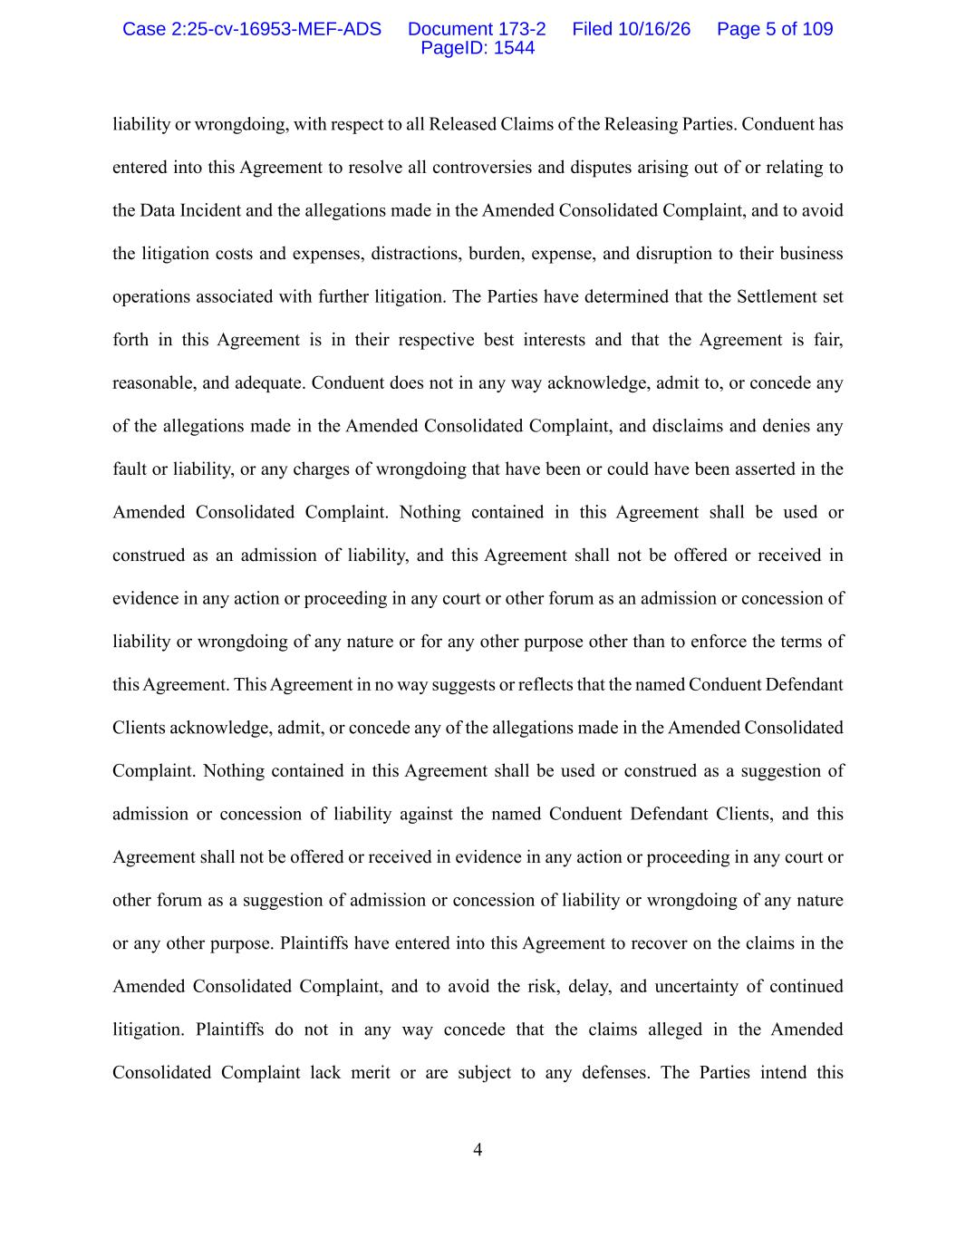
4 liability or wrongdoing, with respect to all Released Claims of the Releasing Parties. Conduent has entered into this Agreement to resolve all controversies and disputes arising out of or relating to the Data Incident and the allegations made in the Amended Consolidated Complaint, and to avoid the litigation costs and expenses, distractions, burden, expense, and disruption to their business operations associated with further litigation. The Parties have determined that the Settlement set forth in this Agreement is in their respective best interests and that the Agreement is fair, reasonable, and adequate. Conduent does not in any way acknowledge, admit to, or concede any of the allegations made in the Amended Consolidated Complaint, and disclaims and denies any fault or liability, or any charges of wrongdoing that have been or could have been asserted in the Amended Consolidated Complaint. Nothing contained in this Agreement shall be used or construed as an admission of liability, and this Agreement shall not be offered or received in evidence in any action or proceeding in any court or other forum as an admission or concession of liability or wrongdoing of any nature or for any other purpose other than to enforce the terms of this Agreement. This Agreement in no way suggests or reflects that the named Conduent Defendant Clients acknowledge, admit, or concede any of the allegations made in the Amended Consolidated Complaint. Nothing contained in this Agreement shall be used or construed as a suggestion of admission or concession of liability against the named Conduent Defendant Clients, and this Agreement shall not be offered or received in evidence in any action or proceeding in any court or other forum as a suggestion of admission or concession of liability or wrongdoing of any nature or any other purpose. Plaintiffs have entered into this Agreement to recover on the claims in the Amended Consolidated Complaint, and to avoid the risk, delay, and uncertainty of continued litigation. Plaintiffs do not in any way concede that the claims alleged in the Amended Consolidated Complaint lack merit or are subject to any defenses. The Parties intend this Case 2:25-cv-16953-MEF-ADS Document 173-2 Filed 10/16/26 Page 5 of 109 PageID: 1544

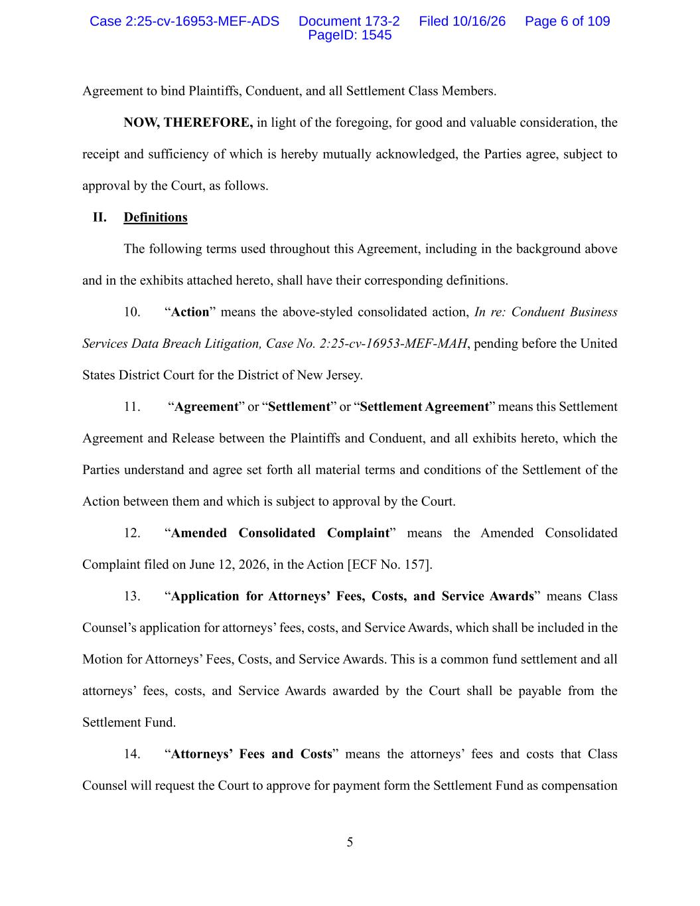
5 Agreement to bind Plaintiffs, Conduent, and all Settlement Class Members. NOW, THEREFORE, in light of the foregoing, for good and valuable consideration, the receipt and sufficiency of which is hereby mutually acknowledged, the Parties agree, subject to approval by the Court, as follows. II. Definitions The following terms used throughout this Agreement, including in the background above and in the exhibits attached hereto, shall have their corresponding definitions. 10. “Action” means the above-styled consolidated action, In re: Conduent Business Services Data Breach Litigation, Case No. 2:25-cv-16953-MEF-MAH, pending before the United States District Court for the District of New Jersey. 11. “Agreement” or “Settlement” or “Settlement Agreement” means this Settlement Agreement and Release between the Plaintiffs and Conduent, and all exhibits hereto, which the Parties understand and agree set forth all material terms and conditions of the Settlement of the Action between them and which is subject to approval by the Court. 12. “Amended Consolidated Complaint” means the Amended Consolidated Complaint filed on June 12, 2026, in the Action [ECF No. 157]. 13. “Application for Attorneys’ Fees, Costs, and Service Awards” means Class Counsel’s application for attorneys’ fees, costs, and Service Awards, which shall be included in the Motion for Attorneys’ Fees, Costs, and Service Awards. This is a common fund settlement and all attorneys’ fees, costs, and Service Awards awarded by the Court shall be payable from the Settlement Fund. 14. “Attorneys’ Fees and Costs” means the attorneys’ fees and costs that Class Counsel will request the Court to approve for payment form the Settlement Fund as compensation Case 2:25-cv-16953-MEF-ADS Document 173-2 Filed 10/16/26 Page 6 of 109 PageID: 1545

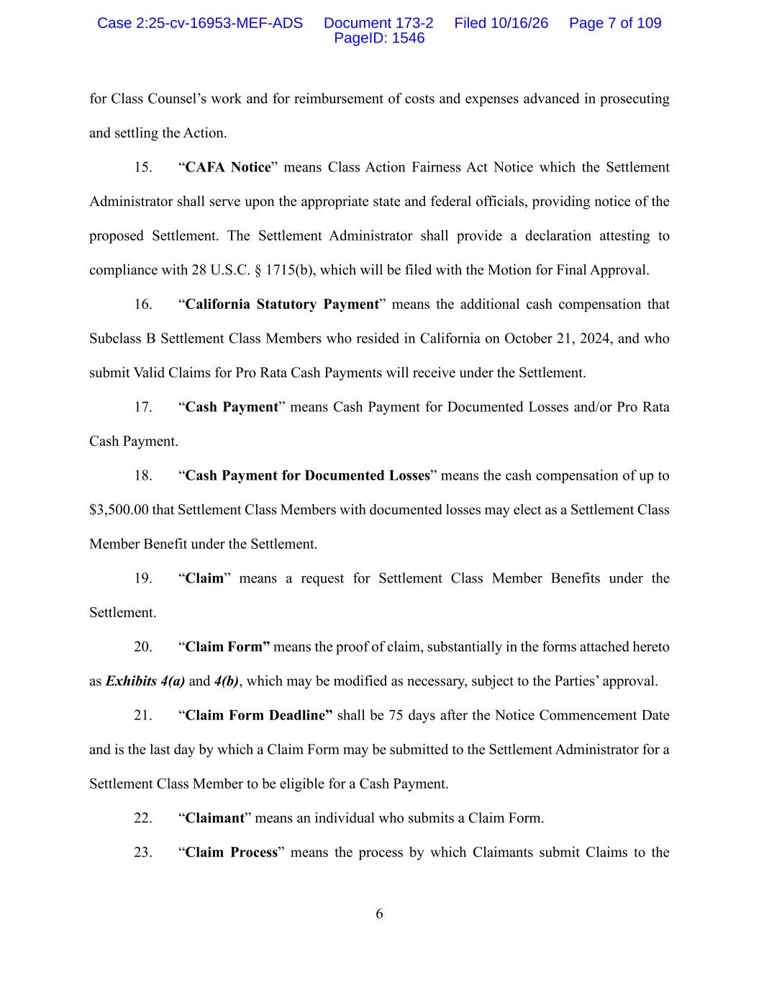
6 for Class Counsel’s work and for reimbursement of costs and expenses advanced in prosecuting and settling the Action. 15. “CAFA Notice” means Class Action Fairness Act Notice which the Settlement Administrator shall serve upon the appropriate state and federal officials, providing notice of the proposed Settlement. The Settlement Administrator shall provide a declaration attesting to compliance with 28 U.S.C. § 1715(b), which will be filed with the Motion for Final Approval. 16. “California Statutory Payment” means the additional cash compensation that Subclass B Settlement Class Members who resided in California on October 21, 2024, and who submit Valid Claims for Pro Rata Cash Payments will receive under the Settlement. 17. “Cash Payment” means Cash Payment for Documented Losses and/or Pro Rata Cash Payment. 18. “Cash Payment for Documented Losses” means the cash compensation of up to $3,500.00 that Settlement Class Members with documented losses may elect as a Settlement Class Member Benefit under the Settlement. 19. “Claim” means a request for Settlement Class Member Benefits under the Settlement. 20. “Claim Form” means the proof of claim, substantially in the forms attached hereto as Exhibits 4(a) and 4(b), which may be modified as necessary, subject to the Parties’ approval. 21. “Claim Form Deadline” shall be 75 days after the Notice Commencement Date and is the last day by which a Claim Form may be submitted to the Settlement Administrator for a Settlement Class Member to be eligible for a Cash Payment. 22. “Claimant” means an individual who submits a Claim Form. 23. “Claim Process” means the process by which Claimants submit Claims to the Case 2:25-cv-16953-MEF-ADS Document 173-2 Filed 10/16/26 Page 7 of 109 PageID: 1546

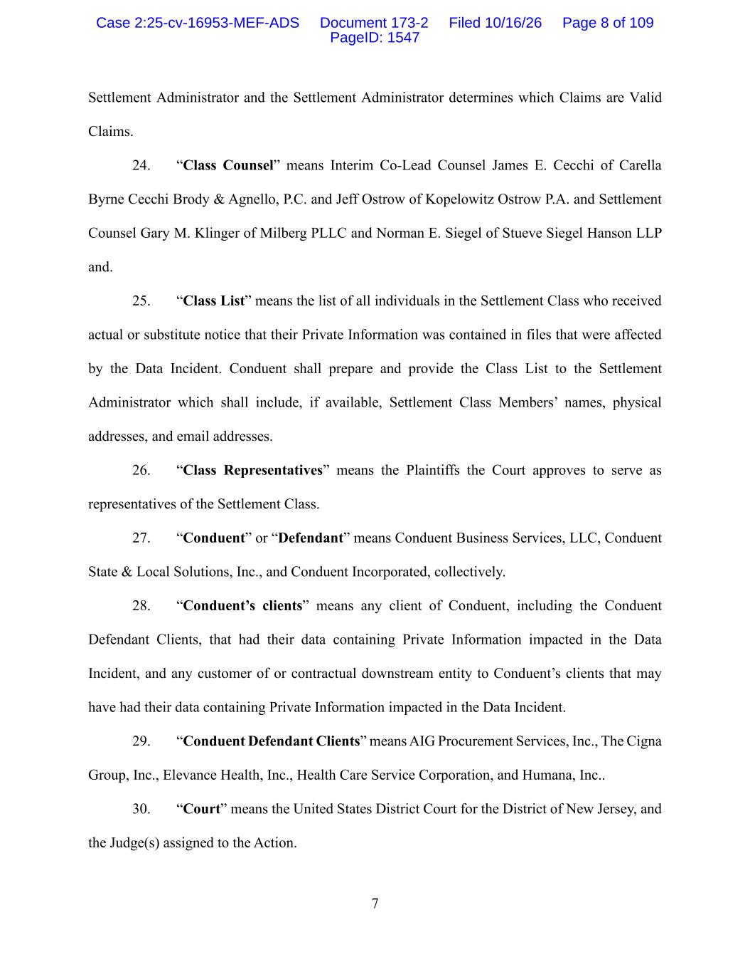
7 Settlement Administrator and the Settlement Administrator determines which Claims are Valid Claims. 24. “Class Counsel” means Interim Co-Lead Counsel James E. Cecchi of Carella Byrne Cecchi Brody & Agnello, P.C. and Jeff Ostrow of Kopelowitz Ostrow P.A. and Settlement Counsel Gary M. Klinger of Milberg PLLC and Norman E. Siegel of Stueve Siegel Hanson LLP and. 25. “Class List” means the list of all individuals in the Settlement Class who received actual or substitute notice that their Private Information was contained in files that were affected by the Data Incident. Conduent shall prepare and provide the Class List to the Settlement Administrator which shall include, if available, Settlement Class Members’ names, physical addresses, and email addresses. 26. “Class Representatives” means the Plaintiffs the Court approves to serve as representatives of the Settlement Class. 27. “Conduent” or “Defendant” means Conduent Business Services, LLC, Conduent State & Local Solutions, Inc., and Conduent Incorporated, collectively. 28. “Conduent’s clients” means any client of Conduent, including the Conduent Defendant Clients, that had their data containing Private Information impacted in the Data Incident, and any customer of or contractual downstream entity to Conduent’s clients that may have had their data containing Private Information impacted in the Data Incident. 29. “Conduent Defendant Clients” means AIG Procurement Services, Inc., The Cigna Group, Inc., Elevance Health, Inc., Health Care Service Corporation, and Humana, Inc.. 30. “Court” means the United States District Court for the District of New Jersey, and the Judge(s) assigned to the Action. Case 2:25-cv-16953-MEF-ADS Document 173-2 Filed 10/16/26 Page 8 of 109 PageID: 1547

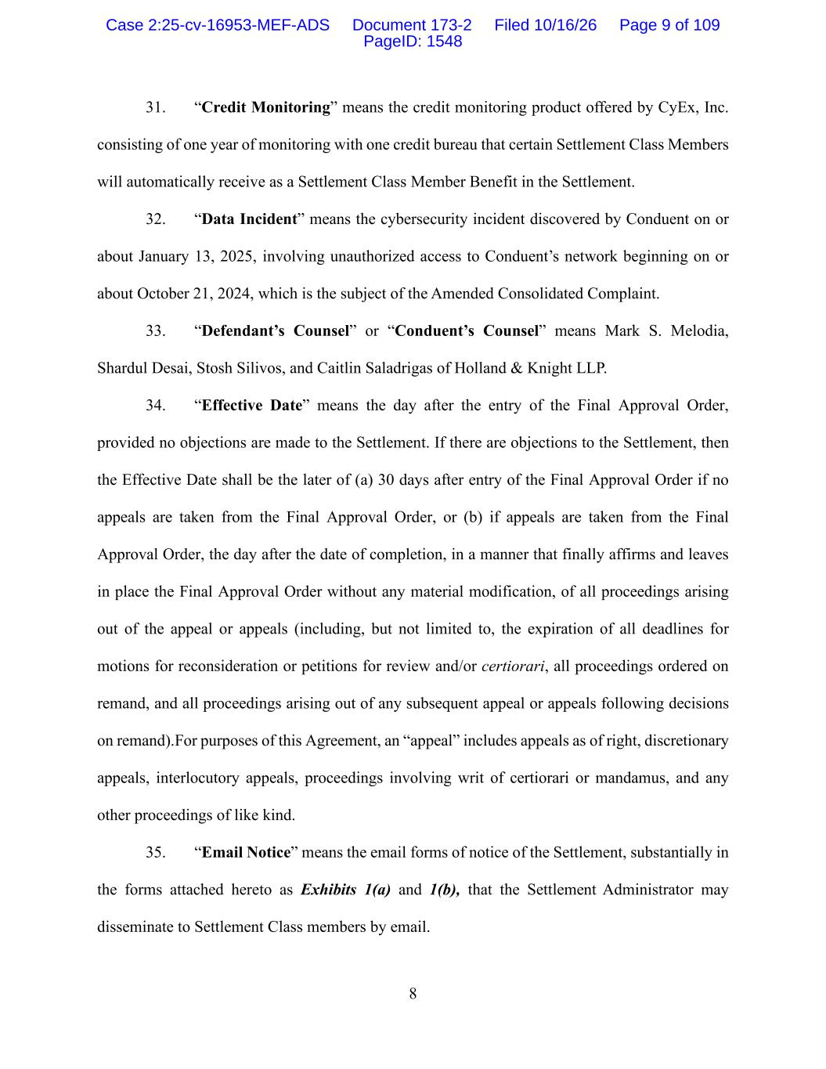
8 31. “Credit Monitoring” means the credit monitoring product offered by CyEx, Inc. consisting of one year of monitoring with one credit bureau that certain Settlement Class Members will automatically receive as a Settlement Class Member Benefit in the Settlement. 32. “Data Incident” means the cybersecurity incident discovered by Conduent on or about January 13, 2025, involving unauthorized access to Conduent’s network beginning on or about October 21, 2024, which is the subject of the Amended Consolidated Complaint. 33. “Defendant’s Counsel” or “Conduent’s Counsel” means Mark S. Melodia, Shardul Desai, Stosh Silivos, and Caitlin Saladrigas of Holland & Knight LLP. 34. “Effective Date” means the day after the entry of the Final Approval Order, provided no objections are made to the Settlement. If there are objections to the Settlement, then the Effective Date shall be the later of (a) 30 days after entry of the Final Approval Order if no appeals are taken from the Final Approval Order, or (b) if appeals are taken from the Final Approval Order, the day after the date of completion, in a manner that finally affirms and leaves in place the Final Approval Order without any material modification, of all proceedings arising out of the appeal or appeals (including, but not limited to, the expiration of all deadlines for motions for reconsideration or petitions for review and/or certiorari, all proceedings ordered on remand, and all proceedings arising out of any subsequent appeal or appeals following decisions on remand).For purposes of this Agreement, an “appeal” includes appeals as of right, discretionary appeals, interlocutory appeals, proceedings involving writ of certiorari or mandamus, and any other proceedings of like kind. 35. “Email Notice” means the email forms of notice of the Settlement, substantially in the forms attached hereto as Exhibits 1(a) and 1(b), that the Settlement Administrator may disseminate to Settlement Class members by email. Case 2:25-cv-16953-MEF-ADS Document 173-2 Filed 10/16/26 Page 9 of 109 PageID: 1548

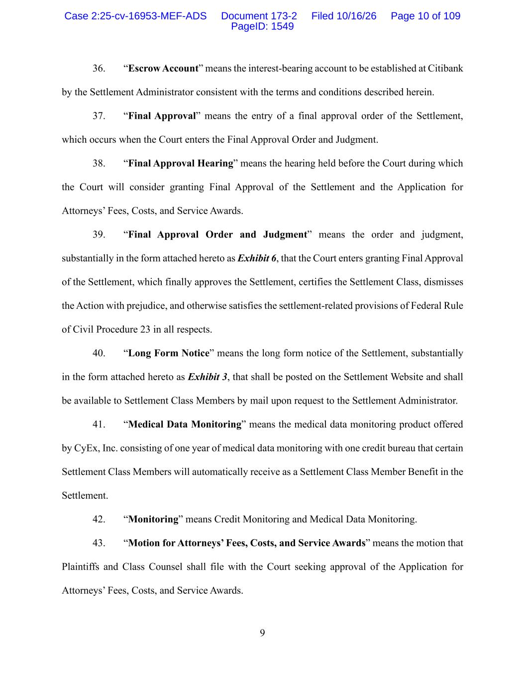
9 36. “Escrow Account” means the interest-bearing account to be established at Citibank by the Settlement Administrator consistent with the terms and conditions described herein. 37. “Final Approval” means the entry of a final approval order of the Settlement, which occurs when the Court enters the Final Approval Order and Judgment. 38. “Final Approval Hearing” means the hearing held before the Court during which the Court will consider granting Final Approval of the Settlement and the Application for Attorneys’ Fees, Costs, and Service Awards. 39. “Final Approval Order and Judgment” means the order and judgment, substantially in the form attached hereto as Exhibit 6, that the Court enters granting Final Approval of the Settlement, which finally approves the Settlement, certifies the Settlement Class, dismisses the Action with prejudice, and otherwise satisfies the settlement-related provisions of Federal Rule of Civil Procedure 23 in all respects. 40. “Long Form Notice” means the long form notice of the Settlement, substantially in the form attached hereto as Exhibit 3, that shall be posted on the Settlement Website and shall be available to Settlement Class Members by mail upon request to the Settlement Administrator. 41. “Medical Data Monitoring” means the medical data monitoring product offered by CyEx, Inc. consisting of one year of medical data monitoring with one credit bureau that certain Settlement Class Members will automatically receive as a Settlement Class Member Benefit in the Settlement. 42. “Monitoring” means Credit Monitoring and Medical Data Monitoring. 43. “Motion for Attorneys’ Fees, Costs, and Service Awards” means the motion that Plaintiffs and Class Counsel shall file with the Court seeking approval of the Application for Attorneys’ Fees, Costs, and Service Awards. Case 2:25-cv-16953-MEF-ADS Document 173-2 Filed 10/16/26 Page 10 of 109 PageID: 1549

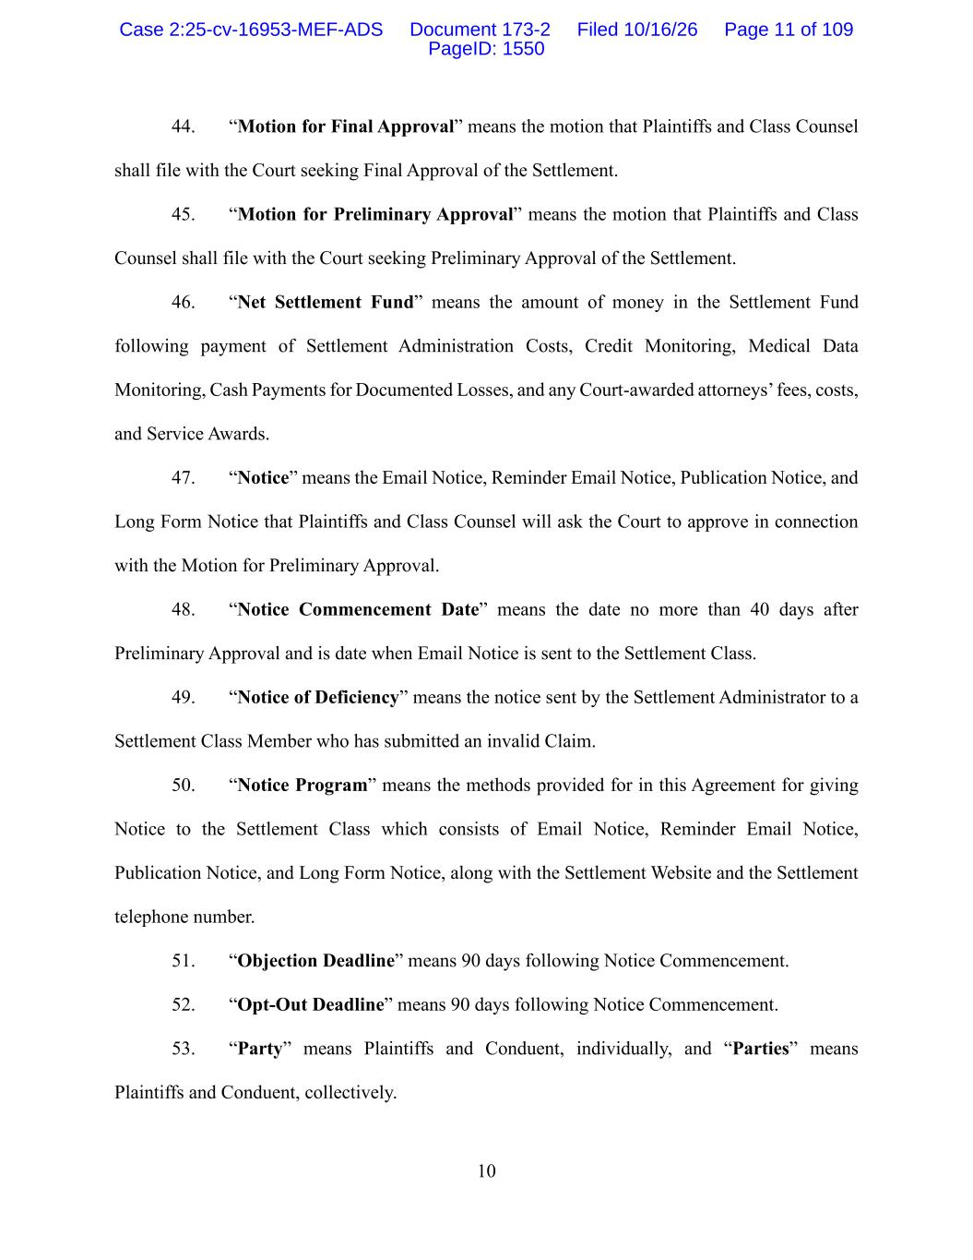
10 44. “Motion for Final Approval” means the motion that Plaintiffs and Class Counsel shall file with the Court seeking Final Approval of the Settlement. 45. “Motion for Preliminary Approval” means the motion that Plaintiffs and Class Counsel shall file with the Court seeking Preliminary Approval of the Settlement. 46. “Net Settlement Fund” means the amount of money in the Settlement Fund following payment of Settlement Administration Costs, Credit Monitoring, Medical Data Monitoring, Cash Payments for Documented Losses, and any Court-awarded attorneys’ fees, costs, and Service Awards. 47. “Notice” means the Email Notice, Reminder Email Notice, Publication Notice, and Long Form Notice that Plaintiffs and Class Counsel will ask the Court to approve in connection with the Motion for Preliminary Approval. 48. “Notice Commencement Date” means the date no more than 40 days after Preliminary Approval and is date when Email Notice is sent to the Settlement Class. 49. “Notice of Deficiency” means the notice sent by the Settlement Administrator to a Settlement Class Member who has submitted an invalid Claim. 50. “Notice Program” means the methods provided for in this Agreement for giving Notice to the Settlement Class which consists of Email Notice, Reminder Email Notice, Publication Notice, and Long Form Notice, along with the Settlement Website and the Settlement telephone number. 51. “Objection Deadline” means 90 days following Notice Commencement. 52. “Opt-Out Deadline” means 90 days following Notice Commencement. 53. “Party” means Plaintiffs and Conduent, individually, and “Parties” means Plaintiffs and Conduent, collectively. Case 2:25-cv-16953-MEF-ADS Document 173-2 Filed 10/16/26 Page 11 of 109 PageID: 1550

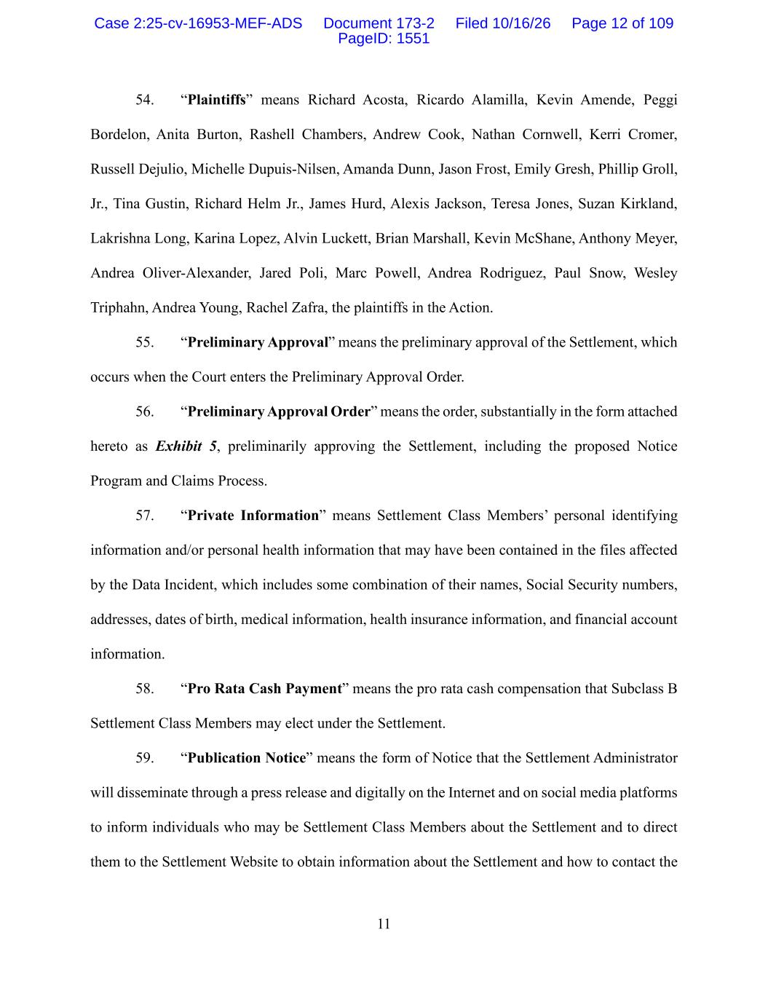
11 54. “Plaintiffs” means Richard Acosta, Ricardo Alamilla, Kevin Amende, Peggi Bordelon, Anita Burton, Rashell Chambers, Andrew Cook, Nathan Cornwell, Kerri Cromer, Russell Dejulio, Michelle Dupuis-Nilsen, Amanda Dunn, Jason Frost, Emily Gresh, Phillip Groll, Jr., Tina Gustin, Richard Helm Jr., James Hurd, Alexis Jackson, Teresa Jones, Suzan Kirkland, Lakrishna Long, Karina Lopez, Alvin Luckett, Brian Marshall, Kevin McShane, Anthony Meyer, Andrea Oliver-Alexander, Jared Poli, Marc Powell, Andrea Rodriguez, Paul Snow, Wesley Triphahn, Andrea Young, Rachel Zafra, the plaintiffs in the Action. 55. “Preliminary Approval” means the preliminary approval of the Settlement, which occurs when the Court enters the Preliminary Approval Order. 56. “Preliminary Approval Order” means the order, substantially in the form attached hereto as Exhibit 5, preliminarily approving the Settlement, including the proposed Notice Program and Claims Process. 57. “Private Information” means Settlement Class Members’ personal identifying information and/or personal health information that may have been contained in the files affected by the Data Incident, which includes some combination of their names, Social Security numbers, addresses, dates of birth, medical information, health insurance information, and financial account information. 58. “Pro Rata Cash Payment” means the pro rata cash compensation that Subclass B Settlement Class Members may elect under the Settlement. 59. “Publication Notice” means the form of Notice that the Settlement Administrator will disseminate through a press release and digitally on the Internet and on social media platforms to inform individuals who may be Settlement Class Members about the Settlement and to direct them to the Settlement Website to obtain information about the Settlement and how to contact the Case 2:25-cv-16953-MEF-ADS Document 173-2 Filed 10/16/26 Page 12 of 109 PageID: 1551

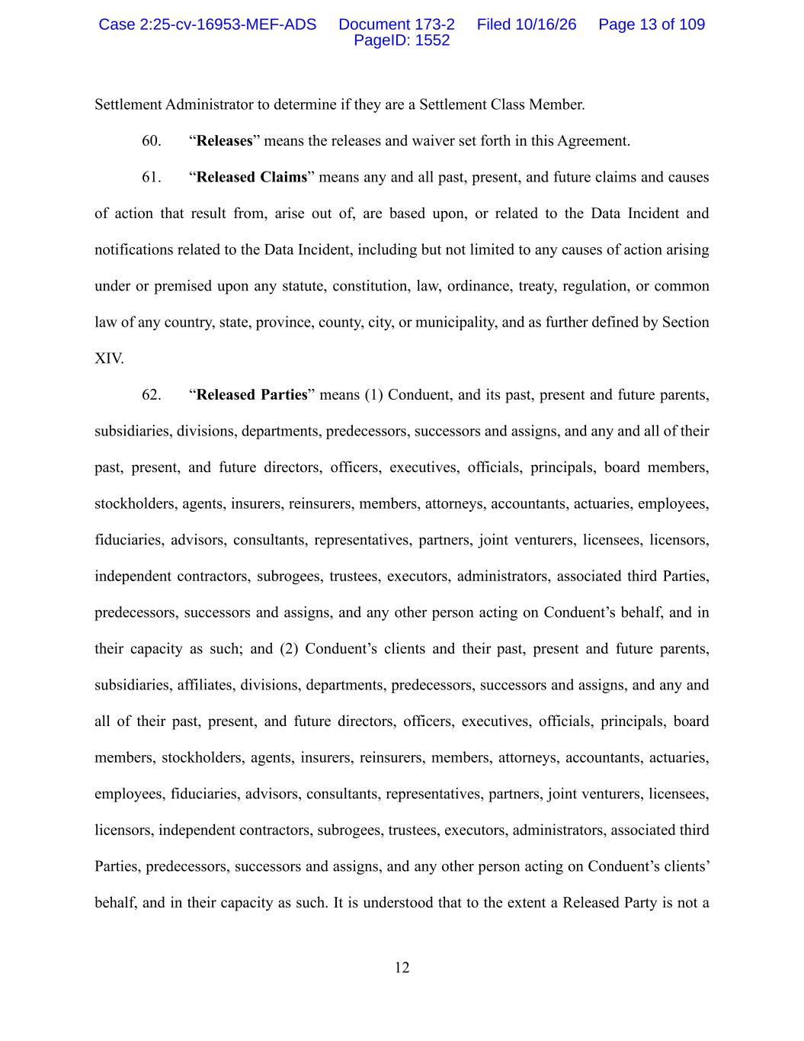
12 Settlement Administrator to determine if they are a Settlement Class Member. 60. “Releases” means the releases and waiver set forth in this Agreement. 61. “Released Claims” means any and all past, present, and future claims and causes of action that result from, arise out of, are based upon, or related to the Data Incident and notifications related to the Data Incident, including but not limited to any causes of action arising under or premised upon any statute, constitution, law, ordinance, treaty, regulation, or common law of any country, state, province, county, city, or municipality, and as further defined by Section XIV. 62. “Released Parties” means (1) Conduent, and its past, present and future parents, subsidiaries, divisions, departments, predecessors, successors and assigns, and any and all of their past, present, and future directors, officers, executives, officials, principals, board members, stockholders, agents, insurers, reinsurers, members, attorneys, accountants, actuaries, employees, fiduciaries, advisors, consultants, representatives, partners, joint venturers, licensees, licensors, independent contractors, subrogees, trustees, executors, administrators, associated third Parties, predecessors, successors and assigns, and any other person acting on Conduent’s behalf, and in their capacity as such; and (2) Conduent’s clients and their past, present and future parents, subsidiaries, affiliates, divisions, departments, predecessors, successors and assigns, and any and all of their past, present, and future directors, officers, executives, officials, principals, board members, stockholders, agents, insurers, reinsurers, members, attorneys, accountants, actuaries, employees, fiduciaries, advisors, consultants, representatives, partners, joint venturers, licensees, licensors, independent contractors, subrogees, trustees, executors, administrators, associated third Parties, predecessors, successors and assigns, and any other person acting on Conduent’s clients’ behalf, and in their capacity as such. It is understood that to the extent a Released Party is not a Case 2:25-cv-16953-MEF-ADS Document 173-2 Filed 10/16/26 Page 13 of 109 PageID: 1552

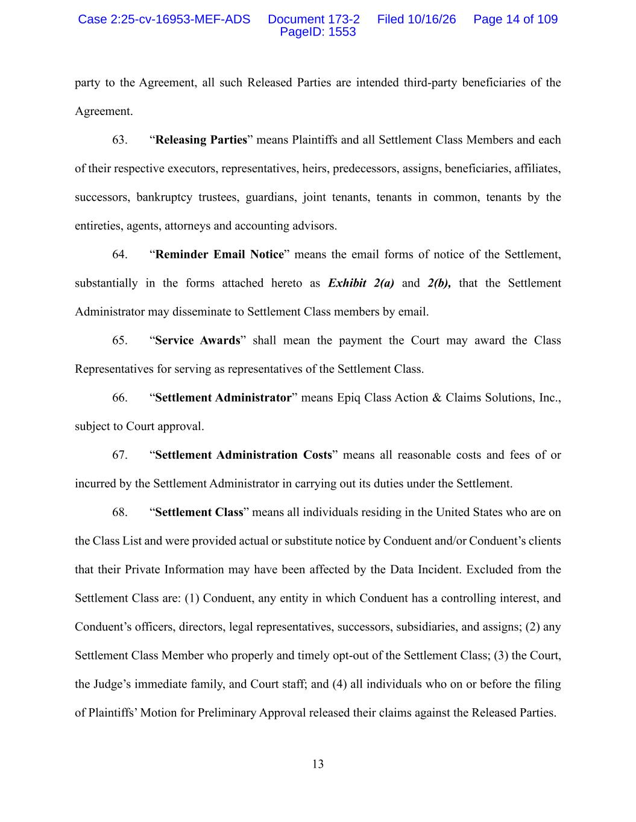
13 party to the Agreement, all such Released Parties are intended third-party beneficiaries of the Agreement. 63. “Releasing Parties” means Plaintiffs and all Settlement Class Members and each of their respective executors, representatives, heirs, predecessors, assigns, beneficiaries, affiliates, successors, bankruptcy trustees, guardians, joint tenants, tenants in common, tenants by the entireties, agents, attorneys and accounting advisors. 64. “Reminder Email Notice” means the email forms of notice of the Settlement, substantially in the forms attached hereto as Exhibit 2(a) and 2(b), that the Settlement Administrator may disseminate to Settlement Class members by email. 65. “Service Awards” shall mean the payment the Court may award the Class Representatives for serving as representatives of the Settlement Class. 66. “Settlement Administrator” means Epiq Class Action & Claims Solutions, Inc., subject to Court approval. 67. “Settlement Administration Costs” means all reasonable costs and fees of or incurred by the Settlement Administrator in carrying out its duties under the Settlement. 68. “Settlement Class” means all individuals residing in the United States who are on the Class List and were provided actual or substitute notice by Conduent and/or Conduent’s clients that their Private Information may have been affected by the Data Incident. Excluded from the Settlement Class are: (1) Conduent, any entity in which Conduent has a controlling interest, and Conduent’s officers, directors, legal representatives, successors, subsidiaries, and assigns; (2) any Settlement Class Member who properly and timely opt-out of the Settlement Class; (3) the Court, the Judge’s immediate family, and Court staff; and (4) all individuals who on or before the filing of Plaintiffs’ Motion for Preliminary Approval released their claims against the Released Parties. Case 2:25-cv-16953-MEF-ADS Document 173-2 Filed 10/16/26 Page 14 of 109 PageID: 1553

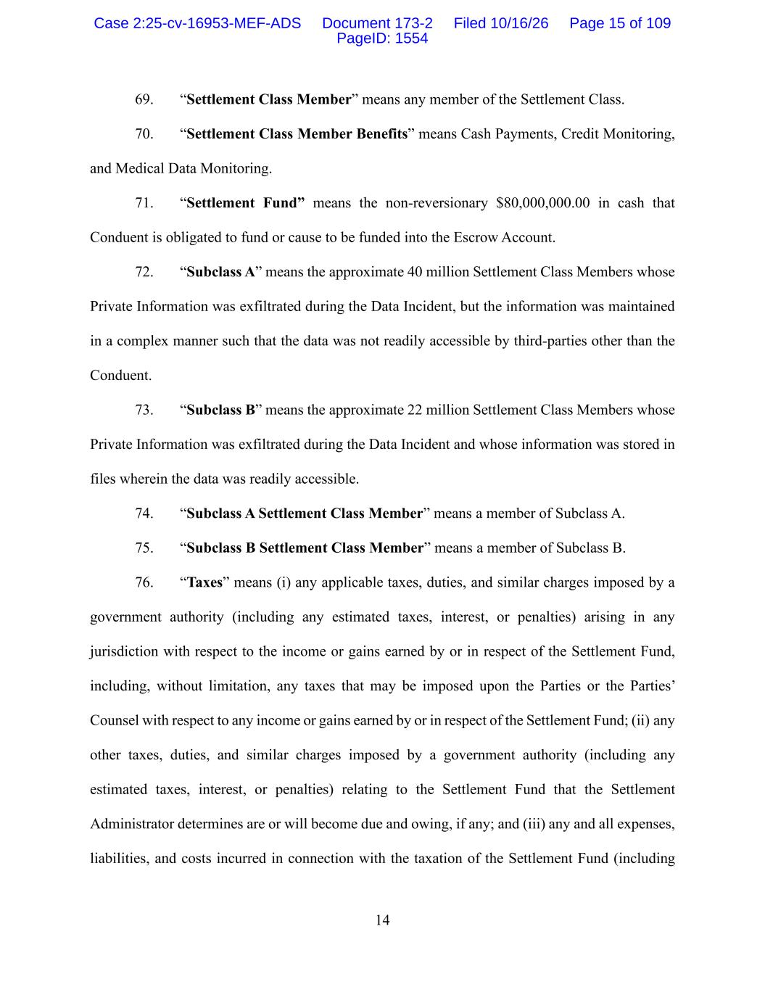
14 69. “Settlement Class Member” means any member of the Settlement Class. 70. “Settlement Class Member Benefits” means Cash Payments, Credit Monitoring, and Medical Data Monitoring. 71. “Settlement Fund” means the non-reversionary $80,000,000.00 in cash that Conduent is obligated to fund or cause to be funded into the Escrow Account. 72. “Subclass A” means the approximate 40 million Settlement Class Members whose Private Information was exfiltrated during the Data Incident, but the information was maintained in a complex manner such that the data was not readily accessible by third-parties other than the Conduent. 73. “Subclass B” means the approximate 22 million Settlement Class Members whose Private Information was exfiltrated during the Data Incident and whose information was stored in files wherein the data was readily accessible. 74. “Subclass A Settlement Class Member” means a member of Subclass A. 75. “Subclass B Settlement Class Member” means a member of Subclass B. 76. “Taxes” means (i) any applicable taxes, duties, and similar charges imposed by a government authority (including any estimated taxes, interest, or penalties) arising in any jurisdiction with respect to the income or gains earned by or in respect of the Settlement Fund, including, without limitation, any taxes that may be imposed upon the Parties or the Parties’ Counsel with respect to any income or gains earned by or in respect of the Settlement Fund; (ii) any other taxes, duties, and similar charges imposed by a government authority (including any estimated taxes, interest, or penalties) relating to the Settlement Fund that the Settlement Administrator determines are or will become due and owing, if any; and (iii) any and all expenses, liabilities, and costs incurred in connection with the taxation of the Settlement Fund (including Case 2:25-cv-16953-MEF-ADS Document 173-2 Filed 10/16/26 Page 15 of 109 PageID: 1554

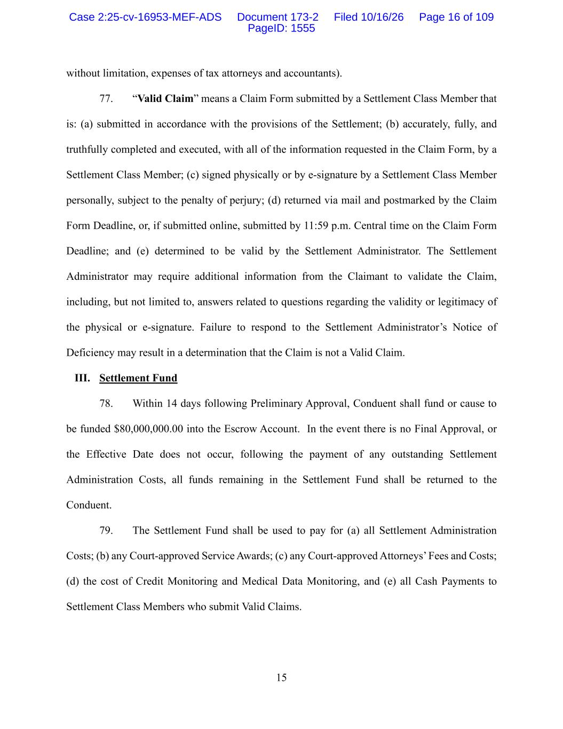
15 without limitation, expenses of tax attorneys and accountants). 77. “Valid Claim” means a Claim Form submitted by a Settlement Class Member that is: (a) submitted in accordance with the provisions of the Settlement; (b) accurately, fully, and truthfully completed and executed, with all of the information requested in the Claim Form, by a Settlement Class Member; (c) signed physically or by e-signature by a Settlement Class Member personally, subject to the penalty of perjury; (d) returned via mail and postmarked by the Claim Form Deadline, or, if submitted online, submitted by 11:59 p.m. Central time on the Claim Form Deadline; and (e) determined to be valid by the Settlement Administrator. The Settlement Administrator may require additional information from the Claimant to validate the Claim, including, but not limited to, answers related to questions regarding the validity or legitimacy of the physical or e-signature. Failure to respond to the Settlement Administrator’s Notice of Deficiency may result in a determination that the Claim is not a Valid Claim. III. Settlement Fund 78. Within 14 days following Preliminary Approval, Conduent shall fund or cause to be funded $80,000,000.00 into the Escrow Account. In the event there is no Final Approval, or the Effective Date does not occur, following the payment of any outstanding Settlement Administration Costs, all funds remaining in the Settlement Fund shall be returned to the Conduent. 79. The Settlement Fund shall be used to pay for (a) all Settlement Administration Costs; (b) any Court-approved Service Awards; (c) any Court-approved Attorneys’ Fees and Costs; (d) the cost of Credit Monitoring and Medical Data Monitoring, and (e) all Cash Payments to Settlement Class Members who submit Valid Claims. Case 2:25-cv-16953-MEF-ADS Document 173-2 Filed 10/16/26 Page 16 of 109 PageID: 1555

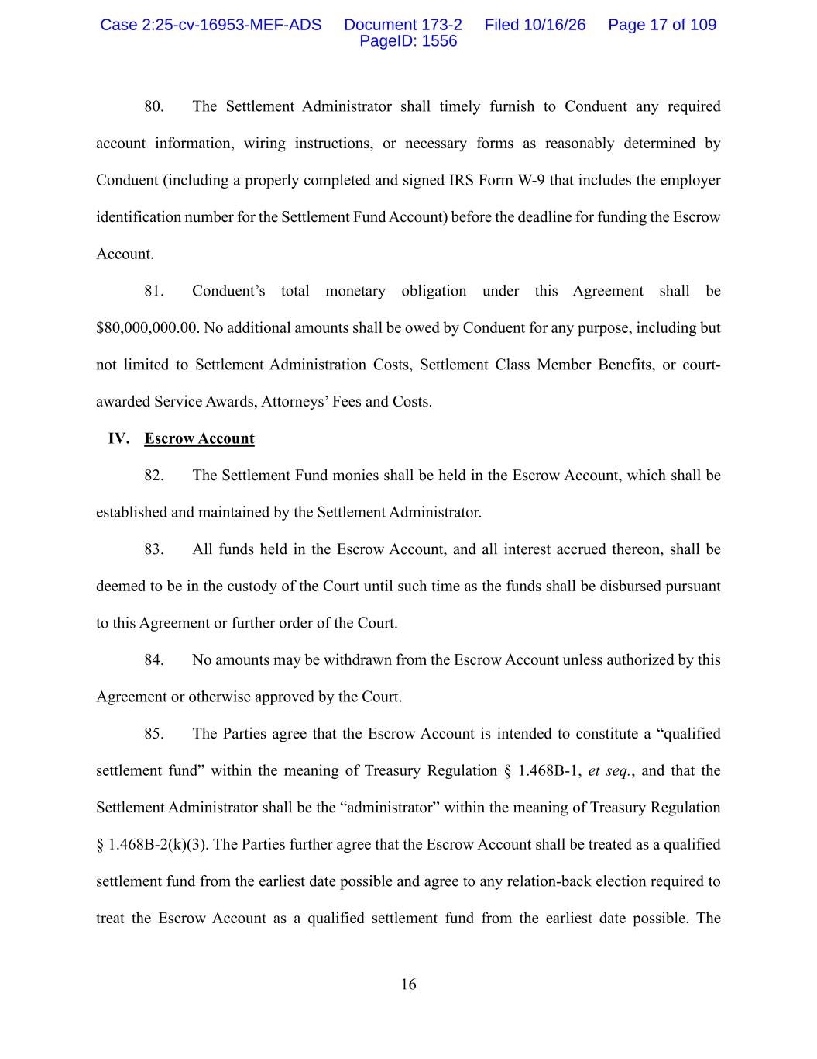
16 80. The Settlement Administrator shall timely furnish to Conduent any required account information, wiring instructions, or necessary forms as reasonably determined by Conduent (including a properly completed and signed IRS Form W-9 that includes the employer identification number for the Settlement Fund Account) before the deadline for funding the Escrow Account. 81. Conduent’s total monetary obligation under this Agreement shall be $80,000,000.00. No additional amounts shall be owed by Conduent for any purpose, including but not limited to Settlement Administration Costs, Settlement Class Member Benefits, or court- awarded Service Awards, Attorneys’ Fees and Costs. IV. Escrow Account 82. The Settlement Fund monies shall be held in the Escrow Account, which shall be established and maintained by the Settlement Administrator. 83. All funds held in the Escrow Account, and all interest accrued thereon, shall be deemed to be in the custody of the Court until such time as the funds shall be disbursed pursuant to this Agreement or further order of the Court. 84. No amounts may be withdrawn from the Escrow Account unless authorized by this Agreement or otherwise approved by the Court. 85. The Parties agree that the Escrow Account is intended to constitute a “qualified settlement fund” within the meaning of Treasury Regulation § 1.468B-1, et seq., and that the Settlement Administrator shall be the “administrator” within the meaning of Treasury Regulation § 1.468B-2(k)(3). The Parties further agree that the Escrow Account shall be treated as a qualified settlement fund from the earliest date possible and agree to any relation-back election required to treat the Escrow Account as a qualified settlement fund from the earliest date possible. The Case 2:25-cv-16953-MEF-ADS Document 173-2 Filed 10/16/26 Page 17 of 109 PageID: 1556

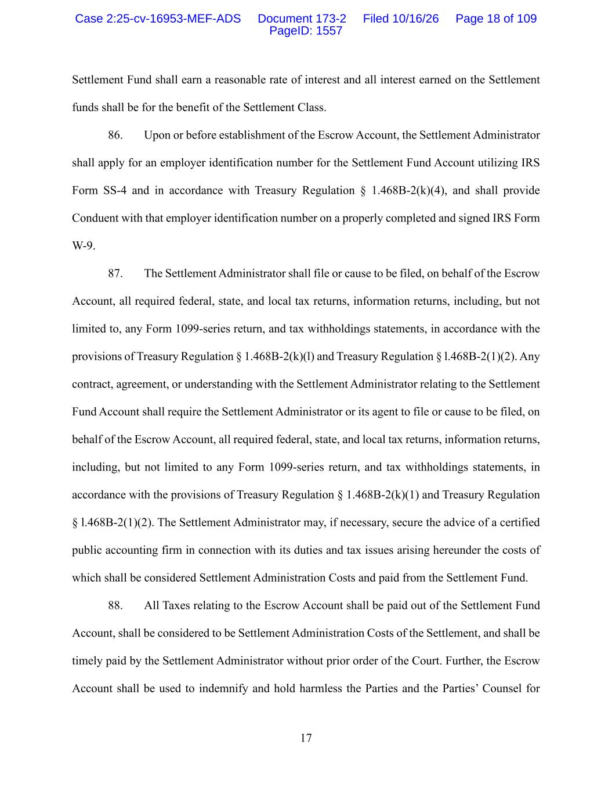
17 Settlement Fund shall earn a reasonable rate of interest and all interest earned on the Settlement funds shall be for the benefit of the Settlement Class. 86. Upon or before establishment of the Escrow Account, the Settlement Administrator shall apply for an employer identification number for the Settlement Fund Account utilizing IRS Form SS-4 and in accordance with Treasury Regulation § 1.468B-2(k)(4), and shall provide Conduent with that employer identification number on a properly completed and signed IRS Form W-9. 87. The Settlement Administrator shall file or cause to be filed, on behalf of the Escrow Account, all required federal, state, and local tax returns, information returns, including, but not limited to, any Form 1099-series return, and tax withholdings statements, in accordance with the provisions of Treasury Regulation § 1.468B-2(k)(l) and Treasury Regulation § l.468B-2(1)(2). Any contract, agreement, or understanding with the Settlement Administrator relating to the Settlement Fund Account shall require the Settlement Administrator or its agent to file or cause to be filed, on behalf of the Escrow Account, all required federal, state, and local tax returns, information returns, including, but not limited to any Form 1099-series return, and tax withholdings statements, in accordance with the provisions of Treasury Regulation § 1.468B-2(k)(1) and Treasury Regulation § l.468B-2(1)(2). The Settlement Administrator may, if necessary, secure the advice of a certified public accounting firm in connection with its duties and tax issues arising hereunder the costs of which shall be considered Settlement Administration Costs and paid from the Settlement Fund. 88. All Taxes relating to the Escrow Account shall be paid out of the Settlement Fund Account, shall be considered to be Settlement Administration Costs of the Settlement, and shall be timely paid by the Settlement Administrator without prior order of the Court. Further, the Escrow Account shall be used to indemnify and hold harmless the Parties and the Parties’ Counsel for Case 2:25-cv-16953-MEF-ADS Document 173-2 Filed 10/16/26 Page 18 of 109 PageID: 1557

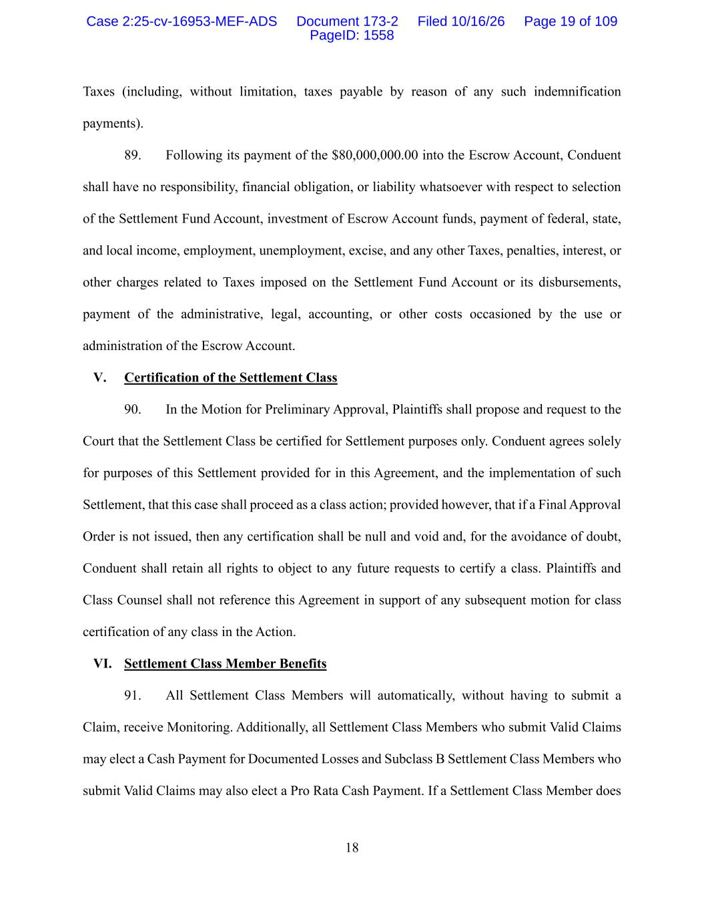
18 Taxes (including, without limitation, taxes payable by reason of any such indemnification payments). 89. Following its payment of the $80,000,000.00 into the Escrow Account, Conduent shall have no responsibility, financial obligation, or liability whatsoever with respect to selection of the Settlement Fund Account, investment of Escrow Account funds, payment of federal, state, and local income, employment, unemployment, excise, and any other Taxes, penalties, interest, or other charges related to Taxes imposed on the Settlement Fund Account or its disbursements, payment of the administrative, legal, accounting, or other costs occasioned by the use or administration of the Escrow Account. V. Certification of the Settlement Class 90. In the Motion for Preliminary Approval, Plaintiffs shall propose and request to the Court that the Settlement Class be certified for Settlement purposes only. Conduent agrees solely for purposes of this Settlement provided for in this Agreement, and the implementation of such Settlement, that this case shall proceed as a class action; provided however, that if a Final Approval Order is not issued, then any certification shall be null and void and, for the avoidance of doubt, Conduent shall retain all rights to object to any future requests to certify a class. Plaintiffs and Class Counsel shall not reference this Agreement in support of any subsequent motion for class certification of any class in the Action. VI. Settlement Class Member Benefits 91. All Settlement Class Members will automatically, without having to submit a Claim, receive Monitoring. Additionally, all Settlement Class Members who submit Valid Claims may elect a Cash Payment for Documented Losses and Subclass B Settlement Class Members who submit Valid Claims may also elect a Pro Rata Cash Payment. If a Settlement Class Member does Case 2:25-cv-16953-MEF-ADS Document 173-2 Filed 10/16/26 Page 19 of 109 PageID: 1558

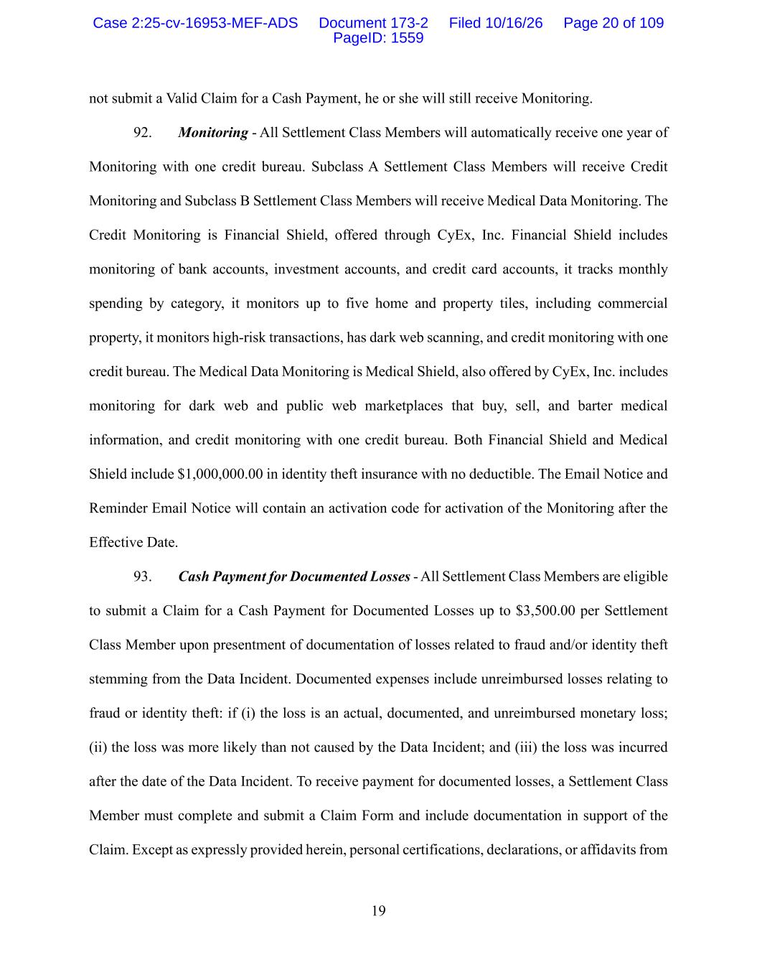
19 not submit a Valid Claim for a Cash Payment, he or she will still receive Monitoring. 92. Monitoring - All Settlement Class Members will automatically receive one year of Monitoring with one credit bureau. Subclass A Settlement Class Members will receive Credit Monitoring and Subclass B Settlement Class Members will receive Medical Data Monitoring. The Credit Monitoring is Financial Shield, offered through CyEx, Inc. Financial Shield includes monitoring of bank accounts, investment accounts, and credit card accounts, it tracks monthly spending by category, it monitors up to five home and property tiles, including commercial property, it monitors high-risk transactions, has dark web scanning, and credit monitoring with one credit bureau. The Medical Data Monitoring is Medical Shield, also offered by CyEx, Inc. includes monitoring for dark web and public web marketplaces that buy, sell, and barter medical information, and credit monitoring with one credit bureau. Both Financial Shield and Medical Shield include $1,000,000.00 in identity theft insurance with no deductible. The Email Notice and Reminder Email Notice will contain an activation code for activation of the Monitoring after the Effective Date. 93. Cash Payment for Documented Losses - All Settlement Class Members are eligible to submit a Claim for a Cash Payment for Documented Losses up to $3,500.00 per Settlement Class Member upon presentment of documentation of losses related to fraud and/or identity theft stemming from the Data Incident. Documented expenses include unreimbursed losses relating to fraud or identity theft: if (i) the loss is an actual, documented, and unreimbursed monetary loss; (ii) the loss was more likely than not caused by the Data Incident; and (iii) the loss was incurred after the date of the Data Incident. To receive payment for documented losses, a Settlement Class Member must complete and submit a Claim Form and include documentation in support of the Claim. Except as expressly provided herein, personal certifications, declarations, or affidavits from Case 2:25-cv-16953-MEF-ADS Document 173-2 Filed 10/16/26 Page 20 of 109 PageID: 1559

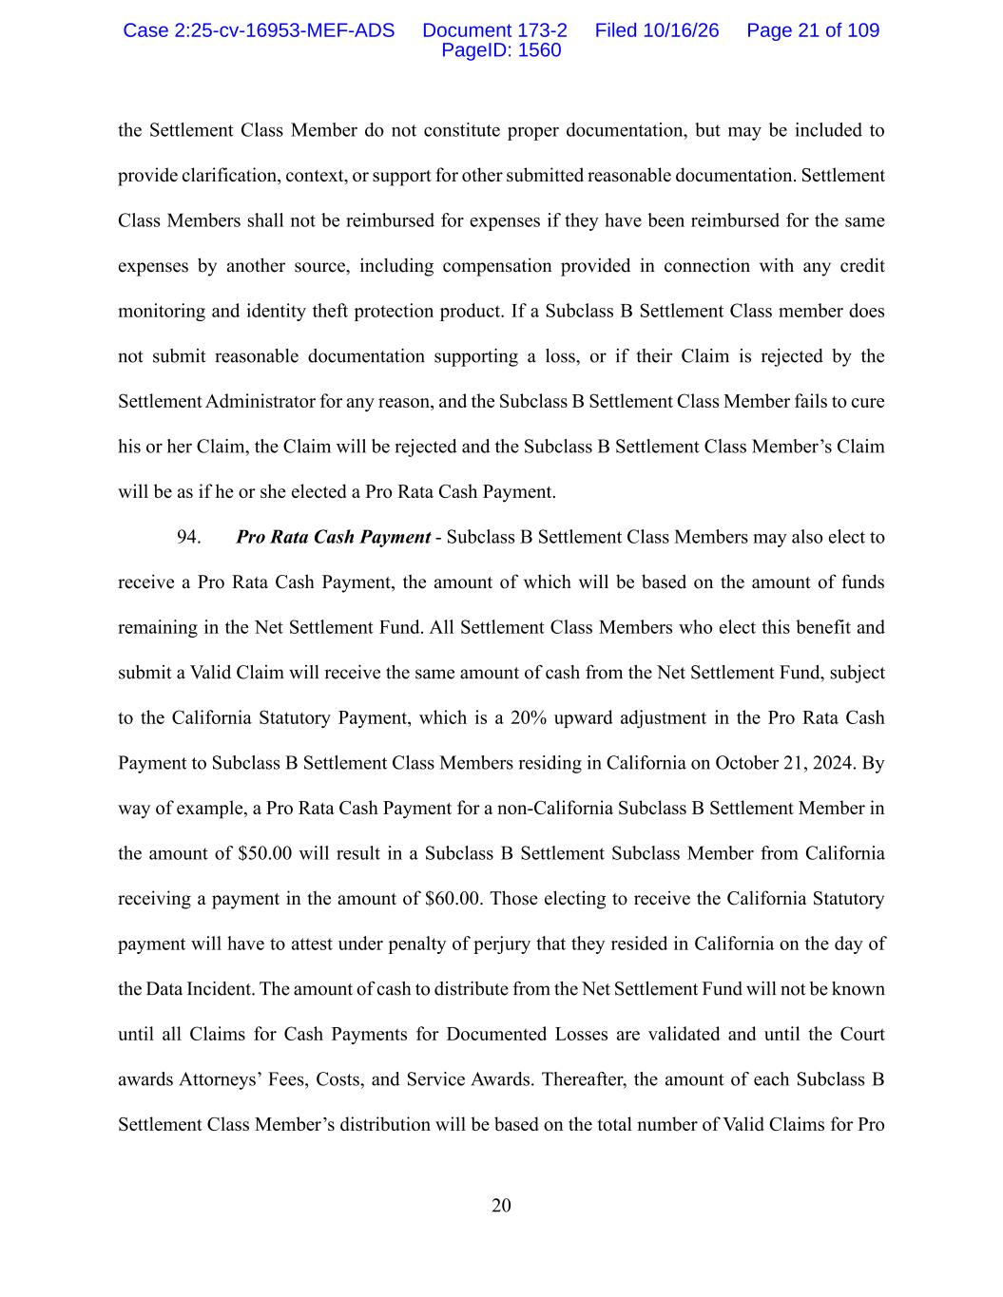
20 the Settlement Class Member do not constitute proper documentation, but may be included to provide clarification, context, or support for other submitted reasonable documentation. Settlement Class Members shall not be reimbursed for expenses if they have been reimbursed for the same expenses by another source, including compensation provided in connection with any credit monitoring and identity theft protection product. If a Subclass B Settlement Class member does not submit reasonable documentation supporting a loss, or if their Claim is rejected by the Settlement Administrator for any reason, and the Subclass B Settlement Class Member fails to cure his or her Claim, the Claim will be rejected and the Subclass B Settlement Class Member’s Claim will be as if he or she elected a Pro Rata Cash Payment. 94. Pro Rata Cash Payment - Subclass B Settlement Class Members may also elect to receive a Pro Rata Cash Payment, the amount of which will be based on the amount of funds remaining in the Net Settlement Fund. All Settlement Class Members who elect this benefit and submit a Valid Claim will receive the same amount of cash from the Net Settlement Fund, subject to the California Statutory Payment, which is a 20% upward adjustment in the Pro Rata Cash Payment to Subclass B Settlement Class Members residing in California on October 21, 2024. By way of example, a Pro Rata Cash Payment for a non-California Subclass B Settlement Member in the amount of $50.00 will result in a Subclass B Settlement Subclass Member from California receiving a payment in the amount of $60.00. Those electing to receive the California Statutory payment will have to attest under penalty of perjury that they resided in California on the day of the Data Incident. The amount of cash to distribute from the Net Settlement Fund will not be known until all Claims for Cash Payments for Documented Losses are validated and until the Court awards Attorneys’ Fees, Costs, and Service Awards. Thereafter, the amount of each Subclass B Settlement Class Member’s distribution will be based on the total number of Valid Claims for Pro Case 2:25-cv-16953-MEF-ADS Document 173-2 Filed 10/16/26 Page 21 of 109 PageID: 1560

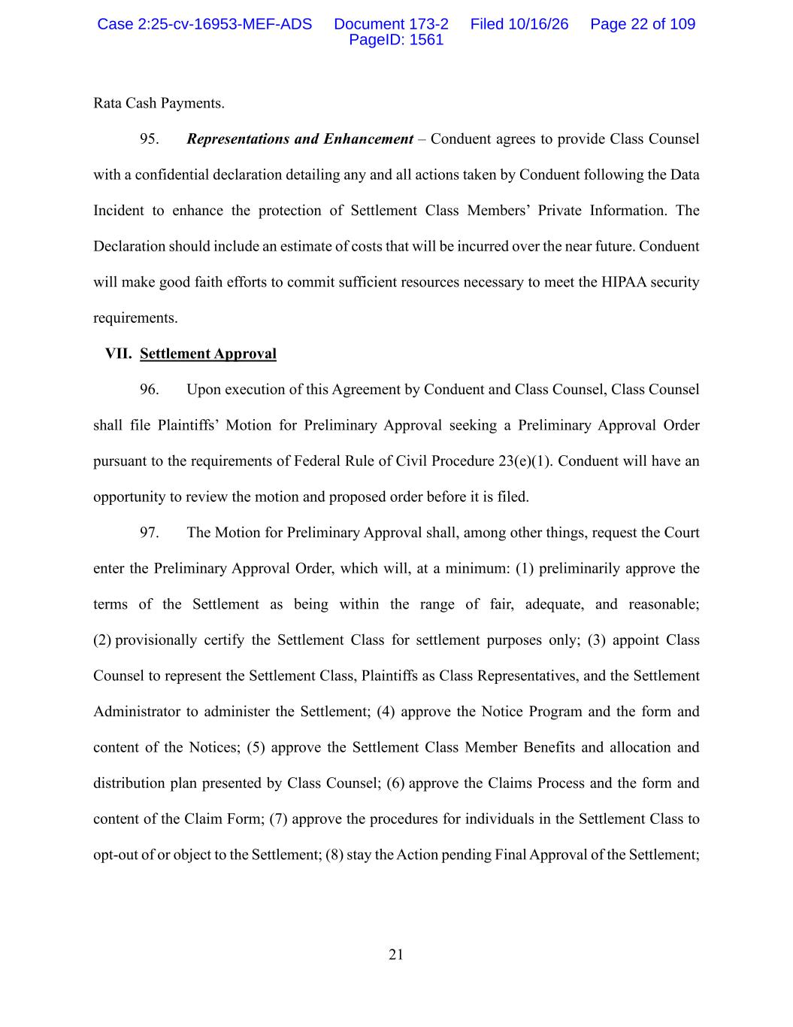
21 Rata Cash Payments. 95. Representations and Enhancement – Conduent agrees to provide Class Counsel with a confidential declaration detailing any and all actions taken by Conduent following the Data Incident to enhance the protection of Settlement Class Members’ Private Information. The Declaration should include an estimate of costs that will be incurred over the near future. Conduent will make good faith efforts to commit sufficient resources necessary to meet the HIPAA security requirements. VII. Settlement Approval 96. Upon execution of this Agreement by Conduent and Class Counsel, Class Counsel shall file Plaintiffs’ Motion for Preliminary Approval seeking a Preliminary Approval Order pursuant to the requirements of Federal Rule of Civil Procedure 23(e)(1). Conduent will have an opportunity to review the motion and proposed order before it is filed. 97. The Motion for Preliminary Approval shall, among other things, request the Court enter the Preliminary Approval Order, which will, at a minimum: (1) preliminarily approve the terms of the Settlement as being within the range of fair, adequate, and reasonable; (2) provisionally certify the Settlement Class for settlement purposes only; (3) appoint Class Counsel to represent the Settlement Class, Plaintiffs as Class Representatives, and the Settlement Administrator to administer the Settlement; (4) approve the Notice Program and the form and content of the Notices; (5) approve the Settlement Class Member Benefits and allocation and distribution plan presented by Class Counsel; (6) approve the Claims Process and the form and content of the Claim Form; (7) approve the procedures for individuals in the Settlement Class to opt-out of or object to the Settlement; (8) stay the Action pending Final Approval of the Settlement; Case 2:25-cv-16953-MEF-ADS Document 173-2 Filed 10/16/26 Page 22 of 109 PageID: 1561

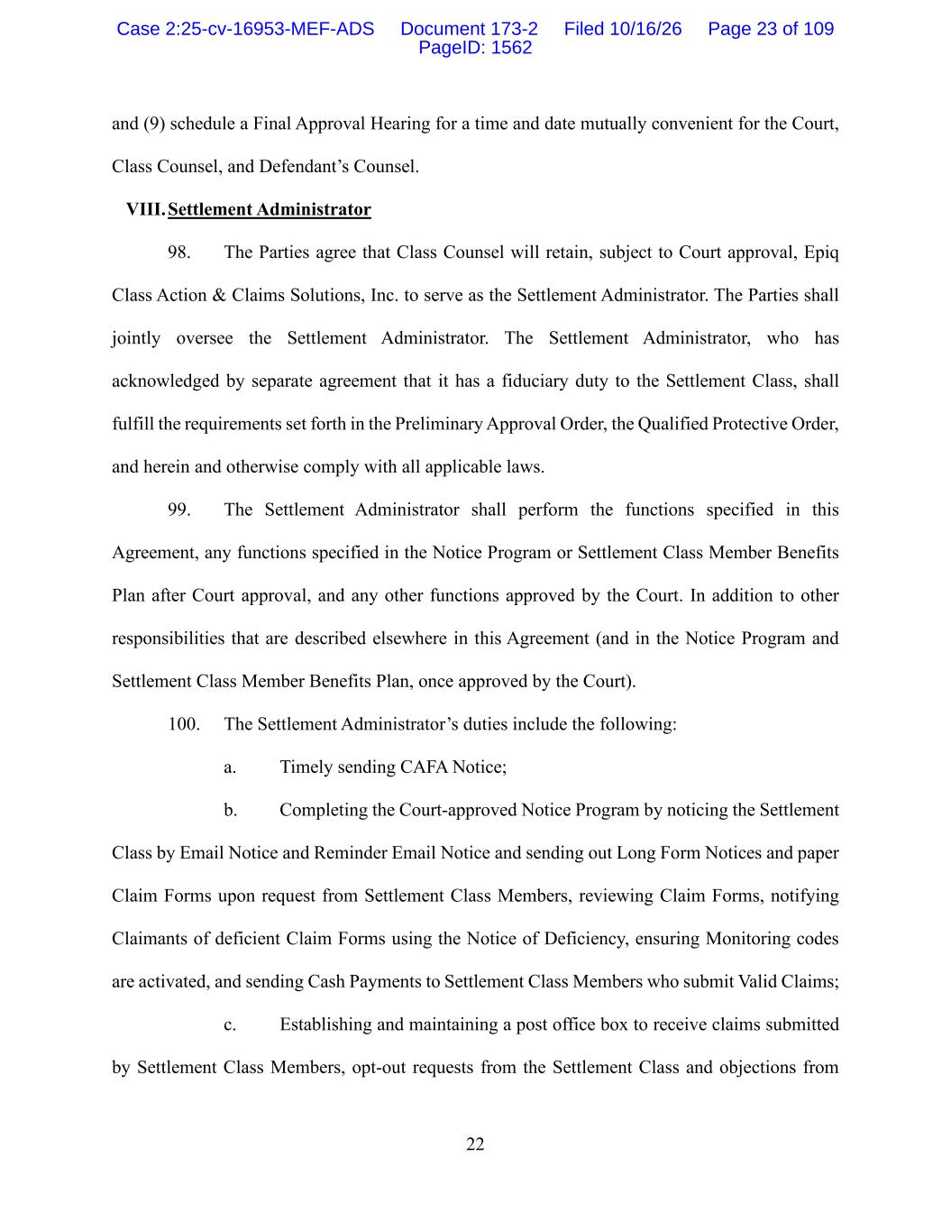
22 and (9) schedule a Final Approval Hearing for a time and date mutually convenient for the Court, Class Counsel, and Defendant’s Counsel. VIII. Settlement Administrator 98. The Parties agree that Class Counsel will retain, subject to Court approval, Epiq Class Action & Claims Solutions, Inc. to serve as the Settlement Administrator. The Parties shall jointly oversee the Settlement Administrator. The Settlement Administrator, who has acknowledged by separate agreement that it has a fiduciary duty to the Settlement Class, shall fulfill the requirements set forth in the Preliminary Approval Order, the Qualified Protective Order, and herein and otherwise comply with all applicable laws. 99. The Settlement Administrator shall perform the functions specified in this Agreement, any functions specified in the Notice Program or Settlement Class Member Benefits Plan after Court approval, and any other functions approved by the Court. In addition to other responsibilities that are described elsewhere in this Agreement (and in the Notice Program and Settlement Class Member Benefits Plan, once approved by the Court). 100. The Settlement Administrator’s duties include the following: a. Timely sending CAFA Notice; b. Completing the Court-approved Notice Program by noticing the Settlement Class by Email Notice and Reminder Email Notice and sending out Long Form Notices and paper Claim Forms upon request from Settlement Class Members, reviewing Claim Forms, notifying Claimants of deficient Claim Forms using the Notice of Deficiency, ensuring Monitoring codes are activated, and sending Cash Payments to Settlement Class Members who submit Valid Claims; c. Establishing and maintaining a post office box to receive claims submitted by Settlement Class Members, opt-out requests from the Settlement Class and objections from Case 2:25-cv-16953-MEF-ADS Document 173-2 Filed 10/16/26 Page 23 of 109 PageID: 1562

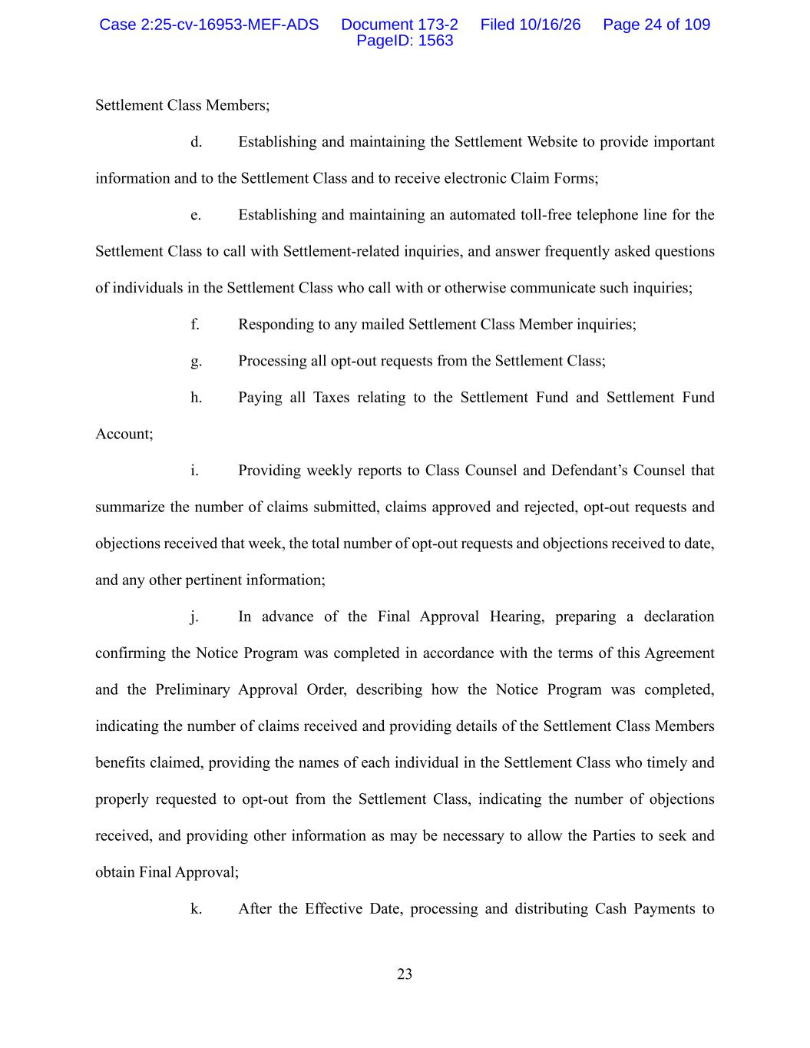
23 Settlement Class Members; d. Establishing and maintaining the Settlement Website to provide important information and to the Settlement Class and to receive electronic Claim Forms; e. Establishing and maintaining an automated toll-free telephone line for the Settlement Class to call with Settlement-related inquiries, and answer frequently asked questions of individuals in the Settlement Class who call with or otherwise communicate such inquiries; f. Responding to any mailed Settlement Class Member inquiries; g. Processing all opt-out requests from the Settlement Class; h. Paying all Taxes relating to the Settlement Fund and Settlement Fund Account; i. Providing weekly reports to Class Counsel and Defendant’s Counsel that summarize the number of claims submitted, claims approved and rejected, opt-out requests and objections received that week, the total number of opt-out requests and objections received to date, and any other pertinent information; j. In advance of the Final Approval Hearing, preparing a declaration confirming the Notice Program was completed in accordance with the terms of this Agreement and the Preliminary Approval Order, describing how the Notice Program was completed, indicating the number of claims received and providing details of the Settlement Class Members benefits claimed, providing the names of each individual in the Settlement Class who timely and properly requested to opt-out from the Settlement Class, indicating the number of objections received, and providing other information as may be necessary to allow the Parties to seek and obtain Final Approval; k. After the Effective Date, processing and distributing Cash Payments to Case 2:25-cv-16953-MEF-ADS Document 173-2 Filed 10/16/26 Page 24 of 109 PageID: 1563

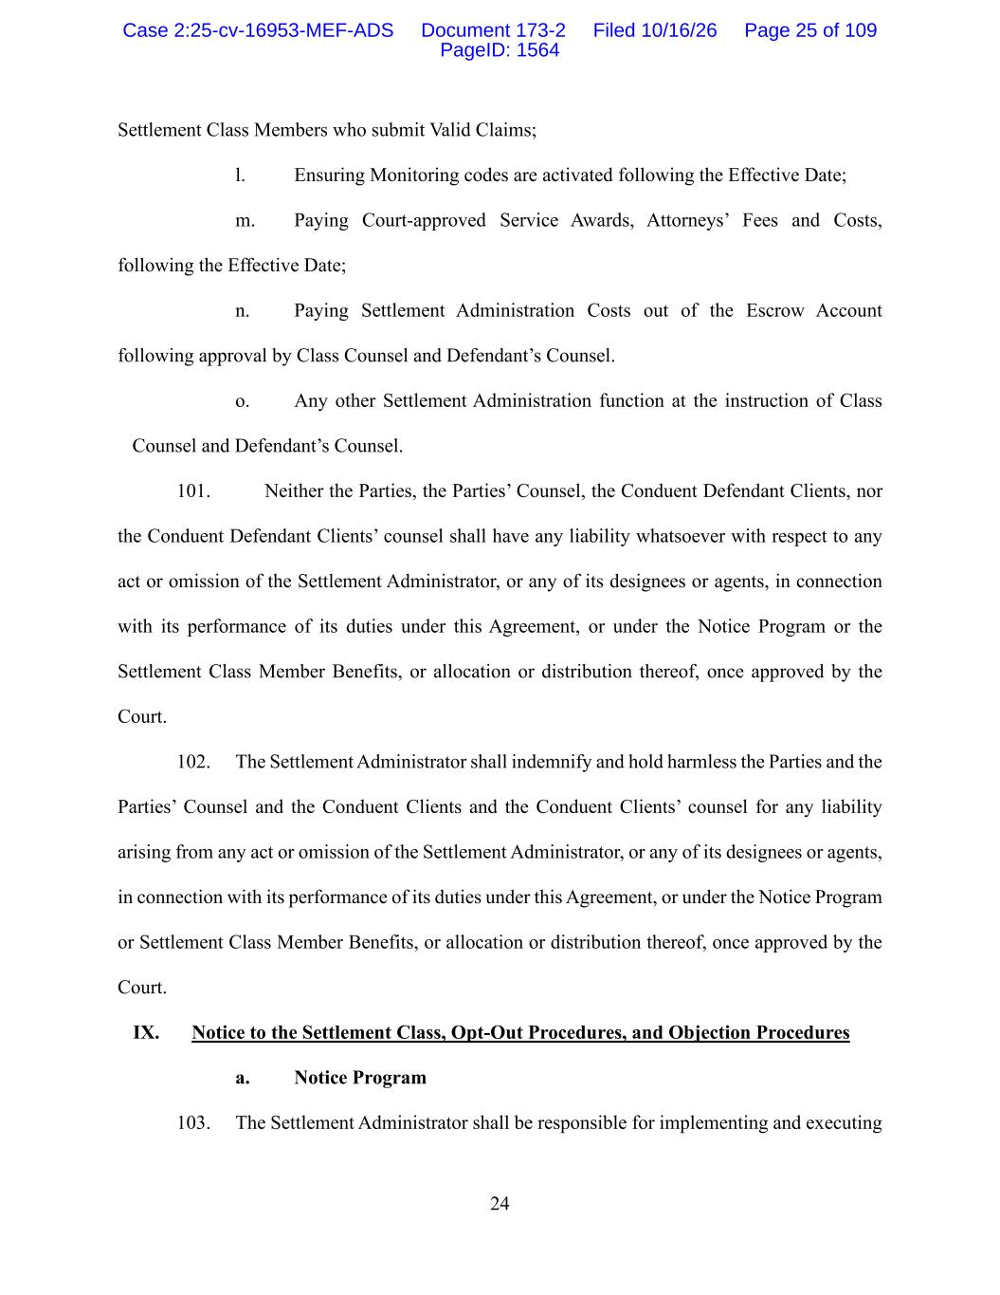
24 Settlement Class Members who submit Valid Claims; l. Ensuring Monitoring codes are activated following the Effective Date; m. Paying Court-approved Service Awards, Attorneys’ Fees and Costs, following the Effective Date; n. Paying Settlement Administration Costs out of the Escrow Account following approval by Class Counsel and Defendant’s Counsel. o. Any other Settlement Administration function at the instruction of Class Counsel and Defendant’s Counsel. 101. Neither the Parties, the Parties’ Counsel, the Conduent Defendant Clients, nor the Conduent Defendant Clients’ counsel shall have any liability whatsoever with respect to any act or omission of the Settlement Administrator, or any of its designees or agents, in connection with its performance of its duties under this Agreement, or under the Notice Program or the Settlement Class Member Benefits, or allocation or distribution thereof, once approved by the Court. 102. The Settlement Administrator shall indemnify and hold harmless the Parties and the Parties’ Counsel and the Conduent Clients and the Conduent Clients’ counsel for any liability arising from any act or omission of the Settlement Administrator, or any of its designees or agents, in connection with its performance of its duties under this Agreement, or under the Notice Program or Settlement Class Member Benefits, or allocation or distribution thereof, once approved by the Court. IX. Notice to the Settlement Class, Opt-Out Procedures, and Objection Procedures a. Notice Program 103. The Settlement Administrator shall be responsible for implementing and executing Case 2:25-cv-16953-MEF-ADS Document 173-2 Filed 10/16/26 Page 25 of 109 PageID: 1564

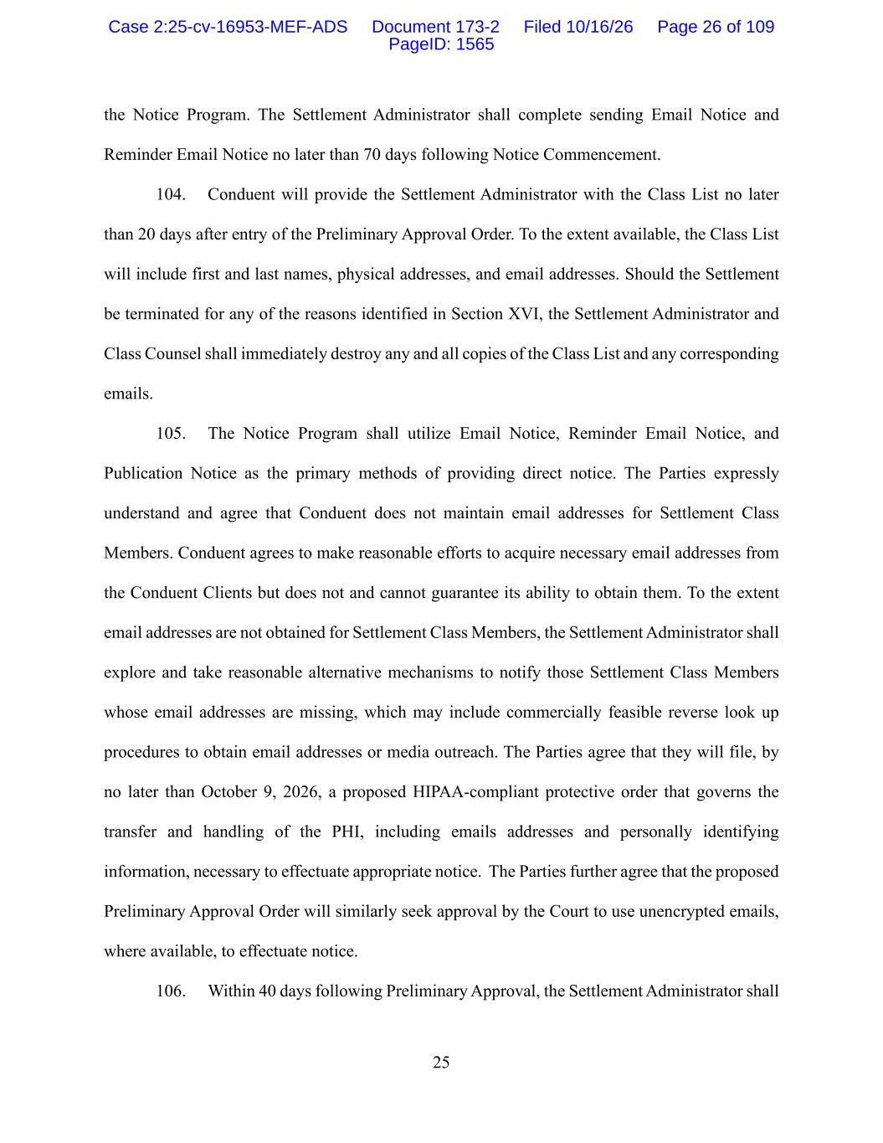
25 the Notice Program. The Settlement Administrator shall complete sending Email Notice and Reminder Email Notice no later than 70 days following Notice Commencement. 104. Conduent will provide the Settlement Administrator with the Class List no later than 20 days after entry of the Preliminary Approval Order. To the extent available, the Class List will include first and last names, physical addresses, and email addresses. Should the Settlement be terminated for any of the reasons identified in Section XVI, the Settlement Administrator and Class Counsel shall immediately destroy any and all copies of the Class List and any corresponding emails. 105. The Notice Program shall utilize Email Notice, Reminder Email Notice, and Publication Notice as the primary methods of providing direct notice. The Parties expressly understand and agree that Conduent does not maintain email addresses for Settlement Class Members. Conduent agrees to make reasonable efforts to acquire necessary email addresses from the Conduent Clients but does not and cannot guarantee its ability to obtain them. To the extent email addresses are not obtained for Settlement Class Members, the Settlement Administrator shall explore and take reasonable alternative mechanisms to notify those Settlement Class Members whose email addresses are missing, which may include commercially feasible reverse look up procedures to obtain email addresses or media outreach. The Parties agree that they will file, by no later than October 9, 2026, a proposed HIPAA-compliant protective order that governs the transfer and handling of the PHI, including emails addresses and personally identifying information, necessary to effectuate appropriate notice. The Parties further agree that the proposed Preliminary Approval Order will similarly seek approval by the Court to use unencrypted emails, where available, to effectuate notice. 106. Within 40 days following Preliminary Approval, the Settlement Administrator shall Case 2:25-cv-16953-MEF-ADS Document 173-2 Filed 10/16/26 Page 26 of 109 PageID: 1565

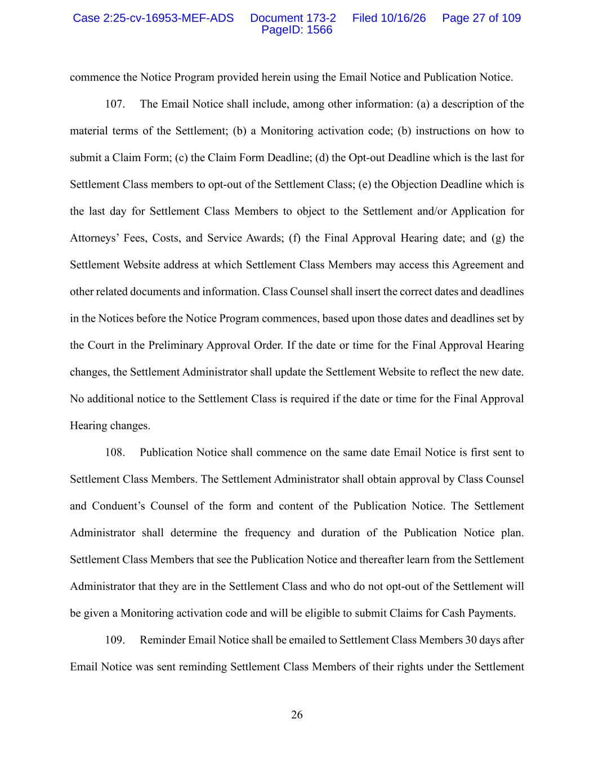
26 commence the Notice Program provided herein using the Email Notice and Publication Notice. 107. The Email Notice shall include, among other information: (a) a description of the material terms of the Settlement; (b) a Monitoring activation code; (b) instructions on how to submit a Claim Form; (c) the Claim Form Deadline; (d) the Opt-out Deadline which is the last for Settlement Class members to opt-out of the Settlement Class; (e) the Objection Deadline which is the last day for Settlement Class Members to object to the Settlement and/or Application for Attorneys’ Fees, Costs, and Service Awards; (f) the Final Approval Hearing date; and (g) the Settlement Website address at which Settlement Class Members may access this Agreement and other related documents and information. Class Counsel shall insert the correct dates and deadlines in the Notices before the Notice Program commences, based upon those dates and deadlines set by the Court in the Preliminary Approval Order. If the date or time for the Final Approval Hearing changes, the Settlement Administrator shall update the Settlement Website to reflect the new date. No additional notice to the Settlement Class is required if the date or time for the Final Approval Hearing changes. 108. Publication Notice shall commence on the same date Email Notice is first sent to Settlement Class Members. The Settlement Administrator shall obtain approval by Class Counsel and Conduent’s Counsel of the form and content of the Publication Notice. The Settlement Administrator shall determine the frequency and duration of the Publication Notice plan. Settlement Class Members that see the Publication Notice and thereafter learn from the Settlement Administrator that they are in the Settlement Class and who do not opt-out of the Settlement will be given a Monitoring activation code and will be eligible to submit Claims for Cash Payments. 109. Reminder Email Notice shall be emailed to Settlement Class Members 30 days after Email Notice was sent reminding Settlement Class Members of their rights under the Settlement Case 2:25-cv-16953-MEF-ADS Document 173-2 Filed 10/16/26 Page 27 of 109 PageID: 1566

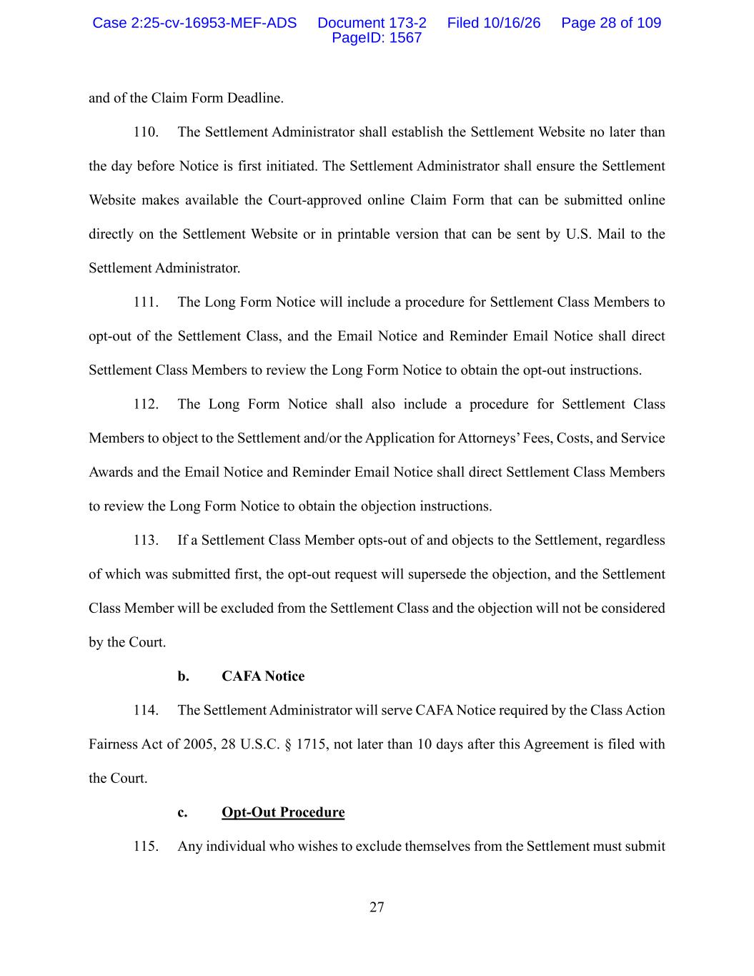
27 and of the Claim Form Deadline. 110. The Settlement Administrator shall establish the Settlement Website no later than the day before Notice is first initiated. The Settlement Administrator shall ensure the Settlement Website makes available the Court-approved online Claim Form that can be submitted online directly on the Settlement Website or in printable version that can be sent by U.S. Mail to the Settlement Administrator. 111. The Long Form Notice will include a procedure for Settlement Class Members to opt-out of the Settlement Class, and the Email Notice and Reminder Email Notice shall direct Settlement Class Members to review the Long Form Notice to obtain the opt-out instructions. 112. The Long Form Notice shall also include a procedure for Settlement Class Members to object to the Settlement and/or the Application for Attorneys’ Fees, Costs, and Service Awards and the Email Notice and Reminder Email Notice shall direct Settlement Class Members to review the Long Form Notice to obtain the objection instructions. 113. If a Settlement Class Member opts-out of and objects to the Settlement, regardless of which was submitted first, the opt-out request will supersede the objection, and the Settlement Class Member will be excluded from the Settlement Class and the objection will not be considered by the Court. b. CAFA Notice 114. The Settlement Administrator will serve CAFA Notice required by the Class Action Fairness Act of 2005, 28 U.S.C. § 1715, not later than 10 days after this Agreement is filed with the Court. c. Opt-Out Procedure 115. Any individual who wishes to exclude themselves from the Settlement must submit Case 2:25-cv-16953-MEF-ADS Document 173-2 Filed 10/16/26 Page 28 of 109 PageID: 1567

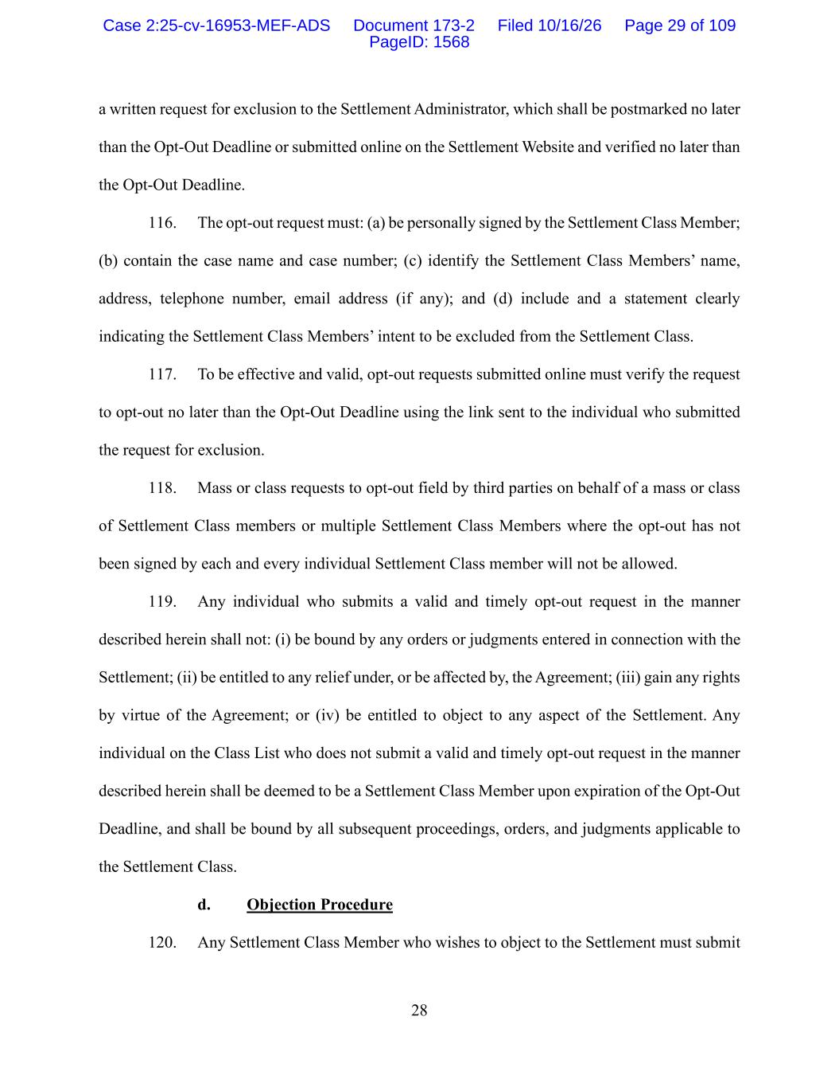
28 a written request for exclusion to the Settlement Administrator, which shall be postmarked no later than the Opt-Out Deadline or submitted online on the Settlement Website and verified no later than the Opt-Out Deadline. 116. The opt-out request must: (a) be personally signed by the Settlement Class Member; (b) contain the case name and case number; (c) identify the Settlement Class Members’ name, address, telephone number, email address (if any); and (d) include and a statement clearly indicating the Settlement Class Members’ intent to be excluded from the Settlement Class. 117. To be effective and valid, opt-out requests submitted online must verify the request to opt-out no later than the Opt-Out Deadline using the link sent to the individual who submitted the request for exclusion. 118. Mass or class requests to opt-out field by third parties on behalf of a mass or class of Settlement Class members or multiple Settlement Class Members where the opt-out has not been signed by each and every individual Settlement Class member will not be allowed. 119. Any individual who submits a valid and timely opt-out request in the manner described herein shall not: (i) be bound by any orders or judgments entered in connection with the Settlement; (ii) be entitled to any relief under, or be affected by, the Agreement; (iii) gain any rights by virtue of the Agreement; or (iv) be entitled to object to any aspect of the Settlement. Any individual on the Class List who does not submit a valid and timely opt-out request in the manner described herein shall be deemed to be a Settlement Class Member upon expiration of the Opt-Out Deadline, and shall be bound by all subsequent proceedings, orders, and judgments applicable to the Settlement Class. d. Objection Procedure 120. Any Settlement Class Member who wishes to object to the Settlement must submit Case 2:25-cv-16953-MEF-ADS Document 173-2 Filed 10/16/26 Page 29 of 109 PageID: 1568

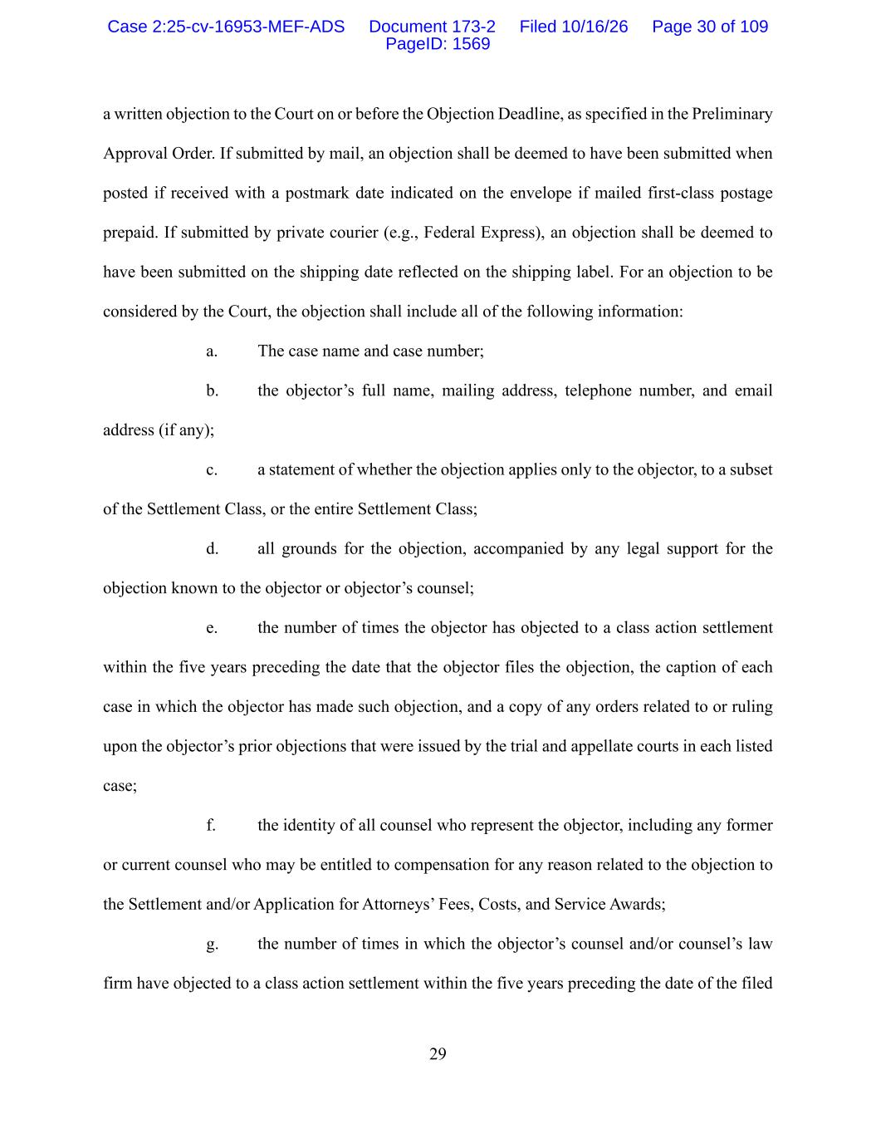
29 a written objection to the Court on or before the Objection Deadline, as specified in the Preliminary Approval Order. If submitted by mail, an objection shall be deemed to have been submitted when posted if received with a postmark date indicated on the envelope if mailed first-class postage prepaid. If submitted by private courier (e.g., Federal Express), an objection shall be deemed to have been submitted on the shipping date reflected on the shipping label. For an objection to be considered by the Court, the objection shall include all of the following information: a. The case name and case number; b. the objector’s full name, mailing address, telephone number, and email address (if any); c. a statement of whether the objection applies only to the objector, to a subset of the Settlement Class, or the entire Settlement Class; d. all grounds for the objection, accompanied by any legal support for the objection known to the objector or objector’s counsel; e. the number of times the objector has objected to a class action settlement within the five years preceding the date that the objector files the objection, the caption of each case in which the objector has made such objection, and a copy of any orders related to or ruling upon the objector’s prior objections that were issued by the trial and appellate courts in each listed case; f. the identity of all counsel who represent the objector, including any former or current counsel who may be entitled to compensation for any reason related to the objection to the Settlement and/or Application for Attorneys’ Fees, Costs, and Service Awards; g. the number of times in which the objector’s counsel and/or counsel’s law firm have objected to a class action settlement within the five years preceding the date of the filed Case 2:25-cv-16953-MEF-ADS Document 173-2 Filed 10/16/26 Page 30 of 109 PageID: 1569

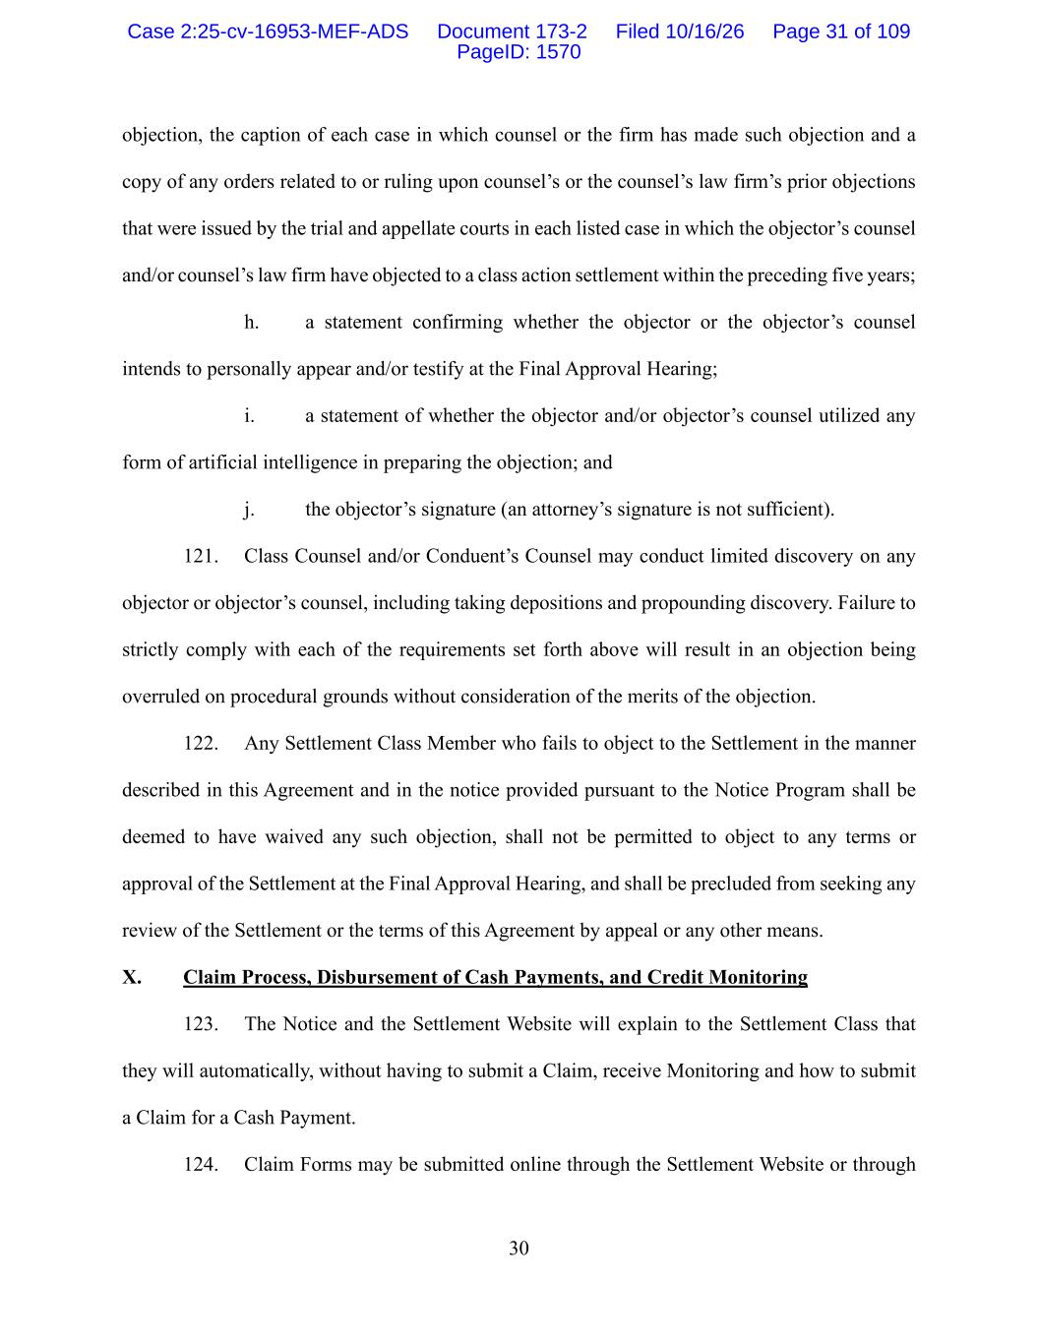
30 objection, the caption of each case in which counsel or the firm has made such objection and a copy of any orders related to or ruling upon counsel’s or the counsel’s law firm’s prior objections that were issued by the trial and appellate courts in each listed case in which the objector’s counsel and/or counsel’s law firm have objected to a class action settlement within the preceding five years; h. a statement confirming whether the objector or the objector’s counsel intends to personally appear and/or testify at the Final Approval Hearing; i. a statement of whether the objector and/or objector’s counsel utilized any form of artificial intelligence in preparing the objection; and j. the objector’s signature (an attorney’s signature is not sufficient). 121. Class Counsel and/or Conduent’s Counsel may conduct limited discovery on any objector or objector’s counsel, including taking depositions and propounding discovery. Failure to strictly comply with each of the requirements set forth above will result in an objection being overruled on procedural grounds without consideration of the merits of the objection. 122. Any Settlement Class Member who fails to object to the Settlement in the manner described in this Agreement and in the notice provided pursuant to the Notice Program shall be deemed to have waived any such objection, shall not be permitted to object to any terms or approval of the Settlement at the Final Approval Hearing, and shall be precluded from seeking any review of the Settlement or the terms of this Agreement by appeal or any other means. X. Claim Process, Disbursement of Cash Payments, and Credit Monitoring 123. The Notice and the Settlement Website will explain to the Settlement Class that they will automatically, without having to submit a Claim, receive Monitoring and how to submit a Claim for a Cash Payment. 124. Claim Forms may be submitted online through the Settlement Website or through Case 2:25-cv-16953-MEF-ADS Document 173-2 Filed 10/16/26 Page 31 of 109 PageID: 1570

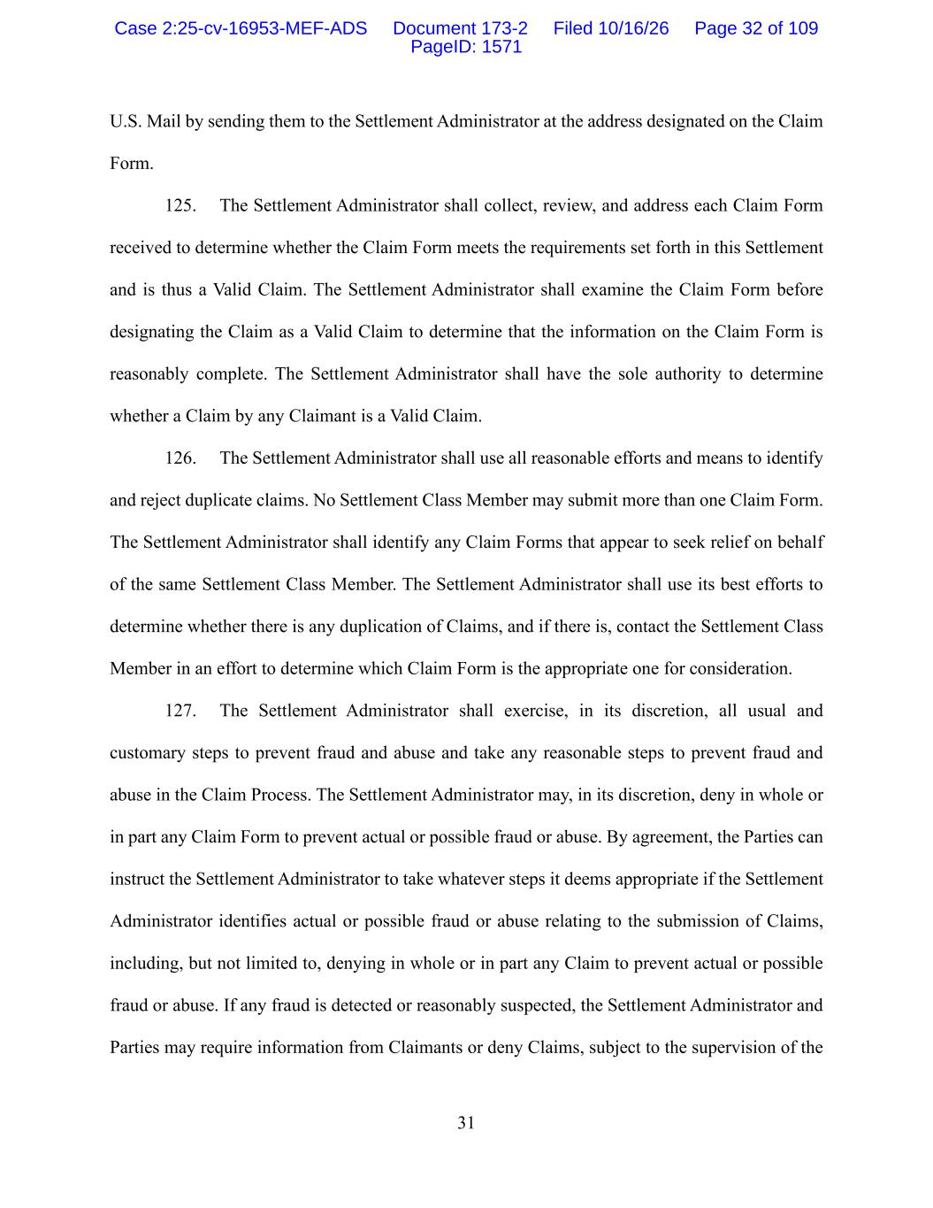
31 U.S. Mail by sending them to the Settlement Administrator at the address designated on the Claim Form. 125. The Settlement Administrator shall collect, review, and address each Claim Form received to determine whether the Claim Form meets the requirements set forth in this Settlement and is thus a Valid Claim. The Settlement Administrator shall examine the Claim Form before designating the Claim as a Valid Claim to determine that the information on the Claim Form is reasonably complete. The Settlement Administrator shall have the sole authority to determine whether a Claim by any Claimant is a Valid Claim. 126. The Settlement Administrator shall use all reasonable efforts and means to identify and reject duplicate claims. No Settlement Class Member may submit more than one Claim Form. The Settlement Administrator shall identify any Claim Forms that appear to seek relief on behalf of the same Settlement Class Member. The Settlement Administrator shall use its best efforts to determine whether there is any duplication of Claims, and if there is, contact the Settlement Class Member in an effort to determine which Claim Form is the appropriate one for consideration. 127. The Settlement Administrator shall exercise, in its discretion, all usual and customary steps to prevent fraud and abuse and take any reasonable steps to prevent fraud and abuse in the Claim Process. The Settlement Administrator may, in its discretion, deny in whole or in part any Claim Form to prevent actual or possible fraud or abuse. By agreement, the Parties can instruct the Settlement Administrator to take whatever steps it deems appropriate if the Settlement Administrator identifies actual or possible fraud or abuse relating to the submission of Claims, including, but not limited to, denying in whole or in part any Claim to prevent actual or possible fraud or abuse. If any fraud is detected or reasonably suspected, the Settlement Administrator and Parties may require information from Claimants or deny Claims, subject to the supervision of the Case 2:25-cv-16953-MEF-ADS Document 173-2 Filed 10/16/26 Page 32 of 109 PageID: 1571

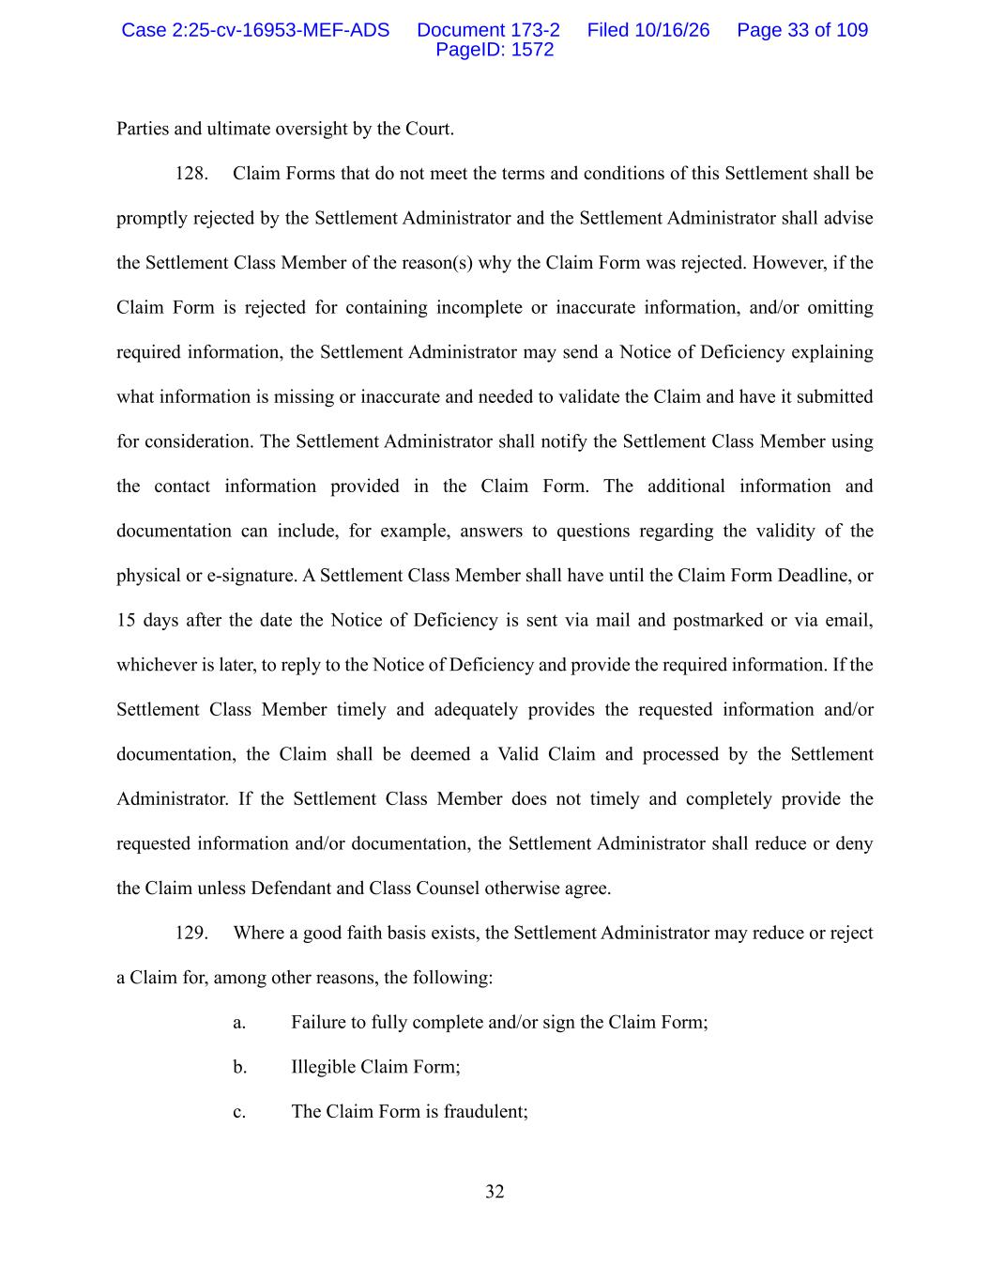
32 Parties and ultimate oversight by the Court. 128. Claim Forms that do not meet the terms and conditions of this Settlement shall be promptly rejected by the Settlement Administrator and the Settlement Administrator shall advise the Settlement Class Member of the reason(s) why the Claim Form was rejected. However, if the Claim Form is rejected for containing incomplete or inaccurate information, and/or omitting required information, the Settlement Administrator may send a Notice of Deficiency explaining what information is missing or inaccurate and needed to validate the Claim and have it submitted for consideration. The Settlement Administrator shall notify the Settlement Class Member using the contact information provided in the Claim Form. The additional information and documentation can include, for example, answers to questions regarding the validity of the physical or e-signature. A Settlement Class Member shall have until the Claim Form Deadline, or 15 days after the date the Notice of Deficiency is sent via mail and postmarked or via email, whichever is later, to reply to the Notice of Deficiency and provide the required information. If the Settlement Class Member timely and adequately provides the requested information and/or documentation, the Claim shall be deemed a Valid Claim and processed by the Settlement Administrator. If the Settlement Class Member does not timely and completely provide the requested information and/or documentation, the Settlement Administrator shall reduce or deny the Claim unless Defendant and Class Counsel otherwise agree. 129. Where a good faith basis exists, the Settlement Administrator may reduce or reject a Claim for, among other reasons, the following: a. Failure to fully complete and/or sign the Claim Form; b. Illegible Claim Form; c. The Claim Form is fraudulent; Case 2:25-cv-16953-MEF-ADS Document 173-2 Filed 10/16/26 Page 33 of 109 PageID: 1572

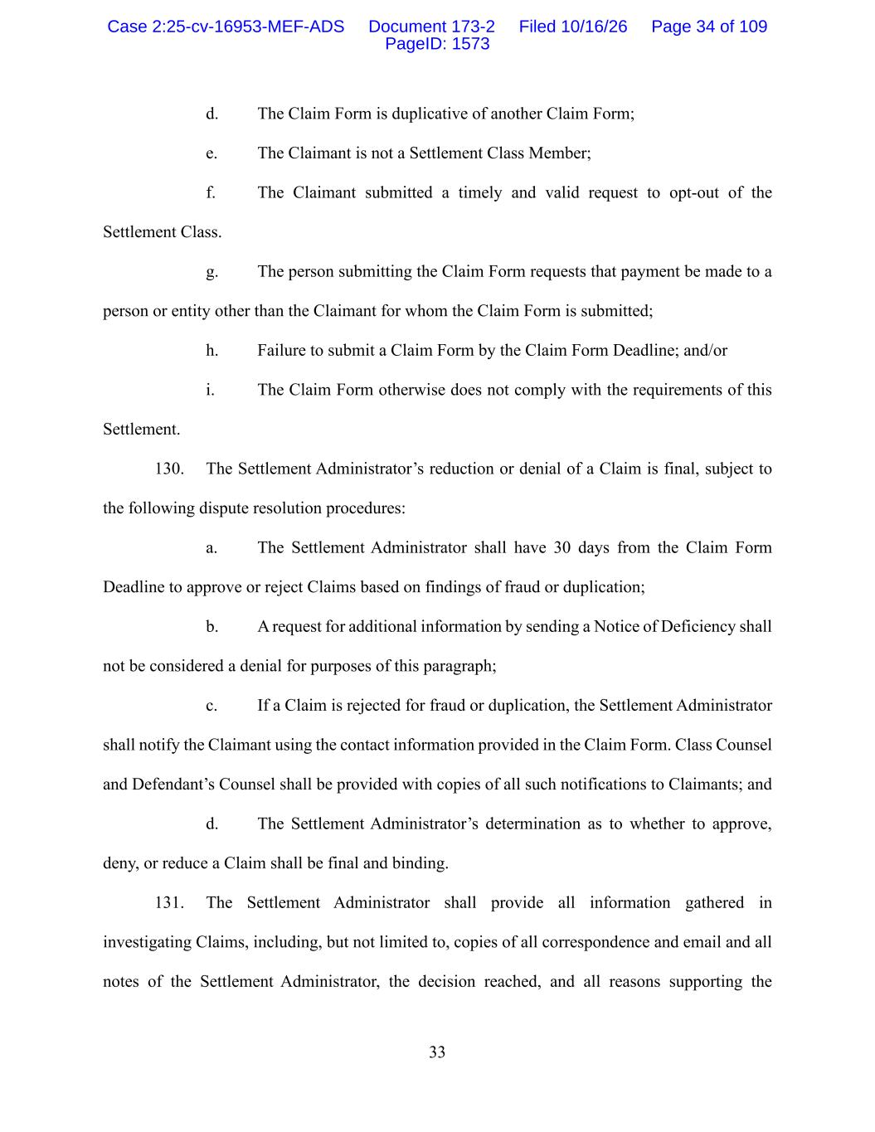
33 d. The Claim Form is duplicative of another Claim Form; e. The Claimant is not a Settlement Class Member; f. The Claimant submitted a timely and valid request to opt-out of the Settlement Class. g. The person submitting the Claim Form requests that payment be made to a person or entity other than the Claimant for whom the Claim Form is submitted; h. Failure to submit a Claim Form by the Claim Form Deadline; and/or i. The Claim Form otherwise does not comply with the requirements of this Settlement. 130. The Settlement Administrator’s reduction or denial of a Claim is final, subject to the following dispute resolution procedures: a. The Settlement Administrator shall have 30 days from the Claim Form Deadline to approve or reject Claims based on findings of fraud or duplication; b. A request for additional information by sending a Notice of Deficiency shall not be considered a denial for purposes of this paragraph; c. If a Claim is rejected for fraud or duplication, the Settlement Administrator shall notify the Claimant using the contact information provided in the Claim Form. Class Counsel and Defendant’s Counsel shall be provided with copies of all such notifications to Claimants; and d. The Settlement Administrator’s determination as to whether to approve, deny, or reduce a Claim shall be final and binding. 131. The Settlement Administrator shall provide all information gathered in investigating Claims, including, but not limited to, copies of all correspondence and email and all notes of the Settlement Administrator, the decision reached, and all reasons supporting the Case 2:25-cv-16953-MEF-ADS Document 173-2 Filed 10/16/26 Page 34 of 109 PageID: 1573

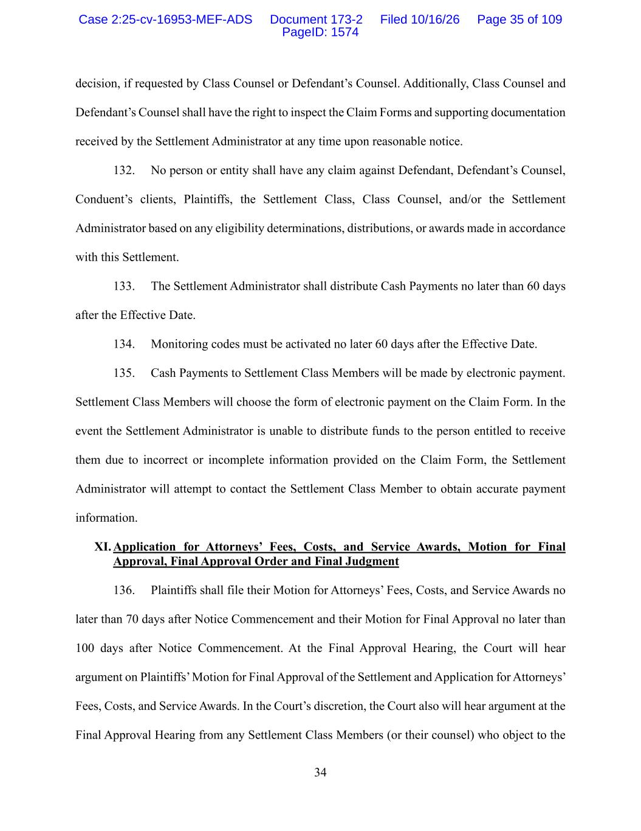
34 decision, if requested by Class Counsel or Defendant’s Counsel. Additionally, Class Counsel and Defendant’s Counsel shall have the right to inspect the Claim Forms and supporting documentation received by the Settlement Administrator at any time upon reasonable notice. 132. No person or entity shall have any claim against Defendant, Defendant’s Counsel, Conduent’s clients, Plaintiffs, the Settlement Class, Class Counsel, and/or the Settlement Administrator based on any eligibility determinations, distributions, or awards made in accordance with this Settlement. 133. The Settlement Administrator shall distribute Cash Payments no later than 60 days after the Effective Date. 134. Monitoring codes must be activated no later 60 days after the Effective Date. 135. Cash Payments to Settlement Class Members will be made by electronic payment. Settlement Class Members will choose the form of electronic payment on the Claim Form. In the event the Settlement Administrator is unable to distribute funds to the person entitled to receive them due to incorrect or incomplete information provided on the Claim Form, the Settlement Administrator will attempt to contact the Settlement Class Member to obtain accurate payment information. XI. Application for Attorneys’ Fees, Costs, and Service Awards, Motion for Final Approval, Final Approval Order and Final Judgment 136. Plaintiffs shall file their Motion for Attorneys’ Fees, Costs, and Service Awards no later than 70 days after Notice Commencement and their Motion for Final Approval no later than 100 days after Notice Commencement. At the Final Approval Hearing, the Court will hear argument on Plaintiffs’ Motion for Final Approval of the Settlement and Application for Attorneys’ Fees, Costs, and Service Awards. In the Court’s discretion, the Court also will hear argument at the Final Approval Hearing from any Settlement Class Members (or their counsel) who object to the Case 2:25-cv-16953-MEF-ADS Document 173-2 Filed 10/16/26 Page 35 of 109 PageID: 1574

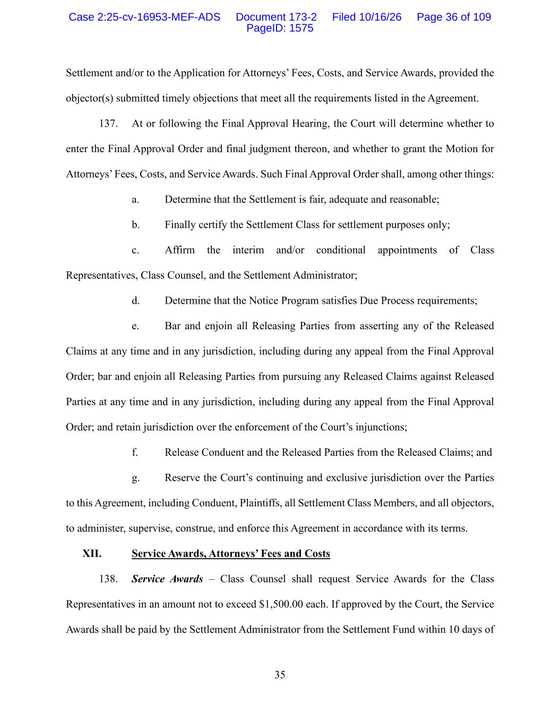
35 Settlement and/or to the Application for Attorneys’ Fees, Costs, and Service Awards, provided the objector(s) submitted timely objections that meet all the requirements listed in the Agreement. 137. At or following the Final Approval Hearing, the Court will determine whether to enter the Final Approval Order and final judgment thereon, and whether to grant the Motion for Attorneys’ Fees, Costs, and Service Awards. Such Final Approval Order shall, among other things: a. Determine that the Settlement is fair, adequate and reasonable; b. Finally certify the Settlement Class for settlement purposes only; c. Affirm the interim and/or conditional appointments of Class Representatives, Class Counsel, and the Settlement Administrator; d. Determine that the Notice Program satisfies Due Process requirements; e. Bar and enjoin all Releasing Parties from asserting any of the Released Claims at any time and in any jurisdiction, including during any appeal from the Final Approval Order; bar and enjoin all Releasing Parties from pursuing any Released Claims against Released Parties at any time and in any jurisdiction, including during any appeal from the Final Approval Order; and retain jurisdiction over the enforcement of the Court’s injunctions; f. Release Conduent and the Released Parties from the Released Claims; and g. Reserve the Court’s continuing and exclusive jurisdiction over the Parties to this Agreement, including Conduent, Plaintiffs, all Settlement Class Members, and all objectors, to administer, supervise, construe, and enforce this Agreement in accordance with its terms. XII. Service Awards, Attorneys’ Fees and Costs 138. Service Awards – Class Counsel shall request Service Awards for the Class Representatives in an amount not to exceed $1,500.00 each. If approved by the Court, the Service Awards shall be paid by the Settlement Administrator from the Settlement Fund within 10 days of Case 2:25-cv-16953-MEF-ADS Document 173-2 Filed 10/16/26 Page 36 of 109 PageID: 1575

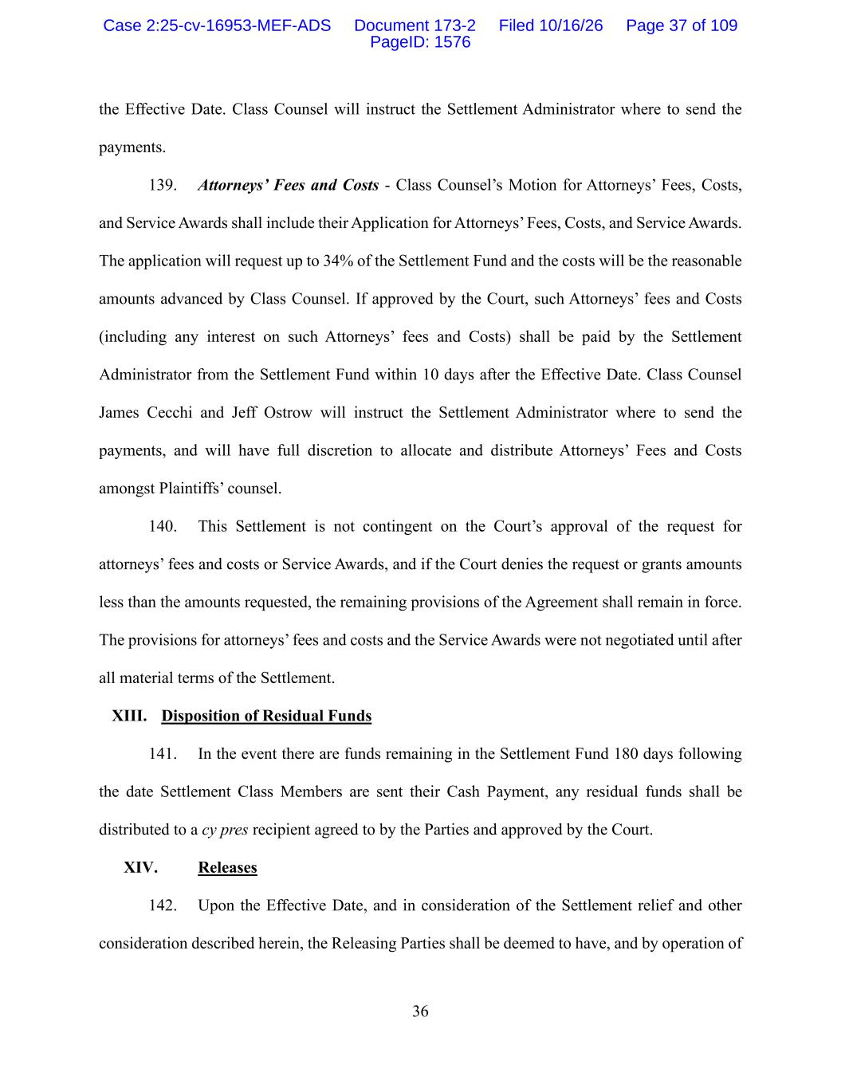
36 the Effective Date. Class Counsel will instruct the Settlement Administrator where to send the payments. 139. Attorneys’ Fees and Costs - Class Counsel’s Motion for Attorneys’ Fees, Costs, and Service Awards shall include their Application for Attorneys’ Fees, Costs, and Service Awards. The application will request up to 34% of the Settlement Fund and the costs will be the reasonable amounts advanced by Class Counsel. If approved by the Court, such Attorneys’ fees and Costs (including any interest on such Attorneys’ fees and Costs) shall be paid by the Settlement Administrator from the Settlement Fund within 10 days after the Effective Date. Class Counsel James Cecchi and Jeff Ostrow will instruct the Settlement Administrator where to send the payments, and will have full discretion to allocate and distribute Attorneys’ Fees and Costs amongst Plaintiffs’ counsel. 140. This Settlement is not contingent on the Court’s approval of the request for attorneys’ fees and costs or Service Awards, and if the Court denies the request or grants amounts less than the amounts requested, the remaining provisions of the Agreement shall remain in force. The provisions for attorneys’ fees and costs and the Service Awards were not negotiated until after all material terms of the Settlement. XIII. Disposition of Residual Funds 141. In the event there are funds remaining in the Settlement Fund 180 days following the date Settlement Class Members are sent their Cash Payment, any residual funds shall be distributed to a cy pres recipient agreed to by the Parties and approved by the Court. XIV. Releases 142. Upon the Effective Date, and in consideration of the Settlement relief and other consideration described herein, the Releasing Parties shall be deemed to have, and by operation of Case 2:25-cv-16953-MEF-ADS Document 173-2 Filed 10/16/26 Page 37 of 109 PageID: 1576

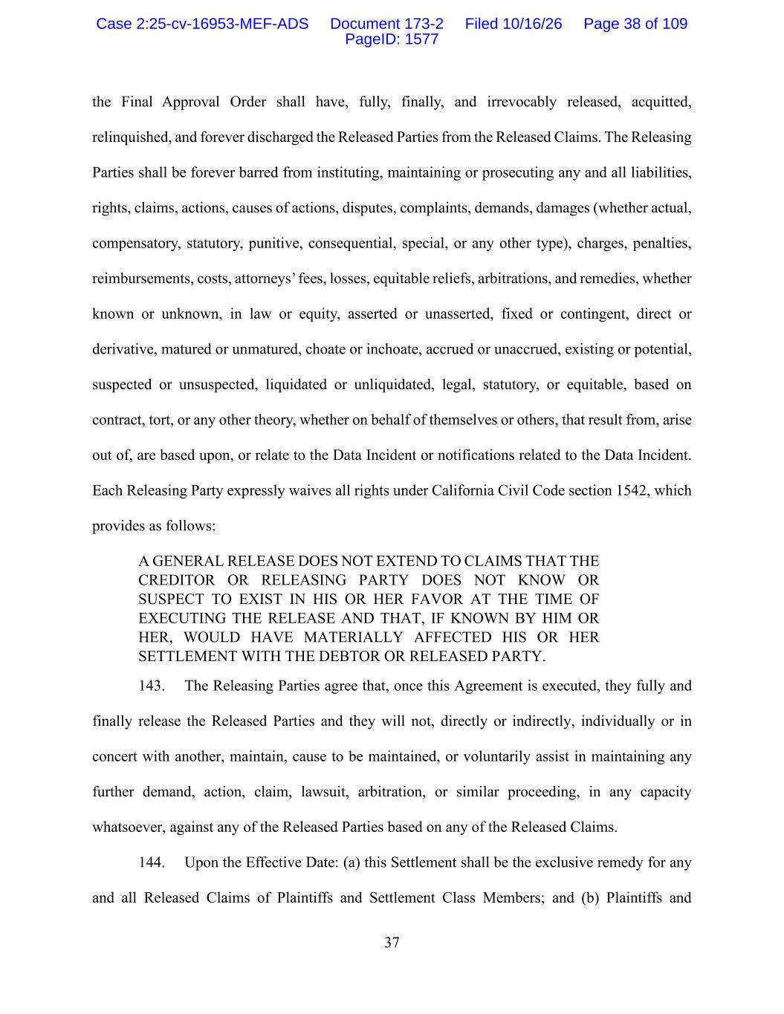
37 the Final Approval Order shall have, fully, finally, and irrevocably released, acquitted, relinquished, and forever discharged the Released Parties from the Released Claims. The Releasing Parties shall be forever barred from instituting, maintaining or prosecuting any and all liabilities, rights, claims, actions, causes of actions, disputes, complaints, demands, damages (whether actual, compensatory, statutory, punitive, consequential, special, or any other type), charges, penalties, reimbursements, costs, attorneys’ fees, losses, equitable reliefs, arbitrations, and remedies, whether known or unknown, in law or equity, asserted or unasserted, fixed or contingent, direct or derivative, matured or unmatured, choate or inchoate, accrued or unaccrued, existing or potential, suspected or unsuspected, liquidated or unliquidated, legal, statutory, or equitable, based on contract, tort, or any other theory, whether on behalf of themselves or others, that result from, arise out of, are based upon, or relate to the Data Incident or notifications related to the Data Incident. Each Releasing Party expressly waives all rights under California Civil Code section 1542, which provides as follows: A GENERAL RELEASE DOES NOT EXTEND TO CLAIMS THAT THE CREDITOR OR RELEASING PARTY DOES NOT KNOW OR SUSPECT TO EXIST IN HIS OR HER FAVOR AT THE TIME OF EXECUTING THE RELEASE AND THAT, IF KNOWN BY HIM OR HER, WOULD HAVE MATERIALLY AFFECTED HIS OR HER SETTLEMENT WITH THE DEBTOR OR RELEASED PARTY. 143. The Releasing Parties agree that, once this Agreement is executed, they fully and finally release the Released Parties and they will not, directly or indirectly, individually or in concert with another, maintain, cause to be maintained, or voluntarily assist in maintaining any further demand, action, claim, lawsuit, arbitration, or similar proceeding, in any capacity whatsoever, against any of the Released Parties based on any of the Released Claims. 144. Upon the Effective Date: (a) this Settlement shall be the exclusive remedy for any and all Released Claims of Plaintiffs and Settlement Class Members; and (b) Plaintiffs and Case 2:25-cv-16953-MEF-ADS Document 173-2 Filed 10/16/26 Page 38 of 109 PageID: 1577

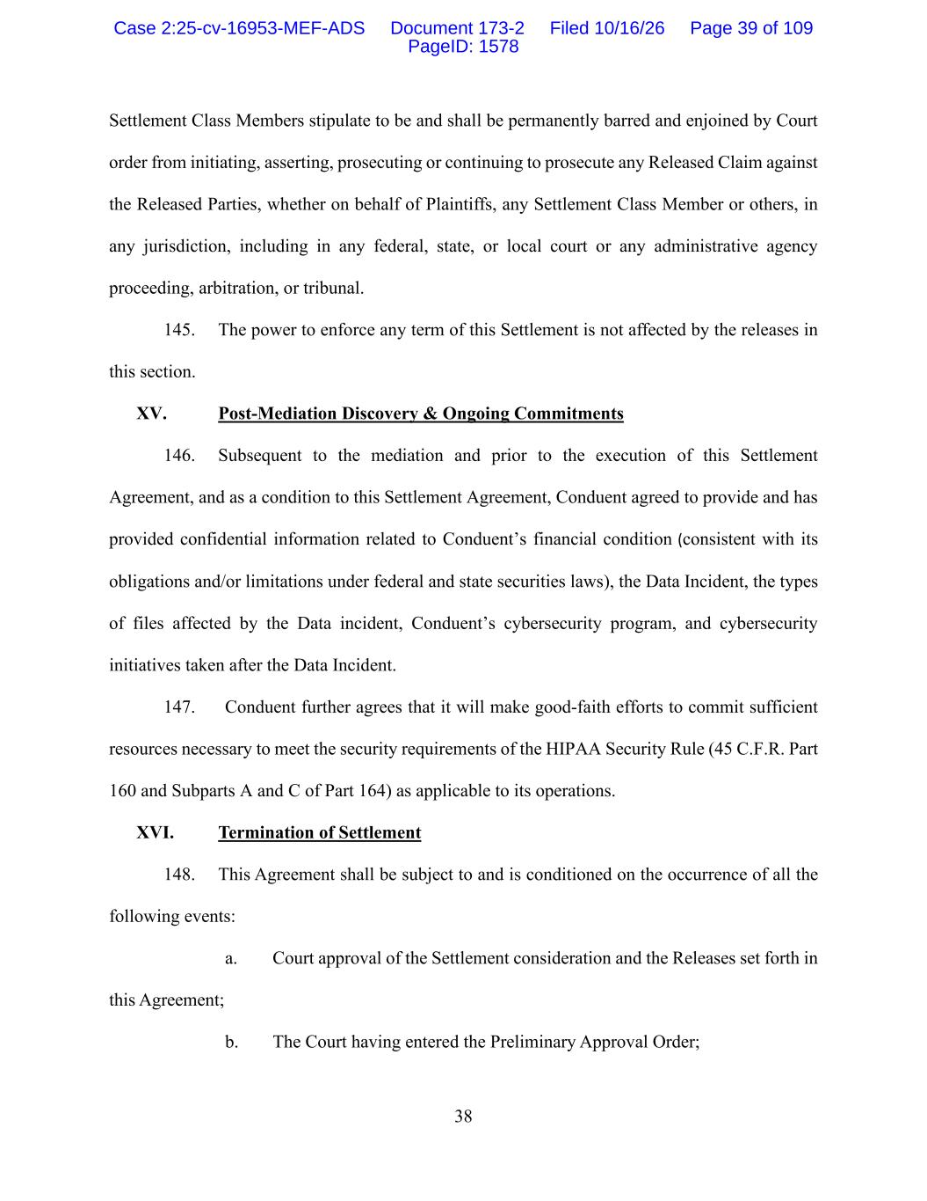
38 Settlement Class Members stipulate to be and shall be permanently barred and enjoined by Court order from initiating, asserting, prosecuting or continuing to prosecute any Released Claim against the Released Parties, whether on behalf of Plaintiffs, any Settlement Class Member or others, in any jurisdiction, including in any federal, state, or local court or any administrative agency proceeding, arbitration, or tribunal. 145. The power to enforce any term of this Settlement is not affected by the releases in this section. XV. Post-Mediation Discovery & Ongoing Commitments 146. Subsequent to the mediation and prior to the execution of this Settlement Agreement, and as a condition to this Settlement Agreement, Conduent agreed to provide and has provided confidential information related to Conduent’s financial condition (consistent with its obligations and/or limitations under federal and state securities laws), the Data Incident, the types of files affected by the Data incident, Conduent’s cybersecurity program, and cybersecurity initiatives taken after the Data Incident. 147. Conduent further agrees that it will make good-faith efforts to commit sufficient resources necessary to meet the security requirements of the HIPAA Security Rule (45 C.F.R. Part 160 and Subparts A and C of Part 164) as applicable to its operations. XVI. Termination of Settlement 148. This Agreement shall be subject to and is conditioned on the occurrence of all the following events: a. Court approval of the Settlement consideration and the Releases set forth in this Agreement; b. The Court having entered the Preliminary Approval Order; Case 2:25-cv-16953-MEF-ADS Document 173-2 Filed 10/16/26 Page 39 of 109 PageID: 1578

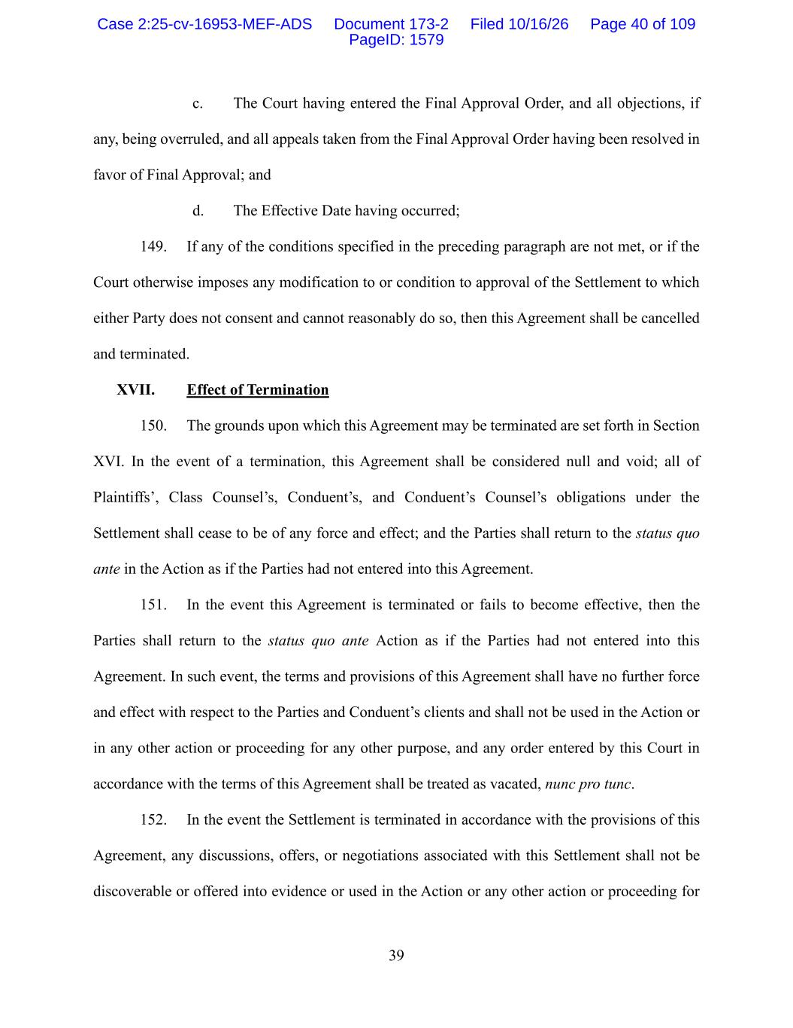
39 c. The Court having entered the Final Approval Order, and all objections, if any, being overruled, and all appeals taken from the Final Approval Order having been resolved in favor of Final Approval; and d. The Effective Date having occurred; 149. If any of the conditions specified in the preceding paragraph are not met, or if the Court otherwise imposes any modification to or condition to approval of the Settlement to which either Party does not consent and cannot reasonably do so, then this Agreement shall be cancelled and terminated. XVII. Effect of Termination 150. The grounds upon which this Agreement may be terminated are set forth in Section XVI. In the event of a termination, this Agreement shall be considered null and void; all of Plaintiffs’, Class Counsel’s, Conduent’s, and Conduent’s Counsel’s obligations under the Settlement shall cease to be of any force and effect; and the Parties shall return to the status quo ante in the Action as if the Parties had not entered into this Agreement. 151. In the event this Agreement is terminated or fails to become effective, then the Parties shall return to the status quo ante Action as if the Parties had not entered into this Agreement. In such event, the terms and provisions of this Agreement shall have no further force and effect with respect to the Parties and Conduent’s clients and shall not be used in the Action or in any other action or proceeding for any other purpose, and any order entered by this Court in accordance with the terms of this Agreement shall be treated as vacated, nunc pro tunc. 152. In the event the Settlement is terminated in accordance with the provisions of this Agreement, any discussions, offers, or negotiations associated with this Settlement shall not be discoverable or offered into evidence or used in the Action or any other action or proceeding for Case 2:25-cv-16953-MEF-ADS Document 173-2 Filed 10/16/26 Page 40 of 109 PageID: 1579

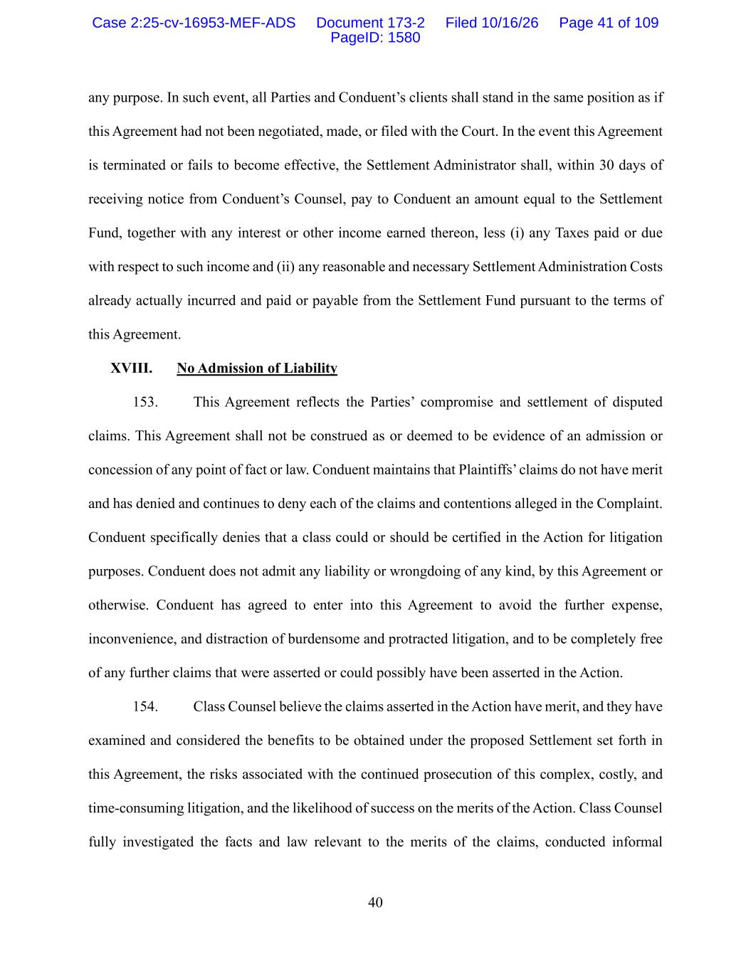
40 any purpose. In such event, all Parties and Conduent’s clients shall stand in the same position as if this Agreement had not been negotiated, made, or filed with the Court. In the event this Agreement is terminated or fails to become effective, the Settlement Administrator shall, within 30 days of receiving notice from Conduent’s Counsel, pay to Conduent an amount equal to the Settlement Fund, together with any interest or other income earned thereon, less (i) any Taxes paid or due with respect to such income and (ii) any reasonable and necessary Settlement Administration Costs already actually incurred and paid or payable from the Settlement Fund pursuant to the terms of this Agreement. XVIII. No Admission of Liability 153. This Agreement reflects the Parties’ compromise and settlement of disputed claims. This Agreement shall not be construed as or deemed to be evidence of an admission or concession of any point of fact or law. Conduent maintains that Plaintiffs’ claims do not have merit and has denied and continues to deny each of the claims and contentions alleged in the Complaint. Conduent specifically denies that a class could or should be certified in the Action for litigation purposes. Conduent does not admit any liability or wrongdoing of any kind, by this Agreement or otherwise. Conduent has agreed to enter into this Agreement to avoid the further expense, inconvenience, and distraction of burdensome and protracted litigation, and to be completely free of any further claims that were asserted or could possibly have been asserted in the Action. 154. Class Counsel believe the claims asserted in the Action have merit, and they have examined and considered the benefits to be obtained under the proposed Settlement set forth in this Agreement, the risks associated with the continued prosecution of this complex, costly, and time-consuming litigation, and the likelihood of success on the merits of the Action. Class Counsel fully investigated the facts and law relevant to the merits of the claims, conducted informal Case 2:25-cv-16953-MEF-ADS Document 173-2 Filed 10/16/26 Page 41 of 109 PageID: 1580

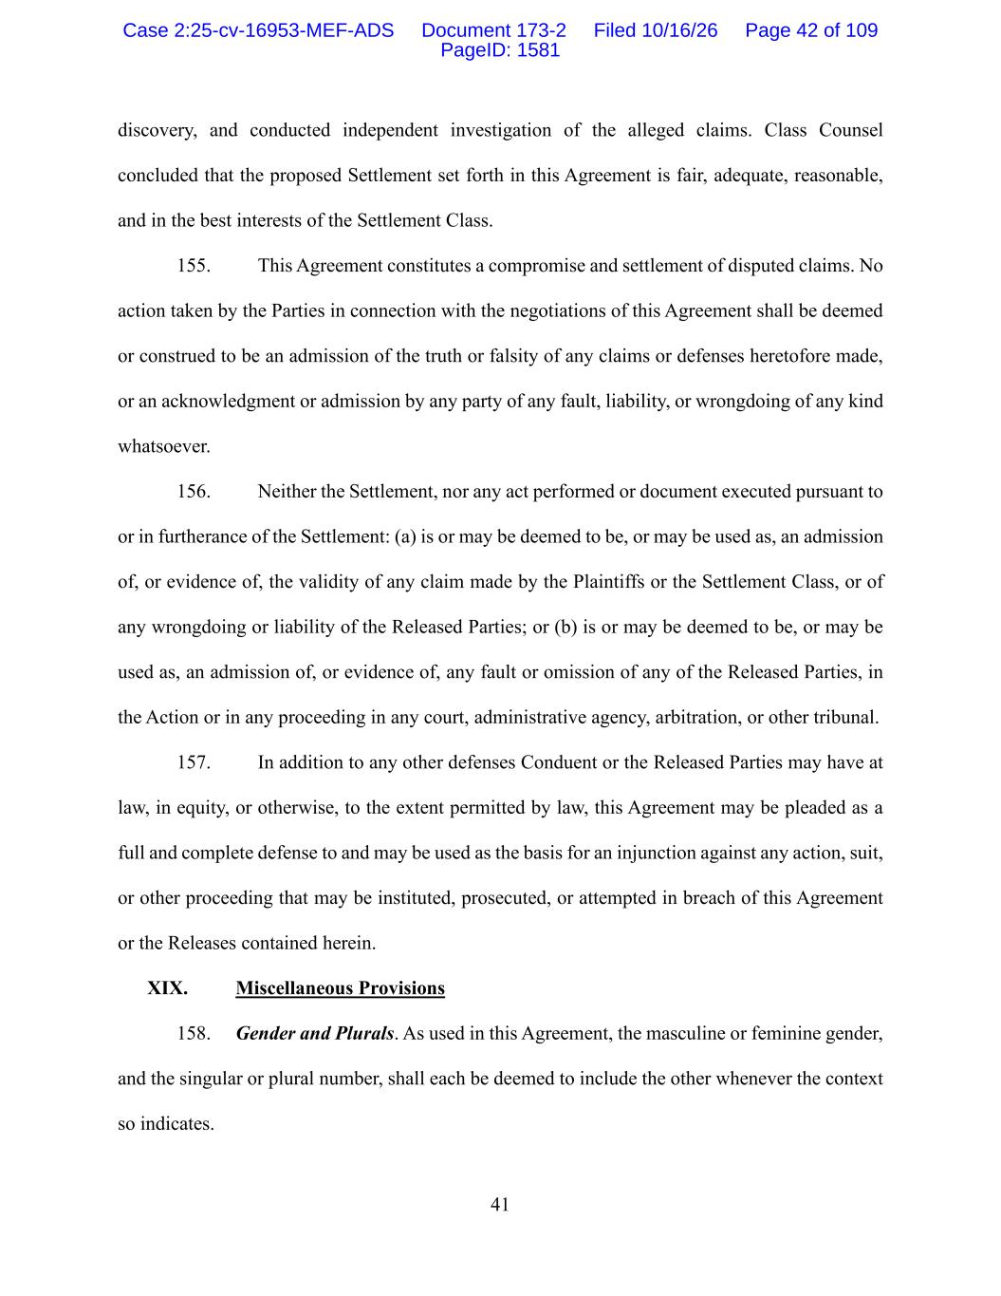
41 discovery, and conducted independent investigation of the alleged claims. Class Counsel concluded that the proposed Settlement set forth in this Agreement is fair, adequate, reasonable, and in the best interests of the Settlement Class. 155. This Agreement constitutes a compromise and settlement of disputed claims. No action taken by the Parties in connection with the negotiations of this Agreement shall be deemed or construed to be an admission of the truth or falsity of any claims or defenses heretofore made, or an acknowledgment or admission by any party of any fault, liability, or wrongdoing of any kind whatsoever. 156. Neither the Settlement, nor any act performed or document executed pursuant to or in furtherance of the Settlement: (a) is or may be deemed to be, or may be used as, an admission of, or evidence of, the validity of any claim made by the Plaintiffs or the Settlement Class, or of any wrongdoing or liability of the Released Parties; or (b) is or may be deemed to be, or may be used as, an admission of, or evidence of, any fault or omission of any of the Released Parties, in the Action or in any proceeding in any court, administrative agency, arbitration, or other tribunal. 157. In addition to any other defenses Conduent or the Released Parties may have at law, in equity, or otherwise, to the extent permitted by law, this Agreement may be pleaded as a full and complete defense to and may be used as the basis for an injunction against any action, suit, or other proceeding that may be instituted, prosecuted, or attempted in breach of this Agreement or the Releases contained herein. XIX. Miscellaneous Provisions 158. Gender and Plurals. As used in this Agreement, the masculine or feminine gender, and the singular or plural number, shall each be deemed to include the other whenever the context so indicates. Case 2:25-cv-16953-MEF-ADS Document 173-2 Filed 10/16/26 Page 42 of 109 PageID: 1581

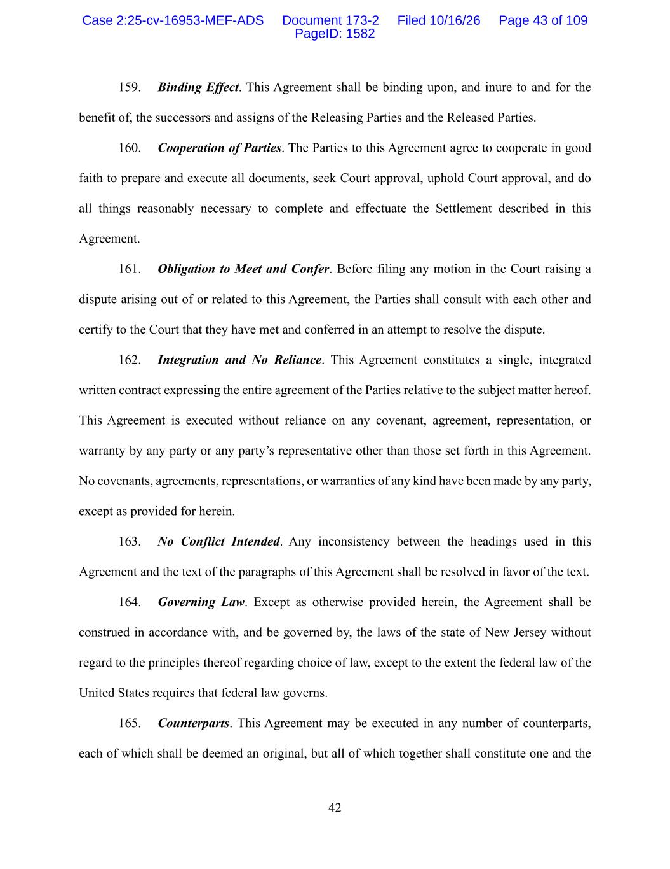
42 159. Binding Effect. This Agreement shall be binding upon, and inure to and for the benefit of, the successors and assigns of the Releasing Parties and the Released Parties. 160. Cooperation of Parties. The Parties to this Agreement agree to cooperate in good faith to prepare and execute all documents, seek Court approval, uphold Court approval, and do all things reasonably necessary to complete and effectuate the Settlement described in this Agreement. 161. Obligation to Meet and Confer. Before filing any motion in the Court raising a dispute arising out of or related to this Agreement, the Parties shall consult with each other and certify to the Court that they have met and conferred in an attempt to resolve the dispute. 162. Integration and No Reliance. This Agreement constitutes a single, integrated written contract expressing the entire agreement of the Parties relative to the subject matter hereof. This Agreement is executed without reliance on any covenant, agreement, representation, or warranty by any party or any party’s representative other than those set forth in this Agreement. No covenants, agreements, representations, or warranties of any kind have been made by any party, except as provided for herein. 163. No Conflict Intended. Any inconsistency between the headings used in this Agreement and the text of the paragraphs of this Agreement shall be resolved in favor of the text. 164. Governing Law. Except as otherwise provided herein, the Agreement shall be construed in accordance with, and be governed by, the laws of the state of New Jersey without regard to the principles thereof regarding choice of law, except to the extent the federal law of the United States requires that federal law governs. 165. Counterparts. This Agreement may be executed in any number of counterparts, each of which shall be deemed an original, but all of which together shall constitute one and the Case 2:25-cv-16953-MEF-ADS Document 173-2 Filed 10/16/26 Page 43 of 109 PageID: 1582

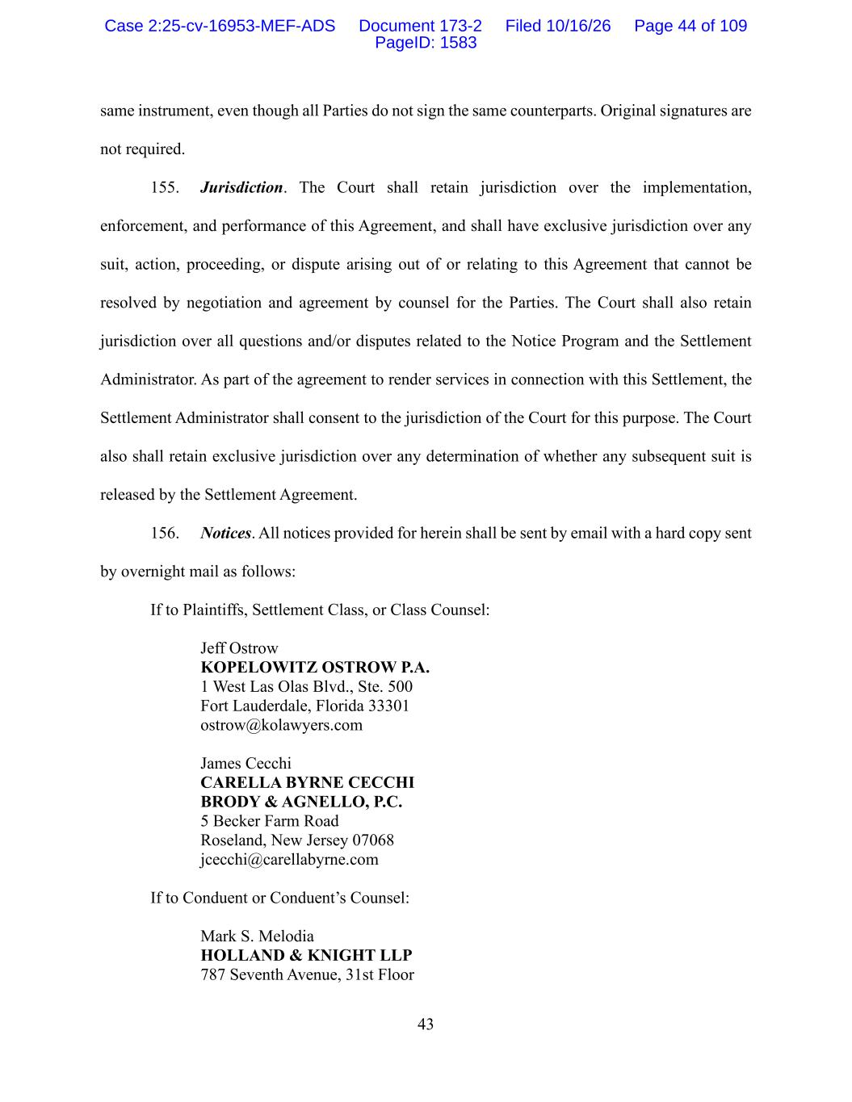
43 same instrument, even though all Parties do not sign the same counterparts. Original signatures are not required. 155. Jurisdiction. The Court shall retain jurisdiction over the implementation, enforcement, and performance of this Agreement, and shall have exclusive jurisdiction over any suit, action, proceeding, or dispute arising out of or relating to this Agreement that cannot be resolved by negotiation and agreement by counsel for the Parties. The Court shall also retain jurisdiction over all questions and/or disputes related to the Notice Program and the Settlement Administrator. As part of the agreement to render services in connection with this Settlement, the Settlement Administrator shall consent to the jurisdiction of the Court for this purpose. The Court also shall retain exclusive jurisdiction over any determination of whether any subsequent suit is released by the Settlement Agreement. 156. Notices. All notices provided for herein shall be sent by email with a hard copy sent by overnight mail as follows: If to Plaintiffs, Settlement Class, or Class Counsel: Jeff Ostrow KOPELOWITZ OSTROW P.A. 1 West Las Olas Blvd., Ste. 500 Fort Lauderdale, Florida 33301 ostrow@kolawyers.com James Cecchi CARELLA BYRNE CECCHI BRODY & AGNELLO, P.C. 5 Becker Farm Road Roseland, New Jersey 07068 jcecchi@carellabyrne.com If to Conduent or Conduent’s Counsel: Mark S. Melodia HOLLAND & KNIGHT LLP 787 Seventh Avenue, 31st Floor Case 2:25-cv-16953-MEF-ADS Document 173-2 Filed 10/16/26 Page 44 of 109 PageID: 1583

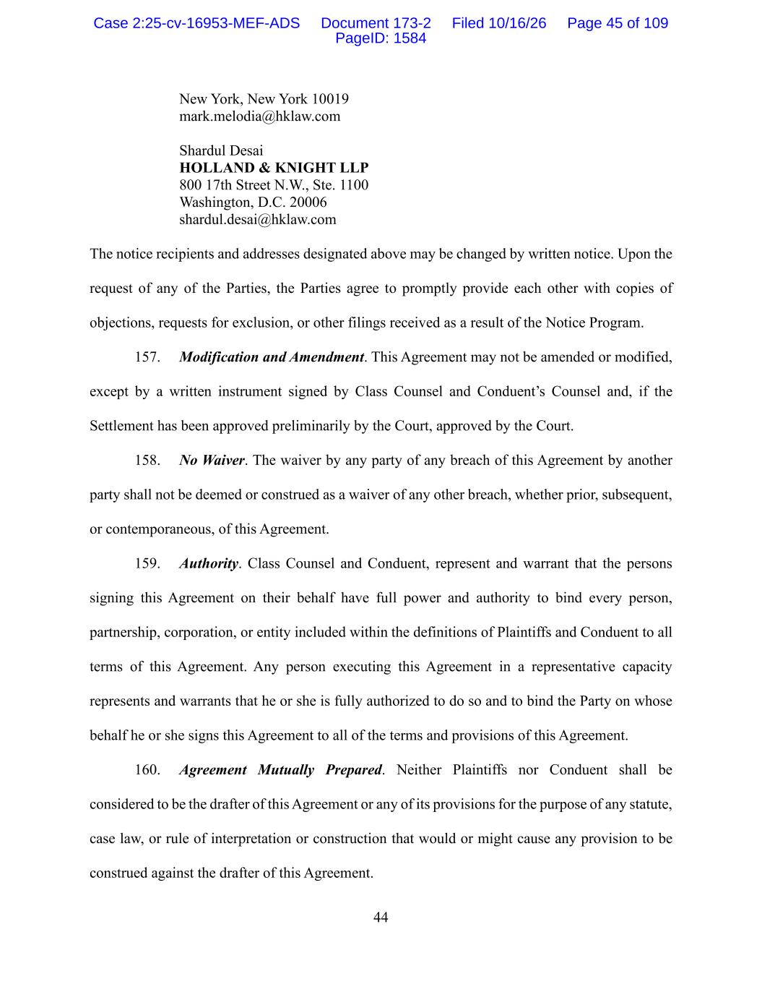
44 New York, New York 10019 mark.melodia@hklaw.com Shardul Desai HOLLAND & KNIGHT LLP 800 17th Street N.W., Ste. 1100 Washington, D.C. 20006 shardul.desai@hklaw.com The notice recipients and addresses designated above may be changed by written notice. Upon the request of any of the Parties, the Parties agree to promptly provide each other with copies of objections, requests for exclusion, or other filings received as a result of the Notice Program. 157. Modification and Amendment. This Agreement may not be amended or modified, except by a written instrument signed by Class Counsel and Conduent’s Counsel and, if the Settlement has been approved preliminarily by the Court, approved by the Court. 158. No Waiver. The waiver by any party of any breach of this Agreement by another party shall not be deemed or construed as a waiver of any other breach, whether prior, subsequent, or contemporaneous, of this Agreement. 159. Authority. Class Counsel and Conduent, represent and warrant that the persons signing this Agreement on their behalf have full power and authority to bind every person, partnership, corporation, or entity included within the definitions of Plaintiffs and Conduent to all terms of this Agreement. Any person executing this Agreement in a representative capacity represents and warrants that he or she is fully authorized to do so and to bind the Party on whose behalf he or she signs this Agreement to all of the terms and provisions of this Agreement. 160. Agreement Mutually Prepared. Neither Plaintiffs nor Conduent shall be considered to be the drafter of this Agreement or any of its provisions for the purpose of any statute, case law, or rule of interpretation or construction that would or might cause any provision to be construed against the drafter of this Agreement. Case 2:25-cv-16953-MEF-ADS Document 173-2 Filed 10/16/26 Page 45 of 109 PageID: 1584

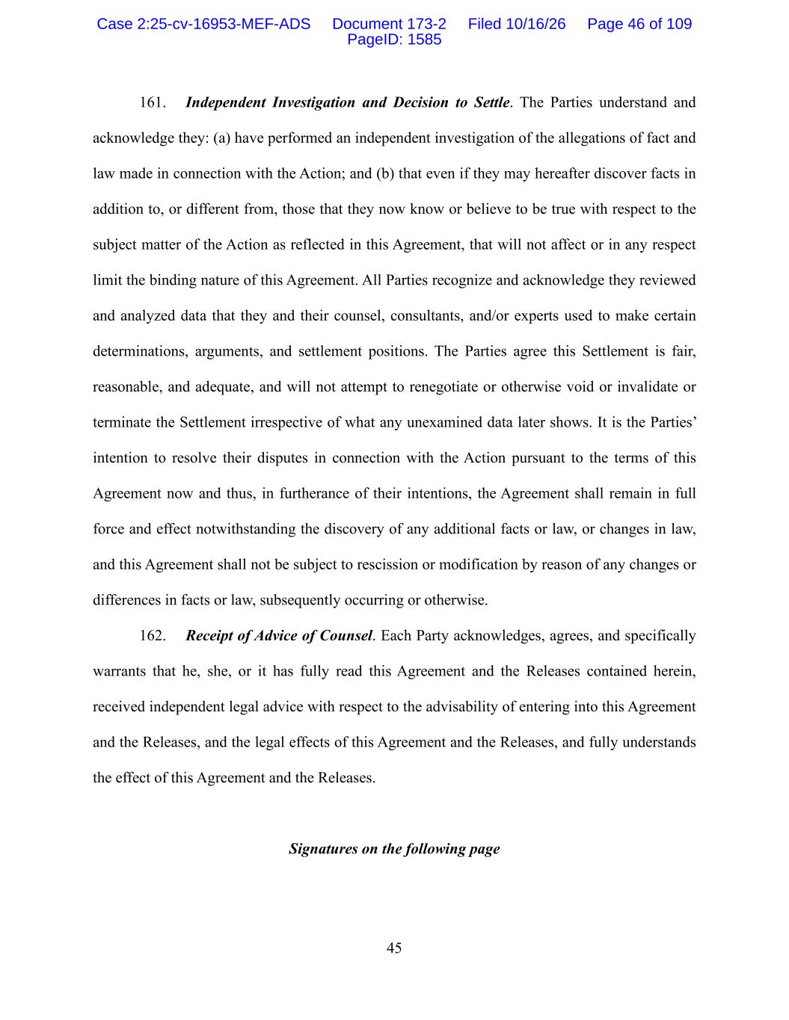
45 161. Independent Investigation and Decision to Settle. The Parties understand and acknowledge they: (a) have performed an independent investigation of the allegations of fact and law made in connection with the Action; and (b) that even if they may hereafter discover facts in addition to, or different from, those that they now know or believe to be true with respect to the subject matter of the Action as reflected in this Agreement, that will not affect or in any respect limit the binding nature of this Agreement. All Parties recognize and acknowledge they reviewed and analyzed data that they and their counsel, consultants, and/or experts used to make certain determinations, arguments, and settlement positions. The Parties agree this Settlement is fair, reasonable, and adequate, and will not attempt to renegotiate or otherwise void or invalidate or terminate the Settlement irrespective of what any unexamined data later shows. It is the Parties’ intention to resolve their disputes in connection with the Action pursuant to the terms of this Agreement now and thus, in furtherance of their intentions, the Agreement shall remain in full force and effect notwithstanding the discovery of any additional facts or law, or changes in law, and this Agreement shall not be subject to rescission or modification by reason of any changes or differences in facts or law, subsequently occurring or otherwise. 162. Receipt of Advice of Counsel. Each Party acknowledges, agrees, and specifically warrants that he, she, or it has fully read this Agreement and the Releases contained herein, received independent legal advice with respect to the advisability of entering into this Agreement and the Releases, and the legal effects of this Agreement and the Releases, and fully understands the effect of this Agreement and the Releases. Signatures on the following page Case 2:25-cv-16953-MEF-ADS Document 173-2 Filed 10/16/26 Page 46 of 109 PageID: 1585

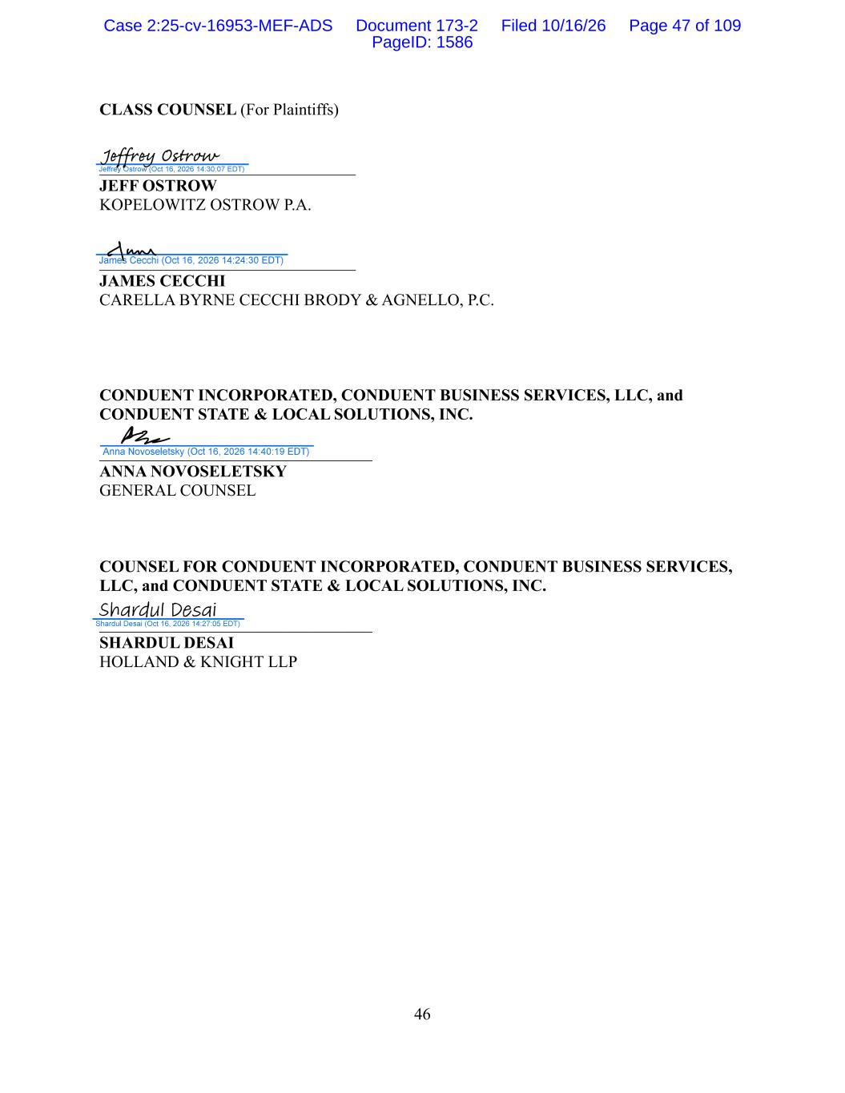
46 CLASS COUNSEL (For Plaintiffs) _______________________________ JEFF OSTROW KOPELOWITZ OSTROW P.A. _______________________________ JAMES CECCHI CARELLA BYRNE CECCHI BRODY & AGNELLO, P.C. CONDUENT INCORPORATED, CONDUENT BUSINESS SERVICES, LLC, and CONDUENT STATE & LOCAL SOLUTIONS, INC. _________________________________ ANNA NOVOSELETSKY GENERAL COUNSEL COUNSEL FOR CONDUENT INCORPORATED, CONDUENT BUSINESS SERVICES, LLC, and CONDUENT STATE & LOCAL SOLUTIONS, INC. _________________________________ SHARDUL DESAI HOLLAND & KNIGHT LLP Case 2:25-cv-16953-MEF-ADS Document 173-2 Filed 10/16/26 Page 47 of 109 PageID: 1586

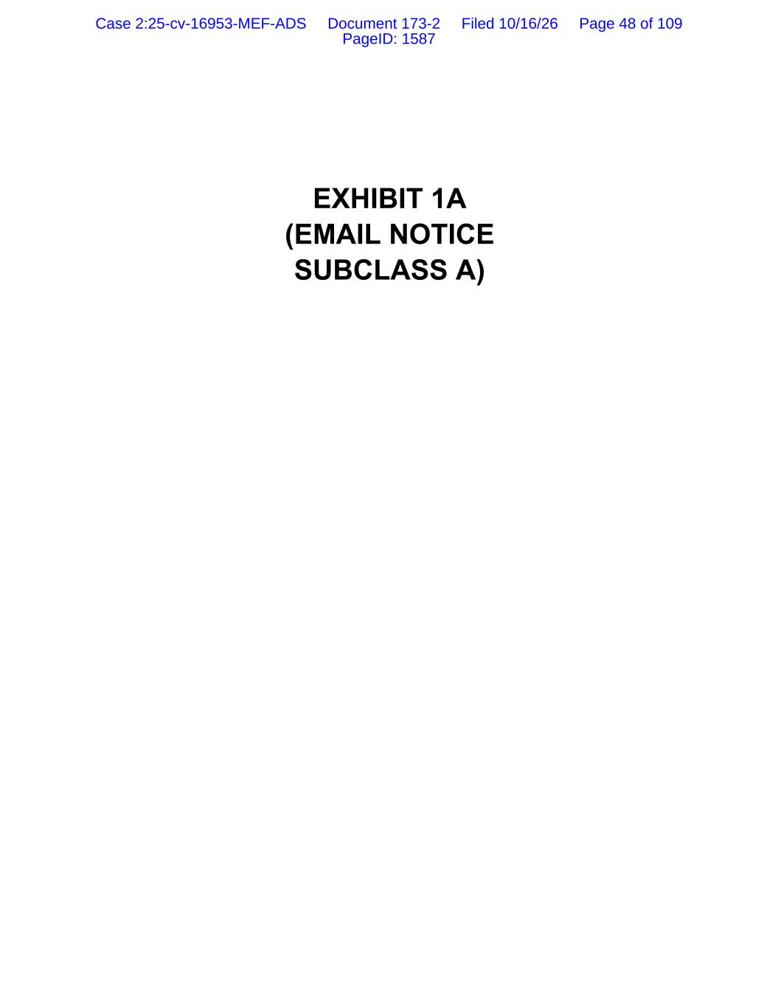
EXHIBIT 1A (EMAIL NOTICE SUBCLASS A) Case 2:25-cv-16953-MEF-ADS Document 173-2 Filed 10/16/26 Page 48 of 109 PageID: 1587

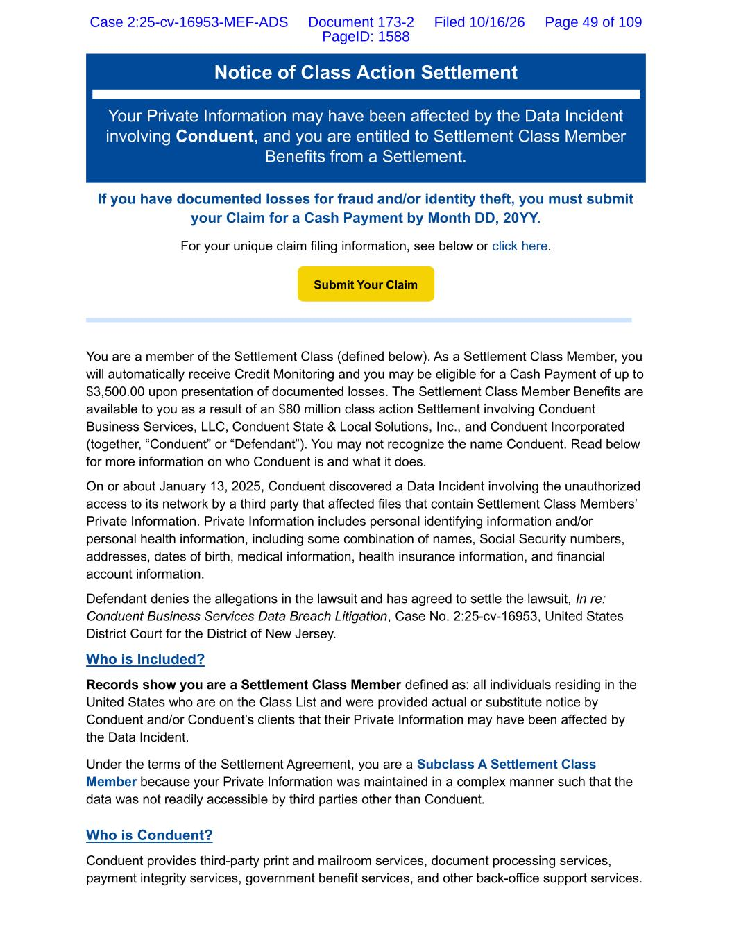
Notice of Class Action Settlement Your Private Information may have been affected by the Data Incident involving Conduent, and you are entitled to Settlement Class Member Benefits from a Settlement. If you have documented losses for fraud and/or identity theft, you must submit your Claim for a Cash Payment by Month DD, 20YY. For your unique claim filing information, see below or click here. You are a member of the Settlement Class (defined below). As a Settlement Class Member, you will automatically receive Credit Monitoring and you may be eligible for a Cash Payment of up to $3,500.00 upon presentation of documented losses. The Settlement Class Member Benefits are available to you as a result of an $80 million class action Settlement involving Conduent Business Services, LLC, Conduent State & Local Solutions, Inc., and Conduent Incorporated (together, “Conduent” or “Defendant”). You may not recognize the name Conduent. Read below for more information on who Conduent is and what it does. On or about January 13, 2025, Conduent discovered a Data Incident involving the unauthorized access to its network by a third party that affected files that contain Settlement Class Members’ Private Information. Private Information includes personal identifying information and/or personal health information, including some combination of names, Social Security numbers, addresses, dates of birth, medical information, health insurance information, and financial account information. Defendant denies the allegations in the lawsuit and has agreed to settle the lawsuit, In re: Conduent Business Services Data Breach Litigation, Case No. 2:25-cv-16953, United States District Court for the District of New Jersey. Who is Included? Records show you are a Settlement Class Member defined as: all individuals residing in the United States who are on the Class List and were provided actual or substitute notice by Conduent and/or Conduent’s clients that their Private Information may have been affected by the Data Incident. Under the terms of the Settlement Agreement, you are a Subclass A Settlement Class Member because your Private Information was maintained in a complex manner such that the data was not readily accessible by third parties other than Conduent. Who is Conduent? Conduent provides third-party print and mailroom services, document processing services, payment integrity services, government benefit services, and other back-office support services. Submit Your Claim Case 2:25-cv-16953-MEF-ADS Document 173-2 Filed 10/16/26 Page 49 of 109 PageID: 1588

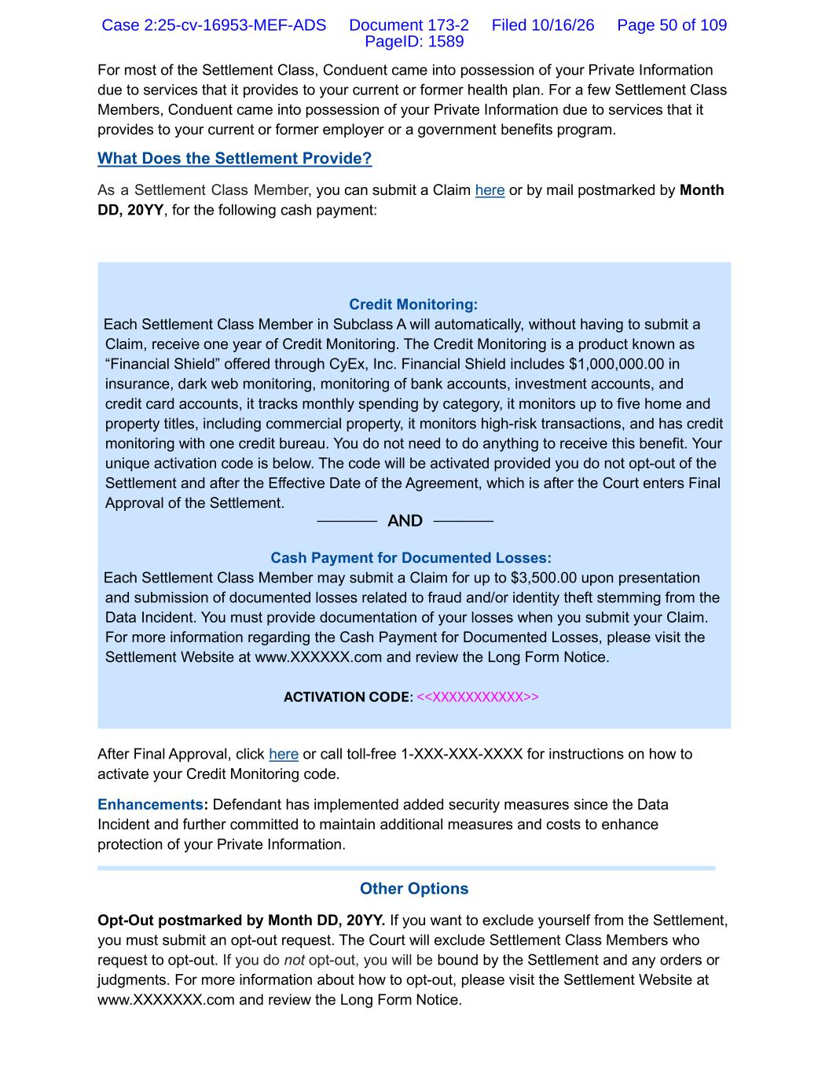
For most of the Settlement Class, Conduent came into possession of your Private Information due to services that it provides to your current or former health plan. For a few Settlement Class Members, Conduent came into possession of your Private Information due to services that it provides to your current or former employer or a government benefits program. What Does the Settlement Provide? As a Settlement Class Member, you can submit a Claim here or by mail postmarked by Month DD, 20YY, for the following cash payment: Credit Monitoring: Each Settlement Class Member in Subclass A will automatically, without having to submit a Claim, receive one year of Credit Monitoring. The Credit Monitoring is a product known as “Financial Shield” offered through CyEx, Inc. Financial Shield includes $1,000,000.00 in insurance, dark web monitoring, monitoring of bank accounts, investment accounts, and credit card accounts, it tracks monthly spending by category, it monitors up to five home and property titles, including commercial property, it monitors high-risk transactions, and has credit monitoring with one credit bureau. You do not need to do anything to receive this benefit. Your unique activation code is below. The code will be activated provided you do not opt-out of the Settlement and after the Effective Date of the Agreement, which is after the Court enters Final Approval of the Settlement. ───── AND ───── Cash Payment for Documented Losses: Each Settlement Class Member may submit a Claim for up to $3,500.00 upon presentation and submission of documented losses related to fraud and/or identity theft stemming from the Data Incident. You must provide documentation of your losses when you submit your Claim. For more information regarding the Cash Payment for Documented Losses, please visit the Settlement Website at www.XXXXXX.com and review the Long Form Notice. ACTIVATION CODE: <<XXXXXXXXXXX>> After Final Approval, click here or call toll-free 1-XXX-XXX-XXXX for instructions on how to activate your Credit Monitoring code. Enhancements: Defendant has implemented added security measures since the Data Incident and further committed to maintain additional measures and costs to enhance protection of your Private Information. Other Options Opt-Out postmarked by Month DD, 20YY. If you want to exclude yourself from the Settlement, you must submit an opt-out request. The Court will exclude Settlement Class Members who request to opt-out. If you do not opt-out, you will be bound by the Settlement and any orders or judgments. For more information about how to opt-out, please visit the Settlement Website at www.XXXXXXX.com and review the Long Form Notice. Case 2:25-cv-16953-MEF-ADS Document 173-2 Filed 10/16/26 Page 50 of 109 PageID: 1589


Object by Month DD, 20YY. If you want to object to any part of the Settlement or the Application for Attorneys’ Fees, Costs, and Service Awards, you must submit your objection timely. For more information on how to object to the Settlement, please visit the Settlement Website at www.XXXXXX.com and review the Long Form Notice. Do Nothing. If you do nothing, you will remain in the Settlement Class. You will receive the Credit Monitoring activation code, but you will not get a Cash Payment from the Settlement, and you will be bound by the Settlement and any orders or judgments. Final Approval Hearing on Month DD, 20YY. The Court will hold a Final Approval Hearing to decide whether to approve the Settlement, Class Counsel's attorneys' fees up to 34% of the Settlement Fund and costs, and any objections. You or your lawyer may ask to appear at the hearing, but it is not required. This Notice is a summary. Learn more here or call toll-free 1-XXX-XXX-XXXX. Your Unique Information <<Variable Data>> If {\recipient_addr} should not be subscribed or if you need to change your subscription information for {\client_name}, please use this preferences page. Submit Your Claim Case 2:25-cv-16953-MEF-ADS Document 173-2 Filed 10/16/26 Page 51 of 109 PageID: 1590

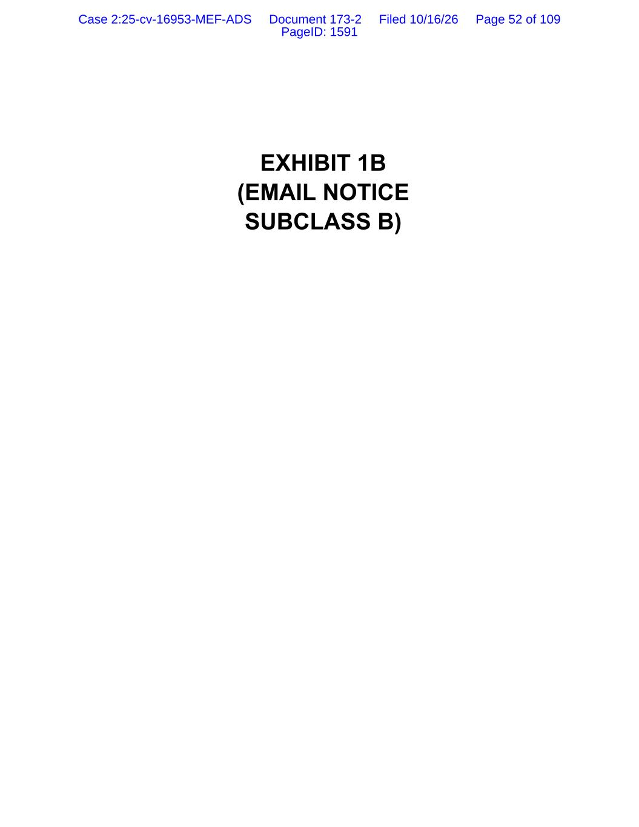
EXHIBIT 1B (EMAIL NOTICE SUBCLASS B) Case 2:25-cv-16953-MEF-ADS Document 173-2 Filed 10/16/26 Page 52 of 109 PageID: 1591

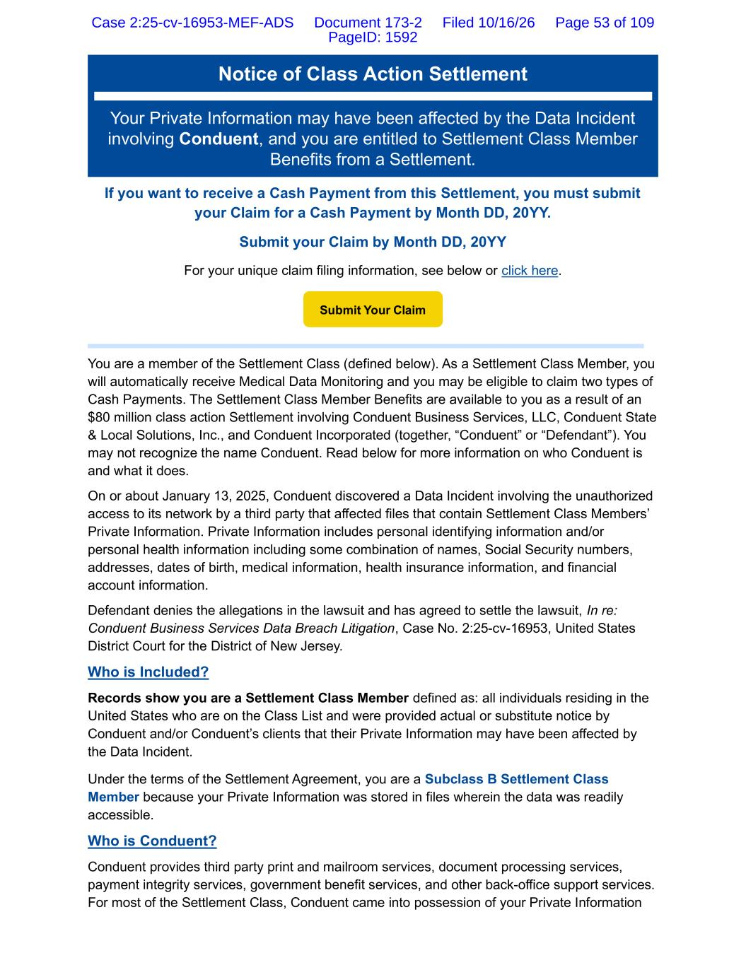
Notice of Class Action Settlement Your Private Information may have been affected by the Data Incident involving Conduent, and you are entitled to Settlement Class Member Benefits from a Settlement. If you want to receive a Cash Payment from this Settlement, you must submit your Claim for a Cash Payment by Month DD, 20YY. Submit your Claim by Month DD, 20YY For your unique claim filing information, see below or click here. You are a member of the Settlement Class (defined below). As a Settlement Class Member, you will automatically receive Medical Data Monitoring and you may be eligible to claim two types of Cash Payments. The Settlement Class Member Benefits are available to you as a result of an $80 million class action Settlement involving Conduent Business Services, LLC, Conduent State & Local Solutions, Inc., and Conduent Incorporated (together, “Conduent” or “Defendant”). You may not recognize the name Conduent. Read below for more information on who Conduent is and what it does. On or about January 13, 2025, Conduent discovered a Data Incident involving the unauthorized access to its network by a third party that affected files that contain Settlement Class Members’ Private Information. Private Information includes personal identifying information and/or personal health information including some combination of names, Social Security numbers, addresses, dates of birth, medical information, health insurance information, and financial account information. Defendant denies the allegations in the lawsuit and has agreed to settle the lawsuit, In re: Conduent Business Services Data Breach Litigation, Case No. 2:25-cv-16953, United States District Court for the District of New Jersey. Who is Included? Records show you are a Settlement Class Member defined as: all individuals residing in the United States who are on the Class List and were provided actual or substitute notice by Conduent and/or Conduent’s clients that their Private Information may have been affected by the Data Incident. Under the terms of the Settlement Agreement, you are a Subclass B Settlement Class Member because your Private Information was stored in files wherein the data was readily accessible. Who is Conduent? Conduent provides third party print and mailroom services, document processing services, payment integrity services, government benefit services, and other back-office support services. For most of the Settlement Class, Conduent came into possession of your Private Information Submit Your Claim Case 2:25-cv-16953-MEF-ADS Document 173-2 Filed 10/16/26 Page 53 of 109 PageID: 1592

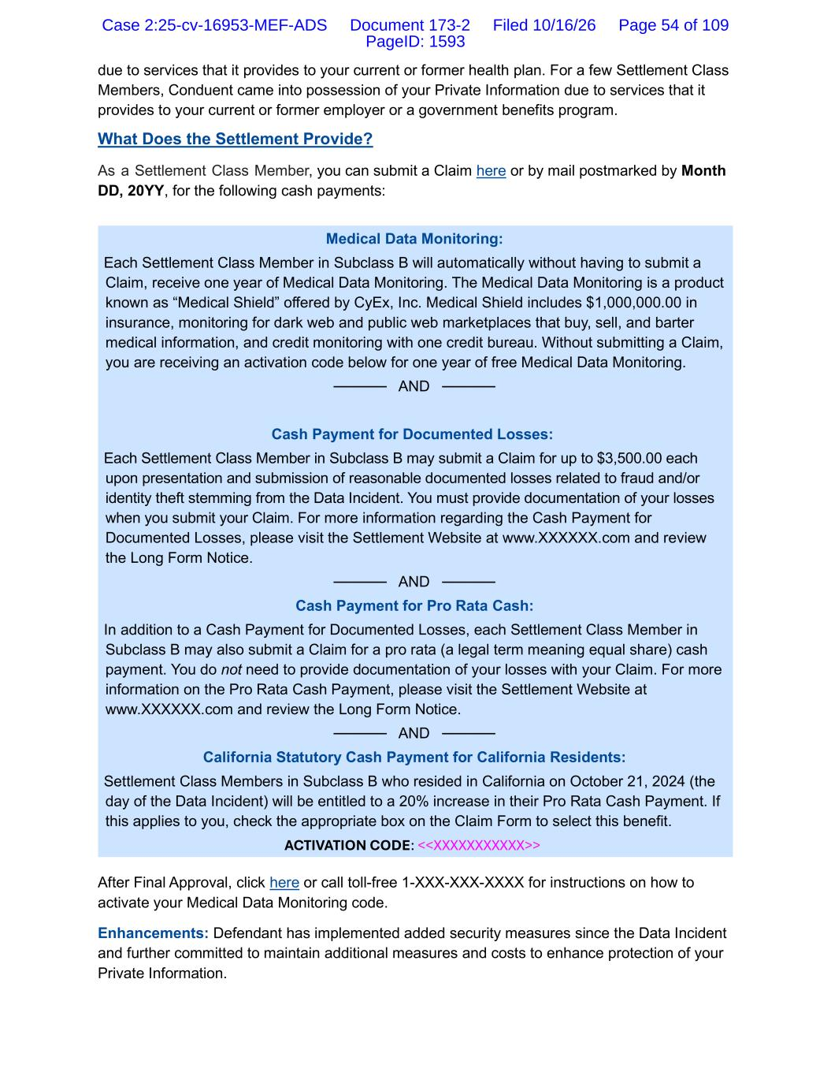
due to services that it provides to your current or former health plan. For a few Settlement Class Members, Conduent came into possession of your Private Information due to services that it provides to your current or former employer or a government benefits program. What Does the Settlement Provide? As a Settlement Class Member, you can submit a Claim here or by mail postmarked by Month DD, 20YY, for the following cash payments: Medical Data Monitoring: Each Settlement Class Member in Subclass B will automatically without having to submit a Claim, receive one year of Medical Data Monitoring. The Medical Data Monitoring is a product known as “Medical Shield” offered by CyEx, Inc. Medical Shield includes $1,000,000.00 in insurance, monitoring for dark web and public web marketplaces that buy, sell, and barter medical information, and credit monitoring with one credit bureau. Without submitting a Claim, you are receiving an activation code below for one year of free Medical Data Monitoring. ───── AND ───── Cash Payment for Documented Losses: Each Settlement Class Member in Subclass B may submit a Claim for up to $3,500.00 each upon presentation and submission of reasonable documented losses related to fraud and/or identity theft stemming from the Data Incident. You must provide documentation of your losses when you submit your Claim. For more information regarding the Cash Payment for Documented Losses, please visit the Settlement Website at www.XXXXXX.com and review the Long Form Notice. ───── AND ───── Cash Payment for Pro Rata Cash: In addition to a Cash Payment for Documented Losses, each Settlement Class Member in Subclass B may also submit a Claim for a pro rata (a legal term meaning equal share) cash payment. You do not need to provide documentation of your losses with your Claim. For more information on the Pro Rata Cash Payment, please visit the Settlement Website at www.XXXXXX.com and review the Long Form Notice. ───── AND ───── California Statutory Cash Payment for California Residents: Settlement Class Members in Subclass B who resided in California on October 21, 2024 (the day of the Data Incident) will be entitled to a 20% increase in their Pro Rata Cash Payment. If this applies to you, check the appropriate box on the Claim Form to select this benefit. ACTIVATION CODE: <<XXXXXXXXXXX>> After Final Approval, click here or call toll-free 1-XXX-XXX-XXXX for instructions on how to activate your Medical Data Monitoring code. Enhancements: Defendant has implemented added security measures since the Data Incident and further committed to maintain additional measures and costs to enhance protection of your Private Information. Case 2:25-cv-16953-MEF-ADS Document 173-2 Filed 10/16/26 Page 54 of 109 PageID: 1593

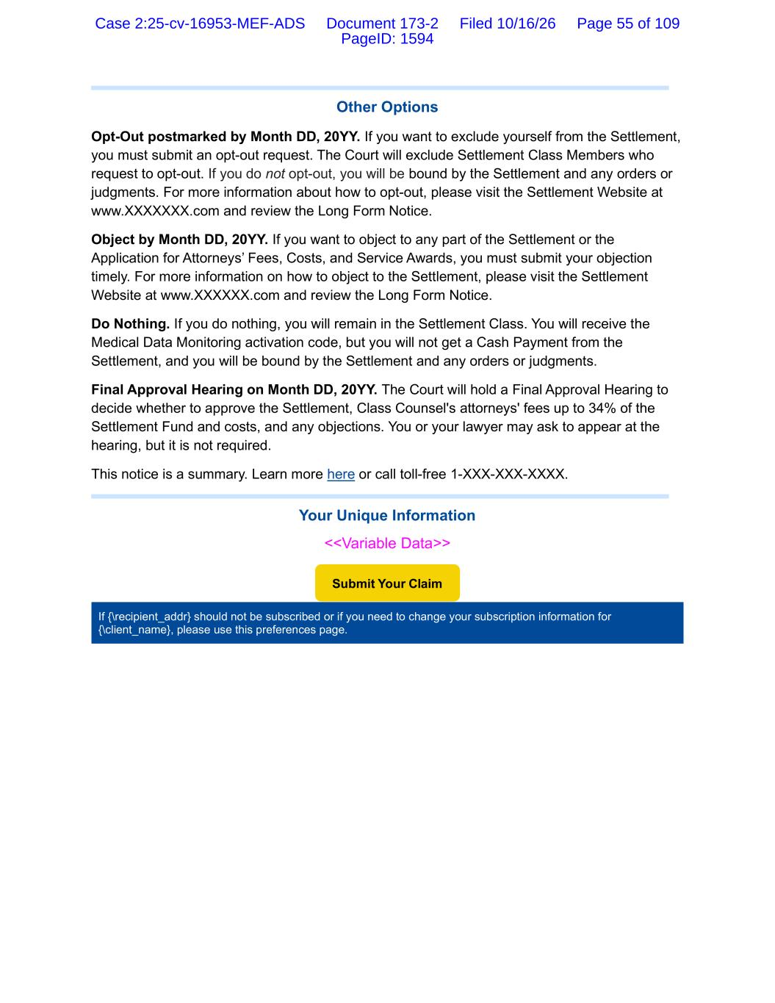
Other Options Opt-Out postmarked by Month DD, 20YY. If you want to exclude yourself from the Settlement, you must submit an opt-out request. The Court will exclude Settlement Class Members who request to opt-out. If you do not opt-out, you will be bound by the Settlement and any orders or judgments. For more information about how to opt-out, please visit the Settlement Website at www.XXXXXXX.com and review the Long Form Notice. Object by Month DD, 20YY. If you want to object to any part of the Settlement or the Application for Attorneys’ Fees, Costs, and Service Awards, you must submit your objection timely. For more information on how to object to the Settlement, please visit the Settlement Website at www.XXXXXX.com and review the Long Form Notice. Do Nothing. If you do nothing, you will remain in the Settlement Class. You will receive the Medical Data Monitoring activation code, but you will not get a Cash Payment from the Settlement, and you will be bound by the Settlement and any orders or judgments. Final Approval Hearing on Month DD, 20YY. The Court will hold a Final Approval Hearing to decide whether to approve the Settlement, Class Counsel's attorneys' fees up to 34% of the Settlement Fund and costs, and any objections. You or your lawyer may ask to appear at the hearing, but it is not required. This notice is a summary. Learn more here or call toll-free 1-XXX-XXX-XXXX. Your Unique Information <<Variable Data>> If {\recipient_addr} should not be subscribed or if you need to change your subscription information for {\client_name}, please use this preferences page. Submit Your Claim Case 2:25-cv-16953-MEF-ADS Document 173-2 Filed 10/16/26 Page 55 of 109 PageID: 1594

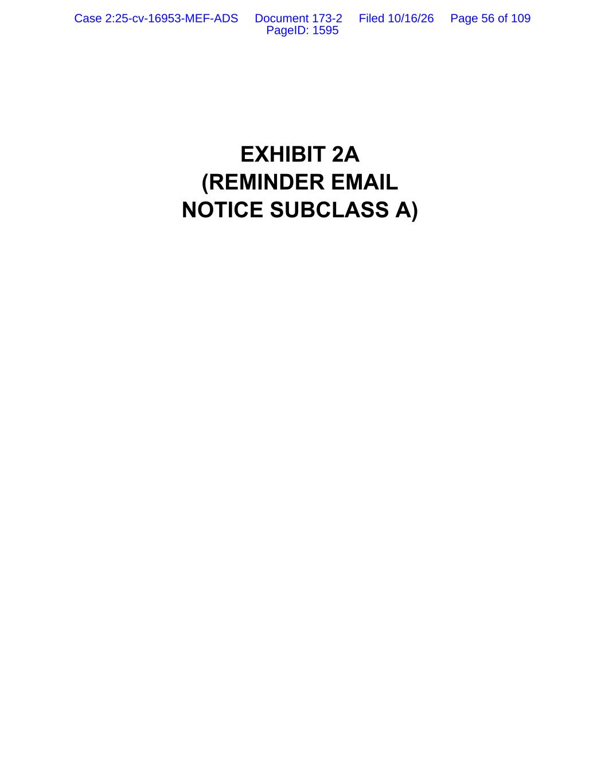
EXHIBIT 2A (REMINDER EMAIL NOTICE SUBCLASS A) Case 2:25-cv-16953-MEF-ADS Document 173-2 Filed 10/16/26 Page 56 of 109 PageID: 1595

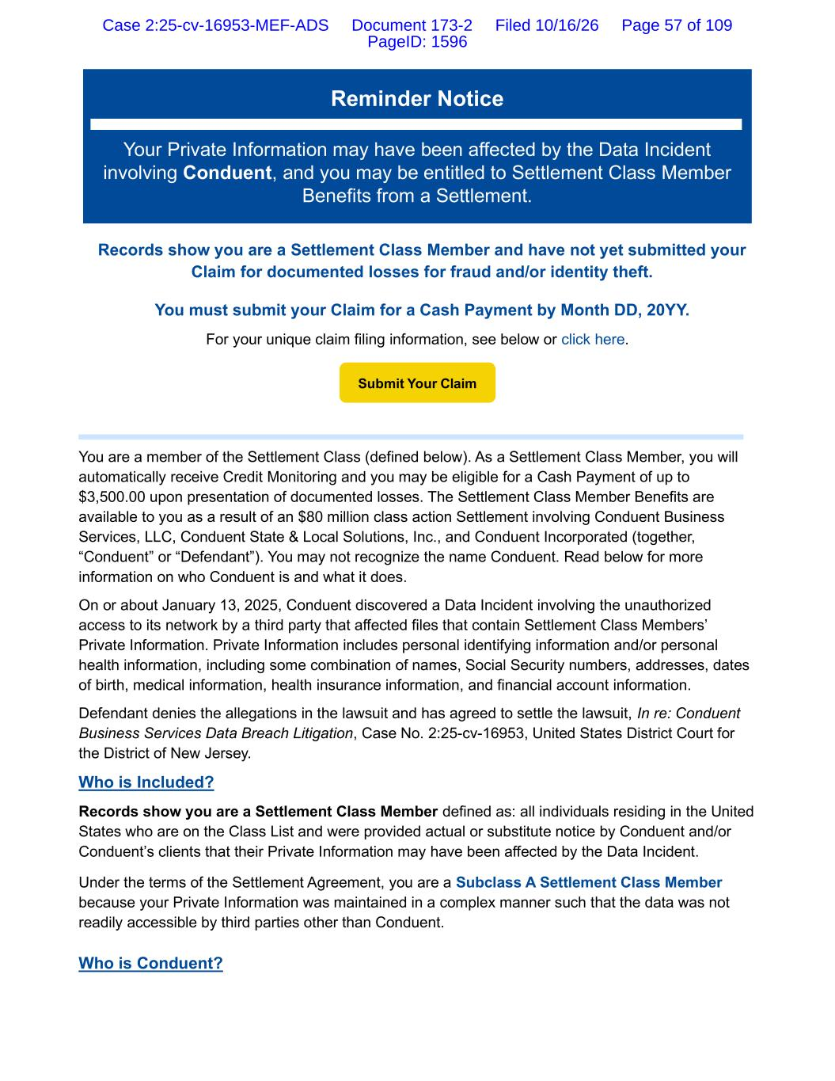
Reminder Notice Your Private Information may have been affected by the Data Incident involving Conduent, and you may be entitled to Settlement Class Member Benefits from a Settlement. Records show you are a Settlement Class Member and have not yet submitted your Claim for documented losses for fraud and/or identity theft. You must submit your Claim for a Cash Payment by Month DD, 20YY. For your unique claim filing information, see below or click here. You are a member of the Settlement Class (defined below). As a Settlement Class Member, you will automatically receive Credit Monitoring and you may be eligible for a Cash Payment of up to $3,500.00 upon presentation of documented losses. The Settlement Class Member Benefits are available to you as a result of an $80 million class action Settlement involving Conduent Business Services, LLC, Conduent State & Local Solutions, Inc., and Conduent Incorporated (together, “Conduent” or “Defendant”). You may not recognize the name Conduent. Read below for more information on who Conduent is and what it does. On or about January 13, 2025, Conduent discovered a Data Incident involving the unauthorized access to its network by a third party that affected files that contain Settlement Class Members’ Private Information. Private Information includes personal identifying information and/or personal health information, including some combination of names, Social Security numbers, addresses, dates of birth, medical information, health insurance information, and financial account information. Defendant denies the allegations in the lawsuit and has agreed to settle the lawsuit, In re: Conduent Business Services Data Breach Litigation, Case No. 2:25-cv-16953, United States District Court for the District of New Jersey. Who is Included? Records show you are a Settlement Class Member defined as: all individuals residing in the United States who are on the Class List and were provided actual or substitute notice by Conduent and/or Conduent’s clients that their Private Information may have been affected by the Data Incident. Under the terms of the Settlement Agreement, you are a Subclass A Settlement Class Member because your Private Information was maintained in a complex manner such that the data was not readily accessible by third parties other than Conduent. Who is Conduent? Submit Your Claim Case 2:25-cv-16953-MEF-ADS Document 173-2 Filed 10/16/26 Page 57 of 109 PageID: 1596

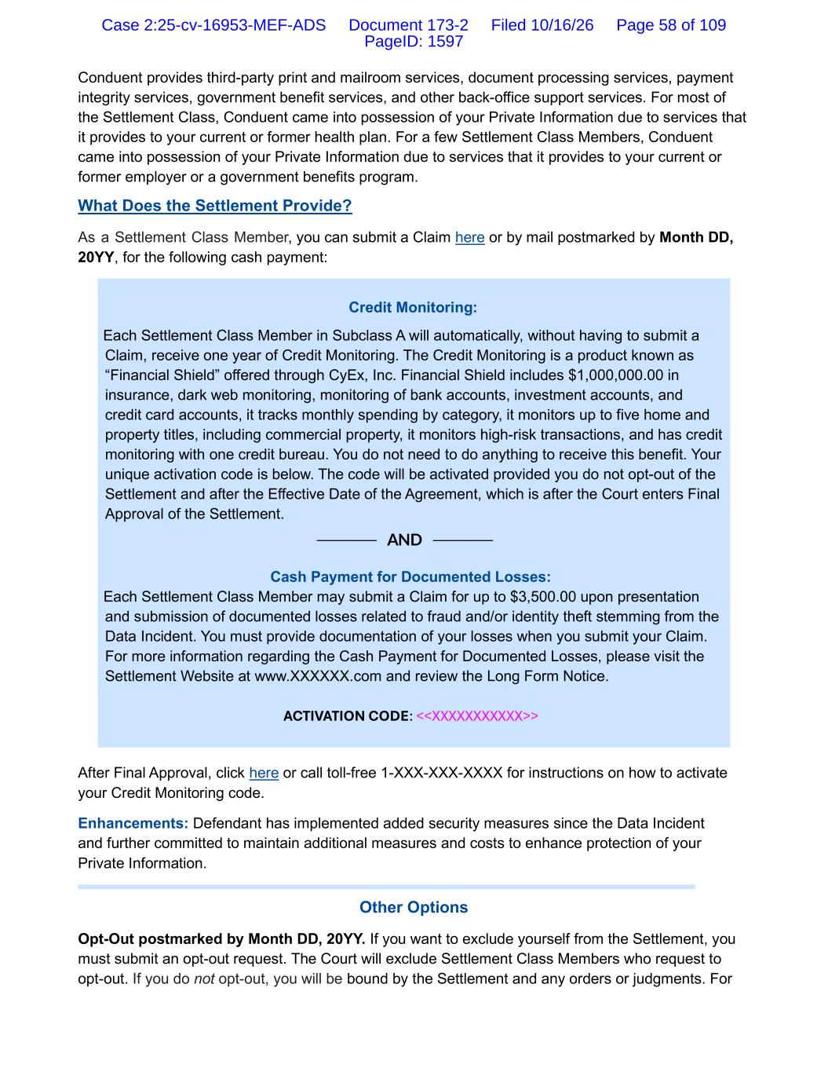
Conduent provides third-party print and mailroom services, document processing services, payment integrity services, government benefit services, and other back-office support services. For most of the Settlement Class, Conduent came into possession of your Private Information due to services that it provides to your current or former health plan. For a few Settlement Class Members, Conduent came into possession of your Private Information due to services that it provides to your current or former employer or a government benefits program. What Does the Settlement Provide? As a Settlement Class Member, you can submit a Claim here or by mail postmarked by Month DD, 20YY, for the following cash payment: Credit Monitoring: Each Settlement Class Member in Subclass A will automatically, without having to submit a Claim, receive one year of Credit Monitoring. The Credit Monitoring is a product known as “Financial Shield” offered through CyEx, Inc. Financial Shield includes $1,000,000.00 in insurance, dark web monitoring, monitoring of bank accounts, investment accounts, and credit card accounts, it tracks monthly spending by category, it monitors up to five home and property titles, including commercial property, it monitors high-risk transactions, and has credit monitoring with one credit bureau. You do not need to do anything to receive this benefit. Your unique activation code is below. The code will be activated provided you do not opt-out of the Settlement and after the Effective Date of the Agreement, which is after the Court enters Final Approval of the Settlement. ───── AND ───── Cash Payment for Documented Losses: Each Settlement Class Member may submit a Claim for up to $3,500.00 upon presentation and submission of documented losses related to fraud and/or identity theft stemming from the Data Incident. You must provide documentation of your losses when you submit your Claim. For more information regarding the Cash Payment for Documented Losses, please visit the Settlement Website at www.XXXXXX.com and review the Long Form Notice. ACTIVATION CODE: <<XXXXXXXXXXX>> After Final Approval, click here or call toll-free 1-XXX-XXX-XXXX for instructions on how to activate your Credit Monitoring code. Enhancements: Defendant has implemented added security measures since the Data Incident and further committed to maintain additional measures and costs to enhance protection of your Private Information. Other Options Opt-Out postmarked by Month DD, 20YY. If you want to exclude yourself from the Settlement, you must submit an opt-out request. The Court will exclude Settlement Class Members who request to opt-out. If you do not opt-out, you will be bound by the Settlement and any orders or judgments. For Case 2:25-cv-16953-MEF-ADS Document 173-2 Filed 10/16/26 Page 58 of 109 PageID: 1597

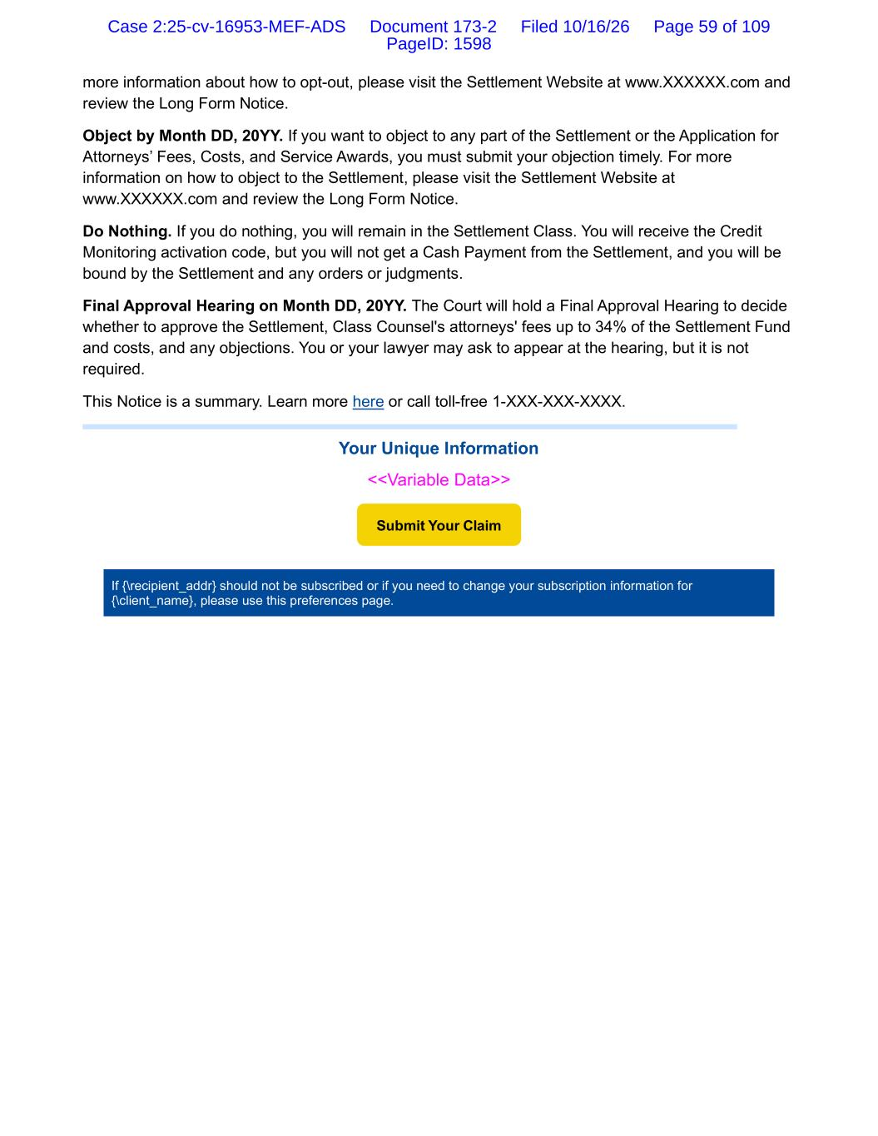
more information about how to opt-out, please visit the Settlement Website at www.XXXXXX.com and review the Long Form Notice. Object by Month DD, 20YY. If you want to object to any part of the Settlement or the Application for Attorneys’ Fees, Costs, and Service Awards, you must submit your objection timely. For more information on how to object to the Settlement, please visit the Settlement Website at www.XXXXXX.com and review the Long Form Notice. Do Nothing. If you do nothing, you will remain in the Settlement Class. You will receive the Credit Monitoring activation code, but you will not get a Cash Payment from the Settlement, and you will be bound by the Settlement and any orders or judgments. Final Approval Hearing on Month DD, 20YY. The Court will hold a Final Approval Hearing to decide whether to approve the Settlement, Class Counsel's attorneys' fees up to 34% of the Settlement Fund and costs, and any objections. You or your lawyer may ask to appear at the hearing, but it is not required. This Notice is a summary. Learn more here or call toll-free 1-XXX-XXX-XXXX. Your Unique Information <<Variable Data>> If {\recipient_addr} should not be subscribed or if you need to change your subscription information for {\client_name}, please use this preferences page. Submit Your Claim Case 2:25-cv-16953-MEF-ADS Document 173-2 Filed 10/16/26 Page 59 of 109 PageID: 1598

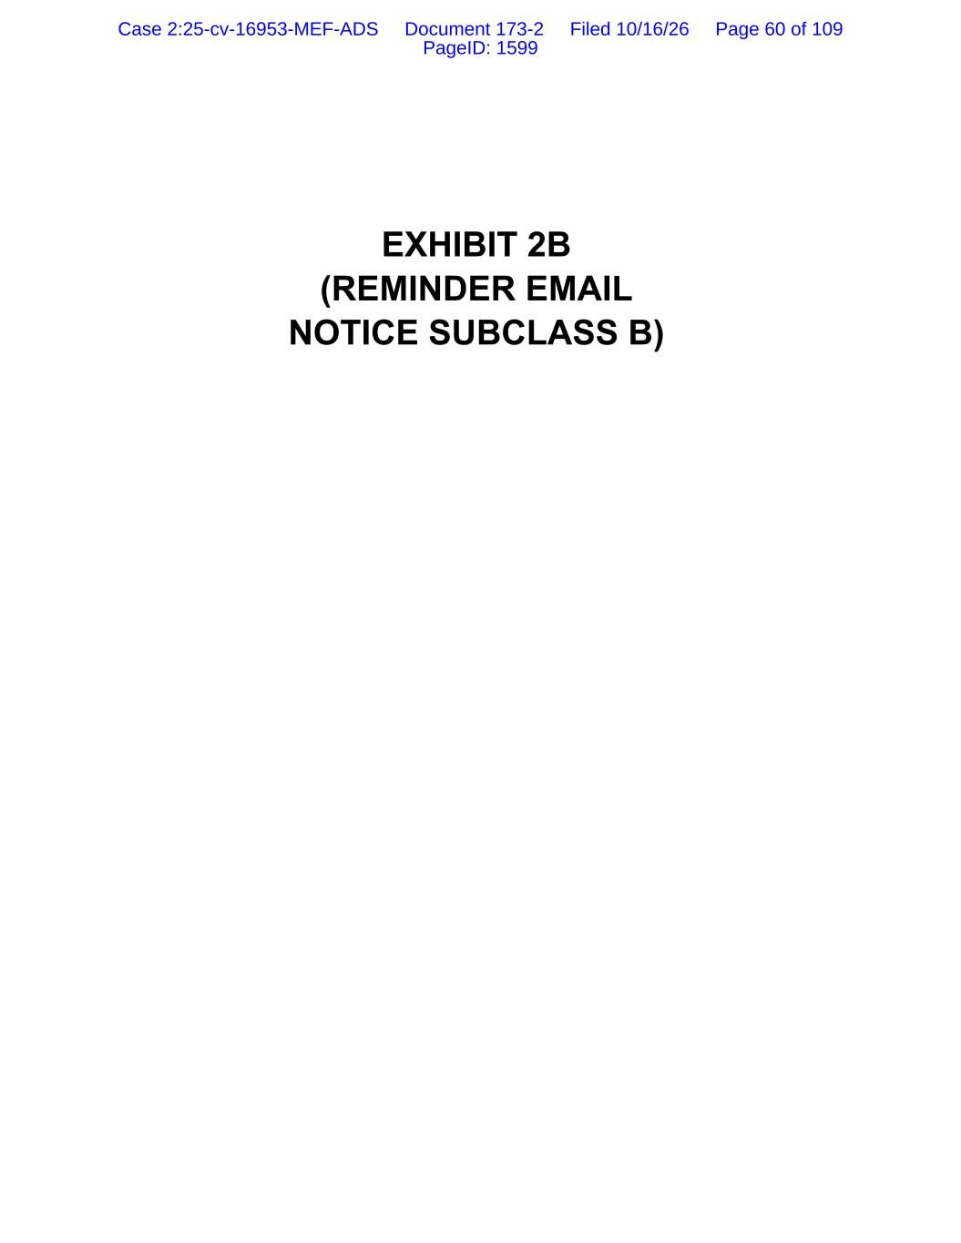
EXHIBIT 2B (REMINDER EMAIL NOTICE SUBCLASS B) Case 2:25-cv-16953-MEF-ADS Document 173-2 Filed 10/16/26 Page 60 of 109 PageID: 1599

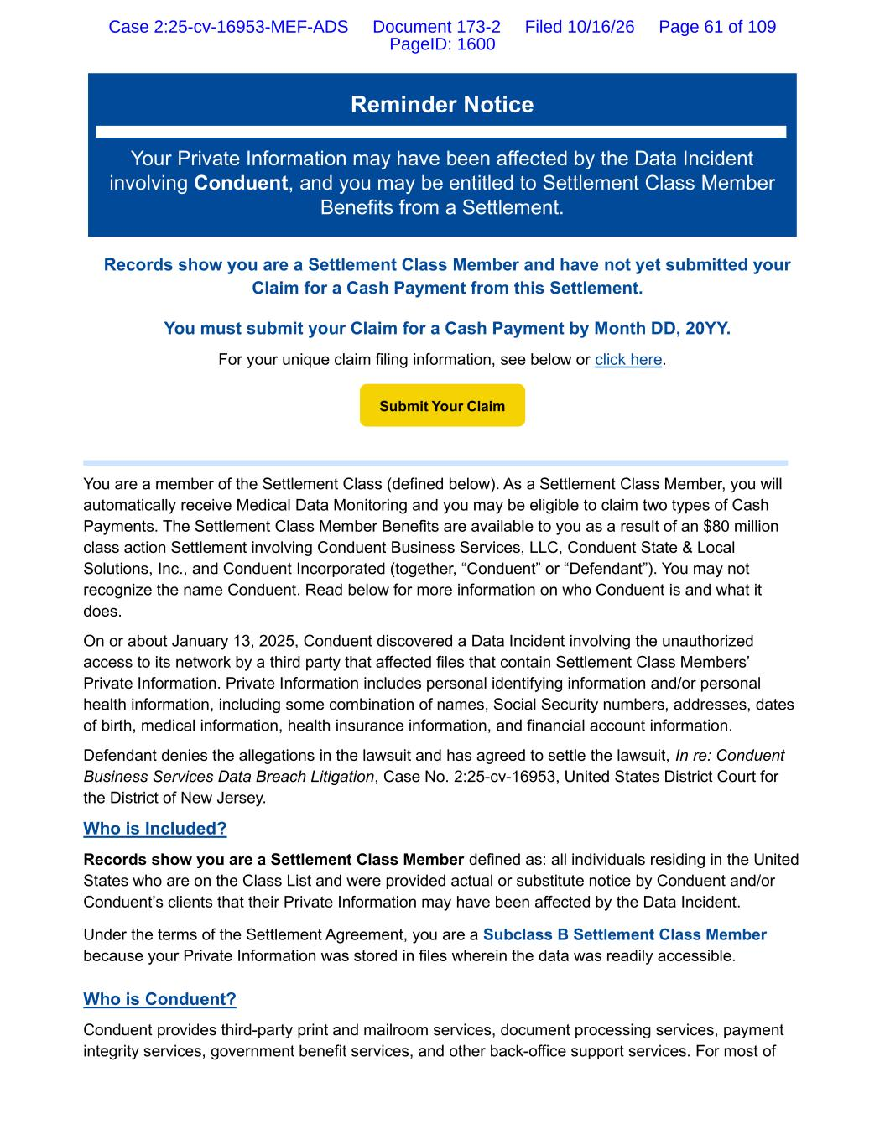
Reminder Notice Your Private Information may have been affected by the Data Incident involving Conduent, and you may be entitled to Settlement Class Member Benefits from a Settlement. Records show you are a Settlement Class Member and have not yet submitted your Claim for a Cash Payment from this Settlement. You must submit your Claim for a Cash Payment by Month DD, 20YY. For your unique claim filing information, see below or click here. You are a member of the Settlement Class (defined below). As a Settlement Class Member, you will automatically receive Medical Data Monitoring and you may be eligible to claim two types of Cash Payments. The Settlement Class Member Benefits are available to you as a result of an $80 million class action Settlement involving Conduent Business Services, LLC, Conduent State & Local Solutions, Inc., and Conduent Incorporated (together, “Conduent” or “Defendant”). You may not recognize the name Conduent. Read below for more information on who Conduent is and what it does. On or about January 13, 2025, Conduent discovered a Data Incident involving the unauthorized access to its network by a third party that affected files that contain Settlement Class Members’ Private Information. Private Information includes personal identifying information and/or personal health information, including some combination of names, Social Security numbers, addresses, dates of birth, medical information, health insurance information, and financial account information. Defendant denies the allegations in the lawsuit and has agreed to settle the lawsuit, In re: Conduent Business Services Data Breach Litigation, Case No. 2:25-cv-16953, United States District Court for the District of New Jersey. Who is Included? Records show you are a Settlement Class Member defined as: all individuals residing in the United States who are on the Class List and were provided actual or substitute notice by Conduent and/or Conduent’s clients that their Private Information may have been affected by the Data Incident. Under the terms of the Settlement Agreement, you are a Subclass B Settlement Class Member because your Private Information was stored in files wherein the data was readily accessible. Who is Conduent? Conduent provides third-party print and mailroom services, document processing services, payment integrity services, government benefit services, and other back-office support services. For most of Submit Your Claim Case 2:25-cv-16953-MEF-ADS Document 173-2 Filed 10/16/26 Page 61 of 109 PageID: 1600

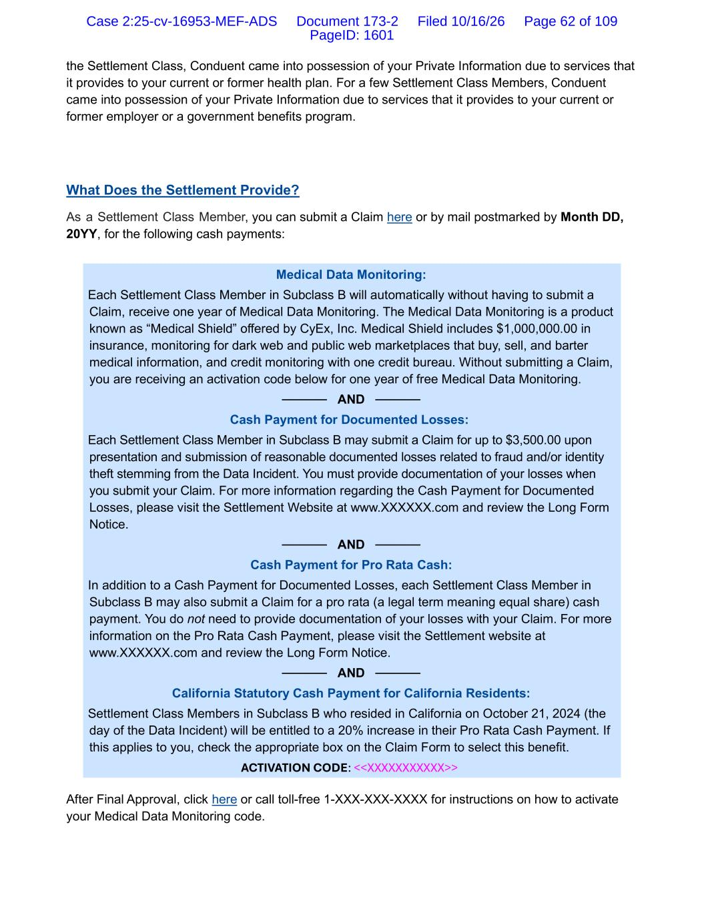
the Settlement Class, Conduent came into possession of your Private Information due to services that it provides to your current or former health plan. For a few Settlement Class Members, Conduent came into possession of your Private Information due to services that it provides to your current or former employer or a government benefits program. What Does the Settlement Provide? As a Settlement Class Member, you can submit a Claim here or by mail postmarked by Month DD, 20YY, for the following cash payments: Medical Data Monitoring: Each Settlement Class Member in Subclass B will automatically without having to submit a Claim, receive one year of Medical Data Monitoring. The Medical Data Monitoring is a product known as “Medical Shield” offered by CyEx, Inc. Medical Shield includes $1,000,000.00 in insurance, monitoring for dark web and public web marketplaces that buy, sell, and barter medical information, and credit monitoring with one credit bureau. Without submitting a Claim, you are receiving an activation code below for one year of free Medical Data Monitoring. ───── AND ───── Cash Payment for Documented Losses: Each Settlement Class Member in Subclass B may submit a Claim for up to $3,500.00 upon presentation and submission of reasonable documented losses related to fraud and/or identity theft stemming from the Data Incident. You must provide documentation of your losses when you submit your Claim. For more information regarding the Cash Payment for Documented Losses, please visit the Settlement Website at www.XXXXXX.com and review the Long Form Notice. ───── AND ───── Cash Payment for Pro Rata Cash: In addition to a Cash Payment for Documented Losses, each Settlement Class Member in Subclass B may also submit a Claim for a pro rata (a legal term meaning equal share) cash payment. You do not need to provide documentation of your losses with your Claim. For more information on the Pro Rata Cash Payment, please visit the Settlement website at www.XXXXXX.com and review the Long Form Notice. ───── AND ───── California Statutory Cash Payment for California Residents: Settlement Class Members in Subclass B who resided in California on October 21, 2024 (the day of the Data Incident) will be entitled to a 20% increase in their Pro Rata Cash Payment. If this applies to you, check the appropriate box on the Claim Form to select this benefit. ACTIVATION CODE: <<XXXXXXXXXXX>> After Final Approval, click here or call toll-free 1-XXX-XXX-XXXX for instructions on how to activate your Medical Data Monitoring code. Case 2:25-cv-16953-MEF-ADS Document 173-2 Filed 10/16/26 Page 62 of 109 PageID: 1601

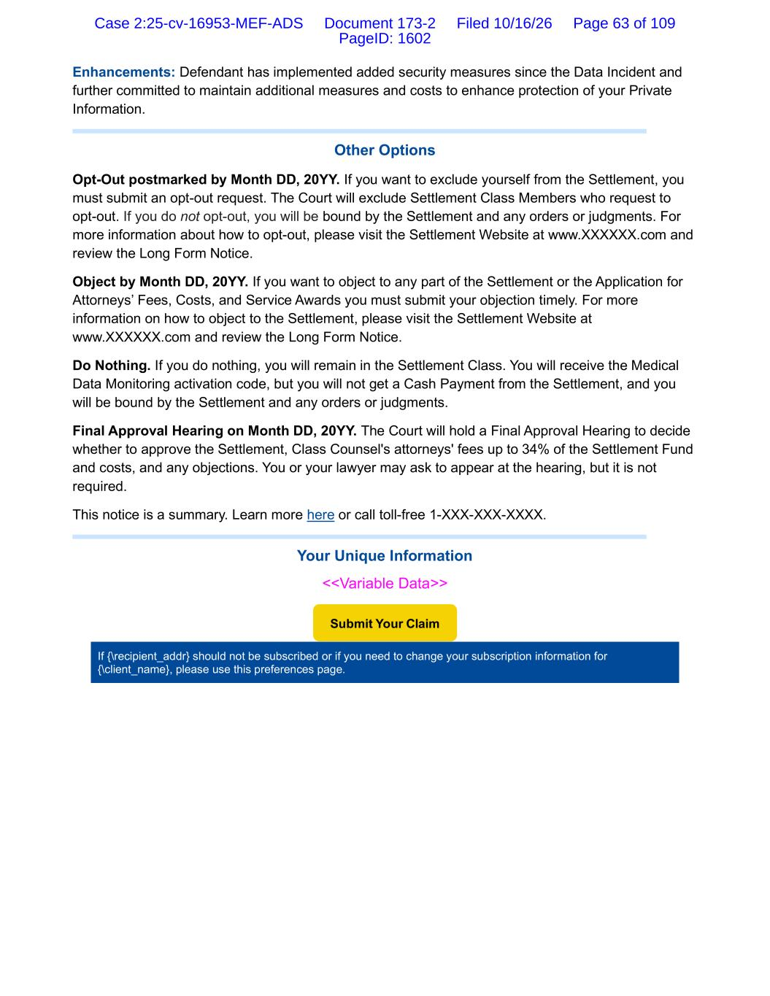
Enhancements: Defendant has implemented added security measures since the Data Incident and further committed to maintain additional measures and costs to enhance protection of your Private Information. Other Options Opt-Out postmarked by Month DD, 20YY. If you want to exclude yourself from the Settlement, you must submit an opt-out request. The Court will exclude Settlement Class Members who request to opt-out. If you do not opt-out, you will be bound by the Settlement and any orders or judgments. For more information about how to opt-out, please visit the Settlement Website at www.XXXXXX.com and review the Long Form Notice. Object by Month DD, 20YY. If you want to object to any part of the Settlement or the Application for Attorneys’ Fees, Costs, and Service Awards you must submit your objection timely. For more information on how to object to the Settlement, please visit the Settlement Website at www.XXXXXX.com and review the Long Form Notice. Do Nothing. If you do nothing, you will remain in the Settlement Class. You will receive the Medical Data Monitoring activation code, but you will not get a Cash Payment from the Settlement, and you will be bound by the Settlement and any orders or judgments. Final Approval Hearing on Month DD, 20YY. The Court will hold a Final Approval Hearing to decide whether to approve the Settlement, Class Counsel's attorneys' fees up to 34% of the Settlement Fund and costs, and any objections. You or your lawyer may ask to appear at the hearing, but it is not required. This notice is a summary. Learn more here or call toll-free 1-XXX-XXX-XXXX. Your Unique Information <<Variable Data>> If {\recipient_addr} should not be subscribed or if you need to change your subscription information for {\client_name}, please use this preferences page. Submit Your Claim Case 2:25-cv-16953-MEF-ADS Document 173-2 Filed 10/16/26 Page 63 of 109 PageID: 1602


EXHIBIT 3 (LONG FORM NOTICE) Case 2:25-cv-16953-MEF-ADS Document 173-2 Filed 10/16/26 Page 64 of 109 PageID: 1603

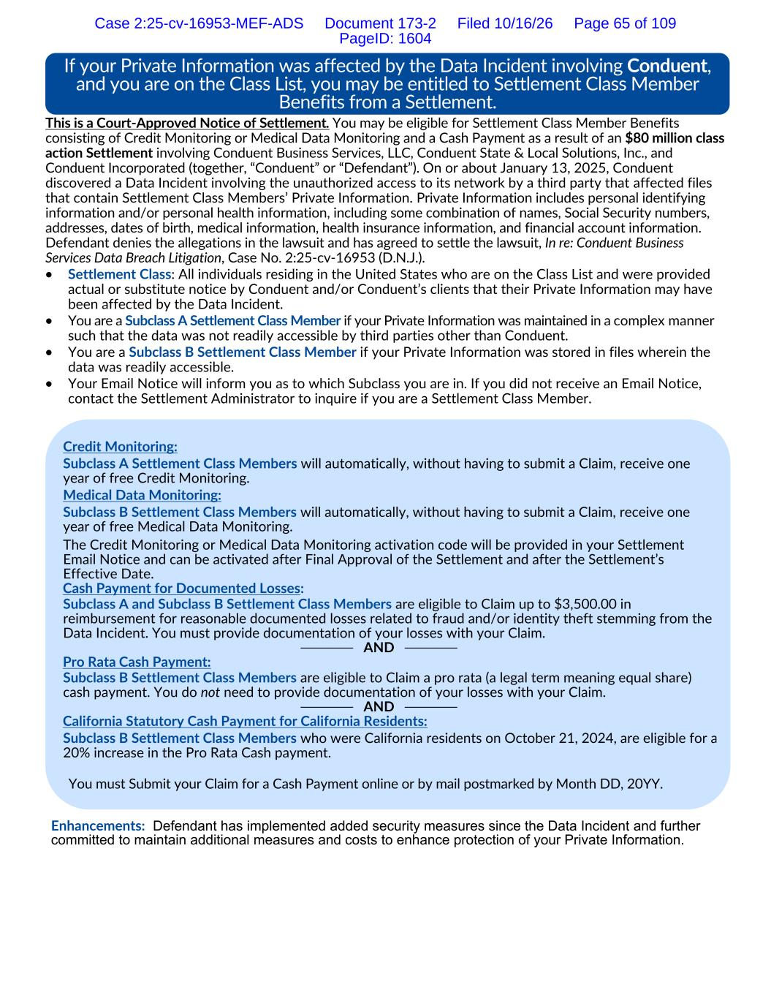
This is a Court-Approved Notice of Settlement. You may be eligible for Settlement Class Member Benefits consisting of Credit Monitoring or Medical Data Monitoring and a Cash Payment as a result of an $80 million class action Settlement involving Conduent Business Services, LLC, Conduent State & Local Solutions, Inc., and Conduent Incorporated (together, “Conduent” or “Defendant”). On or about January 13, 2025, Conduent discovered a Data Incident involving the unauthorized access to its network by a third party that affected files that contain Settlement Class Members’ Private Information. Private Information includes personal identifying information and/or personal health information, including some combination of names, Social Security numbers, addresses, dates of birth, medical information, health insurance information, and financial account information. Defendant denies the allegations in the lawsuit and has agreed to settle the lawsuit, In re: Conduent Business Services Data Breach Litigation, Case No. 2:25-cv-16953 (D.N.J.). • Settlement Class: All individuals residing in the United States who are on the Class List and were provided actual or substitute notice by Conduent and/or Conduent’s clients that their Private Information may have been affected by the Data Incident. • You are a Subclass A Settlement Class Member if your Private Information was maintained in a complex manner such that the data was not readily accessible by third parties other than Conduent. • You are a Subclass B Settlement Class Member if your Private Information was stored in files wherein the data was readily accessible. • Your Email Notice will inform you as to which Subclass you are in. If you did not receive an Email Notice, contact the Settlement Administrator to inquire if you are a Settlement Class Member. Enhancements: Defendant has implemented added security measures since the Data Incident and further committed to maintain additional measures and costs to enhance protection of your Private Information. If your Private Information was affected by the Data Incident involving Conduent, and you are on the Class List, you may be entitled to Settlement Class Member Benefits from a Settlement. Credit Monitoring: Subclass A Settlement Class Members will automatically, without having to submit a Claim, receive one year of free Credit Monitoring. Medical Data Monitoring: Subclass B Settlement Class Members will automatically, without having to submit a Claim, receive one year of free Medical Data Monitoring. The Credit Monitoring or Medical Data Monitoring activation code will be provided in your Settlement Email Notice and can be activated after Final Approval of the Settlement and after the Settlement’s Effective Date. Cash Payment for Documented Losses: Subclass A and Subclass B Settlement Class Members are eligible to Claim up to $3,500.00 in reimbursement for reasonable documented losses related to fraud and/or identity theft stemming from the Data Incident. You must provide documentation of your losses with your Claim. ───── AND ───── Pro Rata Cash Payment: Subclass B Settlement Class Members are eligible to Claim a pro rata (a legal term meaning equal share) cash payment. You do not need to provide documentation of your losses with your Claim. ───── AND ───── California Statutory Cash Payment for California Residents: Subclass B Settlement Class Members who were California residents on October 21, 2024, are eligible for a 20% increase in the Pro Rata Cash payment. You must Submit your Claim for a Cash Payment online or by mail postmarked by Month DD, 20YY. Case 2:25-cv-16953-MEF-ADS Document 173-2 Filed 10/16/26 Page 65 of 109 PageID: 1604

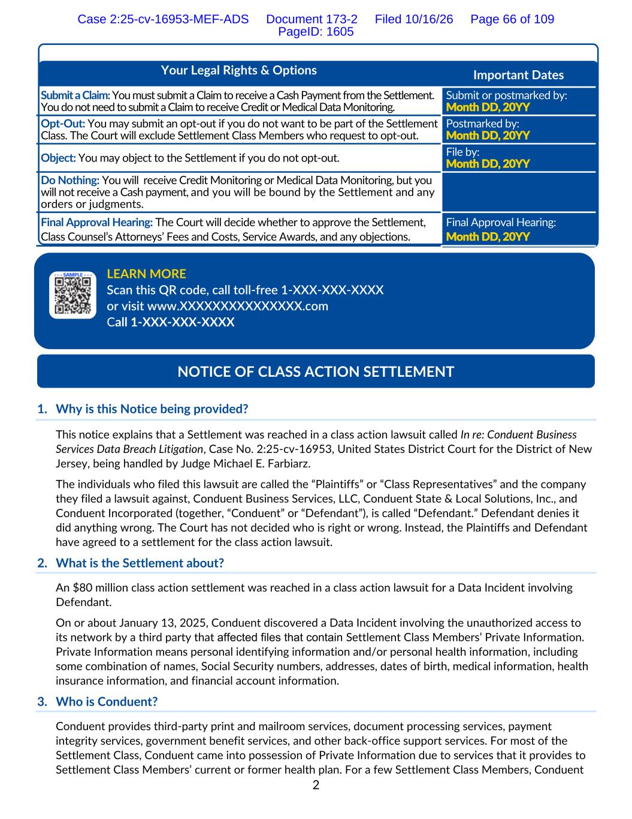
2 Your Legal Rights & Options Important Dates Submit a Claim: You must submit a Claim to receive a Cash Payment from the Settlement. You do not need to submit a Claim to receive Credit or Medical Data Monitoring. Submit or postmarked by: Month DD, 20YY Opt-Out: You may submit an opt-out if you do not want to be part of the Settlement Class. The Court will exclude Settlement Class Members who request to opt-out. Postmarked by: Month DD, 20YY Object: You may object to the Settlement if you do not opt-out. File by: Month DD, 20YY Do Nothing: You will receive Credit Monitoring or Medical Data Monitoring, but you will not receive a Cash payment, and you will be bound by the Settlement and any orders or judgments. Final Approval Hearing: The Court will decide whether to approve the Settlement, Class Counsel’s Attorneys’ Fees and Costs, Service Awards, and any objections. Final Approval Hearing: Month DD, 20YY 1. Why is this Notice being provided? This notice explains that a Settlement was reached in a class action lawsuit called In re: Conduent Business Services Data Breach Litigation, Case No. 2:25-cv-16953, United States District Court for the District of New Jersey, being handled by Judge Michael E. Farbiarz. The individuals who filed this lawsuit are called the “Plaintiffs” or “Class Representatives” and the company they filed a lawsuit against, Conduent Business Services, LLC, Conduent State & Local Solutions, Inc., and Conduent Incorporated (together, “Conduent” or “Defendant”), is called “Defendant.” Defendant denies it did anything wrong. The Court has not decided who is right or wrong. Instead, the Plaintiffs and Defendant have agreed to a settlement for the class action lawsuit. 2. What is the Settlement about? An $80 million class action settlement was reached in a class action lawsuit for a Data Incident involving Defendant. On or about January 13, 2025, Conduent discovered a Data Incident involving the unauthorized access to its network by a third party that affected files that contain Settlement Class Members’ Private Information. Private Information means personal identifying information and/or personal health information, including some combination of names, Social Security numbers, addresses, dates of birth, medical information, health insurance information, and financial account information. 3. Who is Conduent? Conduent provides third-party print and mailroom services, document processing services, payment integrity services, government benefit services, and other back-office support services. For most of the Settlement Class, Conduent came into possession of Private Information due to services that it provides to Settlement Class Members’ current or former health plan. For a few Settlement Class Members, Conduent LEARN MORE Scan this QR code, call toll-free 1-XXX-XXX-XXXX or visit www.XXXXXXXXXXXXXXX.com Call 1-XXX-XXX-XXXX NOTICE OF CLASS ACTION SETTLEMENT Case 2:25-cv-16953-MEF-ADS Document 173-2 Filed 10/16/26 Page 66 of 109 PageID: 1605

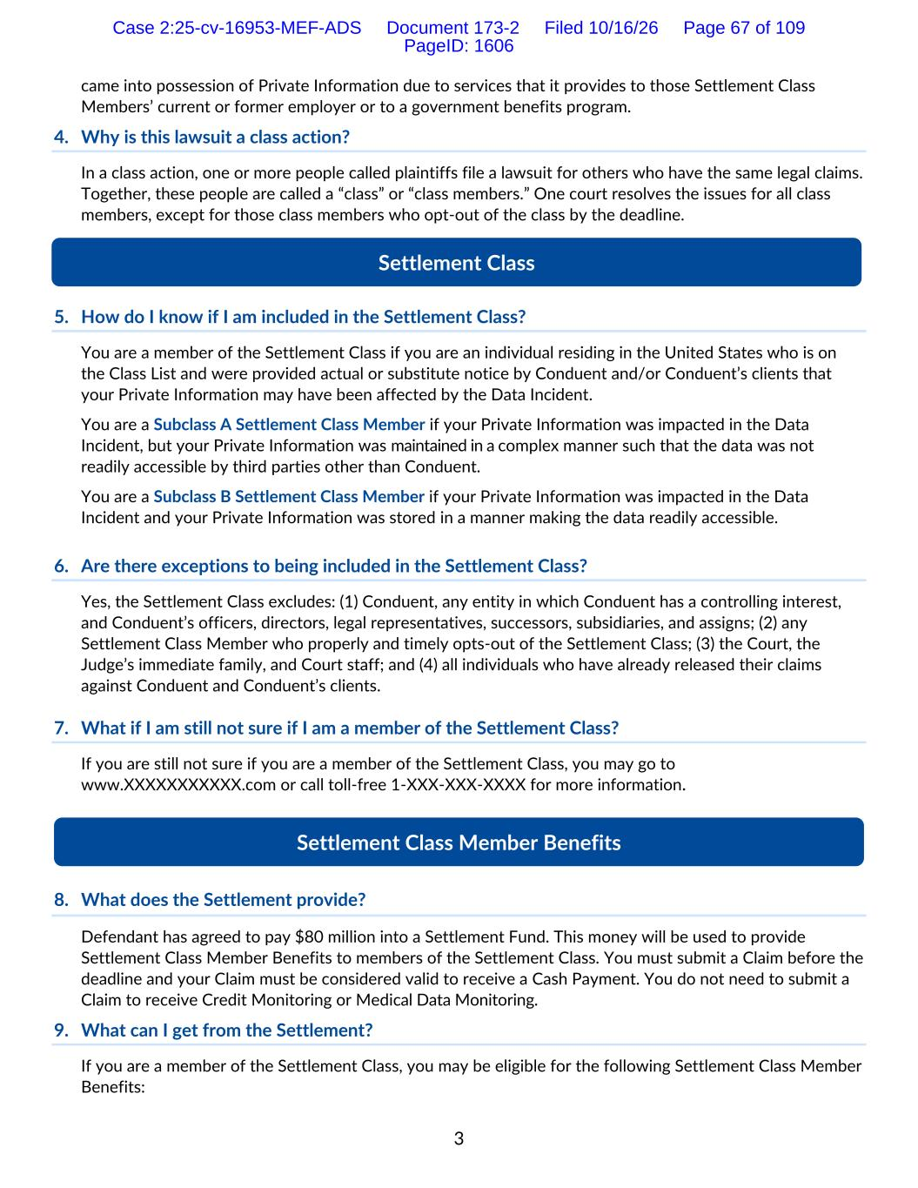
3 came into possession of Private Information due to services that it provides to those Settlement Class Members’ current or former employer or to a government benefits program. 4. Why is this lawsuit a class action? In a class action, one or more people called plaintiffs file a lawsuit for others who have the same legal claims. Together, these people are called a “class” or “class members.” One court resolves the issues for all class members, except for those class members who opt-out of the class by the deadline. 5. How do I know if I am included in the Settlement Class? You are a member of the Settlement Class if you are an individual residing in the United States who is on the Class List and were provided actual or substitute notice by Conduent and/or Conduent’s clients that your Private Information may have been affected by the Data Incident. You are a Subclass A Settlement Class Member if your Private Information was impacted in the Data Incident, but your Private Information was maintained in a complex manner such that the data was not readily accessible by third parties other than Conduent. You are a Subclass B Settlement Class Member if your Private Information was impacted in the Data Incident and your Private Information was stored in a manner making the data readily accessible. 6. Are there exceptions to being included in the Settlement Class? Yes, the Settlement Class excludes: (1) Conduent, any entity in which Conduent has a controlling interest, and Conduent’s officers, directors, legal representatives, successors, subsidiaries, and assigns; (2) any Settlement Class Member who properly and timely opts-out of the Settlement Class; (3) the Court, the Judge’s immediate family, and Court staff; and (4) all individuals who have already released their claims against Conduent and Conduent’s clients. 7. What if I am still not sure if I am a member of the Settlement Class? If you are still not sure if you are a member of the Settlement Class, you may go to www.XXXXXXXXXXX.com or call toll-free 1-XXX-XXX-XXXX for more information. 8. What does the Settlement provide? Defendant has agreed to pay $80 million into a Settlement Fund. This money will be used to provide Settlement Class Member Benefits to members of the Settlement Class. You must submit a Claim before the deadline and your Claim must be considered valid to receive a Cash Payment. You do not need to submit a Claim to receive Credit Monitoring or Medical Data Monitoring. 9. What can I get from the Settlement? If you are a member of the Settlement Class, you may be eligible for the following Settlement Class Member Benefits: Settlement Class Settlement Class Member Benefits Case 2:25-cv-16953-MEF-ADS Document 173-2 Filed 10/16/26 Page 67 of 109 PageID: 1606

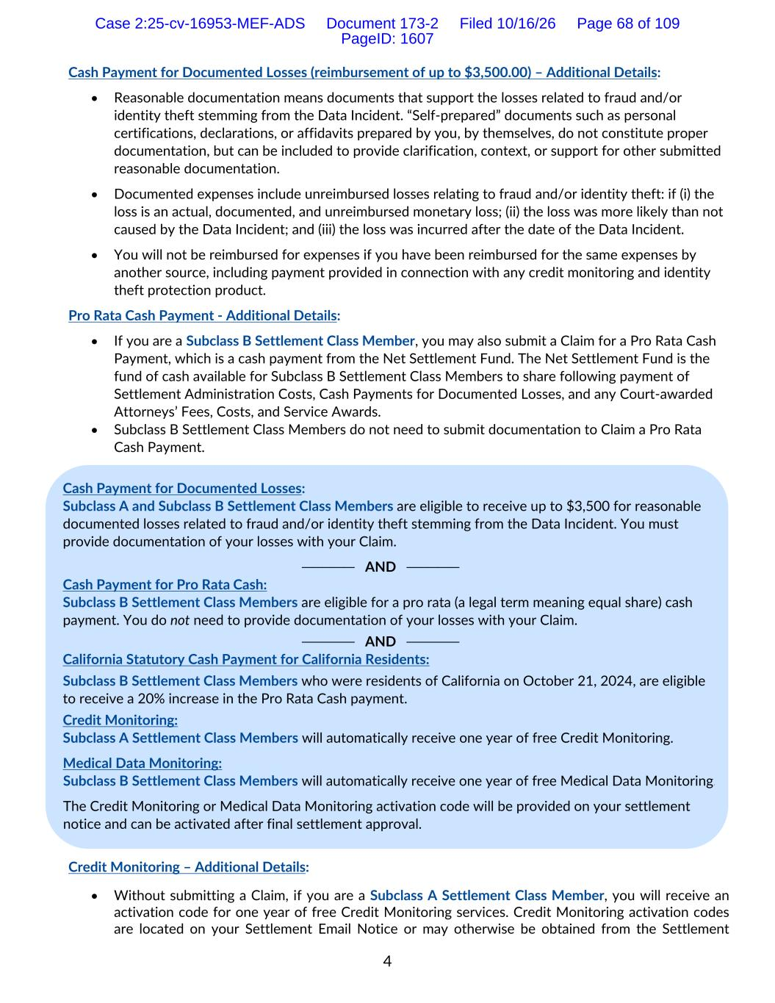
4 Cash Payment for Documented Losses (reimbursement of up to $3,500.00) – Additional Details: • Reasonable documentation means documents that support the losses related to fraud and/or identity theft stemming from the Data Incident. “Self-prepared” documents such as personal certifications, declarations, or affidavits prepared by you, by themselves, do not constitute proper documentation, but can be included to provide clarification, context, or support for other submitted reasonable documentation. • Documented expenses include unreimbursed losses relating to fraud and/or identity theft: if (i) the loss is an actual, documented, and unreimbursed monetary loss; (ii) the loss was more likely than not caused by the Data Incident; and (iii) the loss was incurred after the date of the Data Incident. • You will not be reimbursed for expenses if you have been reimbursed for the same expenses by another source, including payment provided in connection with any credit monitoring and identity theft protection product. Pro Rata Cash Payment - Additional Details: • If you are a Subclass B Settlement Class Member, you may also submit a Claim for a Pro Rata Cash Payment, which is a cash payment from the Net Settlement Fund. The Net Settlement Fund is the fund of cash available for Subclass B Settlement Class Members to share following payment of Settlement Administration Costs, Cash Payments for Documented Losses, and any Court-awarded Attorneys’ Fees, Costs, and Service Awards. • Subclass B Settlement Class Members do not need to submit documentation to Claim a Pro Rata Cash Payment. Credit Monitoring – Additional Details: • Without submitting a Claim, if you are a Subclass A Settlement Class Member, you will receive an activation code for one year of free Credit Monitoring services. Credit Monitoring activation codes are located on your Settlement Email Notice or may otherwise be obtained from the Settlement Cash Payment for Documented Losses: Subclass A and Subclass B Settlement Class Members are eligible to receive up to $3,500 for reasonable documented losses related to fraud and/or identity theft stemming from the Data Incident. You must provide documentation of your losses with your Claim. ───── AND ───── Cash Payment for Pro Rata Cash: Subclass B Settlement Class Members are eligible for a pro rata (a legal term meaning equal share) cash payment. You do not need to provide documentation of your losses with your Claim. ───── AND ───── California Statutory Cash Payment for California Residents: Subclass B Settlement Class Members who were residents of California on October 21, 2024, are eligible to receive a 20% increase in the Pro Rata Cash payment. Credit Monitoring: Subclass A Settlement Class Members will automatically receive one year of free Credit Monitoring. Medical Data Monitoring: Subclass B Settlement Class Members will automatically receive one year of free Medical Data Monitoring. The Credit Monitoring or Medical Data Monitoring activation code will be provided on your settlement notice and can be activated after final settlement approval. Case 2:25-cv-16953-MEF-ADS Document 173-2 Filed 10/16/26 Page 68 of 109 PageID: 1607

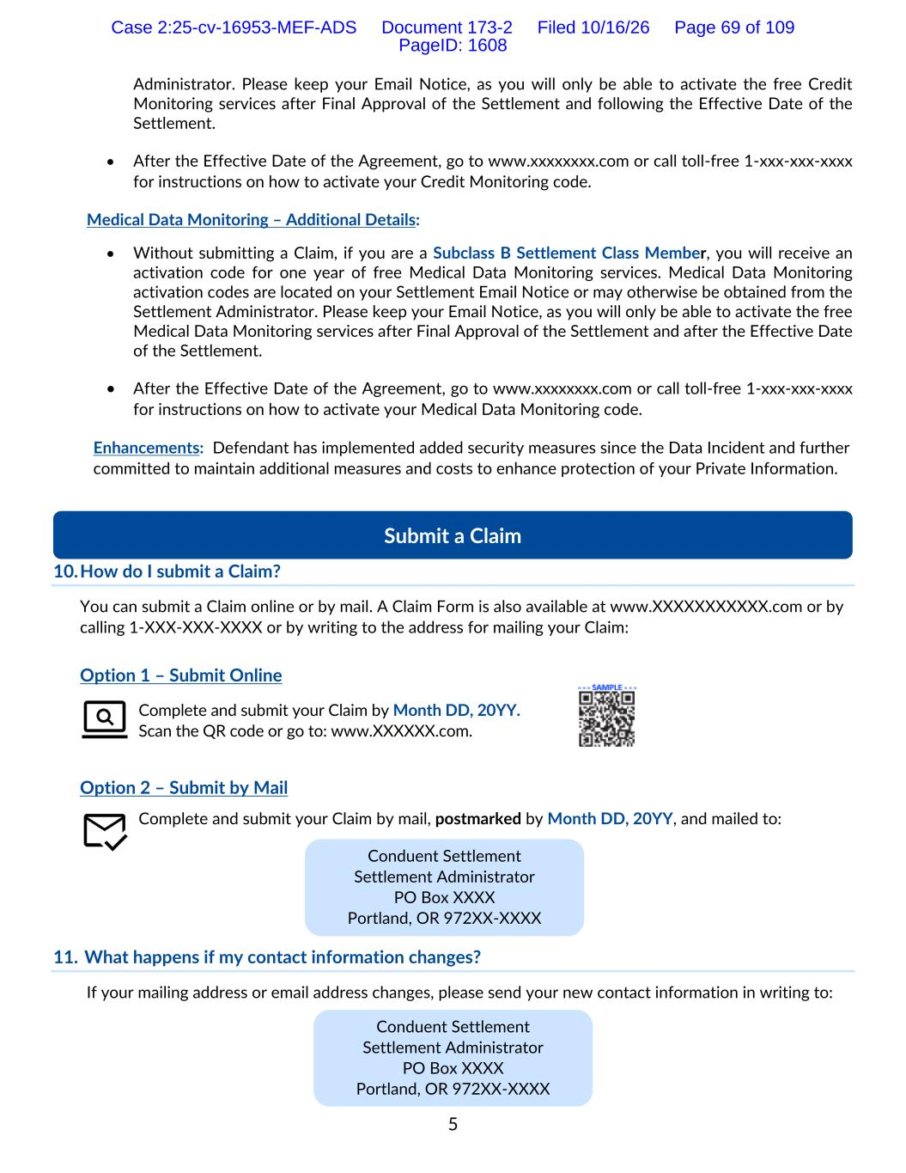
5 Administrator. Please keep your Email Notice, as you will only be able to activate the free Credit Monitoring services after Final Approval of the Settlement and following the Effective Date of the Settlement. • After the Effective Date of the Agreement, go to www.xxxxxxxx.com or call toll-free 1-xxx-xxx-xxxx for instructions on how to activate your Credit Monitoring code. Medical Data Monitoring – Additional Details: • Without submitting a Claim, if you are a Subclass B Settlement Class Member, you will receive an activation code for one year of free Medical Data Monitoring services. Medical Data Monitoring activation codes are located on your Settlement Email Notice or may otherwise be obtained from the Settlement Administrator. Please keep your Email Notice, as you will only be able to activate the free Medical Data Monitoring services after Final Approval of the Settlement and after the Effective Date of the Settlement. • After the Effective Date of the Agreement, go to www.xxxxxxxx.com or call toll-free 1-xxx-xxx-xxxx for instructions on how to activate your Medical Data Monitoring code. Enhancements: Defendant has implemented added security measures since the Data Incident and further committed to maintain additional measures and costs to enhance protection of your Private Information. 10. How do I submit a Claim? You can submit a Claim online or by mail. A Claim Form is also available at www.XXXXXXXXXXX.com or by calling 1-XXX-XXX-XXXX or by writing to the address for mailing your Claim: Option 1 – Submit Online Complete and submit your Claim by Month DD, 20YY. Scan the QR code or go to: www.XXXXXX.com. Option 2 – Submit by Mail Complete and submit your Claim by mail, postmarked by Month DD, 20YY, and mailed to: 11. What happens if my contact information changes? If your mailing address or email address changes, please send your new contact information in writing to: Submit a Claim Conduent Settlement Settlement Administrator PO Box XXXX Portland, OR 972XX-XXXX Conduent Settlement Settlement Administrator PO Box XXXX Portland, OR 972XX-XXXX Case 2:25-cv-16953-MEF-ADS Document 173-2 Filed 10/16/26 Page 69 of 109 PageID: 1608

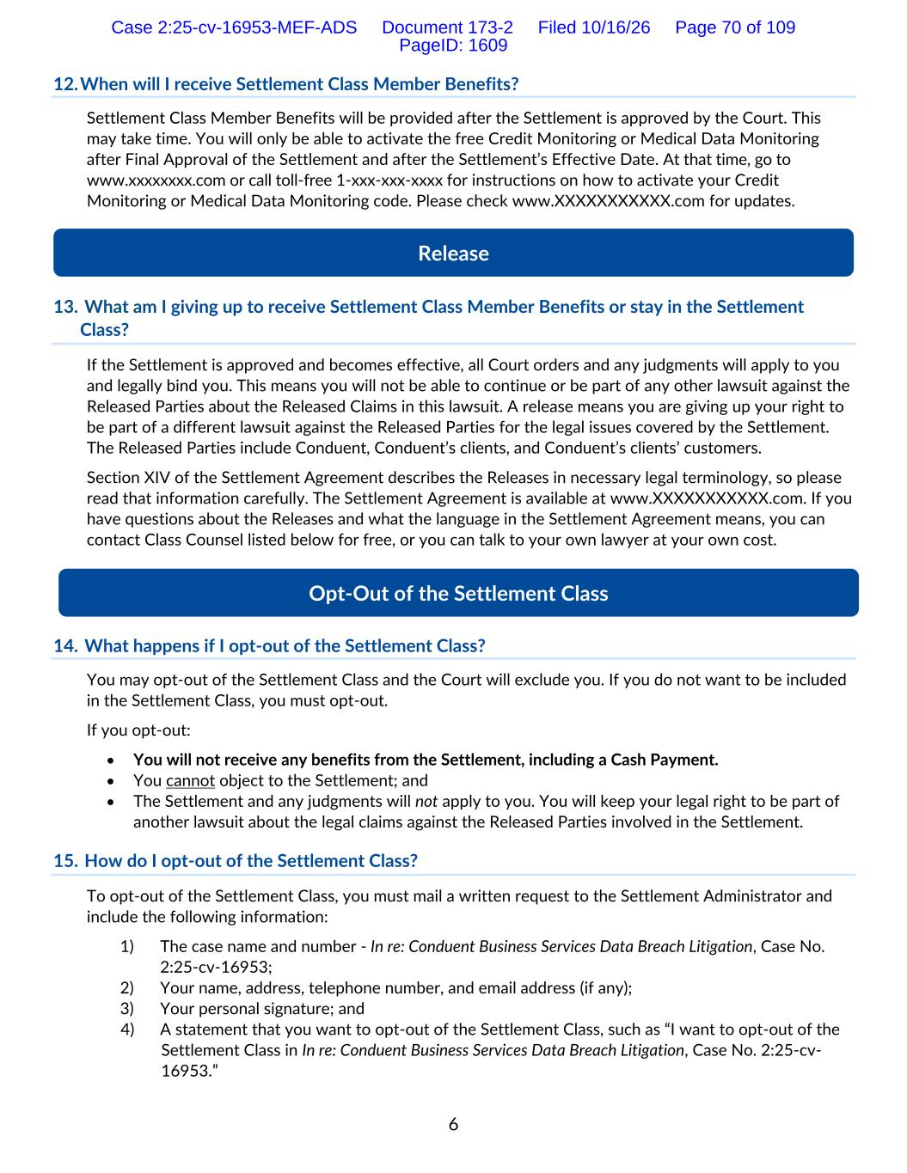
6 12. When will I receive Settlement Class Member Benefits? Settlement Class Member Benefits will be provided after the Settlement is approved by the Court. This may take time. You will only be able to activate the free Credit Monitoring or Medical Data Monitoring after Final Approval of the Settlement and after the Settlement’s Effective Date. At that time, go to www.xxxxxxxx.com or call toll-free 1-xxx-xxx-xxxx for instructions on how to activate your Credit Monitoring or Medical Data Monitoring code. Please check www.XXXXXXXXXXX.com for updates. 13. What am I giving up to receive Settlement Class Member Benefits or stay in the Settlement Class? If the Settlement is approved and becomes effective, all Court orders and any judgments will apply to you and legally bind you. This means you will not be able to continue or be part of any other lawsuit against the Released Parties about the Released Claims in this lawsuit. A release means you are giving up your right to be part of a different lawsuit against the Released Parties for the legal issues covered by the Settlement. The Released Parties include Conduent, Conduent’s clients, and Conduent’s clients’ customers. Section XIV of the Settlement Agreement describes the Releases in necessary legal terminology, so please read that information carefully. The Settlement Agreement is available at www.XXXXXXXXXXX.com. If you have questions about the Releases and what the language in the Settlement Agreement means, you can contact Class Counsel listed below for free, or you can talk to your own lawyer at your own cost. 14. What happens if I opt-out of the Settlement Class? You may opt-out of the Settlement Class and the Court will exclude you. If you do not want to be included in the Settlement Class, you must opt-out. If you opt-out: • You will not receive any benefits from the Settlement, including a Cash Payment. • You cannot object to the Settlement; and • The Settlement and any judgments will not apply to you. You will keep your legal right to be part of another lawsuit about the legal claims against the Released Parties involved in the Settlement. 15. How do I opt-out of the Settlement Class? To opt-out of the Settlement Class, you must mail a written request to the Settlement Administrator and include the following information: 1) The case name and number - In re: Conduent Business Services Data Breach Litigation, Case No. 2:25-cv-16953; 2) Your name, address, telephone number, and email address (if any); 3) Your personal signature; and 4) A statement that you want to opt-out of the Settlement Class, such as “I want to opt-out of the Settlement Class in In re: Conduent Business Services Data Breach Litigation, Case No. 2:25-cv- 16953.” Opt-Out of the Settlement Class Release Case 2:25-cv-16953-MEF-ADS Document 173-2 Filed 10/16/26 Page 70 of 109 PageID: 1609

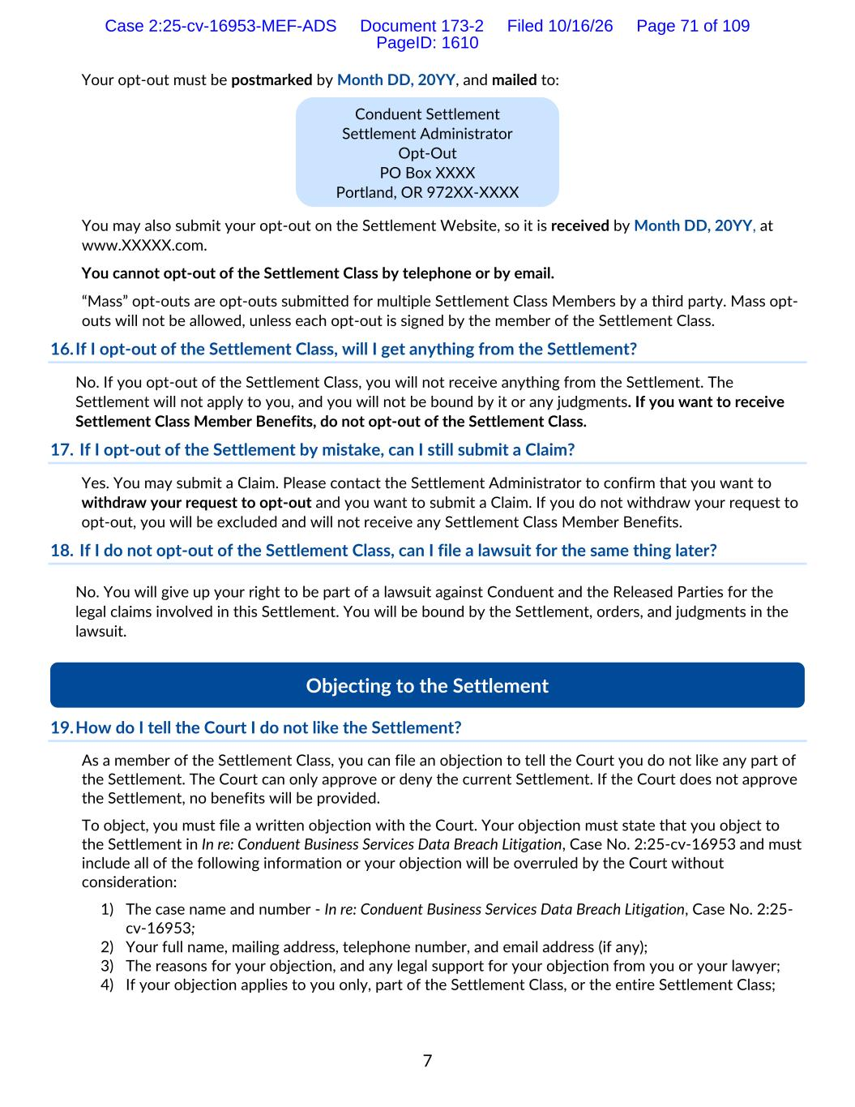
7 Your opt-out must be postmarked by Month DD, 20YY, and mailed to: You may also submit your opt-out on the Settlement Website, so it is received by Month DD, 20YY, at www.XXXXX.com. You cannot opt-out of the Settlement Class by telephone or by email. “Mass” opt-outs are opt-outs submitted for multiple Settlement Class Members by a third party. Mass opt- outs will not be allowed, unless each opt-out is signed by the member of the Settlement Class. 16. If I opt-out of the Settlement Class, will I get anything from the Settlement? No. If you opt-out of the Settlement Class, you will not receive anything from the Settlement. The Settlement will not apply to you, and you will not be bound by it or any judgments. If you want to receive Settlement Class Member Benefits, do not opt-out of the Settlement Class. 17. If I opt-out of the Settlement by mistake, can I still submit a Claim? Yes. You may submit a Claim. Please contact the Settlement Administrator to confirm that you want to withdraw your request to opt-out and you want to submit a Claim. If you do not withdraw your request to opt-out, you will be excluded and will not receive any Settlement Class Member Benefits. 18. If I do not opt-out of the Settlement Class, can I file a lawsuit for the same thing later? No. You will give up your right to be part of a lawsuit against Conduent and the Released Parties for the legal claims involved in this Settlement. You will be bound by the Settlement, orders, and judgments in the lawsuit. 19. How do I tell the Court I do not like the Settlement? As a member of the Settlement Class, you can file an objection to tell the Court you do not like any part of the Settlement. The Court can only approve or deny the current Settlement. If the Court does not approve the Settlement, no benefits will be provided. To object, you must file a written objection with the Court. Your objection must state that you object to the Settlement in In re: Conduent Business Services Data Breach Litigation, Case No. 2:25-cv-16953 and must include all of the following information or your objection will be overruled by the Court without consideration: 1) The case name and number - In re: Conduent Business Services Data Breach Litigation, Case No. 2:25- cv-16953; 2) Your full name, mailing address, telephone number, and email address (if any); 3) The reasons for your objection, and any legal support for your objection from you or your lawyer; 4) If your objection applies to you only, part of the Settlement Class, or the entire Settlement Class; Conduent Settlement Settlement Administrator Opt-Out PO Box XXXX Portland, OR 972XX-XXXX Objecting to the Settlement Case 2:25-cv-16953-MEF-ADS Document 173-2 Filed 10/16/26 Page 71 of 109 PageID: 1610

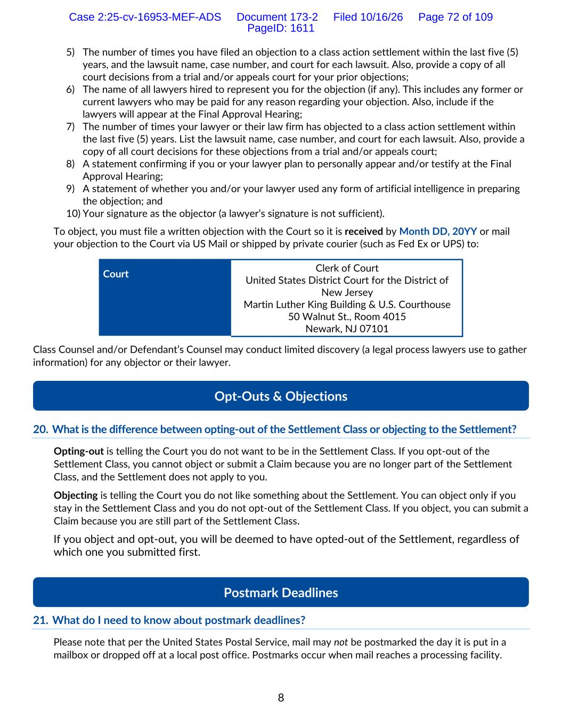
8 5) The number of times you have filed an objection to a class action settlement within the last five (5) years, and the lawsuit name, case number, and court for each lawsuit. Also, provide a copy of all court decisions from a trial and/or appeals court for your prior objections; 6) The name of all lawyers hired to represent you for the objection (if any). This includes any former or current lawyers who may be paid for any reason regarding your objection. Also, include if the lawyers will appear at the Final Approval Hearing; 7) The number of times your lawyer or their law firm has objected to a class action settlement within the last five (5) years. List the lawsuit name, case number, and court for each lawsuit. Also, provide a copy of all court decisions for these objections from a trial and/or appeals court; 8) A statement confirming if you or your lawyer plan to personally appear and/or testify at the Final Approval Hearing; 9) A statement of whether you and/or your lawyer used any form of artificial intelligence in preparing the objection; and 10) Your signature as the objector (a lawyer’s signature is not sufficient). To object, you must file a written objection with the Court so it is received by Month DD, 20YY or mail your objection to the Court via US Mail or shipped by private courier (such as Fed Ex or UPS) to: Court Clerk of Court United States District Court for the District of New Jersey Martin Luther King Building & U.S. Courthouse 50 Walnut St., Room 4015 Newark, NJ 07101 Class Counsel and/or Defendant’s Counsel may conduct limited discovery (a legal process lawyers use to gather information) for any objector or their lawyer. 20. What is the difference between opting-out of the Settlement Class or objecting to the Settlement? Opting-out is telling the Court you do not want to be in the Settlement Class. If you opt-out of the Settlement Class, you cannot object or submit a Claim because you are no longer part of the Settlement Class, and the Settlement does not apply to you. Objecting is telling the Court you do not like something about the Settlement. You can object only if you stay in the Settlement Class and you do not opt-out of the Settlement Class. If you object, you can submit a Claim because you are still part of the Settlement Class. If you object and opt-out, you will be deemed to have opted-out of the Settlement, regardless of which one you submitted first. 21. What do I need to know about postmark deadlines? Please note that per the United States Postal Service, mail may not be postmarked the day it is put in a mailbox or dropped off at a local post office. Postmarks occur when mail reaches a processing facility. Postmark Deadlines Opt-Outs & Objections Case 2:25-cv-16953-MEF-ADS Document 173-2 Filed 10/16/26 Page 72 of 109 PageID: 1611

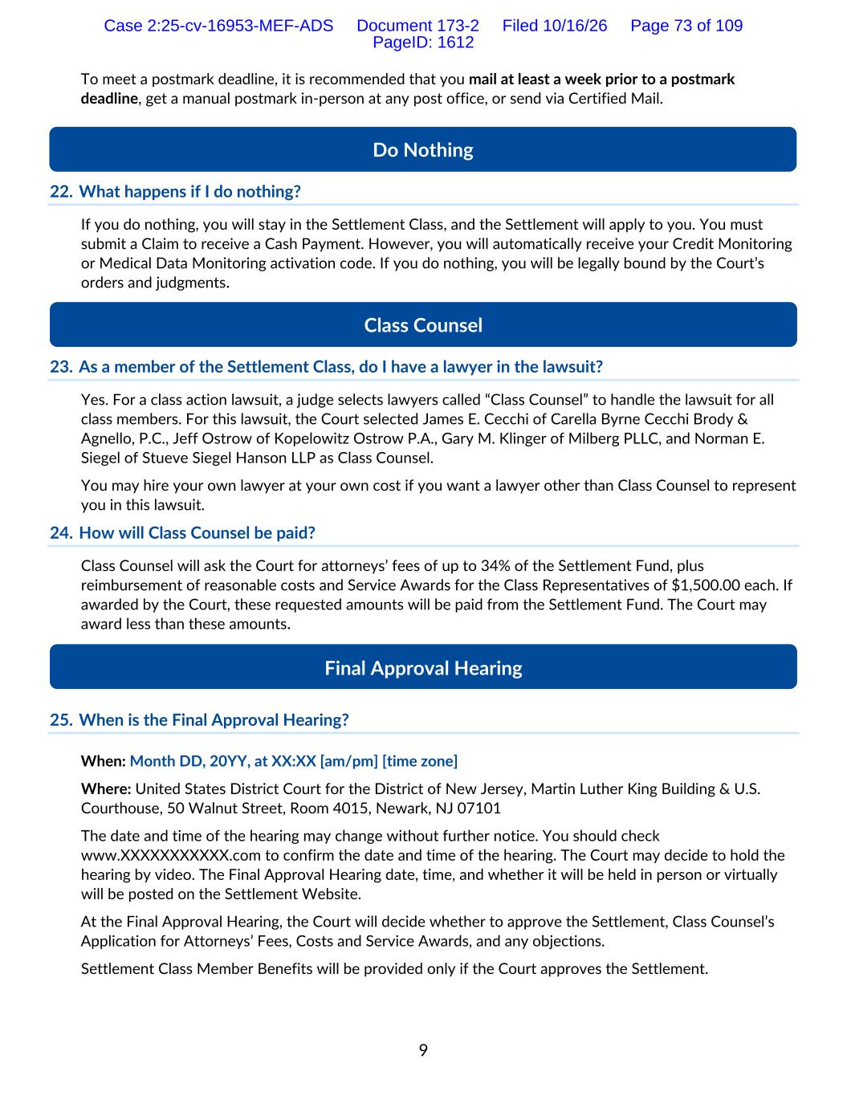
9 To meet a postmark deadline, it is recommended that you mail at least a week prior to a postmark deadline, get a manual postmark in-person at any post office, or send via Certified Mail. 22. What happens if I do nothing? If you do nothing, you will stay in the Settlement Class, and the Settlement will apply to you. You must submit a Claim to receive a Cash Payment. However, you will automatically receive your Credit Monitoring or Medical Data Monitoring activation code. If you do nothing, you will be legally bound by the Court’s orders and judgments. 23. As a member of the Settlement Class, do I have a lawyer in the lawsuit? Yes. For a class action lawsuit, a judge selects lawyers called “Class Counsel” to handle the lawsuit for all class members. For this lawsuit, the Court selected James E. Cecchi of Carella Byrne Cecchi Brody & Agnello, P.C., Jeff Ostrow of Kopelowitz Ostrow P.A., Gary M. Klinger of Milberg PLLC, and Norman E. Siegel of Stueve Siegel Hanson LLP as Class Counsel. You may hire your own lawyer at your own cost if you want a lawyer other than Class Counsel to represent you in this lawsuit. 24. How will Class Counsel be paid? Class Counsel will ask the Court for attorneys’ fees of up to 34% of the Settlement Fund, plus reimbursement of reasonable costs and Service Awards for the Class Representatives of $1,500.00 each. If awarded by the Court, these requested amounts will be paid from the Settlement Fund. The Court may award less than these amounts. 25. When is the Final Approval Hearing? When: Month DD, 20YY, at XX:XX [am/pm] [time zone] Where: United States District Court for the District of New Jersey, Martin Luther King Building & U.S. Courthouse, 50 Walnut Street, Room 4015, Newark, NJ 07101 The date and time of the hearing may change without further notice. You should check www.XXXXXXXXXXX.com to confirm the date and time of the hearing. The Court may decide to hold the hearing by video. The Final Approval Hearing date, time, and whether it will be held in person or virtually will be posted on the Settlement Website. At the Final Approval Hearing, the Court will decide whether to approve the Settlement, Class Counsel’s Application for Attorneys’ Fees, Costs and Service Awards, and any objections. Settlement Class Member Benefits will be provided only if the Court approves the Settlement. Final Approval Hearing Class Counsel Do Nothing Case 2:25-cv-16953-MEF-ADS Document 173-2 Filed 10/16/26 Page 73 of 109 PageID: 1612

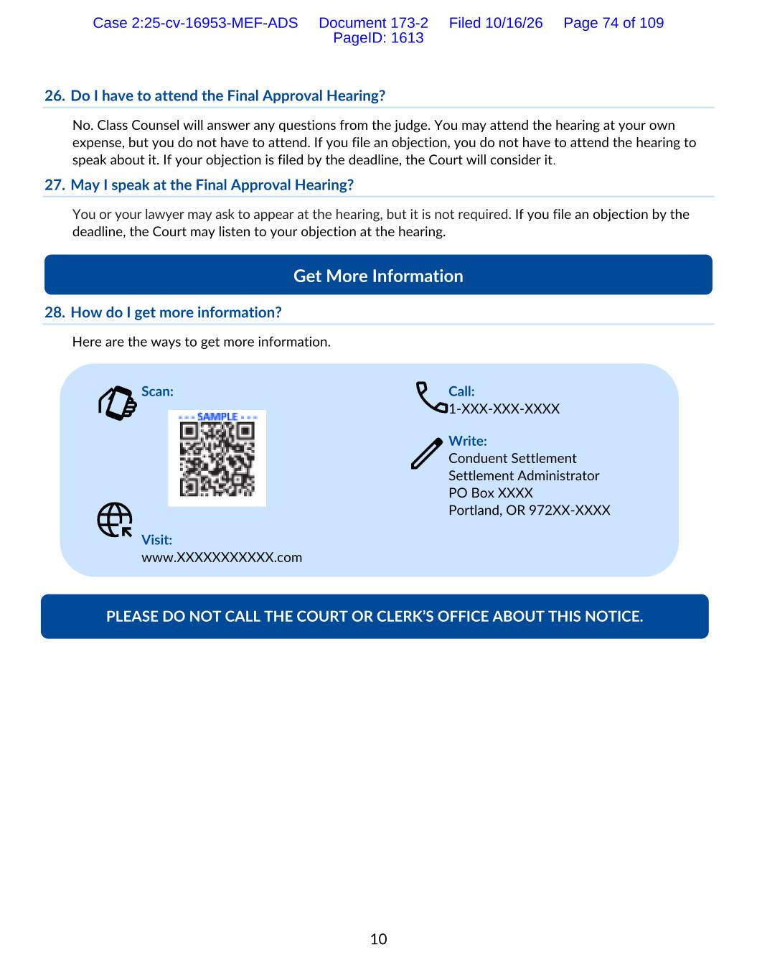
10 26. Do I have to attend the Final Approval Hearing? No. Class Counsel will answer any questions from the judge. You may attend the hearing at your own expense, but you do not have to attend. If you file an objection, you do not have to attend the hearing to speak about it. If your objection is filed by the deadline, the Court will consider it. 27. May I speak at the Final Approval Hearing? You or your lawyer may ask to appear at the hearing, but it is not required. If you file an objection by the deadline, the Court may listen to your objection at the hearing. 28. How do I get more information? Here are the ways to get more information. Scan: Visit: www.XXXXXXXXXXX.com Call: 1-XXX-XXX-XXXX Write: Conduent Settlement Settlement Administrator PO Box XXXX Portland, OR 972XX-XXXX Get More Information PLEASE DO NOT CALL THE COURT OR CLERK’S OFFICE ABOUT THIS NOTICE. Case 2:25-cv-16953-MEF-ADS Document 173-2 Filed 10/16/26 Page 74 of 109 PageID: 1613

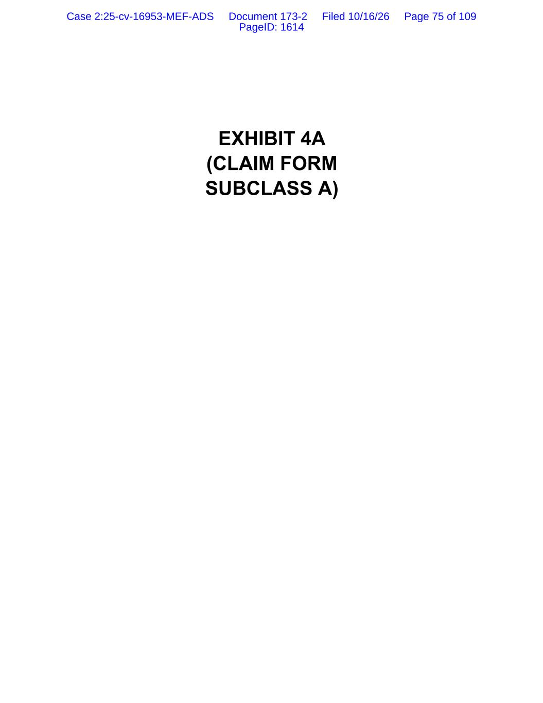
EXHIBIT 4A (CLAIM FORM SUBCLASS A) Case 2:25-cv-16953-MEF-ADS Document 173-2 Filed 10/16/26 Page 75 of 109 PageID: 1614

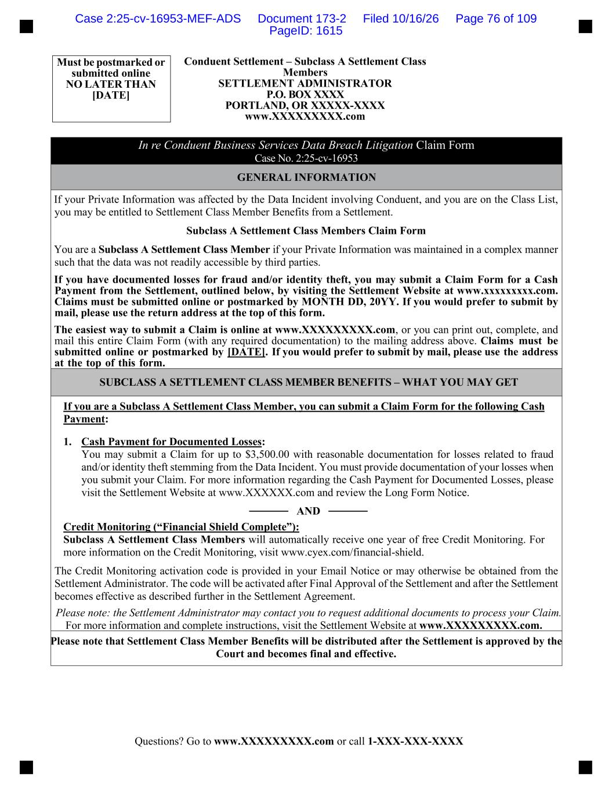
Questions? Go to www.XXXXXXXXX.com or call 1-XXX-XXX-XXXX Must be postmarked or submitted online NO LATER THAN [DATE] Conduent Settlement – Subclass A Settlement Class Members SETTLEMENT ADMINISTRATOR P.O. BOX XXXX PORTLAND, OR XXXXX-XXXX www.XXXXXXXXX.com In re Conduent Business Services Data Breach Litigation Claim Form Case No. 2:25-cv-16953 GENERAL INFORMATION If your Private Information was affected by the Data Incident involving Conduent, and you are on the Class List, you may be entitled to Settlement Class Member Benefits from a Settlement. Subclass A Settlement Class Members Claim Form You are a Subclass A Settlement Class Member if your Private Information was maintained in a complex manner such that the data was not readily accessible by third parties. If you have documented losses for fraud and/or identity theft, you may submit a Claim Form for a Cash Payment from the Settlement, outlined below, by visiting the Settlement Website at www.xxxxxxxxx.com. Claims must be submitted online or postmarked by MONTH DD, 20YY. If you would prefer to submit by mail, please use the return address at the top of this form. The easiest way to submit a Claim is online at www.XXXXXXXXX.com, or you can print out, complete, and mail this entire Claim Form (with any required documentation) to the mailing address above. Claims must be submitted online or postmarked by [DATE]. If you would prefer to submit by mail, please use the address at the top of this form. SUBCLASS A SETTLEMENT CLASS MEMBER BENEFITS – WHAT YOU MAY GET If you are a Subclass A Settlement Class Member, you can submit a Claim Form for the following Cash Payment: 1. Cash Payment for Documented Losses: You may submit a Claim for up to $3,500.00 with reasonable documentation for losses related to fraud and/or identity theft stemming from the Data Incident. You must provide documentation of your losses when you submit your Claim. For more information regarding the Cash Payment for Documented Losses, please visit the Settlement Website at www.XXXXXX.com and review the Long Form Notice. ───── AND ───── Credit Monitoring (“Financial Shield Complete”): Subclass A Settlement Class Members will automatically receive one year of free Credit Monitoring. For more information on the Credit Monitoring, visit www.cyex.com/financial-shield. The Credit Monitoring activation code is provided in your Email Notice or may otherwise be obtained from the Settlement Administrator. The code will be activated after Final Approval of the Settlement and after the Settlement becomes effective as described further in the Settlement Agreement. Please note: the Settlement Administrator may contact you to request additional documents to process your Claim. For more information and complete instructions, visit the Settlement Website at www.XXXXXXXXX.com. Please note that Settlement Class Member Benefits will be distributed after the Settlement is approved by the Court and becomes final and effective. Case 2:25-cv-16953-MEF-ADS Document 173-2 Filed 10/16/26 Page 76 of 109 PageID: 1615

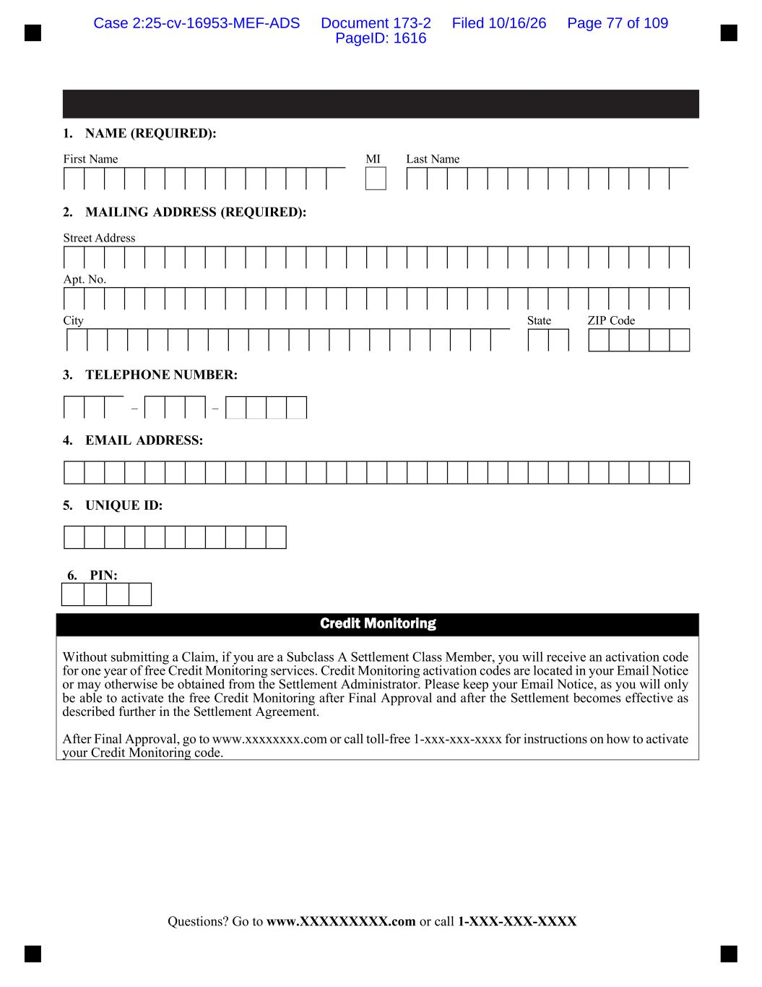
Questions? Go to www.XXXXXXXXX.com or call 1-XXX-XXX-XXXX 1. NAME (REQUIRED): First Name MI Last Name 2. MAILING ADDRESS (REQUIRED): Street Address Apt. No. City State ZIP Code 3. TELEPHONE NUMBER: 4. EMAIL ADDRESS: 5. UNIQUE ID: 6. PIN: Credit Monitoring Without submitting a Claim, if you are a Subclass A Settlement Class Member, you will receive an activation code for one year of free Credit Monitoring services. Credit Monitoring activation codes are located in your Email Notice or may otherwise be obtained from the Settlement Administrator. Please keep your Email Notice, as you will only be able to activate the free Credit Monitoring after Final Approval and after the Settlement becomes effective as described further in the Settlement Agreement. After Final Approval, go to www.xxxxxxxx.com or call toll-free 1-xxx-xxx-xxxx for instructions on how to activate your Credit Monitoring code. – – Case 2:25-cv-16953-MEF-ADS Document 173-2 Filed 10/16/26 Page 77 of 109 PageID: 1616

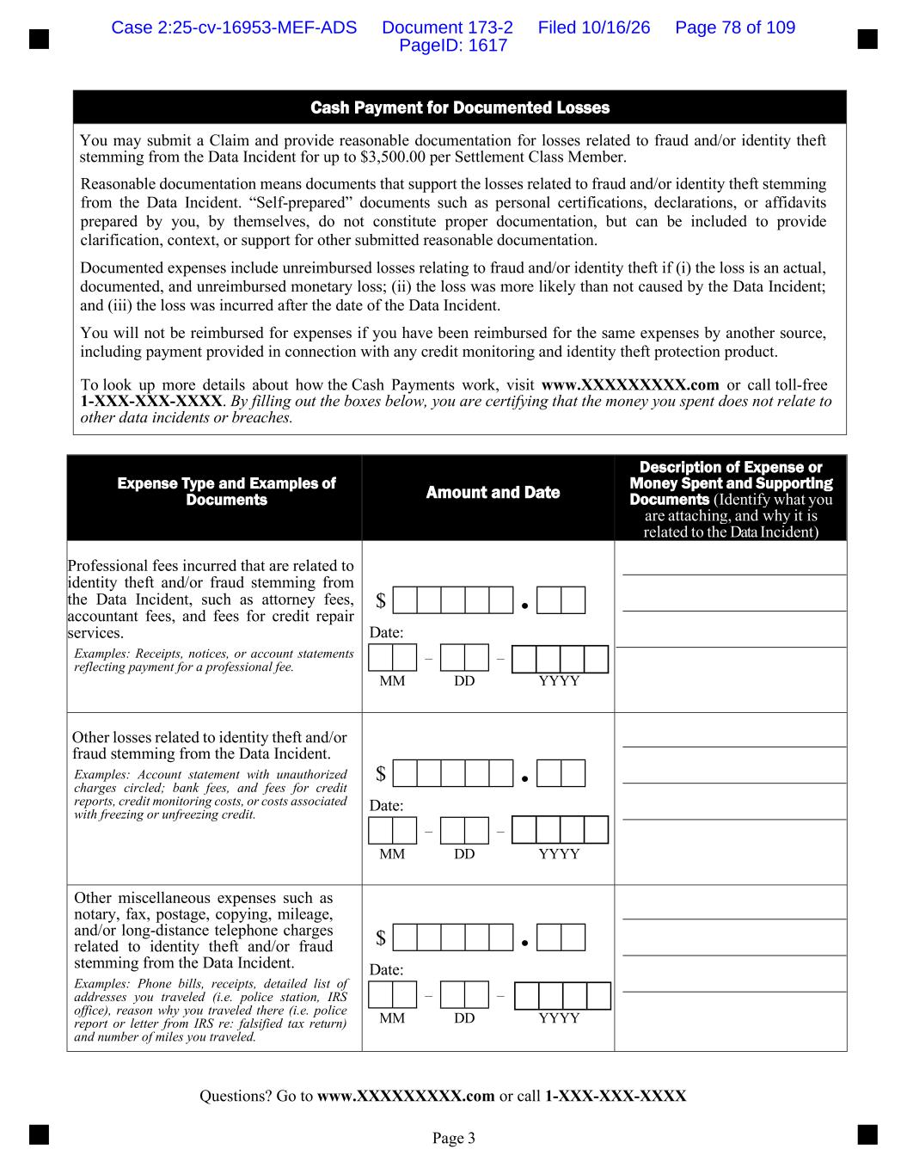
Questions? Go to www.XXXXXXXXX.com or call 1-XXX-XXX-XXXX Page 3 Expense Type and Examples of Documents Amount and Date Description of Expense or Money Spent and Supporting Documents (Identify what you are attaching, and why it is related to the Data Incident) Professional fees incurred that are related to identity theft and/or fraud stemming from the Data Incident, such as attorney fees, accountant fees, and fees for credit repair services. Examples: Receipts, notices, or account statements reflecting payment for a professional fee. $ ● Date: – – MM DD YYYY Other losses related to identity theft and/or fraud stemming from the Data Incident. Examples: Account statement with unauthorized charges circled; bank fees, and fees for credit reports, credit monitoring costs, or costs associated with freezing or unfreezing credit. $ ● Date: – – MM DD YYYY Other miscellaneous expenses such as notary, fax, postage, copying, mileage, and/or long-distance telephone charges related to identity theft and/or fraud stemming from the Data Incident. Examples: Phone bills, receipts, detailed list of addresses you traveled (i.e. police station, IRS office), reason why you traveled there (i.e. police report or letter from IRS re: falsified tax return) and number of miles you traveled. $ ● Date: – – MM DD YYYY Cash Payment for Documented Losses You may submit a Claim and provide reasonable documentation for losses related to fraud and/or identity theft stemming from the Data Incident for up to $3,500.00 per Settlement Class Member. Reasonable documentation means documents that support the losses related to fraud and/or identity theft stemming from the Data Incident. “Self-prepared” documents such as personal certifications, declarations, or affidavits prepared by you, by themselves, do not constitute proper documentation, but can be included to provide clarification, context, or support for other submitted reasonable documentation. Documented expenses include unreimbursed losses relating to fraud and/or identity theft if (i) the loss is an actual, documented, and unreimbursed monetary loss; (ii) the loss was more likely than not caused by the Data Incident; and (iii) the loss was incurred after the date of the Data Incident. You will not be reimbursed for expenses if you have been reimbursed for the same expenses by another source, including payment provided in connection with any credit monitoring and identity theft protection product. To look up more details about how the Cash Payments work, visit www.XXXXXXXXX.com or call toll-free 1-XXX-XXX-XXXX. By filling out the boxes below, you are certifying that the money you spent does not relate to other data incidents or breaches. Case 2:25-cv-16953-MEF-ADS Document 173-2 Filed 10/16/26 Page 78 of 109 PageID: 1617

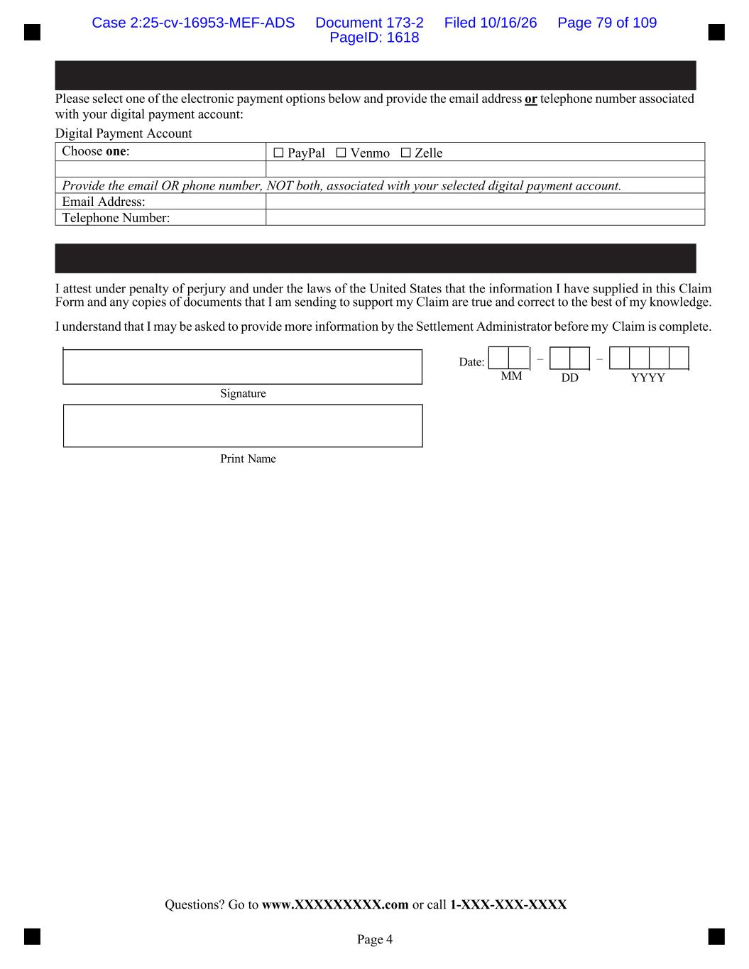
Questions? Go to www.XXXXXXXXX.com or call 1-XXX-XXX-XXXX Page 4 Please select one of the electronic payment options below and provide the email address or telephone number associated with your digital payment account: Digital Payment Account I attest under penalty of perjury and under the laws of the United States that the information I have supplied in this Claim Form and any copies of documents that I am sending to support my Claim are true and correct to the best of my knowledge. I understand that I may be asked to provide more information by the Settlement Administrator before my Claim is complete. Date: – – MM DD YYYY Signature Print Name Choose one: ☐ PayPal ☐ Venmo ☐ Zelle Provide the email OR phone number, NOT both, associated with your selected digital payment account. Email Address: Telephone Number: Case 2:25-cv-16953-MEF-ADS Document 173-2 Filed 10/16/26 Page 79 of 109 PageID: 1618

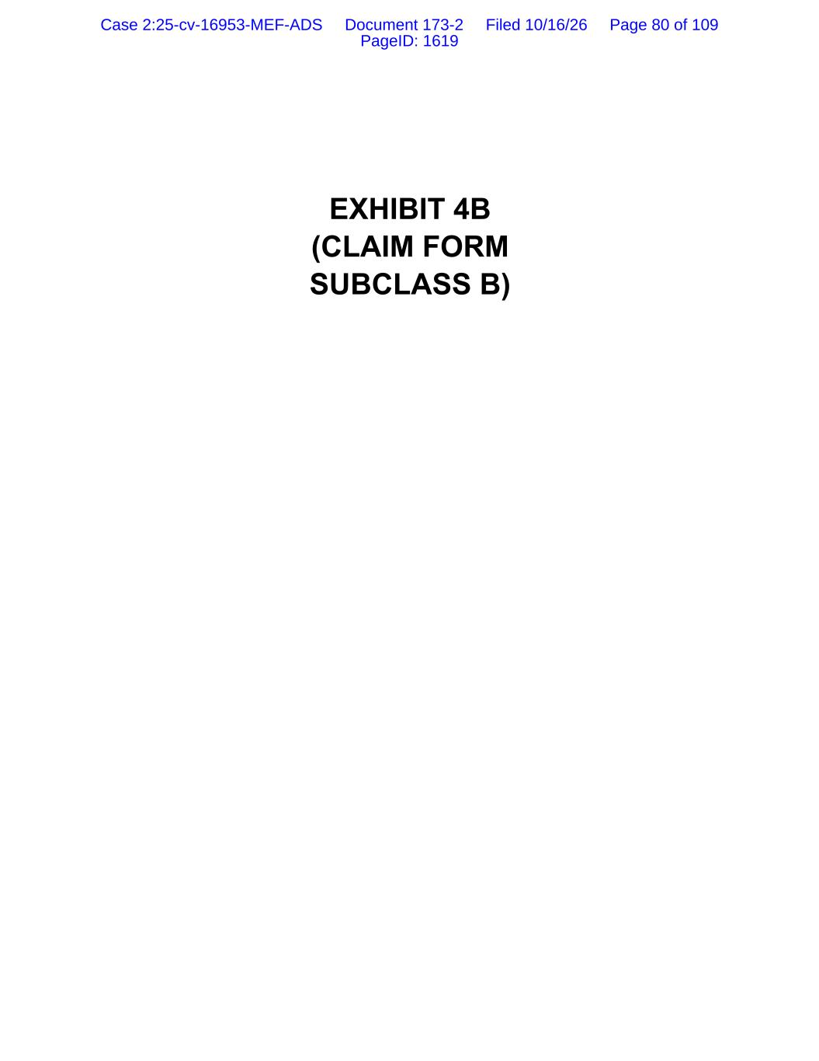
EXHIBIT 4B (CLAIM FORM SUBCLASS B) Case 2:25-cv-16953-MEF-ADS Document 173-2 Filed 10/16/26 Page 80 of 109 PageID: 1619

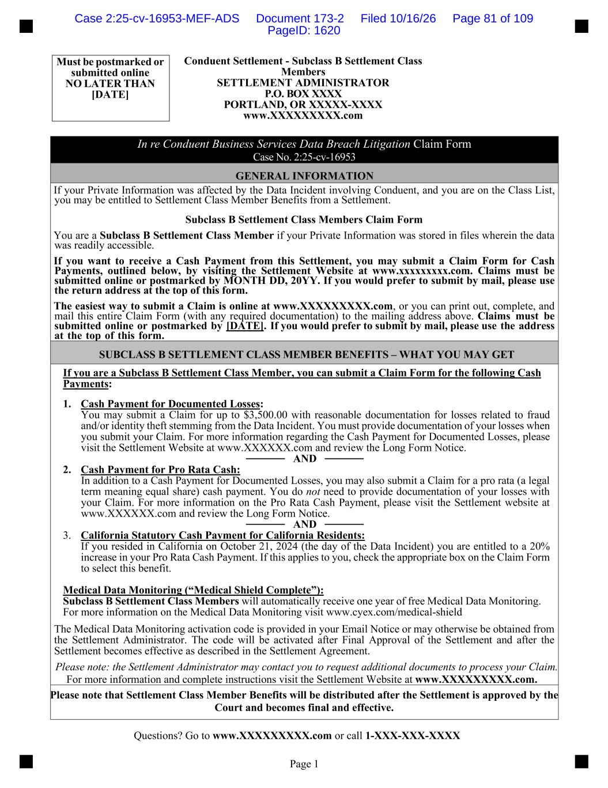
Questions? Go to www.XXXXXXXXX.com or call 1-XXX-XXX-XXXX Page 1 Must be postmarked or submitted online NO LATER THAN [DATE] Conduent Settlement - Subclass B Settlement Class Members SETTLEMENT ADMINISTRATOR P.O. BOX XXXX PORTLAND, OR XXXXX-XXXX www.XXXXXXXXX.com In re Conduent Business Services Data Breach Litigation Claim Form Case No. 2:25-cv-16953 GENERAL INFORMATION If your Private Information was affected by the Data Incident involving Conduent, and you are on the Class List, you may be entitled to Settlement Class Member Benefits from a Settlement. Subclass B Settlement Class Members Claim Form You are a Subclass B Settlement Class Member if your Private Information was stored in files wherein the data was readily accessible. If you want to receive a Cash Payment from this Settlement, you may submit a Claim Form for Cash Payments, outlined below, by visiting the Settlement Website at www.xxxxxxxxx.com. Claims must be submitted online or postmarked by MONTH DD, 20YY. If you would prefer to submit by mail, please use the return address at the top of this form. The easiest way to submit a Claim is online at www.XXXXXXXXX.com, or you can print out, complete, and mail this entire Claim Form (with any required documentation) to the mailing address above. Claims must be submitted online or postmarked by [DATE]. If you would prefer to submit by mail, please use the address at the top of this form. SUBCLASS B SETTLEMENT CLASS MEMBER BENEFITS – WHAT YOU MAY GET If you are a Subclass B Settlement Class Member, you can submit a Claim Form for the following Cash Payments: 1. Cash Payment for Documented Losses: You may submit a Claim for up to $3,500.00 with reasonable documentation for losses related to fraud and/or identity theft stemming from the Data Incident. You must provide documentation of your losses when you submit your Claim. For more information regarding the Cash Payment for Documented Losses, please visit the Settlement Website at www.XXXXXX.com and review the Long Form Notice. ───── AND ───── 2. Cash Payment for Pro Rata Cash: In addition to a Cash Payment for Documented Losses, you may also submit a Claim for a pro rata (a legal term meaning equal share) cash payment. You do not need to provide documentation of your losses with your Claim. For more information on the Pro Rata Cash Payment, please visit the Settlement website at www.XXXXXX.com and review the Long Form Notice. ───── AND ───── 3. California Statutory Cash Payment for California Residents: If you resided in California on October 21, 2024 (the day of the Data Incident) you are entitled to a 20% increase in your Pro Rata Cash Payment. If this applies to you, check the appropriate box on the Claim Form to select this benefit. Medical Data Monitoring (“Medical Shield Complete”): Subclass B Settlement Class Members will automatically receive one year of free Medical Data Monitoring. For more information on the Medical Data Monitoring visit www.cyex.com/medical-shield The Medical Data Monitoring activation code is provided in your Email Notice or may otherwise be obtained from the Settlement Administrator. The code will be activated after Final Approval of the Settlement and after the Settlement becomes effective as described in the Settlement Agreement. Please note: the Settlement Administrator may contact you to request additional documents to process your Claim. For more information and complete instructions visit the Settlement Website at www.XXXXXXXXX.com. Please note that Settlement Class Member Benefits will be distributed after the Settlement is approved by the Court and becomes final and effective. Case 2:25-cv-16953-MEF-ADS Document 173-2 Filed 10/16/26 Page 81 of 109 PageID: 1620

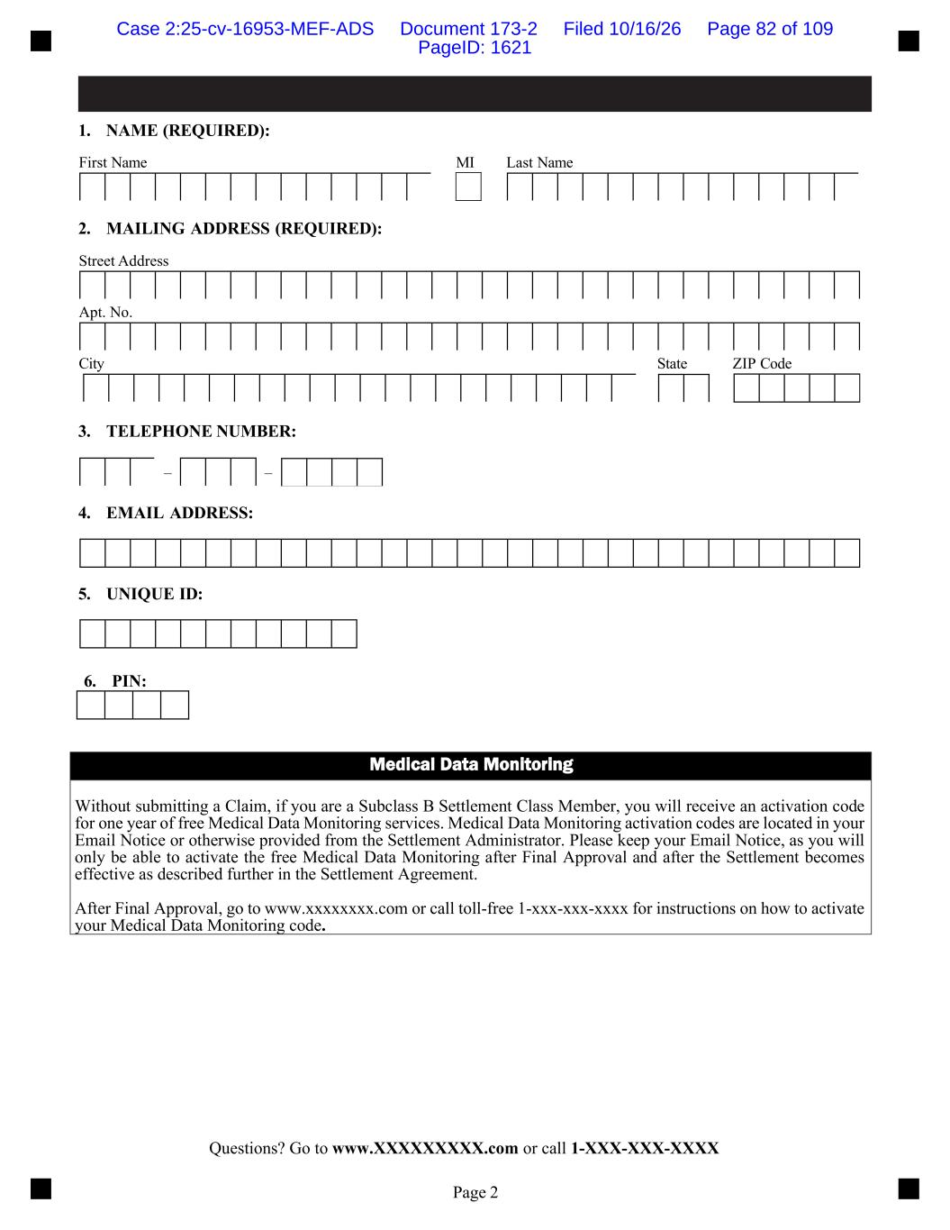
Questions? Go to www.XXXXXXXXX.com or call 1-XXX-XXX-XXXX Page 2 1. NAME (REQUIRED): First Name MI Last Name 2. MAILING ADDRESS (REQUIRED): Street Address Apt. No. City State ZIP Code 3. TELEPHONE NUMBER: 4. EMAIL ADDRESS: 5. UNIQUE ID: 6. PIN: Medical Data Monitoring Without submitting a Claim, if you are a Subclass B Settlement Class Member, you will receive an activation code for one year of free Medical Data Monitoring services. Medical Data Monitoring activation codes are located in your Email Notice or otherwise provided from the Settlement Administrator. Please keep your Email Notice, as you will only be able to activate the free Medical Data Monitoring after Final Approval and after the Settlement becomes effective as described further in the Settlement Agreement. After Final Approval, go to www.xxxxxxxx.com or call toll-free 1-xxx-xxx-xxxx for instructions on how to activate your Medical Data Monitoring code. – – Case 2:25-cv-16953-MEF-ADS Document 173-2 Filed 10/16/26 Page 82 of 109 PageID: 1621

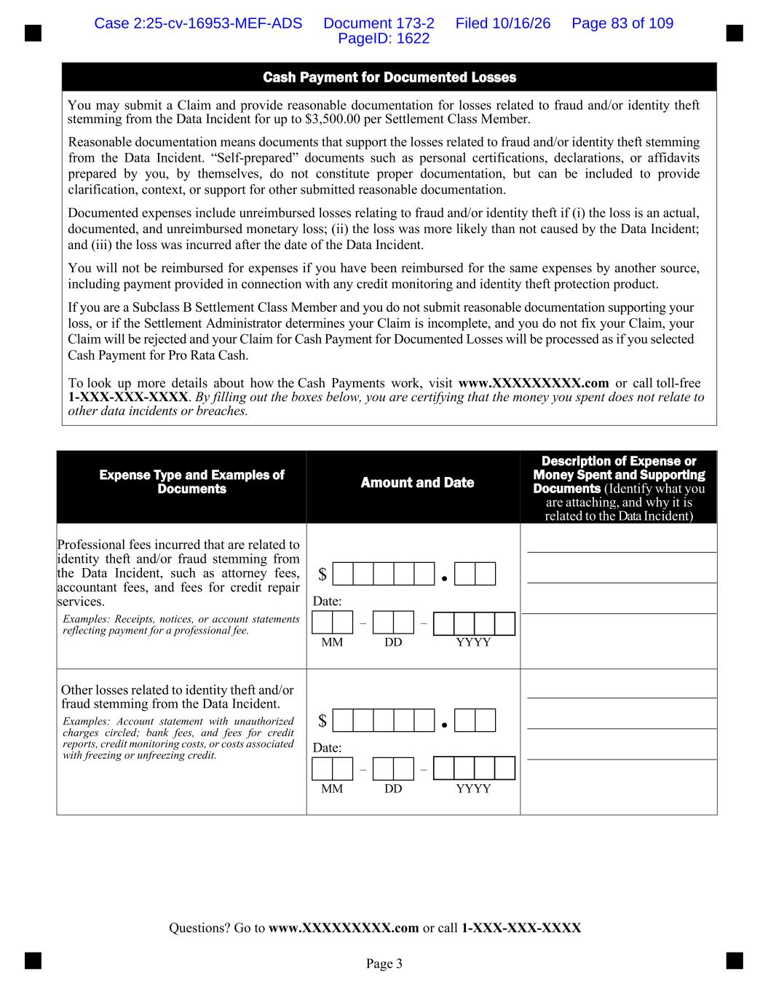
Questions? Go to www.XXXXXXXXX.com or call 1-XXX-XXX-XXXX Page 3 Cash Payment for Documented Losses You may submit a Claim and provide reasonable documentation for losses related to fraud and/or identity theft stemming from the Data Incident for up to $3,500.00 per Settlement Class Member. Reasonable documentation means documents that support the losses related to fraud and/or identity theft stemming from the Data Incident. “Self-prepared” documents such as personal certifications, declarations, or affidavits prepared by you, by themselves, do not constitute proper documentation, but can be included to provide clarification, context, or support for other submitted reasonable documentation. Documented expenses include unreimbursed losses relating to fraud and/or identity theft if (i) the loss is an actual, documented, and unreimbursed monetary loss; (ii) the loss was more likely than not caused by the Data Incident; and (iii) the loss was incurred after the date of the Data Incident. You will not be reimbursed for expenses if you have been reimbursed for the same expenses by another source, including payment provided in connection with any credit monitoring and identity theft protection product. If you are a Subclass B Settlement Class Member and you do not submit reasonable documentation supporting your loss, or if the Settlement Administrator determines your Claim is incomplete, and you do not fix your Claim, your Claim will be rejected and your Claim for Cash Payment for Documented Losses will be processed as if you selected Cash Payment for Pro Rata Cash. To look up more details about how the Cash Payments work, visit www.XXXXXXXXX.com or call toll-free 1-XXX-XXX-XXXX. By filling out the boxes below, you are certifying that the money you spent does not relate to other data incidents or breaches. Expense Type and Examples of Documents Amount and Date Description of Expense or Money Spent and Supporting Documents (Identify what you are attaching, and why it is related to the Data Incident) Professional fees incurred that are related to identity theft and/or fraud stemming from the Data Incident, such as attorney fees, accountant fees, and fees for credit repair services. Examples: Receipts, notices, or account statements reflecting payment for a professional fee. $ ● Date: – – MM DD YYYY Other losses related to identity theft and/or fraud stemming from the Data Incident. Examples: Account statement with unauthorized charges circled; bank fees, and fees for credit reports, credit monitoring costs, or costs associated with freezing or unfreezing credit. $ ● Date: – – MM DD YYYY Case 2:25-cv-16953-MEF-ADS Document 173-2 Filed 10/16/26 Page 83 of 109 PageID: 1622

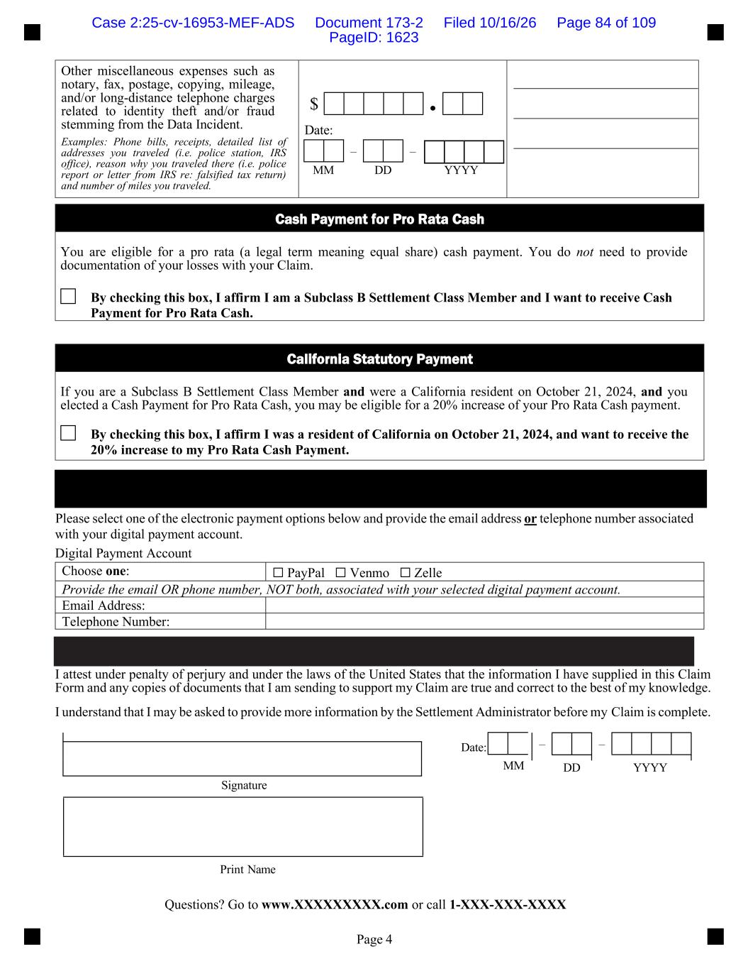
Questions? Go to www.XXXXXXXXX.com or call 1-XXX-XXX-XXXX Page 4 Please select one of the electronic payment options below and provide the email address or telephone number associated with your digital payment account. Digital Payment Account I attest under penalty of perjury and under the laws of the United States that the information I have supplied in this Claim Form and any copies of documents that I am sending to support my Claim are true and correct to the best of my knowledge. I understand that I may be asked to provide more information by the Settlement Administrator before my Claim is complete. Date: – – MM DD YYYY Signature Print Name Other miscellaneous expenses such as notary, fax, postage, copying, mileage, and/or long-distance telephone charges related to identity theft and/or fraud stemming from the Data Incident. Examples: Phone bills, receipts, detailed list of addresses you traveled (i.e. police station, IRS office), reason why you traveled there (i.e. police report or letter from IRS re: falsified tax return) and number of miles you traveled. $ ● Date: – – MM DD YYYY Cash Payment for Pro Rata Cash You are eligible for a pro rata (a legal term meaning equal share) cash payment. You do not need to provide documentation of your losses with your Claim. By checking this box, I affirm I am a Subclass B Settlement Class Member and I want to receive Cash Payment for Pro Rata Cash. California Statutory Payment If you are a Subclass B Settlement Class Member and were a California resident on October 21, 2024, and you elected a Cash Payment for Pro Rata Cash, you may be eligible for a 20% increase of your Pro Rata Cash payment. By checking this box, I affirm I was a resident of California on October 21, 2024, and want to receive the 20% increase to my Pro Rata Cash Payment. Choose one: ☐ PayPal ☐ Venmo ☐ Zelle Provide the email OR phone number, NOT both, associated with your selected digital payment account. Email Address: Telephone Number: Case 2:25-cv-16953-MEF-ADS Document 173-2 Filed 10/16/26 Page 84 of 109 PageID: 1623

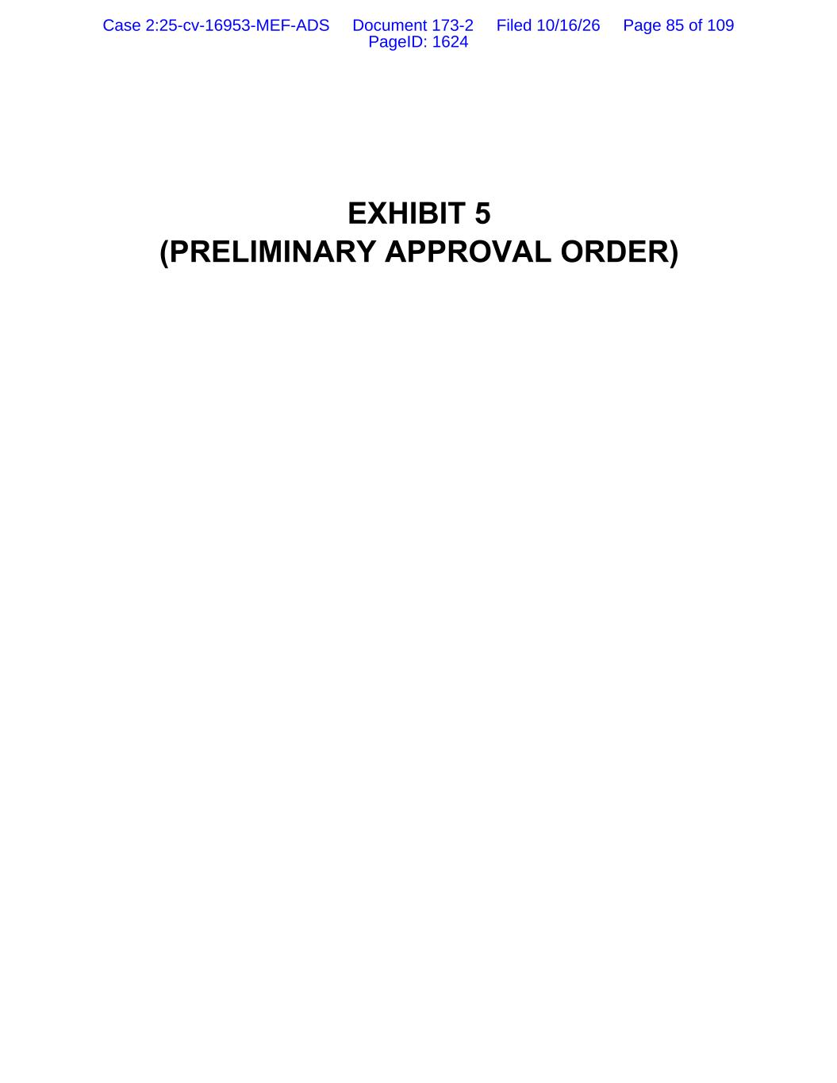
EXHIBIT 5 (PRELIMINARY APPROVAL ORDER) Case 2:25-cv-16953-MEF-ADS Document 173-2 Filed 10/16/26 Page 85 of 109 PageID: 1624

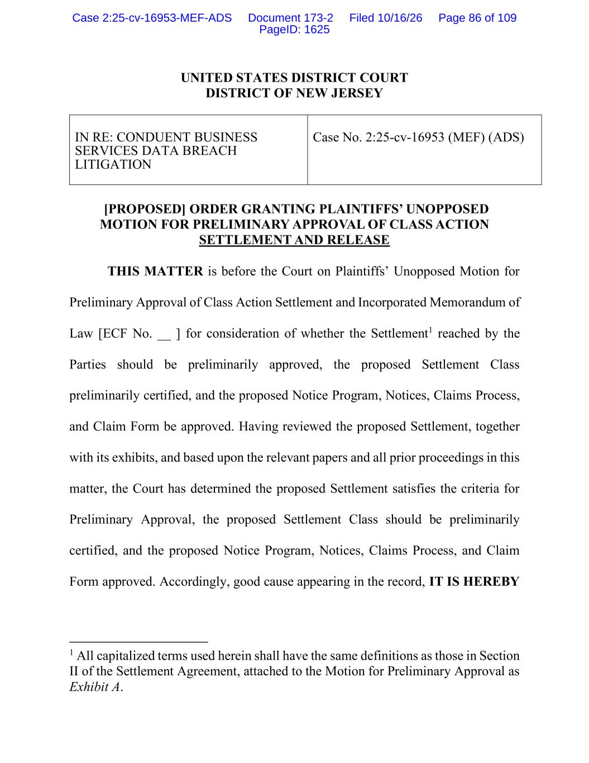
UNITED STATES DISTRICT COURT DISTRICT OF NEW JERSEY IN RE: CONDUENT BUSINESS SERVICES DATA BREACH LITIGATION Case No. 2:25-cv-16953 (MEF) (ADS) [PROPOSED] ORDER GRANTING PLAINTIFFS’ UNOPPOSED MOTION FOR PRELIMINARY APPROVAL OF CLASS ACTION SETTLEMENT AND RELEASE THIS MATTER is before the Court on Plaintiffs’ Unopposed Motion for Preliminary Approval of Class Action Settlement and Incorporated Memorandum of Law [ECF No. __ ] for consideration of whether the Settlement1 reached by the Parties should be preliminarily approved, the proposed Settlement Class preliminarily certified, and the proposed Notice Program, Notices, Claims Process, and Claim Form be approved. Having reviewed the proposed Settlement, together with its exhibits, and based upon the relevant papers and all prior proceedings in this matter, the Court has determined the proposed Settlement satisfies the criteria for Preliminary Approval, the proposed Settlement Class should be preliminarily certified, and the proposed Notice Program, Notices, Claims Process, and Claim Form approved. Accordingly, good cause appearing in the record, IT IS HEREBY 1 All capitalized terms used herein shall have the same definitions as those in Section II of the Settlement Agreement, attached to the Motion for Preliminary Approval as Exhibit A. Case 2:25-cv-16953-MEF-ADS Document 173-2 Filed 10/16/26 Page 86 of 109 PageID: 1625

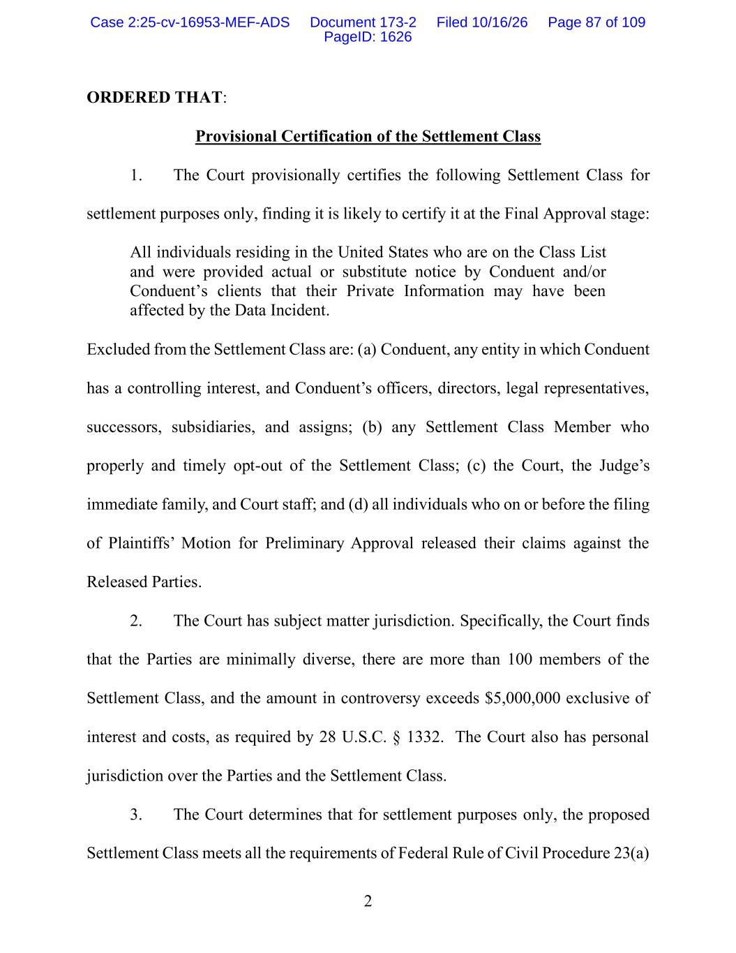
2 ORDERED THAT: Provisional Certification of the Settlement Class 1. The Court provisionally certifies the following Settlement Class for settlement purposes only, finding it is likely to certify it at the Final Approval stage: All individuals residing in the United States who are on the Class List and were provided actual or substitute notice by Conduent and/or Conduent’s clients that their Private Information may have been affected by the Data Incident. Excluded from the Settlement Class are: (a) Conduent, any entity in which Conduent has a controlling interest, and Conduent’s officers, directors, legal representatives, successors, subsidiaries, and assigns; (b) any Settlement Class Member who properly and timely opt-out of the Settlement Class; (c) the Court, the Judge’s immediate family, and Court staff; and (d) all individuals who on or before the filing of Plaintiffs’ Motion for Preliminary Approval released their claims against the Released Parties. 2. The Court has subject matter jurisdiction. Specifically, the Court finds that the Parties are minimally diverse, there are more than 100 members of the Settlement Class, and the amount in controversy exceeds $5,000,000 exclusive of interest and costs, as required by 28 U.S.C. § 1332. The Court also has personal jurisdiction over the Parties and the Settlement Class. 3. The Court determines that for settlement purposes only, the proposed Settlement Class meets all the requirements of Federal Rule of Civil Procedure 23(a) Case 2:25-cv-16953-MEF-ADS Document 173-2 Filed 10/16/26 Page 87 of 109 PageID: 1626

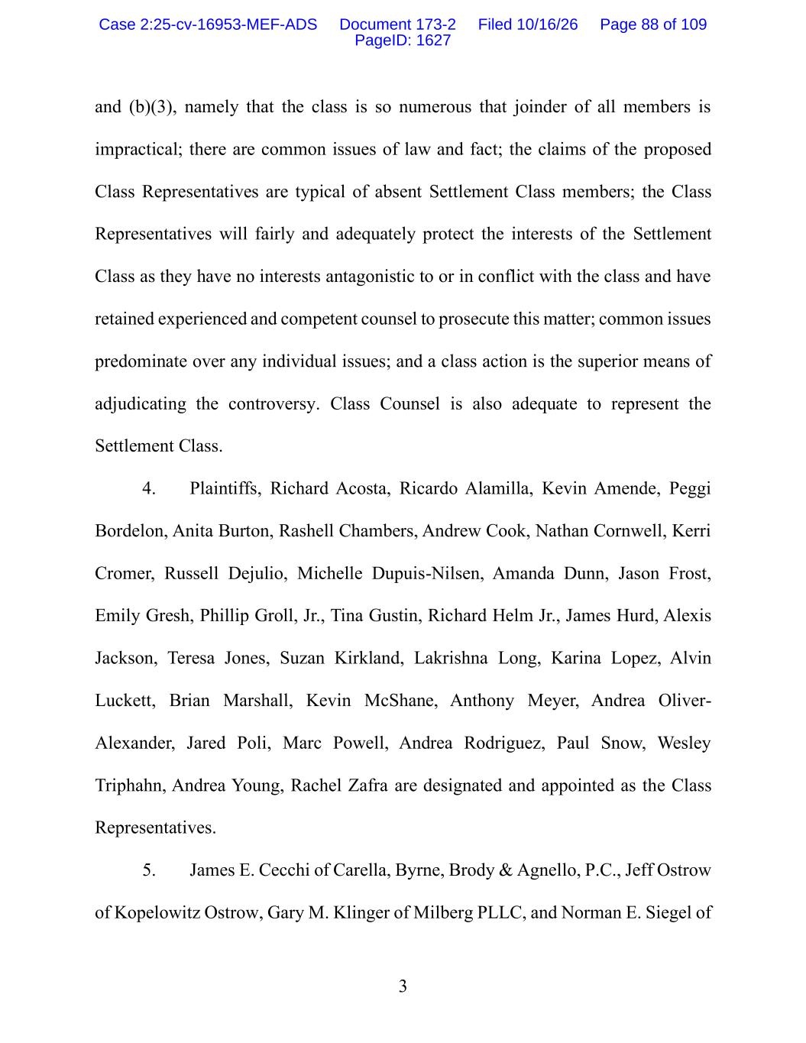
3 and (b)(3), namely that the class is so numerous that joinder of all members is impractical; there are common issues of law and fact; the claims of the proposed Class Representatives are typical of absent Settlement Class members; the Class Representatives will fairly and adequately protect the interests of the Settlement Class as they have no interests antagonistic to or in conflict with the class and have retained experienced and competent counsel to prosecute this matter; common issues predominate over any individual issues; and a class action is the superior means of adjudicating the controversy. Class Counsel is also adequate to represent the Settlement Class. 4. Plaintiffs, Richard Acosta, Ricardo Alamilla, Kevin Amende, Peggi Bordelon, Anita Burton, Rashell Chambers, Andrew Cook, Nathan Cornwell, Kerri Cromer, Russell Dejulio, Michelle Dupuis-Nilsen, Amanda Dunn, Jason Frost, Emily Gresh, Phillip Groll, Jr., Tina Gustin, Richard Helm Jr., James Hurd, Alexis Jackson, Teresa Jones, Suzan Kirkland, Lakrishna Long, Karina Lopez, Alvin Luckett, Brian Marshall, Kevin McShane, Anthony Meyer, Andrea Oliver- Alexander, Jared Poli, Marc Powell, Andrea Rodriguez, Paul Snow, Wesley Triphahn, Andrea Young, Rachel Zafra are designated and appointed as the Class Representatives. 5. James E. Cecchi of Carella, Byrne, Brody & Agnello, P.C., Jeff Ostrow of Kopelowitz Ostrow, Gary M. Klinger of Milberg PLLC, and Norman E. Siegel of Case 2:25-cv-16953-MEF-ADS Document 173-2 Filed 10/16/26 Page 88 of 109 PageID: 1627

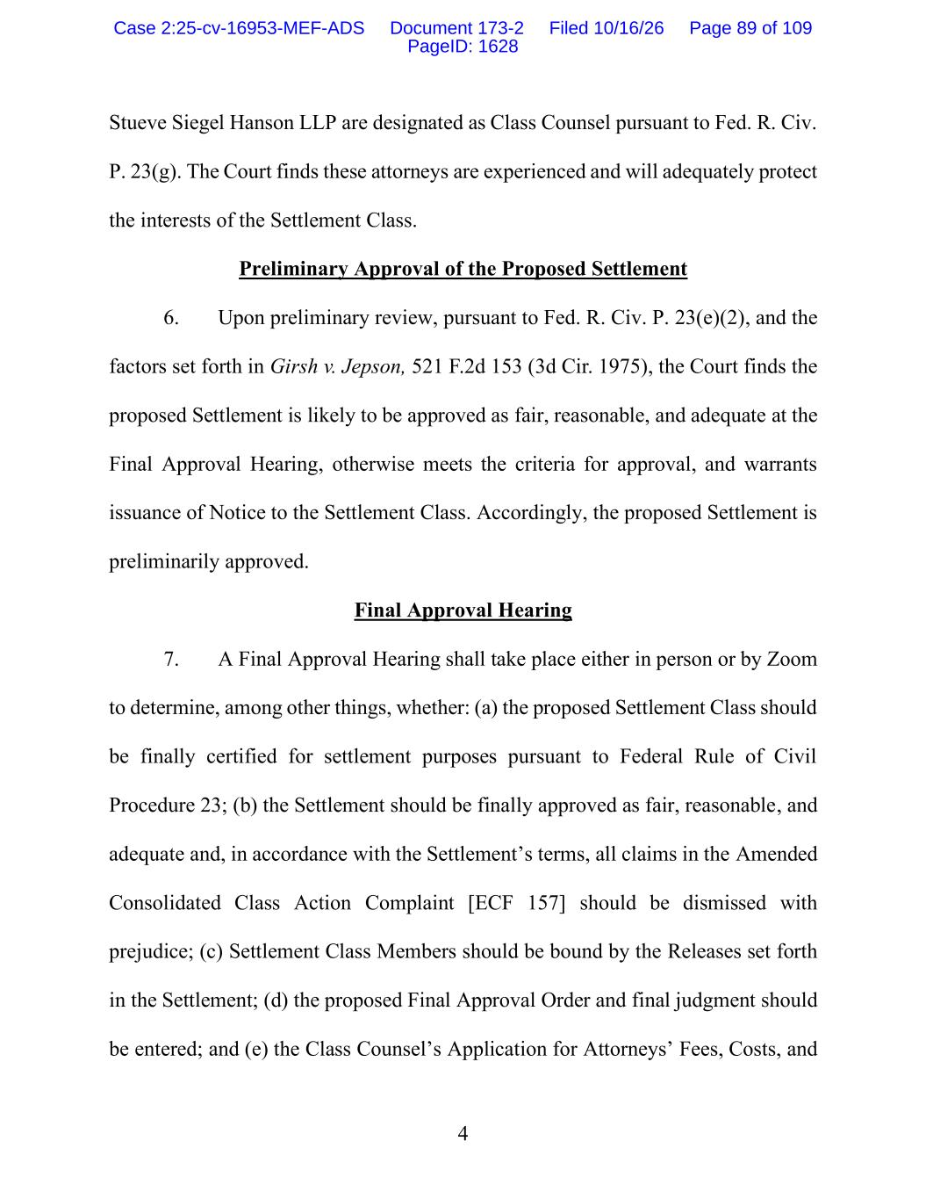
4 Stueve Siegel Hanson LLP are designated as Class Counsel pursuant to Fed. R. Civ. P. 23(g). The Court finds these attorneys are experienced and will adequately protect the interests of the Settlement Class. Preliminary Approval of the Proposed Settlement 6. Upon preliminary review, pursuant to Fed. R. Civ. P. 23(e)(2), and the factors set forth in Girsh v. Jepson, 521 F.2d 153 (3d Cir. 1975), the Court finds the proposed Settlement is likely to be approved as fair, reasonable, and adequate at the Final Approval Hearing, otherwise meets the criteria for approval, and warrants issuance of Notice to the Settlement Class. Accordingly, the proposed Settlement is preliminarily approved. Final Approval Hearing 7. A Final Approval Hearing shall take place either in person or by Zoom to determine, among other things, whether: (a) the proposed Settlement Class should be finally certified for settlement purposes pursuant to Federal Rule of Civil Procedure 23; (b) the Settlement should be finally approved as fair, reasonable, and adequate and, in accordance with the Settlement’s terms, all claims in the Amended Consolidated Class Action Complaint [ECF 157] should be dismissed with prejudice; (c) Settlement Class Members should be bound by the Releases set forth in the Settlement; (d) the proposed Final Approval Order and final judgment should be entered; and (e) the Class Counsel’s Application for Attorneys’ Fees, Costs, and Case 2:25-cv-16953-MEF-ADS Document 173-2 Filed 10/16/26 Page 89 of 109 PageID: 1628

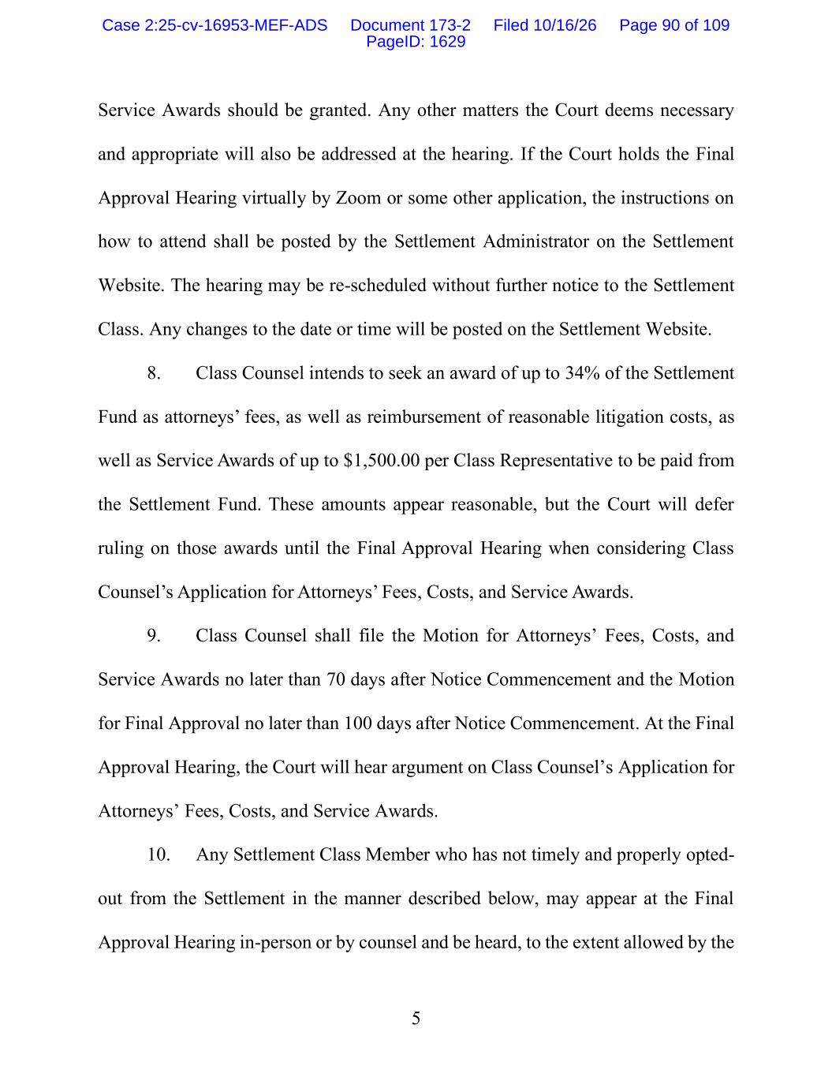
5 Service Awards should be granted. Any other matters the Court deems necessary and appropriate will also be addressed at the hearing. If the Court holds the Final Approval Hearing virtually by Zoom or some other application, the instructions on how to attend shall be posted by the Settlement Administrator on the Settlement Website. The hearing may be re-scheduled without further notice to the Settlement Class. Any changes to the date or time will be posted on the Settlement Website. 8. Class Counsel intends to seek an award of up to 34% of the Settlement Fund as attorneys’ fees, as well as reimbursement of reasonable litigation costs, as well as Service Awards of up to $1,500.00 per Class Representative to be paid from the Settlement Fund. These amounts appear reasonable, but the Court will defer ruling on those awards until the Final Approval Hearing when considering Class Counsel’s Application for Attorneys’ Fees, Costs, and Service Awards. 9. Class Counsel shall file the Motion for Attorneys’ Fees, Costs, and Service Awards no later than 70 days after Notice Commencement and the Motion for Final Approval no later than 100 days after Notice Commencement. At the Final Approval Hearing, the Court will hear argument on Class Counsel’s Application for Attorneys’ Fees, Costs, and Service Awards. 10. Any Settlement Class Member who has not timely and properly opted- out from the Settlement in the manner described below, may appear at the Final Approval Hearing in-person or by counsel and be heard, to the extent allowed by the Case 2:25-cv-16953-MEF-ADS Document 173-2 Filed 10/16/26 Page 90 of 109 PageID: 1629

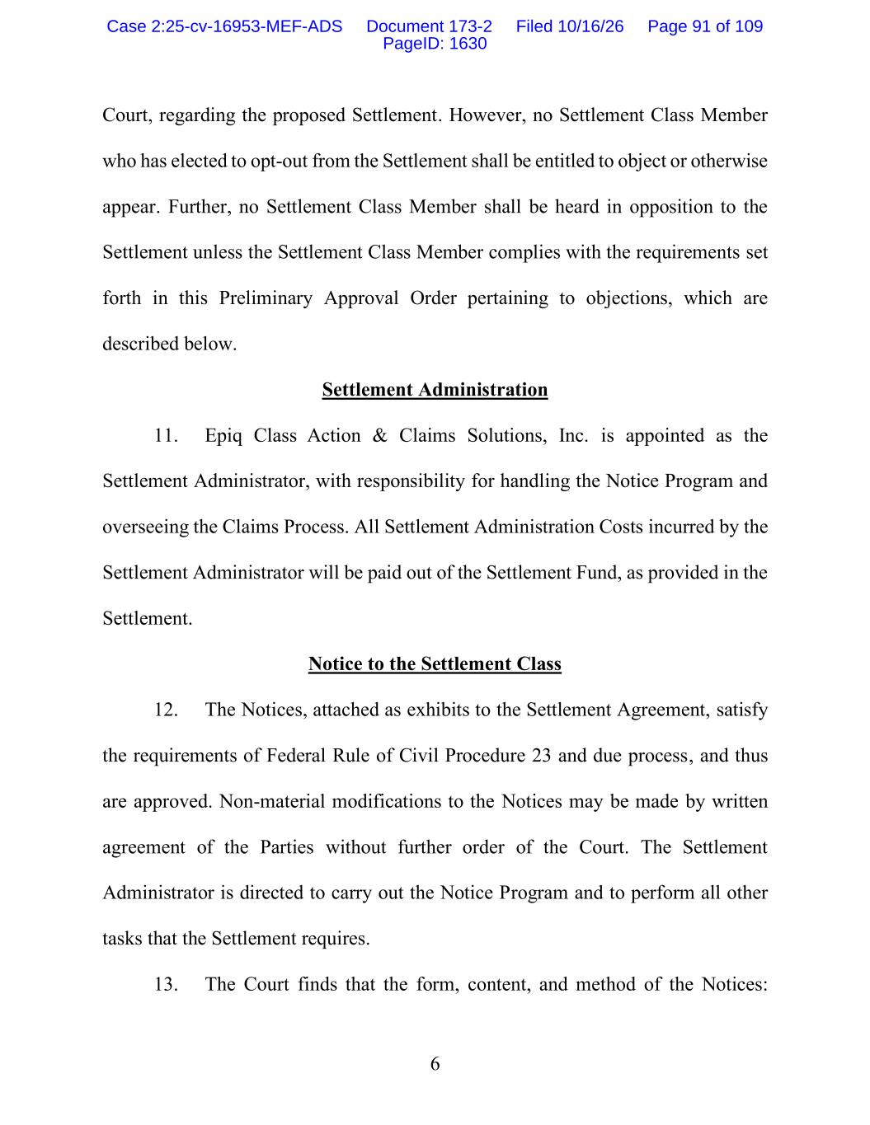
6 Court, regarding the proposed Settlement. However, no Settlement Class Member who has elected to opt-out from the Settlement shall be entitled to object or otherwise appear. Further, no Settlement Class Member shall be heard in opposition to the Settlement unless the Settlement Class Member complies with the requirements set forth in this Preliminary Approval Order pertaining to objections, which are described below. Settlement Administration 11. Epiq Class Action & Claims Solutions, Inc. is appointed as the Settlement Administrator, with responsibility for handling the Notice Program and overseeing the Claims Process. All Settlement Administration Costs incurred by the Settlement Administrator will be paid out of the Settlement Fund, as provided in the Settlement. Notice to the Settlement Class 12. The Notices, attached as exhibits to the Settlement Agreement, satisfy the requirements of Federal Rule of Civil Procedure 23 and due process, and thus are approved. Non-material modifications to the Notices may be made by written agreement of the Parties without further order of the Court. The Settlement Administrator is directed to carry out the Notice Program and to perform all other tasks that the Settlement requires. 13. The Court finds that the form, content, and method of the Notices: Case 2:25-cv-16953-MEF-ADS Document 173-2 Filed 10/16/26 Page 91 of 109 PageID: 1630

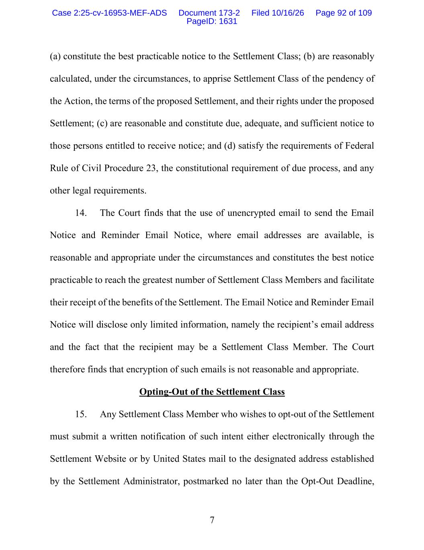
7 (a) constitute the best practicable notice to the Settlement Class; (b) are reasonably calculated, under the circumstances, to apprise Settlement Class of the pendency of the Action, the terms of the proposed Settlement, and their rights under the proposed Settlement; (c) are reasonable and constitute due, adequate, and sufficient notice to those persons entitled to receive notice; and (d) satisfy the requirements of Federal Rule of Civil Procedure 23, the constitutional requirement of due process, and any other legal requirements. 14. The Court finds that the use of unencrypted email to send the Email Notice and Reminder Email Notice, where email addresses are available, is reasonable and appropriate under the circumstances and constitutes the best notice practicable to reach the greatest number of Settlement Class Members and facilitate their receipt of the benefits of the Settlement. The Email Notice and Reminder Email Notice will disclose only limited information, namely the recipient’s email address and the fact that the recipient may be a Settlement Class Member. The Court therefore finds that encryption of such emails is not reasonable and appropriate. Opting-Out of the Settlement Class 15. Any Settlement Class Member who wishes to opt-out of the Settlement must submit a written notification of such intent either electronically through the Settlement Website or by United States mail to the designated address established by the Settlement Administrator, postmarked no later than the Opt-Out Deadline, Case 2:25-cv-16953-MEF-ADS Document 173-2 Filed 10/16/26 Page 92 of 109 PageID: 1631

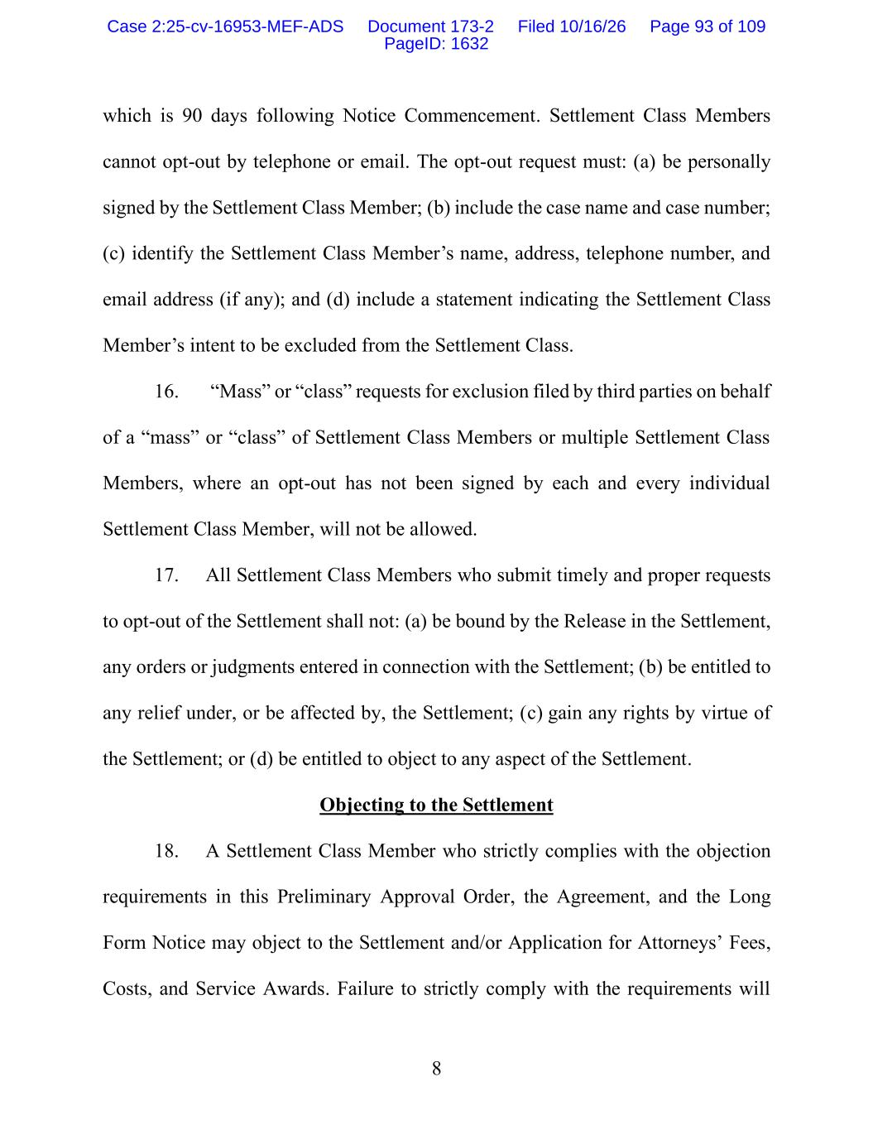
8 which is 90 days following Notice Commencement. Settlement Class Members cannot opt-out by telephone or email. The opt-out request must: (a) be personally signed by the Settlement Class Member; (b) include the case name and case number; (c) identify the Settlement Class Member’s name, address, telephone number, and email address (if any); and (d) include a statement indicating the Settlement Class Member’s intent to be excluded from the Settlement Class. 16. “Mass” or “class” requests for exclusion filed by third parties on behalf of a “mass” or “class” of Settlement Class Members or multiple Settlement Class Members, where an opt-out has not been signed by each and every individual Settlement Class Member, will not be allowed. 17. All Settlement Class Members who submit timely and proper requests to opt-out of the Settlement shall not: (a) be bound by the Release in the Settlement, any orders or judgments entered in connection with the Settlement; (b) be entitled to any relief under, or be affected by, the Settlement; (c) gain any rights by virtue of the Settlement; or (d) be entitled to object to any aspect of the Settlement. Objecting to the Settlement 18. A Settlement Class Member who strictly complies with the objection requirements in this Preliminary Approval Order, the Agreement, and the Long Form Notice may object to the Settlement and/or Application for Attorneys’ Fees, Costs, and Service Awards. Failure to strictly comply with the requirements will Case 2:25-cv-16953-MEF-ADS Document 173-2 Filed 10/16/26 Page 93 of 109 PageID: 1632

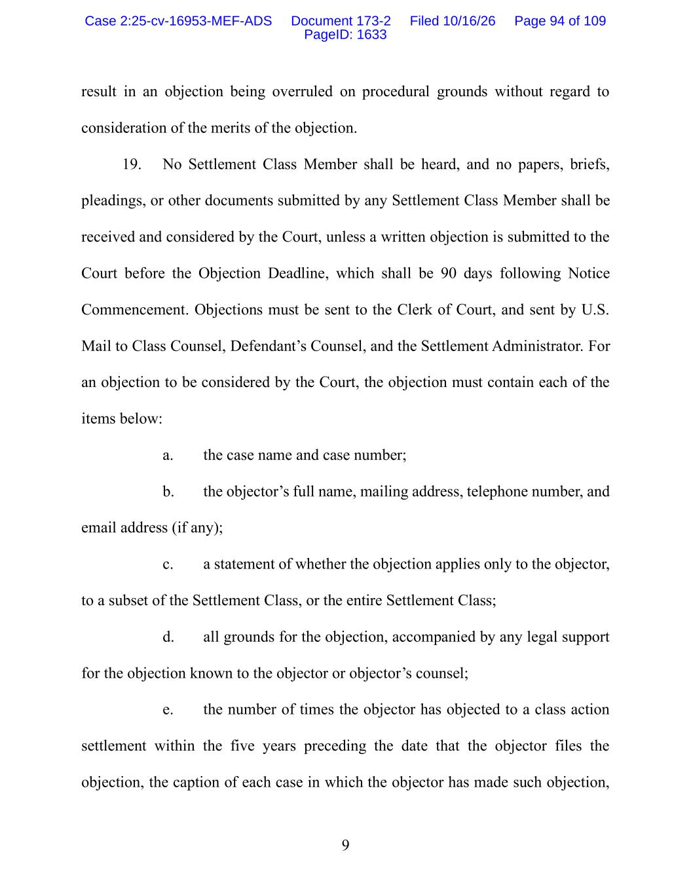
9 result in an objection being overruled on procedural grounds without regard to consideration of the merits of the objection. 19. No Settlement Class Member shall be heard, and no papers, briefs, pleadings, or other documents submitted by any Settlement Class Member shall be received and considered by the Court, unless a written objection is submitted to the Court before the Objection Deadline, which shall be 90 days following Notice Commencement. Objections must be sent to the Clerk of Court, and sent by U.S. Mail to Class Counsel, Defendant’s Counsel, and the Settlement Administrator. For an objection to be considered by the Court, the objection must contain each of the items below: a. the case name and case number; b. the objector’s full name, mailing address, telephone number, and email address (if any); c. a statement of whether the objection applies only to the objector, to a subset of the Settlement Class, or the entire Settlement Class; d. all grounds for the objection, accompanied by any legal support for the objection known to the objector or objector’s counsel; e. the number of times the objector has objected to a class action settlement within the five years preceding the date that the objector files the objection, the caption of each case in which the objector has made such objection, Case 2:25-cv-16953-MEF-ADS Document 173-2 Filed 10/16/26 Page 94 of 109 PageID: 1633

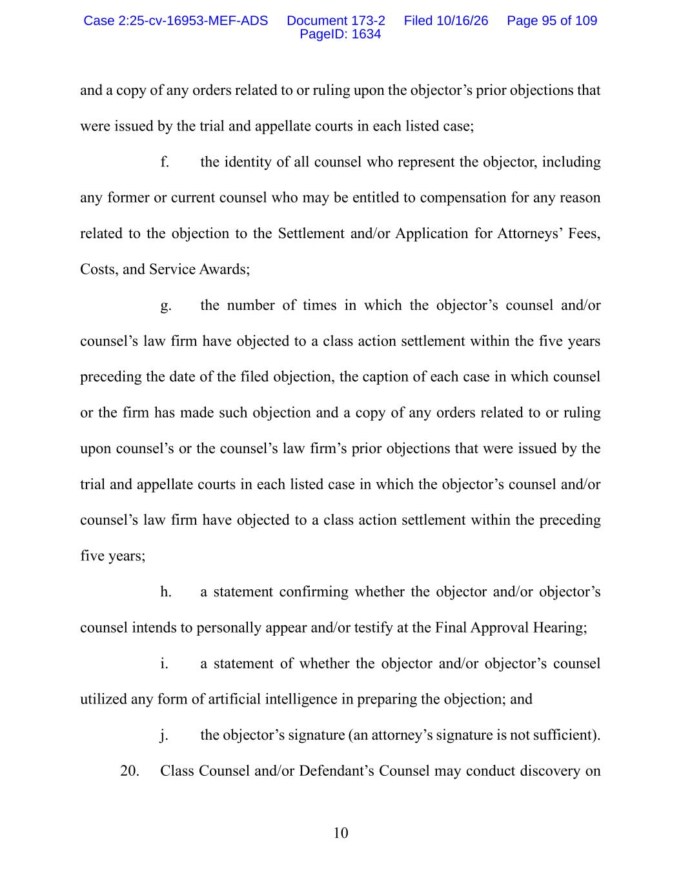
10 and a copy of any orders related to or ruling upon the objector’s prior objections that were issued by the trial and appellate courts in each listed case; f. the identity of all counsel who represent the objector, including any former or current counsel who may be entitled to compensation for any reason related to the objection to the Settlement and/or Application for Attorneys’ Fees, Costs, and Service Awards; g. the number of times in which the objector’s counsel and/or counsel’s law firm have objected to a class action settlement within the five years preceding the date of the filed objection, the caption of each case in which counsel or the firm has made such objection and a copy of any orders related to or ruling upon counsel’s or the counsel’s law firm’s prior objections that were issued by the trial and appellate courts in each listed case in which the objector’s counsel and/or counsel’s law firm have objected to a class action settlement within the preceding five years; h. a statement confirming whether the objector and/or objector’s counsel intends to personally appear and/or testify at the Final Approval Hearing; i. a statement of whether the objector and/or objector’s counsel utilized any form of artificial intelligence in preparing the objection; and j. the objector’s signature (an attorney’s signature is not sufficient). 20. Class Counsel and/or Defendant’s Counsel may conduct discovery on Case 2:25-cv-16953-MEF-ADS Document 173-2 Filed 10/16/26 Page 95 of 109 PageID: 1634

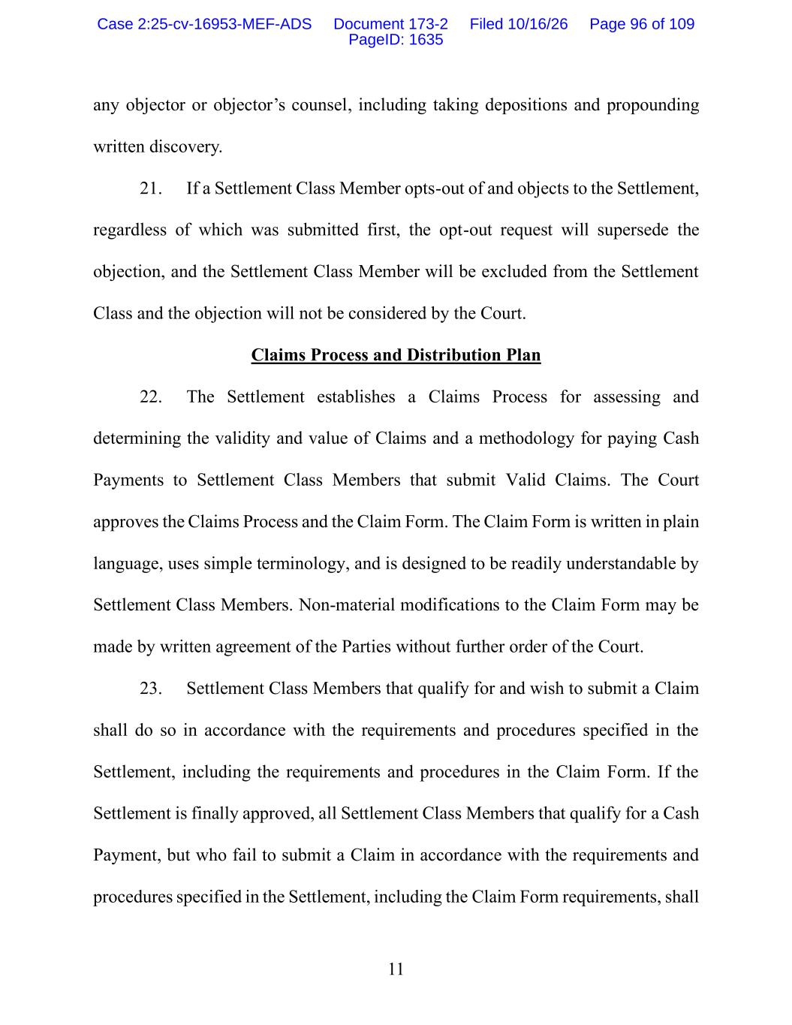
11 any objector or objector’s counsel, including taking depositions and propounding written discovery. 21. If a Settlement Class Member opts-out of and objects to the Settlement, regardless of which was submitted first, the opt-out request will supersede the objection, and the Settlement Class Member will be excluded from the Settlement Class and the objection will not be considered by the Court. Claims Process and Distribution Plan 22. The Settlement establishes a Claims Process for assessing and determining the validity and value of Claims and a methodology for paying Cash Payments to Settlement Class Members that submit Valid Claims. The Court approves the Claims Process and the Claim Form. The Claim Form is written in plain language, uses simple terminology, and is designed to be readily understandable by Settlement Class Members. Non-material modifications to the Claim Form may be made by written agreement of the Parties without further order of the Court. 23. Settlement Class Members that qualify for and wish to submit a Claim shall do so in accordance with the requirements and procedures specified in the Settlement, including the requirements and procedures in the Claim Form. If the Settlement is finally approved, all Settlement Class Members that qualify for a Cash Payment, but who fail to submit a Claim in accordance with the requirements and procedures specified in the Settlement, including the Claim Form requirements, shall Case 2:25-cv-16953-MEF-ADS Document 173-2 Filed 10/16/26 Page 96 of 109 PageID: 1635

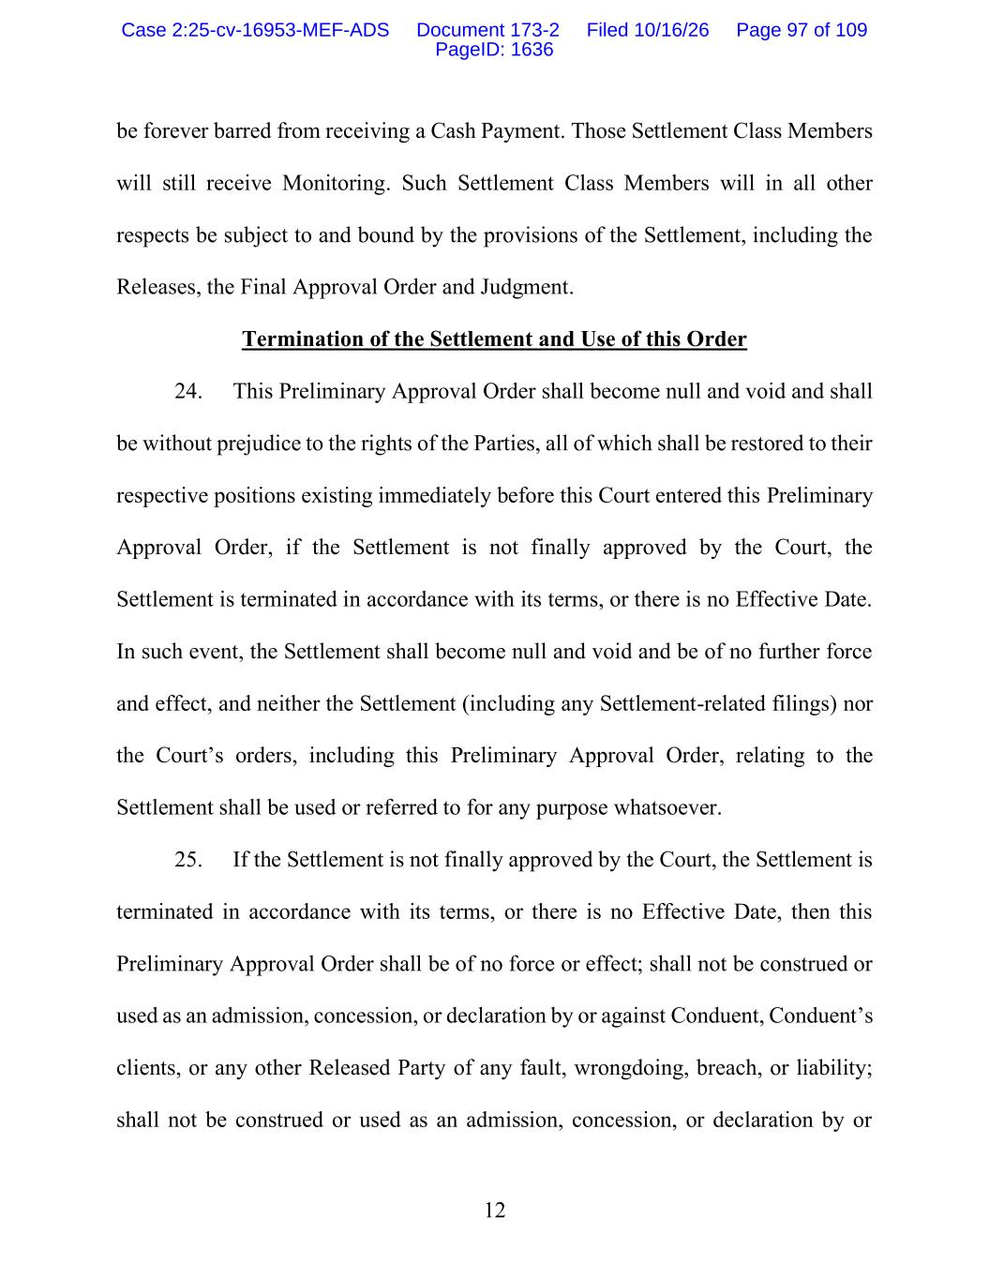
12 be forever barred from receiving a Cash Payment. Those Settlement Class Members will still receive Monitoring. Such Settlement Class Members will in all other respects be subject to and bound by the provisions of the Settlement, including the Releases, the Final Approval Order and Judgment. Termination of the Settlement and Use of this Order 24. This Preliminary Approval Order shall become null and void and shall be without prejudice to the rights of the Parties, all of which shall be restored to their respective positions existing immediately before this Court entered this Preliminary Approval Order, if the Settlement is not finally approved by the Court, the Settlement is terminated in accordance with its terms, or there is no Effective Date. In such event, the Settlement shall become null and void and be of no further force and effect, and neither the Settlement (including any Settlement-related filings) nor the Court’s orders, including this Preliminary Approval Order, relating to the Settlement shall be used or referred to for any purpose whatsoever. 25. If the Settlement is not finally approved by the Court, the Settlement is terminated in accordance with its terms, or there is no Effective Date, then this Preliminary Approval Order shall be of no force or effect; shall not be construed or used as an admission, concession, or declaration by or against Conduent, Conduent’s clients, or any other Released Party of any fault, wrongdoing, breach, or liability; shall not be construed or used as an admission, concession, or declaration by or Case 2:25-cv-16953-MEF-ADS Document 173-2 Filed 10/16/26 Page 97 of 109 PageID: 1636

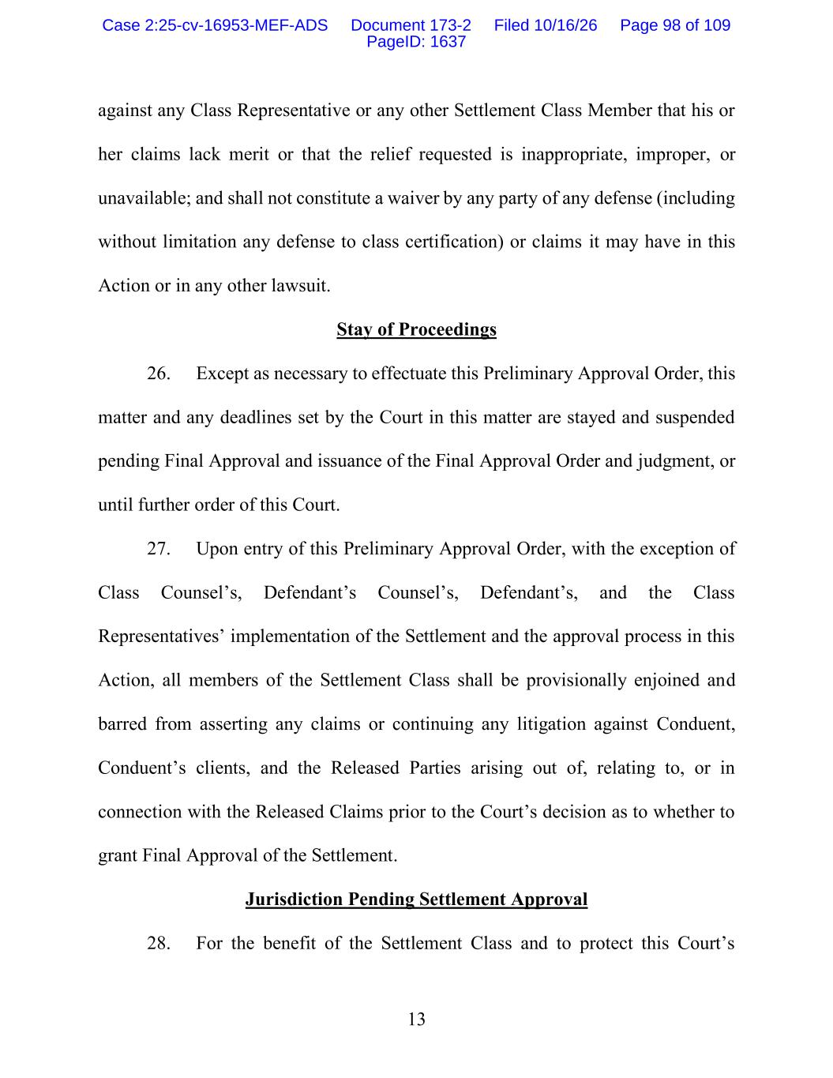
13 against any Class Representative or any other Settlement Class Member that his or her claims lack merit or that the relief requested is inappropriate, improper, or unavailable; and shall not constitute a waiver by any party of any defense (including without limitation any defense to class certification) or claims it may have in this Action or in any other lawsuit. Stay of Proceedings 26. Except as necessary to effectuate this Preliminary Approval Order, this matter and any deadlines set by the Court in this matter are stayed and suspended pending Final Approval and issuance of the Final Approval Order and judgment, or until further order of this Court. 27. Upon entry of this Preliminary Approval Order, with the exception of Class Counsel’s, Defendant’s Counsel’s, Defendant’s, and the Class Representatives’ implementation of the Settlement and the approval process in this Action, all members of the Settlement Class shall be provisionally enjoined and barred from asserting any claims or continuing any litigation against Conduent, Conduent’s clients, and the Released Parties arising out of, relating to, or in connection with the Released Claims prior to the Court’s decision as to whether to grant Final Approval of the Settlement. Jurisdiction Pending Settlement Approval 28. For the benefit of the Settlement Class and to protect this Court’s Case 2:25-cv-16953-MEF-ADS Document 173-2 Filed 10/16/26 Page 98 of 109 PageID: 1637

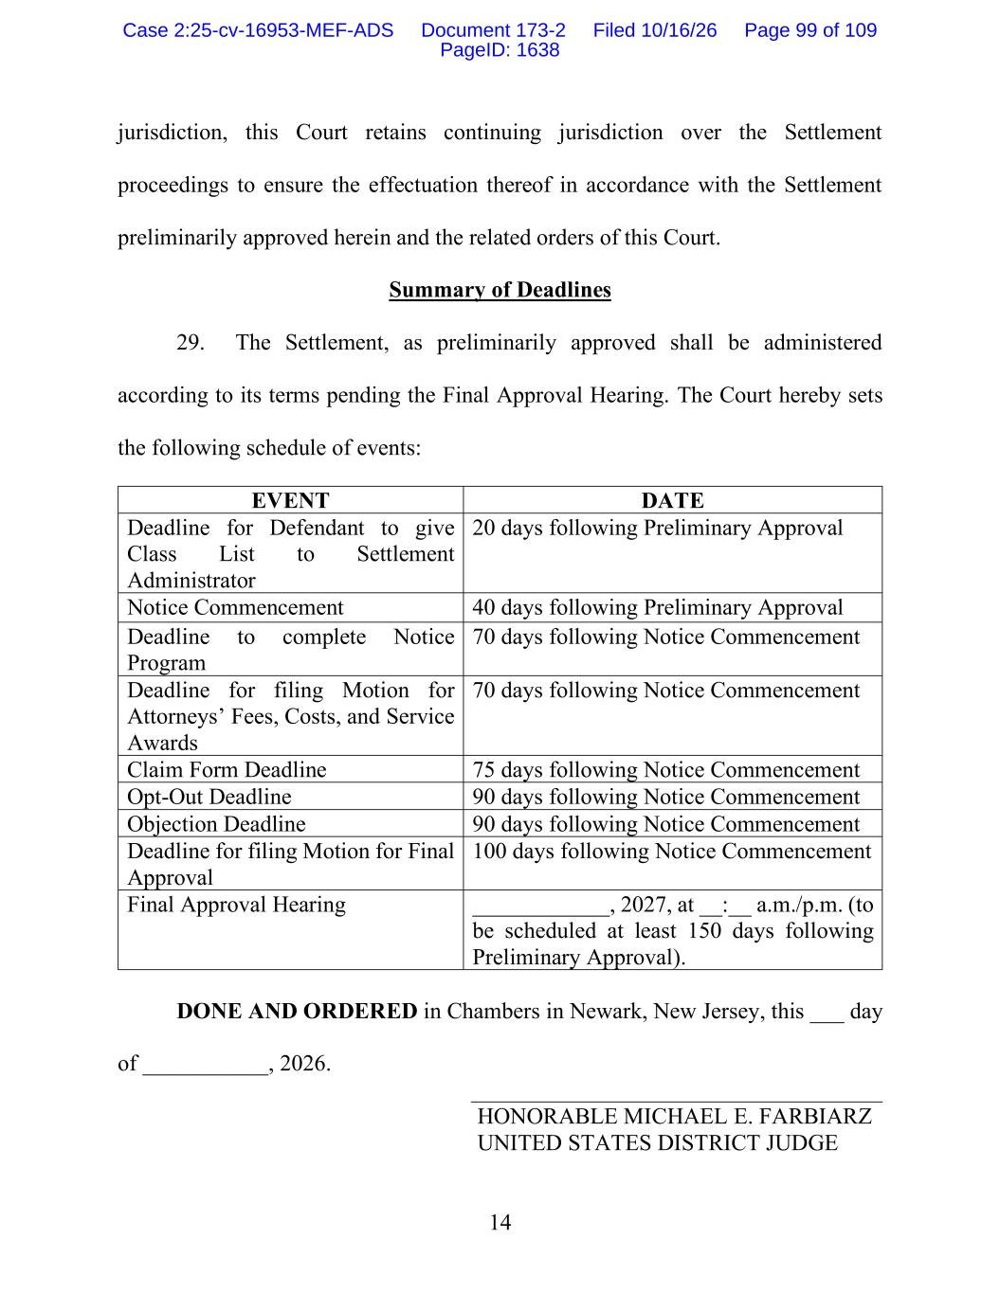
14 jurisdiction, this Court retains continuing jurisdiction over the Settlement proceedings to ensure the effectuation thereof in accordance with the Settlement preliminarily approved herein and the related orders of this Court. Summary of Deadlines 29. The Settlement, as preliminarily approved shall be administered according to its terms pending the Final Approval Hearing. The Court hereby sets the following schedule of events: EVENT DATE Deadline for Defendant to give Class List to Settlement Administrator 20 days following Preliminary Approval Notice Commencement 40 days following Preliminary Approval Deadline to complete Notice Program 70 days following Notice Commencement Deadline for filing Motion for Attorneys’ Fees, Costs, and Service Awards 70 days following Notice Commencement Claim Form Deadline 75 days following Notice Commencement Opt-Out Deadline 90 days following Notice Commencement Objection Deadline 90 days following Notice Commencement Deadline for filing Motion for Final Approval 100 days following Notice Commencement Final Approval Hearing ____________, 2027, at __:__ a.m./p.m. (to be scheduled at least 150 days following Preliminary Approval). DONE AND ORDERED in Chambers in Newark, New Jersey, this ___ day of ___________, 2026. HONORABLE MICHAEL E. FARBIARZ UNITED STATES DISTRICT JUDGE Case 2:25-cv-16953-MEF-ADS Document 173-2 Filed 10/16/26 Page 99 of 109 PageID: 1638

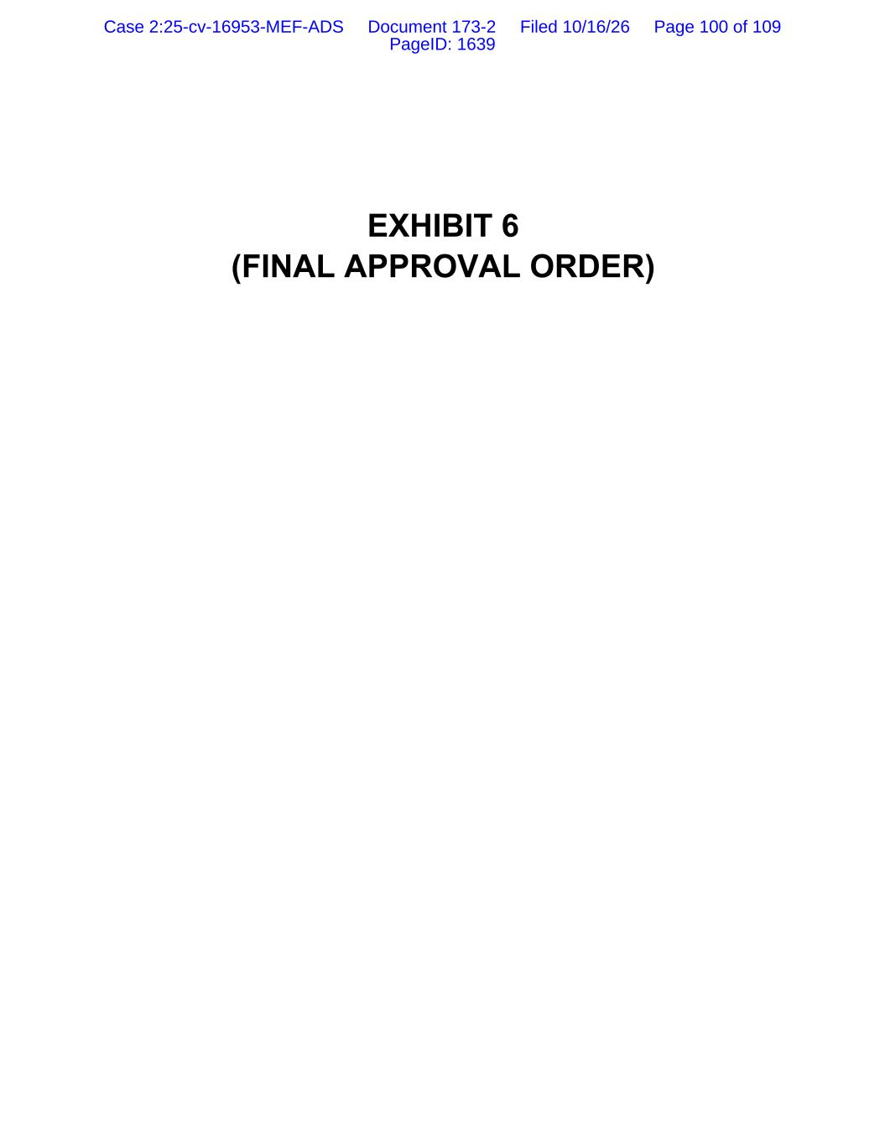
EXHIBIT 6 (FINAL APPROVAL ORDER) Case 2:25-cv-16953-MEF-ADS Document 173-2 Filed 10/16/26 Page 100 of 109 PageID: 1639

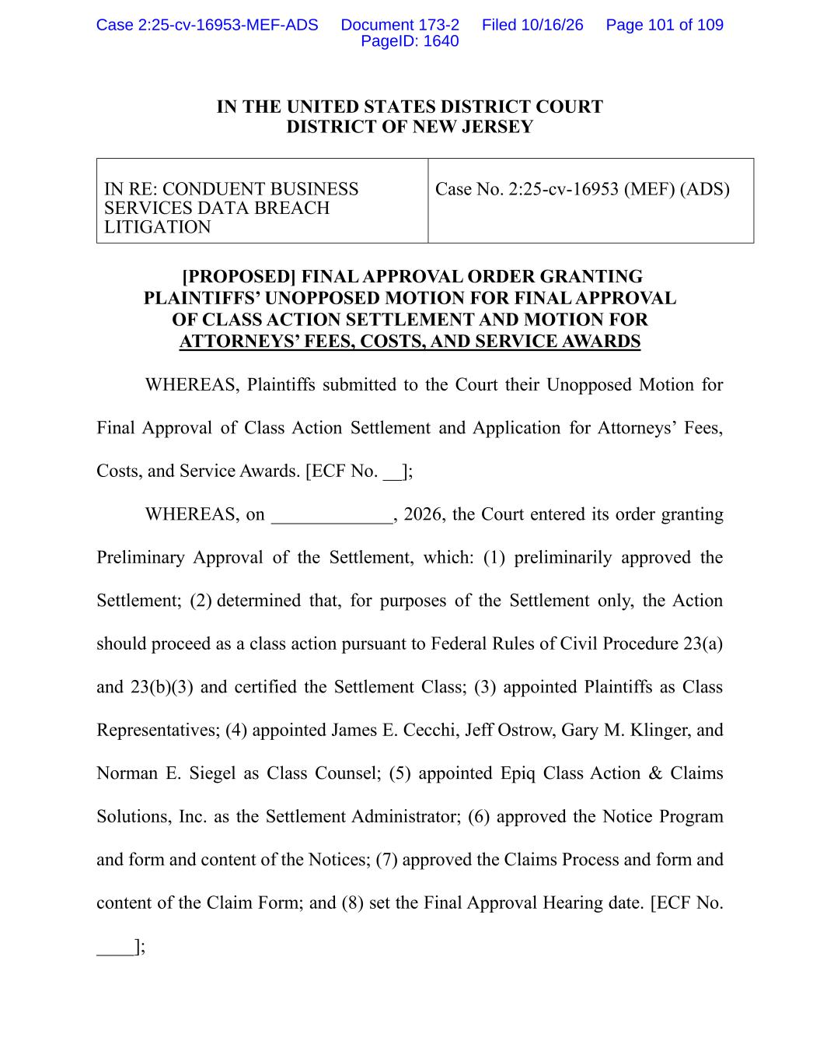
IN THE UNITED STATES DISTRICT COURT DISTRICT OF NEW JERSEY IN RE: CONDUENT BUSINESS SERVICES DATA BREACH LITIGATION Case No. 2:25-cv-16953 (MEF) (ADS) [PROPOSED] FINAL APPROVAL ORDER GRANTING PLAINTIFFS’ UNOPPOSED MOTION FOR FINAL APPROVAL OF CLASS ACTION SETTLEMENT AND MOTION FOR ATTORNEYS’ FEES, COSTS, AND SERVICE AWARDS WHEREAS, Plaintiffs submitted to the Court their Unopposed Motion for Final Approval of Class Action Settlement and Application for Attorneys’ Fees, Costs, and Service Awards. [ECF No. __]; WHEREAS, on _____________, 2026, the Court entered its order granting Preliminary Approval of the Settlement, which: (1) preliminarily approved the Settlement; (2) determined that, for purposes of the Settlement only, the Action should proceed as a class action pursuant to Federal Rules of Civil Procedure 23(a) and 23(b)(3) and certified the Settlement Class; (3) appointed Plaintiffs as Class Representatives; (4) appointed James E. Cecchi, Jeff Ostrow, Gary M. Klinger, and Norman E. Siegel as Class Counsel; (5) appointed Epiq Class Action & Claims Solutions, Inc. as the Settlement Administrator; (6) approved the Notice Program and form and content of the Notices; (7) approved the Claims Process and form and content of the Claim Form; and (8) set the Final Approval Hearing date. [ECF No. ____]; Case 2:25-cv-16953-MEF-ADS Document 173-2 Filed 10/16/26 Page 101 of 109 PageID: 1640

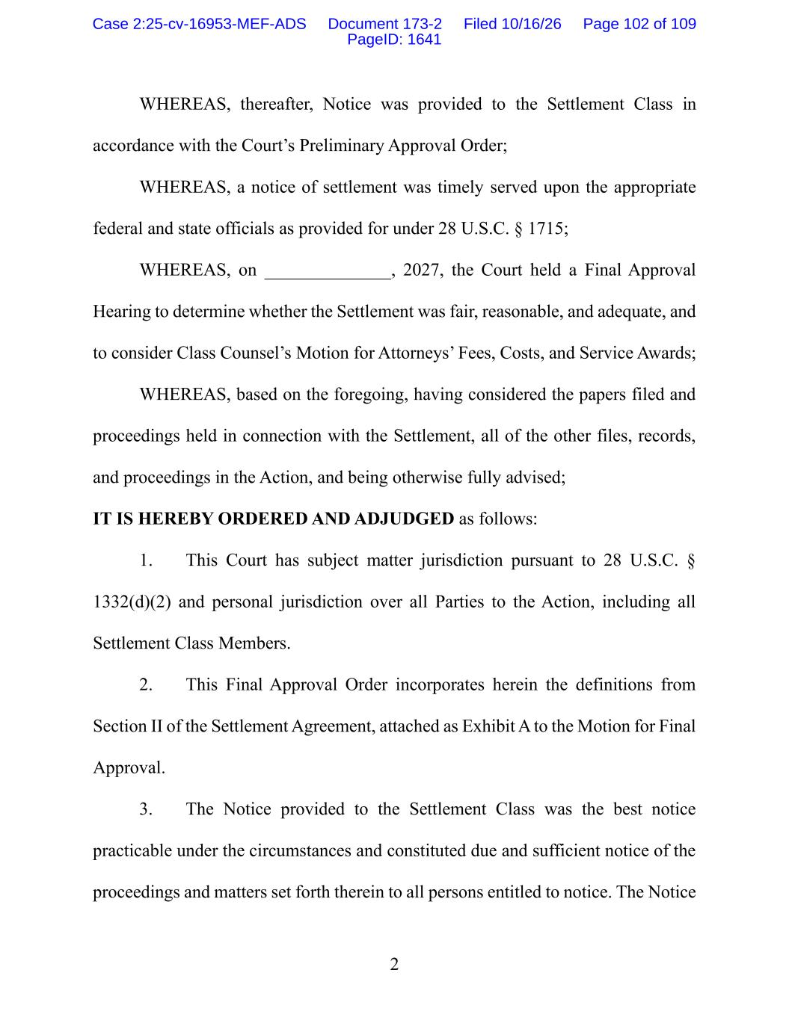
2 WHEREAS, thereafter, Notice was provided to the Settlement Class in accordance with the Court’s Preliminary Approval Order; WHEREAS, a notice of settlement was timely served upon the appropriate federal and state officials as provided for under 28 U.S.C. § 1715; WHEREAS, on ______________, 2027, the Court held a Final Approval Hearing to determine whether the Settlement was fair, reasonable, and adequate, and to consider Class Counsel’s Motion for Attorneys’ Fees, Costs, and Service Awards; WHEREAS, based on the foregoing, having considered the papers filed and proceedings held in connection with the Settlement, all of the other files, records, and proceedings in the Action, and being otherwise fully advised; IT IS HEREBY ORDERED AND ADJUDGED as follows: 1. This Court has subject matter jurisdiction pursuant to 28 U.S.C. § 1332(d)(2) and personal jurisdiction over all Parties to the Action, including all Settlement Class Members. 2. This Final Approval Order incorporates herein the definitions from Section II of the Settlement Agreement, attached as Exhibit A to the Motion for Final Approval. 3. The Notice provided to the Settlement Class was the best notice practicable under the circumstances and constituted due and sufficient notice of the proceedings and matters set forth therein to all persons entitled to notice. The Notice Case 2:25-cv-16953-MEF-ADS Document 173-2 Filed 10/16/26 Page 102 of 109 PageID: 1641

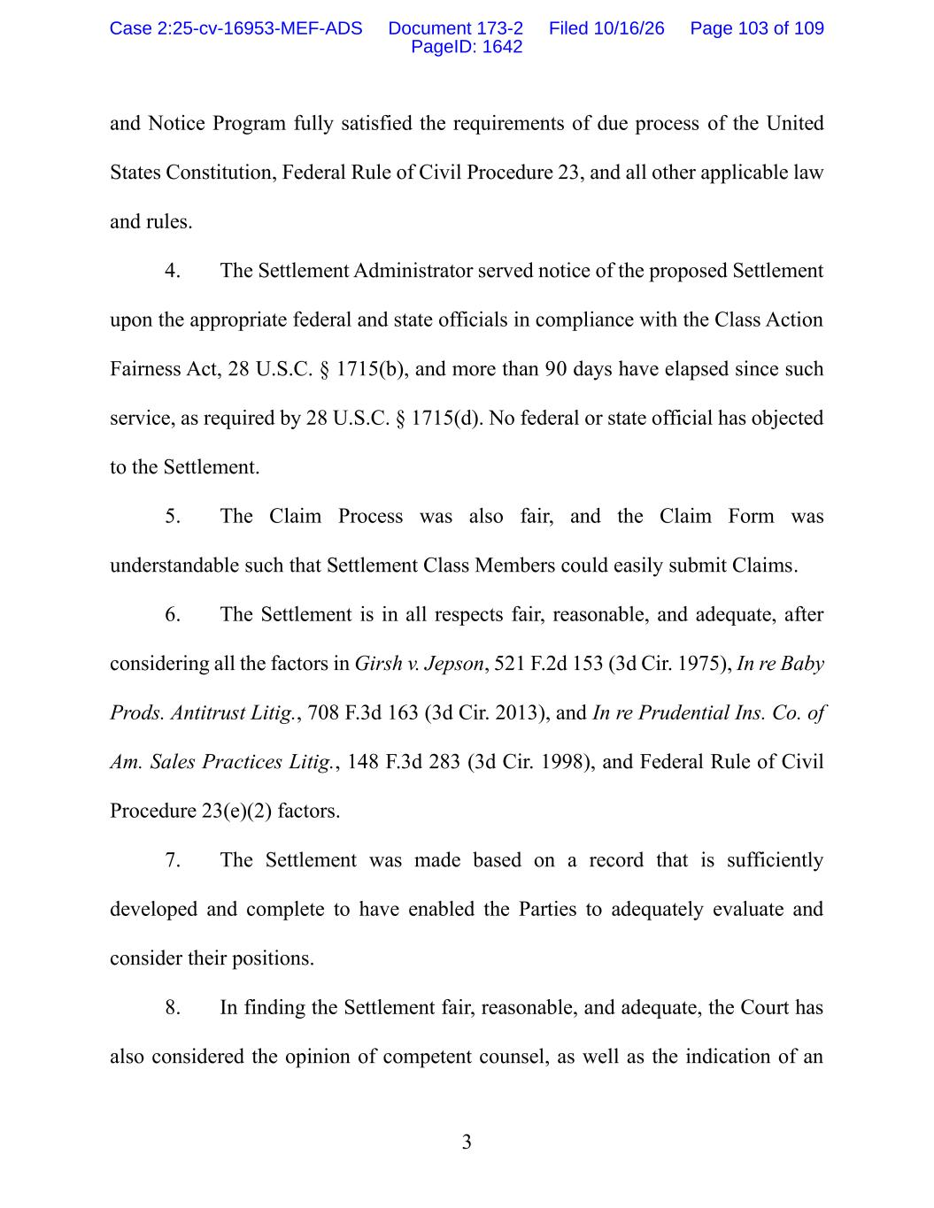
3 and Notice Program fully satisfied the requirements of due process of the United States Constitution, Federal Rule of Civil Procedure 23, and all other applicable law and rules. 4. The Settlement Administrator served notice of the proposed Settlement upon the appropriate federal and state officials in compliance with the Class Action Fairness Act, 28 U.S.C. § 1715(b), and more than 90 days have elapsed since such service, as required by 28 U.S.C. § 1715(d). No federal or state official has objected to the Settlement. 5. The Claim Process was also fair, and the Claim Form was understandable such that Settlement Class Members could easily submit Claims. 6. The Settlement is in all respects fair, reasonable, and adequate, after considering all the factors in Girsh v. Jepson, 521 F.2d 153 (3d Cir. 1975), In re Baby Prods. Antitrust Litig., 708 F.3d 163 (3d Cir. 2013), and In re Prudential Ins. Co. of Am. Sales Practices Litig., 148 F.3d 283 (3d Cir. 1998), and Federal Rule of Civil Procedure 23(e)(2) factors. 7. The Settlement was made based on a record that is sufficiently developed and complete to have enabled the Parties to adequately evaluate and consider their positions. 8. In finding the Settlement fair, reasonable, and adequate, the Court has also considered the opinion of competent counsel, as well as the indication of an Case 2:25-cv-16953-MEF-ADS Document 173-2 Filed 10/16/26 Page 103 of 109 PageID: 1642

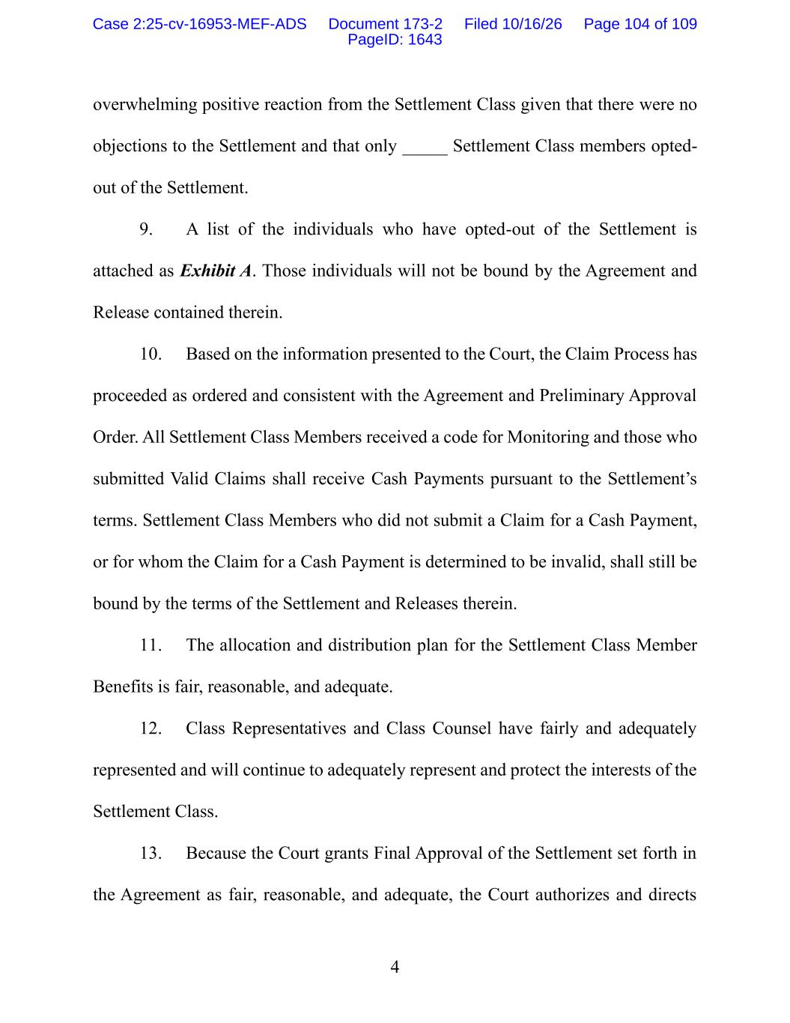
4 overwhelming positive reaction from the Settlement Class given that there were no objections to the Settlement and that only _____ Settlement Class members opted- out of the Settlement. 9. A list of the individuals who have opted-out of the Settlement is attached as Exhibit A. Those individuals will not be bound by the Agreement and Release contained therein. 10. Based on the information presented to the Court, the Claim Process has proceeded as ordered and consistent with the Agreement and Preliminary Approval Order. All Settlement Class Members received a code for Monitoring and those who submitted Valid Claims shall receive Cash Payments pursuant to the Settlement’s terms. Settlement Class Members who did not submit a Claim for a Cash Payment, or for whom the Claim for a Cash Payment is determined to be invalid, shall still be bound by the terms of the Settlement and Releases therein. 11. The allocation and distribution plan for the Settlement Class Member Benefits is fair, reasonable, and adequate. 12. Class Representatives and Class Counsel have fairly and adequately represented and will continue to adequately represent and protect the interests of the Settlement Class. 13. Because the Court grants Final Approval of the Settlement set forth in the Agreement as fair, reasonable, and adequate, the Court authorizes and directs Case 2:25-cv-16953-MEF-ADS Document 173-2 Filed 10/16/26 Page 104 of 109 PageID: 1643

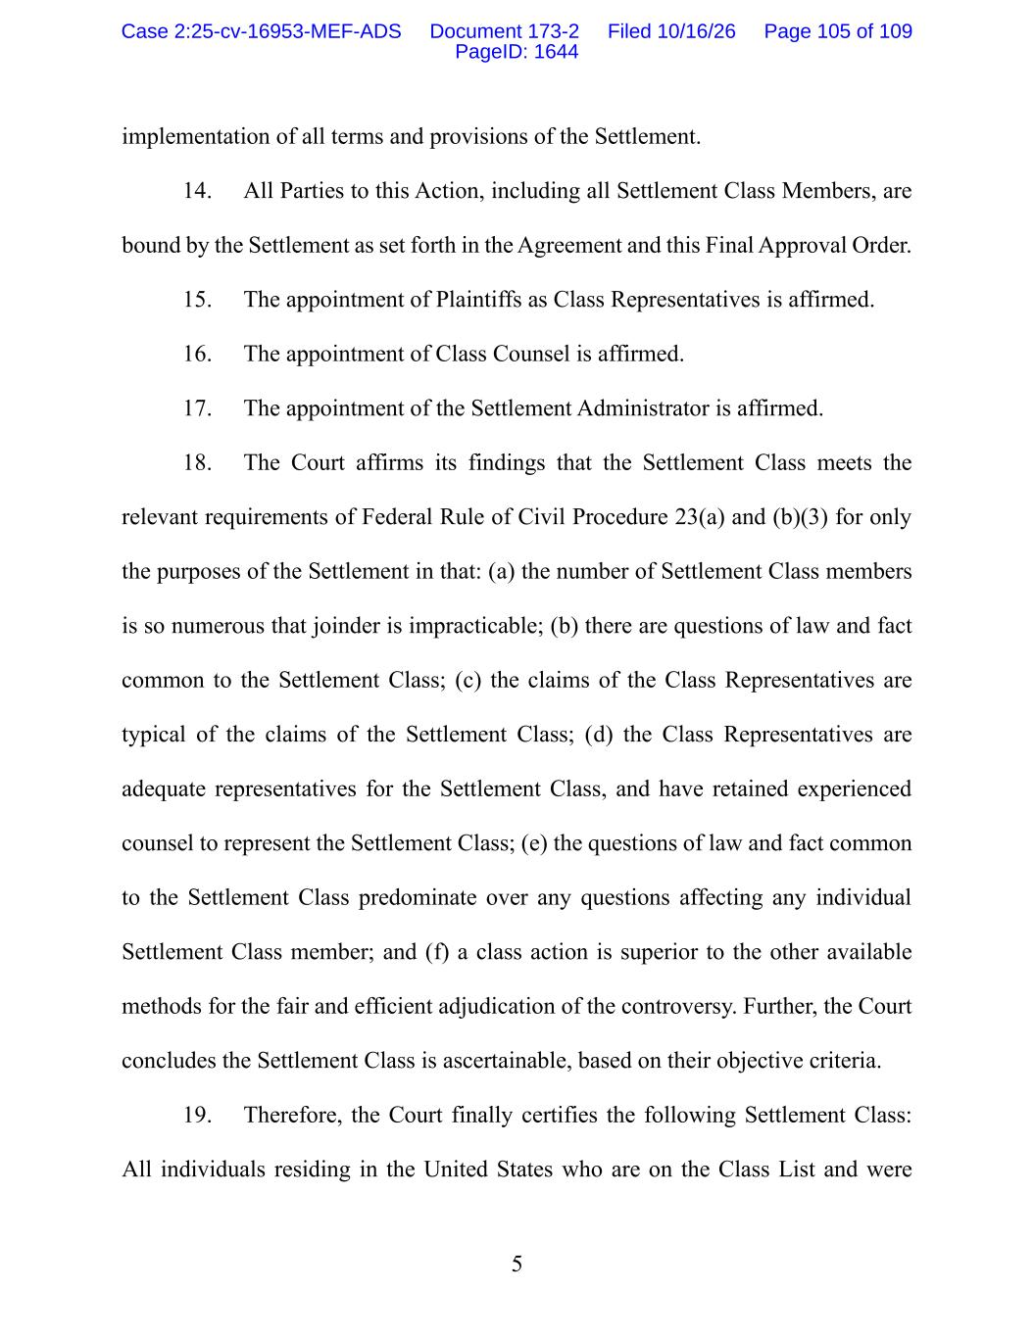
5 implementation of all terms and provisions of the Settlement. 14. All Parties to this Action, including all Settlement Class Members, are bound by the Settlement as set forth in the Agreement and this Final Approval Order. 15. The appointment of Plaintiffs as Class Representatives is affirmed. 16. The appointment of Class Counsel is affirmed. 17. The appointment of the Settlement Administrator is affirmed. 18. The Court affirms its findings that the Settlement Class meets the relevant requirements of Federal Rule of Civil Procedure 23(a) and (b)(3) for only the purposes of the Settlement in that: (a) the number of Settlement Class members is so numerous that joinder is impracticable; (b) there are questions of law and fact common to the Settlement Class; (c) the claims of the Class Representatives are typical of the claims of the Settlement Class; (d) the Class Representatives are adequate representatives for the Settlement Class, and have retained experienced counsel to represent the Settlement Class; (e) the questions of law and fact common to the Settlement Class predominate over any questions affecting any individual Settlement Class member; and (f) a class action is superior to the other available methods for the fair and efficient adjudication of the controversy. Further, the Court concludes the Settlement Class is ascertainable, based on their objective criteria. 19. Therefore, the Court finally certifies the following Settlement Class: All individuals residing in the United States who are on the Class List and were Case 2:25-cv-16953-MEF-ADS Document 173-2 Filed 10/16/26 Page 105 of 109 PageID: 1644

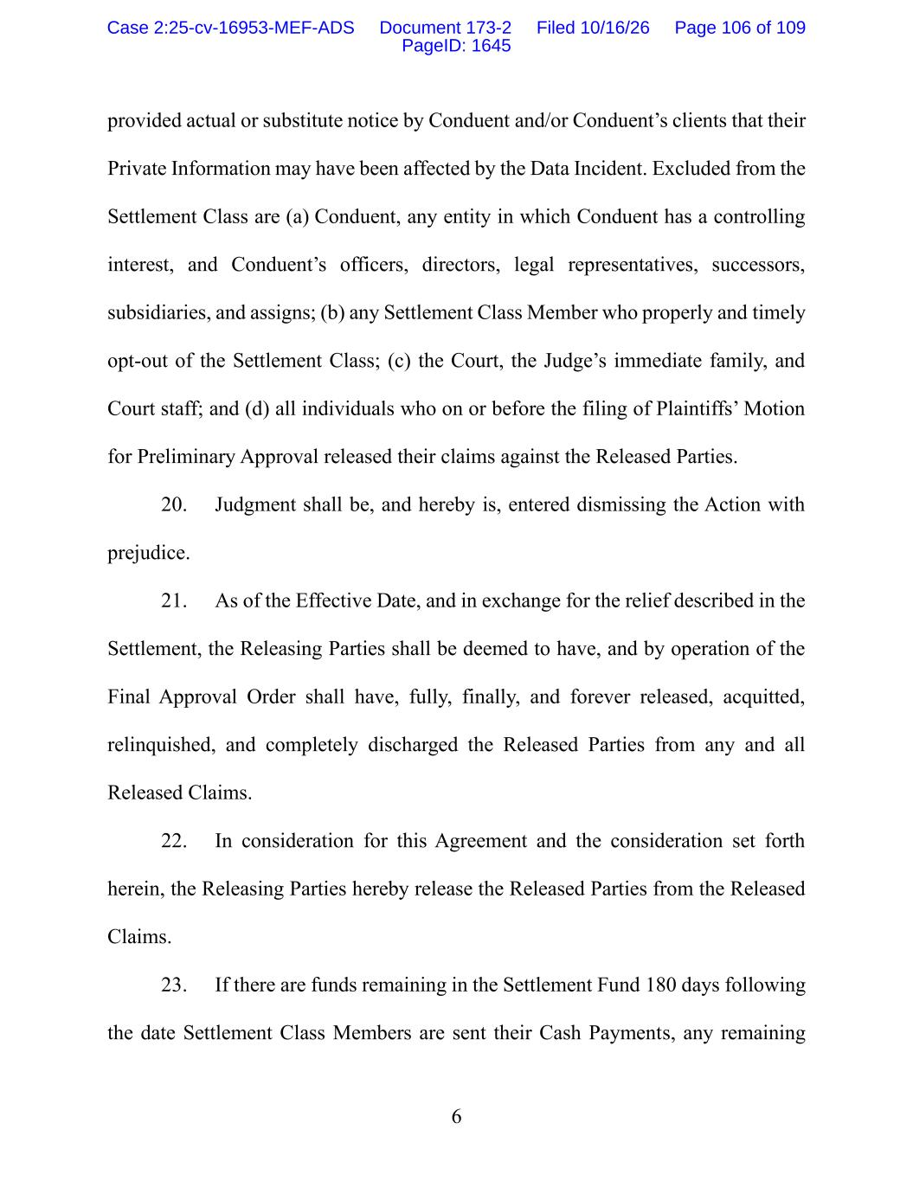
6 provided actual or substitute notice by Conduent and/or Conduent’s clients that their Private Information may have been affected by the Data Incident. Excluded from the Settlement Class are (a) Conduent, any entity in which Conduent has a controlling interest, and Conduent’s officers, directors, legal representatives, successors, subsidiaries, and assigns; (b) any Settlement Class Member who properly and timely opt-out of the Settlement Class; (c) the Court, the Judge’s immediate family, and Court staff; and (d) all individuals who on or before the filing of Plaintiffs’ Motion for Preliminary Approval released their claims against the Released Parties. 20. Judgment shall be, and hereby is, entered dismissing the Action with prejudice. 21. As of the Effective Date, and in exchange for the relief described in the Settlement, the Releasing Parties shall be deemed to have, and by operation of the Final Approval Order shall have, fully, finally, and forever released, acquitted, relinquished, and completely discharged the Released Parties from any and all Released Claims. 22. In consideration for this Agreement and the consideration set forth herein, the Releasing Parties hereby release the Released Parties from the Released Claims. 23. If there are funds remaining in the Settlement Fund 180 days following the date Settlement Class Members are sent their Cash Payments, any remaining Case 2:25-cv-16953-MEF-ADS Document 173-2 Filed 10/16/26 Page 106 of 109 PageID: 1645

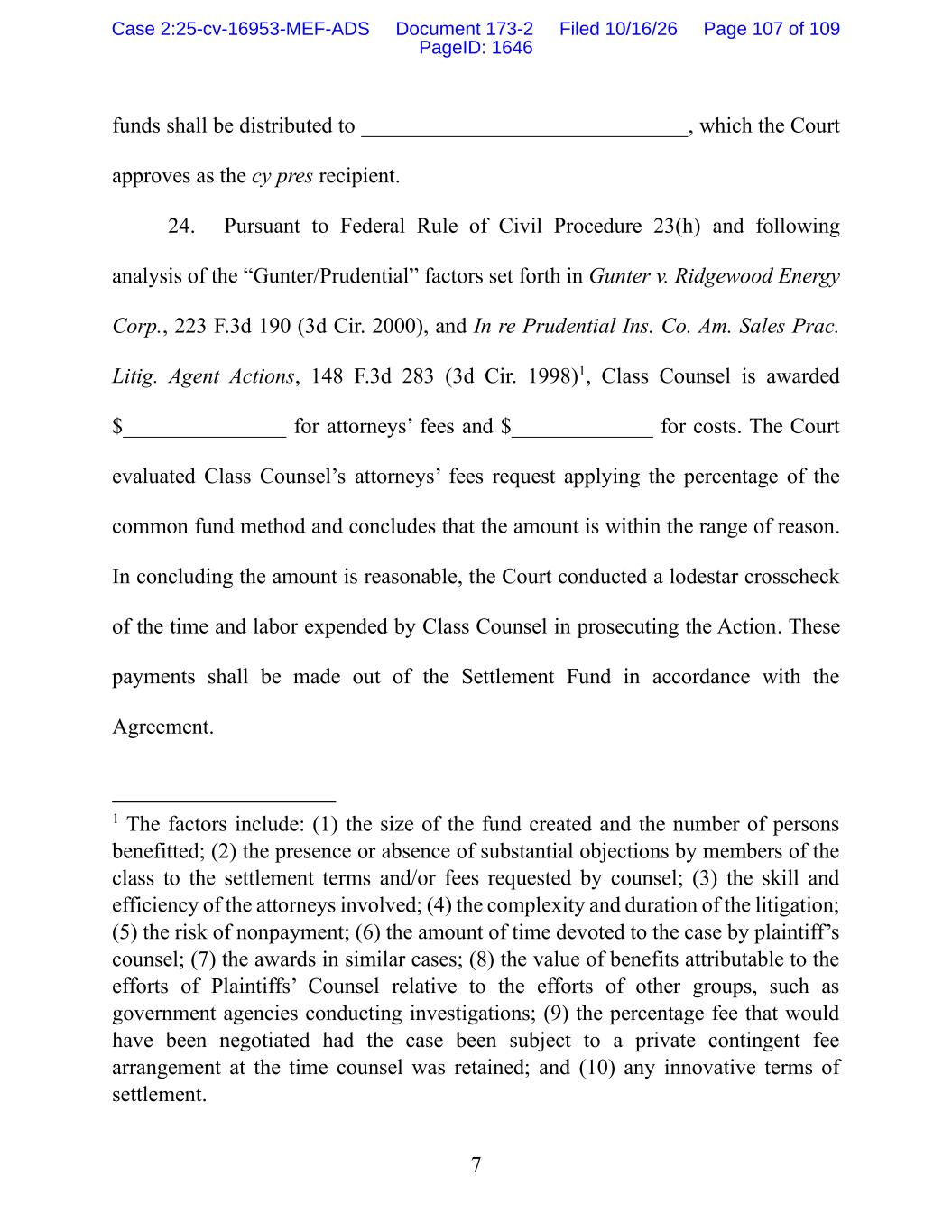
7 funds shall be distributed to ______________________________, which the Court approves as the cy pres recipient. 24. Pursuant to Federal Rule of Civil Procedure 23(h) and following analysis of the “Gunter/Prudential” factors set forth in Gunter v. Ridgewood Energy Corp., 223 F.3d 190 (3d Cir. 2000), and In re Prudential Ins. Co. Am. Sales Prac. Litig. Agent Actions, 148 F.3d 283 (3d Cir. 1998)1, Class Counsel is awarded $_______________ for attorneys’ fees and $_____________ for costs. The Court evaluated Class Counsel’s attorneys’ fees request applying the percentage of the common fund method and concludes that the amount is within the range of reason. In concluding the amount is reasonable, the Court conducted a lodestar crosscheck of the time and labor expended by Class Counsel in prosecuting the Action. These payments shall be made out of the Settlement Fund in accordance with the Agreement. 1 The factors include: (1) the size of the fund created and the number of persons benefitted; (2) the presence or absence of substantial objections by members of the class to the settlement terms and/or fees requested by counsel; (3) the skill and efficiency of the attorneys involved; (4) the complexity and duration of the litigation; (5) the risk of nonpayment; (6) the amount of time devoted to the case by plaintiff’s counsel; (7) the awards in similar cases; (8) the value of benefits attributable to the efforts of Plaintiffs’ Counsel relative to the efforts of other groups, such as government agencies conducting investigations; (9) the percentage fee that would have been negotiated had the case been subject to a private contingent fee arrangement at the time counsel was retained; and (10) any innovative terms of settlement. Case 2:25-cv-16953-MEF-ADS Document 173-2 Filed 10/16/26 Page 107 of 109 PageID: 1646

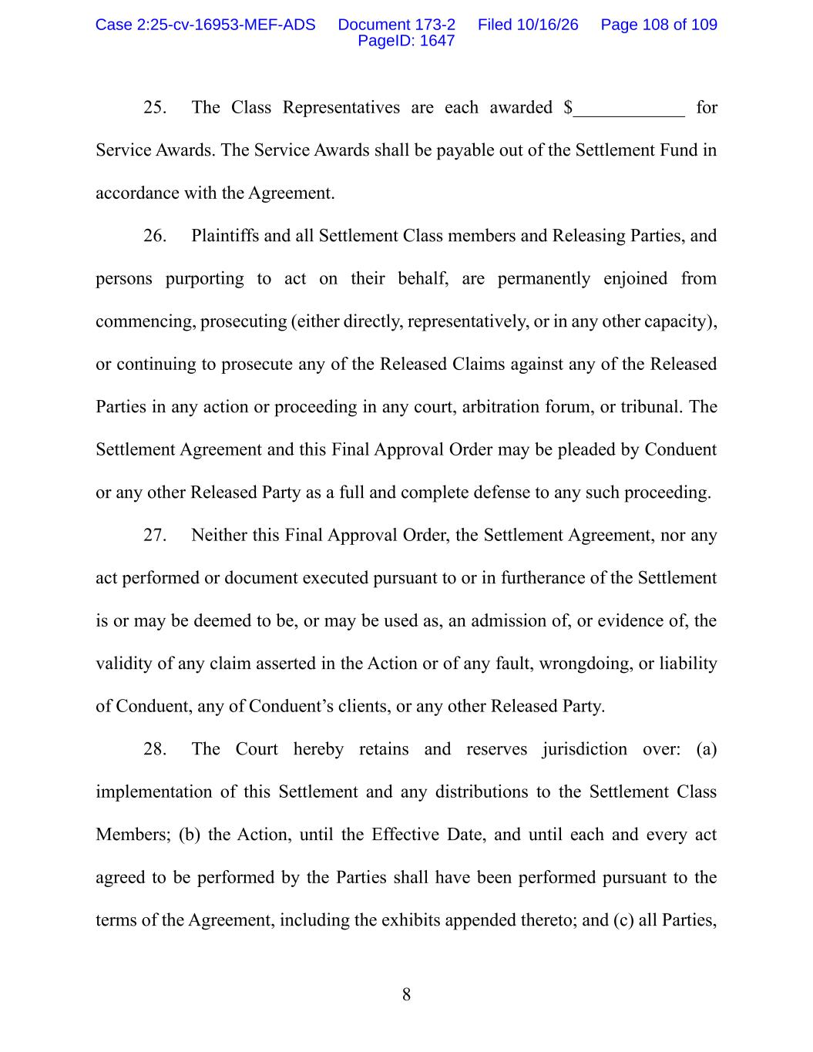
8 25. The Class Representatives are each awarded $____________ for Service Awards. The Service Awards shall be payable out of the Settlement Fund in accordance with the Agreement. 26. Plaintiffs and all Settlement Class members and Releasing Parties, and persons purporting to act on their behalf, are permanently enjoined from commencing, prosecuting (either directly, representatively, or in any other capacity), or continuing to prosecute any of the Released Claims against any of the Released Parties in any action or proceeding in any court, arbitration forum, or tribunal. The Settlement Agreement and this Final Approval Order may be pleaded by Conduent or any other Released Party as a full and complete defense to any such proceeding. 27. Neither this Final Approval Order, the Settlement Agreement, nor any act performed or document executed pursuant to or in furtherance of the Settlement is or may be deemed to be, or may be used as, an admission of, or evidence of, the validity of any claim asserted in the Action or of any fault, wrongdoing, or liability of Conduent, any of Conduent’s clients, or any other Released Party. 28. The Court hereby retains and reserves jurisdiction over: (a) implementation of this Settlement and any distributions to the Settlement Class Members; (b) the Action, until the Effective Date, and until each and every act agreed to be performed by the Parties shall have been performed pursuant to the terms of the Agreement, including the exhibits appended thereto; and (c) all Parties, Case 2:25-cv-16953-MEF-ADS Document 173-2 Filed 10/16/26 Page 108 of 109 PageID: 1647

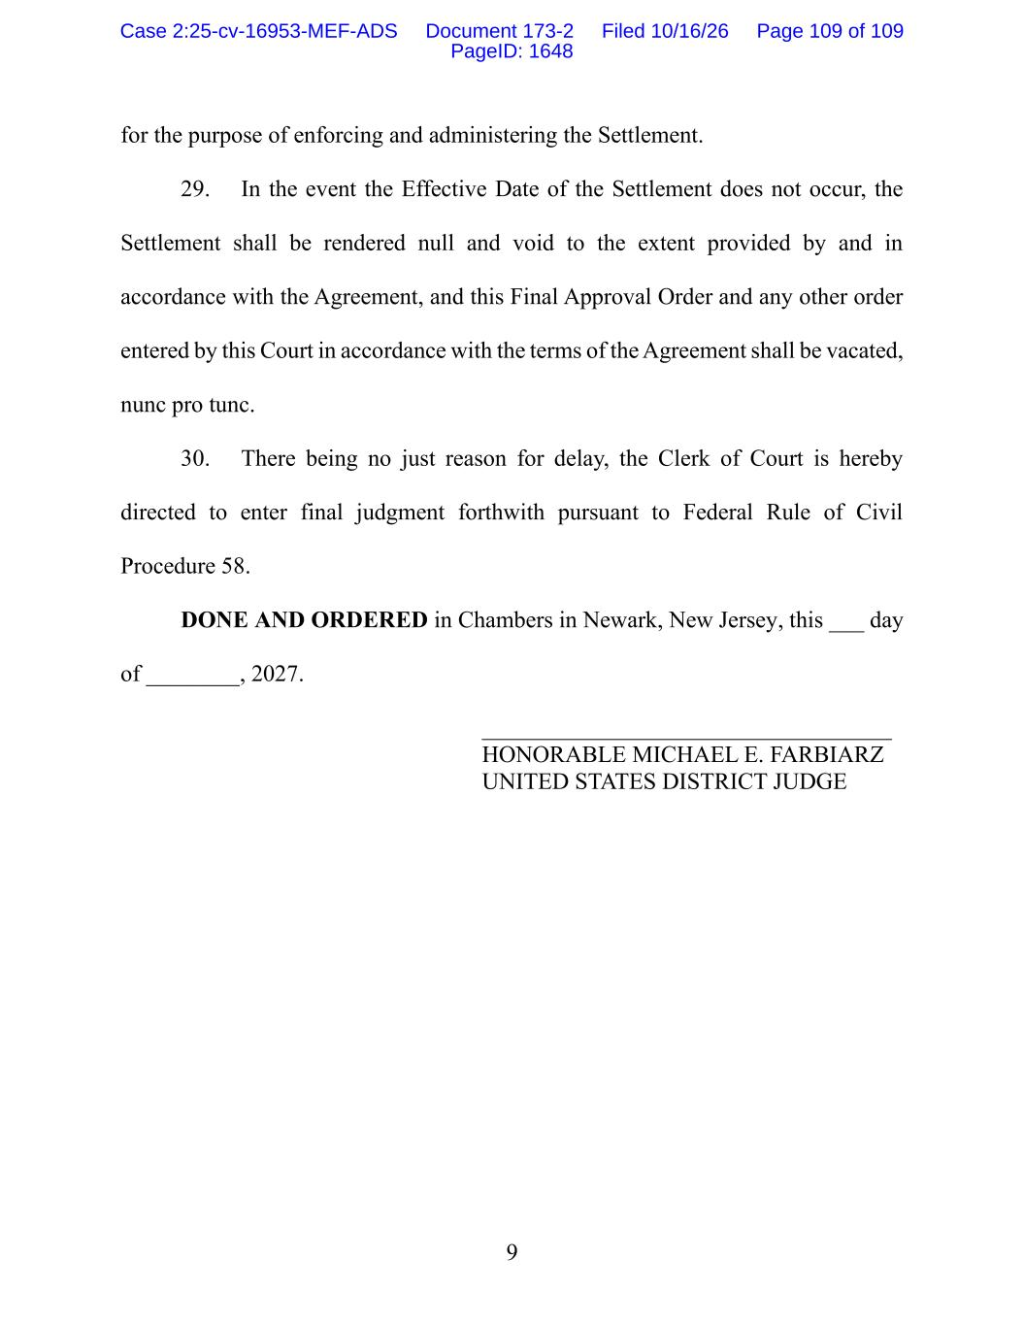
9 for the purpose of enforcing and administering the Settlement. 29. In the event the Effective Date of the Settlement does not occur, the Settlement shall be rendered null and void to the extent provided by and in accordance with the Agreement, and this Final Approval Order and any other order entered by this Court in accordance with the terms of the Agreement shall be vacated, nunc pro tunc. 30. There being no just reason for delay, the Clerk of Court is hereby directed to enter final judgment forthwith pursuant to Federal Rule of Civil Procedure 58. DONE AND ORDERED in Chambers in Newark, New Jersey, this ___ day of ________, 2027. ___________________________________ HONORABLE MICHAEL E. FARBIARZ UNITED STATES DISTRICT JUDGE Case 2:25-cv-16953-MEF-ADS Document 173-2 Filed 10/16/26 Page 109 of 109 PageID: 1648

