UNITED STATES
SECURITIES AND EXCHANGE COMMISSION
Washington, D.C. 20549
FORM 8-K

CURRENT REPORT
Pursuant to Section 13 or 15(d)
of the Securities Exchange Act of 1934

Date of Report (date of earliest event reported): October 14, 2026

CONDUENT INCORPORATED
(Exact name of registrant as specified in its charter)
New York |  |  |  |  |  | 001-37817 |  |  |  |  |  | 81-2983623
(State or other jurisdiction of  incorporation or organization) |  |  |  |  |  | (Commission  File Number) |  |  |  |  |  | (IRS Employer  Identification No.)
100 Campus Drive, |  |  |  |  |  | Suite 200,
Florham Park, |  |  | New Jersey
07932
(Address of principal executive offices) (Zip Code)

Registrant’s telephone number, including area code: (844) 663-2638
Not Applicable
(Former name or former address, if changed since last report)
Check the appropriate box below if the Form 8-K filing is intended to simultaneously satisfy the filing obligation of the registrant under any of the following provisions (see General Instruction A.2. below):

☐ |  |  | Written communications pursuant to Rule 425 under the Securities Act (17 CFR 230.425)
☐ |  |  | Soliciting material pursuant to Rule 14a-12 under the Exchange Act (17 CFR 240.14a-12)
☐ |  |  | Pre-commencement communications pursuant to Rule 14d-2(b) under the Exchange Act (17 CFR 240.14d-2(b))
☐ |  |  | Pre-commencement communications pursuant to Rule 13e-4(c) under the Exchange Act (17 CFR 240.13e-4(c))

Securities registered pursuant to Section 12(b) of the Act:
Title of each class |  |  | Trading Symbol(s) |  |  | Name of each exchange on which registered
Common Stock, $0.01 par value |  |  | CNDT |  |  | NASDAQ Global Select Market
Indicate by check mark whether the registrant is an emerging growth company as defined in Rule 405 of the Securities Act of 1933 (CFR 230.405) or Rule 12b-2 of the Securities Exchange Act of 1934 (CFR 240.12b-2).
Emerging Growth Company ☐
If an emerging growth company, indicate by check mark if the registrant has elected not to use the extended transition period for complying with any new or revised financial accounting standards provided pursuant to Section 13(a) of the Exchange Act. ☐

Item 1.01 Entry into a Material Definitive Agreement.
Conduent Incorporated (the “Company”) and its revolving credit lenders are finalizing the refinancing of its revolving credit facilities. In connection therewith, on October 14, 2026, the Company, Conduent Business Services, LLC, Conduent State & Local Solutions, Inc. and Affiliated Computer Services International B.V. (collectively, the “Company Parties”), and certain subsidiaries of the Company, as guarantors, entered into Amendment No. 4 (the “Amendment”), with certain revolving credit lenders party thereto and Bank of America, N.A., as administrative agent and collateral agent (the “Agent”), to the Credit Agreement, dated as of October 15, 2021, among the Company Parties, the lenders from time to time party thereto, L/C issuers party thereto and the Agent, to extend the maturity date of the revolving credit commitments scheduled to mature on October 15, 2026 to October 30, 2026. The maturity dates of the remaining revolving credit commitments are not affected by the Amendment.
The foregoing description of the Amendment does not purport to be complete and is qualified in its entirety by reference to the full text of the Amendment, a copy of which is filed as Exhibit 10.1 hereto, and is incorporated herein by reference.
Item 2.03 Creation of a Direct Financial Obligation or an Obligation under an Off-Balance Sheet Arrangement of a Registrant.
The information set forth under Item 1.01 of this Current Report on Form 8-K is incorporated by reference into this Item 2.03.

Item 9.01 Financial Statements and Exhibits.
(d) Exhibits.
Exhibit No. |  |  |  |  |  | Description
10.1 |  |  |  |  |  | Amendment No. 4 to Credit Agreement, dated as of October 14, 2026, among Conduent Business Services, LLC, Conduent State & Local Solutions, Inc., Affiliated Computer Services International B.V., Conduent Incorporated, the other guarantors party thereto, the lenders party thereto and Bank of America, N.A., as administrative agent and collateral agent.
104 |  |  |  |  |  | Cover Page Interactive Data File (embedded within the Inline XBRL document)

Forward-Looking Statements
This Report and any exhibits to this Report may contain "forward-looking statements" as defined in the Private Securities Litigation Reform Act of 1995, as amended. The words "anticipate," "believe," "estimate," "expect," "plan," "intend," "will," "aim," "should," "could," "forecast," "target," "may," "continue to," "endeavor," "if," "growing," "projected," "potential," "likely," "see," "ahead," "further," "going forward," "on the horizon," and similar expressions (including the negative and plural forms of such words and phrases), as they relate to us, are intended to identify forward-looking statements, but the absence of these words does not mean that a statement is not forward-looking. These statements include, but may not be limited to, statements regarding the refinancing of the Company's revolving credit facilities and the Company's discussions with its revolving credit lenders. These statements reflect our current views with respect to future events and are subject to certain risks, uncertainties and assumptions, many of which are outside of our control, that could cause actual results to differ materially from those expected or implied by such forward-looking statements contained in this Report, any exhibits to this Report and other public statements we make. Important factors and uncertainties that could cause our actual results to differ materially from those in our forward-looking statements include, but are not limited to: our significant indebtedness and the terms of such indebtedness; our ability to refinance, extend or replace our indebtedness, including our revolving credit facilities, on acceptable terms or at all; our failure to obtain or maintain a satisfactory credit rating and financial performance; and other factors that are set forth in the "Risk Factors" and other sections of our Annual Report on Form 10-K, as well as in our Quarterly Reports on Form 10-Q and Current Reports on Form 8-K filed with or furnished to the Securities and Exchange Commission. Any forward-looking statements made by us in this Report speak only as of the date on which they are made. We are under no obligation to, and expressly disclaim any obligation to, update or alter our forward-looking statements, whether because of new information, subsequent events or otherwise, except as required by law.

SIGNATURES
Pursuant to the requirements of the Securities Exchange Act of 1934, Registrant has duly authorized this report to be signed on its behalf by the undersigned duly authorized.
Date: October 15, 2026

CONDUENT INCORPORATED
By: |  |  |  |  |  | /s/ GEORGE ABATE
 |  |  |  |  |  | George Abate
 |  |  |  |  |  | Vice President and Chief Accounting Officer

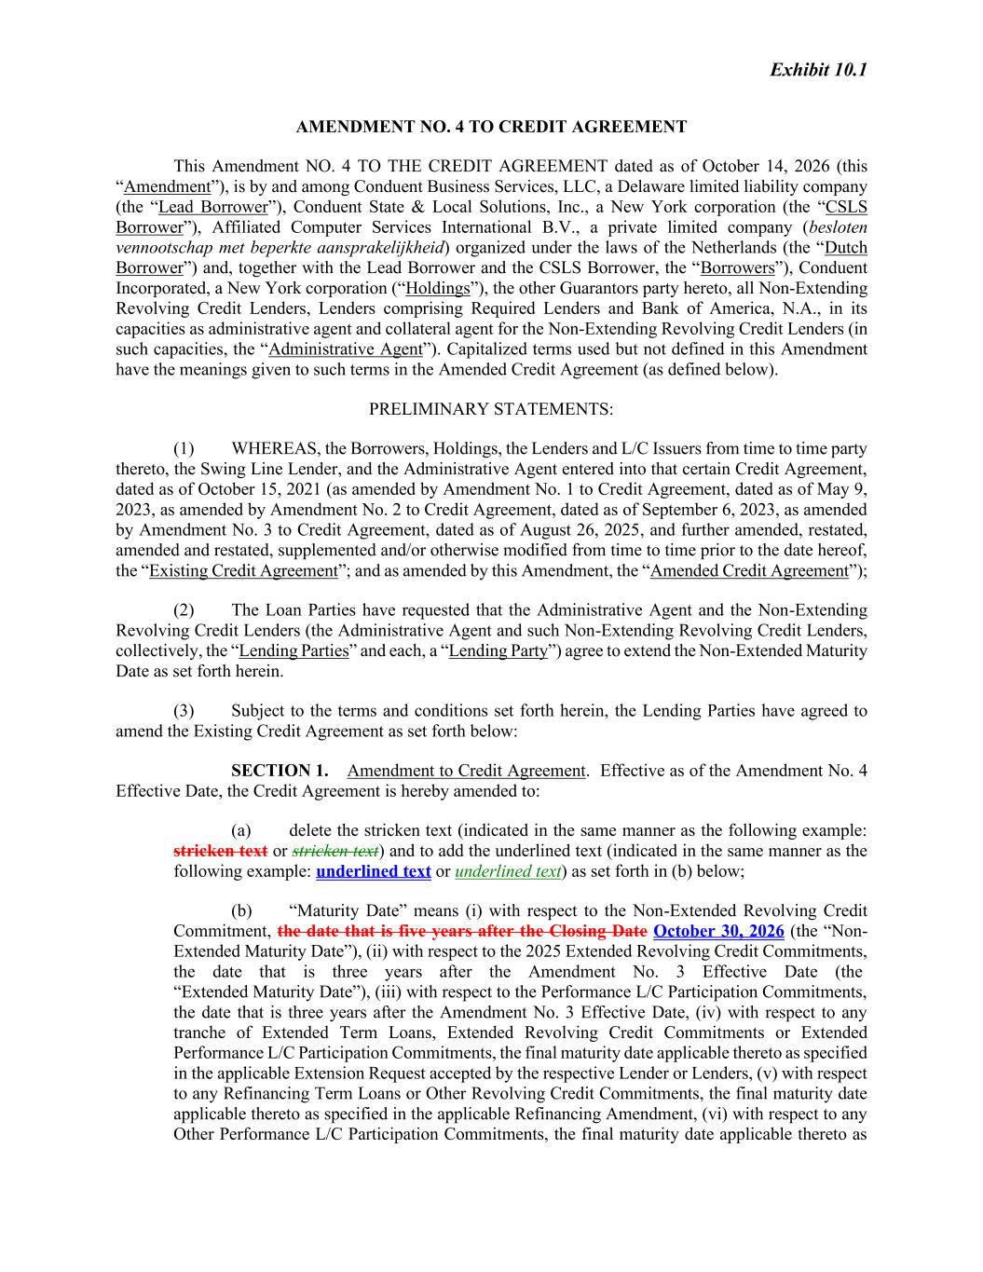

Exhibit 10.1 AMENDMENT NO. 4 TO CREDIT AGREEMENT This Amendment NO. 4 TO THE CREDIT AGREEMENT dated as of October 14, 2026 (this “Amendment”), is by and among Conduent Business Services, LLC, a Delaware limited liability company (the “Lead Borrower”), Conduent State & Local Solutions, Inc., a New York corporation (the “CSLS Borrower”), Affiliated Computer Services International B.V., a private limited company (besloten vennootschap met beperkte aansprakelijkheid) organized under the laws of the Netherlands (the “Dutch Borrower”) and, together with the Lead Borrower and the CSLS Borrower, the “Borrowers”), Conduent Incorporated, a New York corporation (“Holdings”), the other Guarantors party hereto, all Non-Extending Revolving Credit Lenders, Lenders comprising Required Lenders and Bank of America, N.A., in its capacities as administrative agent and collateral agent for the Non-Extending Revolving Credit Lenders (in such capacities, the “Administrative Agent”). Capitalized terms used but not defined in this Amendment have the meanings given to such terms in the Amended Credit Agreement (as defined below). PRELIMINARY STATEMENTS: (1) WHEREAS, the Borrowers, Holdings, the Lenders and L/C Issuers from time to time party thereto, the Swing Line Lender, and the Administrative Agent entered into that certain Credit Agreement, dated as of October 15, 2021 (as amended by Amendment No. 1 to Credit Agreement, dated as of May 9, 2023, as amended by Amendment No. 2 to Credit Agreement, dated as of September 6, 2023, as amended by Amendment No. 3 to Credit Agreement, dated as of August 26, 2025, and further amended, restated, amended and restated, supplemented and/or otherwise modified from time to time prior to the date hereof, the “Existing Credit Agreement”; and as amended by this Amendment, the “Amended Credit Agreement”); (2) The Loan Parties have requested that the Administrative Agent and the Non-Extending Revolving Credit Lenders (the Administrative Agent and such Non-Extending Revolving Credit Lenders, collectively, the “Lending Parties” and each, a “Lending Party”) agree to extend the Non-Extended Maturity Date as set forth herein. (3) Subject to the terms and conditions set forth herein, the Lending Parties have agreed to amend the Existing Credit Agreement as set forth below: SECTION 1. Amendment to Credit Agreement. Effective as of the Amendment No. 4 Effective Date, the Credit Agreement is hereby amended to: (a) delete the stricken text (indicated in the same manner as the following example: stricken text or stricken text) and to add the underlined text (indicated in the same manner as the following example: underlined text or underlined text) as set forth in (b) below; (b) “Maturity Date” means (i) with respect to the Non-Extended Revolving Credit Commitment, the date that is five years after the Closing Date October 30, 2026 (the “Non- Extended Maturity Date”), (ii) with respect to the 2025 Extended Revolving Credit Commitments, the date that is three years after the Amendment No. 3 Effective Date (the “Extended Maturity Date”), (iii) with respect to the Performance L/C Participation Commitments, the date that is three years after the Amendment No. 3 Effective Date, (iv) with respect to any tranche of Extended Term Loans, Extended Revolving Credit Commitments or Extended Performance L/C Participation Commitments, the final maturity date applicable thereto as specified in the applicable Extension Request accepted by the respective Lender or Lenders, (v) with respect to any Refinancing Term Loans or Other Revolving Credit Commitments, the final maturity date applicable thereto as specified in the applicable Refinancing Amendment, (vi) with respect to any Other Performance L/C Participation Commitments, the final maturity date applicable thereto as

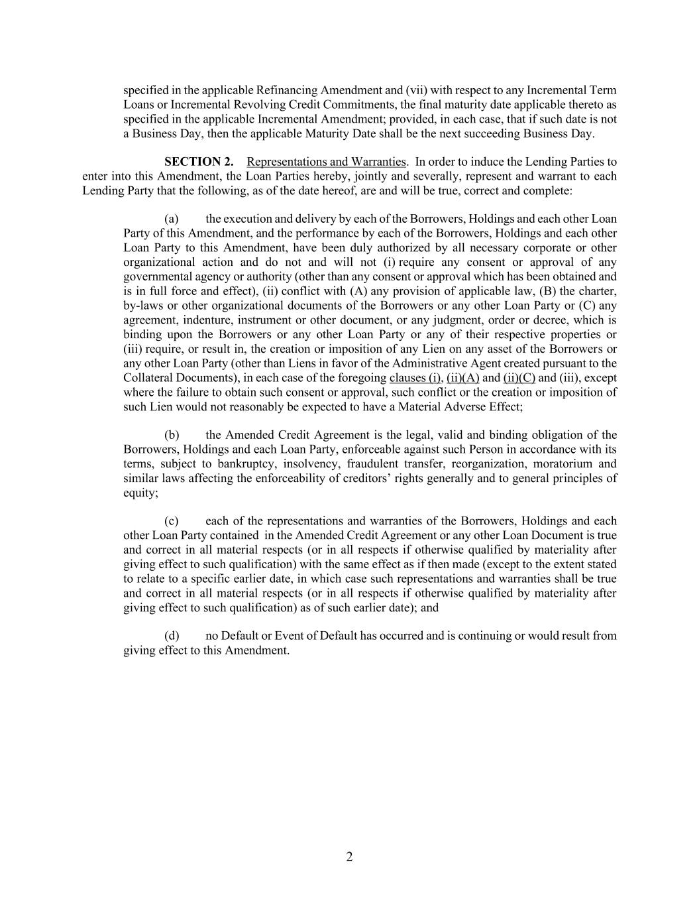
2 specified in the applicable Refinancing Amendment and (vii) with respect to any Incremental Term Loans or Incremental Revolving Credit Commitments, the final maturity date applicable thereto as specified in the applicable Incremental Amendment; provided, in each case, that if such date is not a Business Day, then the applicable Maturity Date shall be the next succeeding Business Day. SECTION 2. Representations and Warranties. In order to induce the Lending Parties to enter into this Amendment, the Loan Parties hereby, jointly and severally, represent and warrant to each Lending Party that the following, as of the date hereof, are and will be true, correct and complete: (a) the execution and delivery by each of the Borrowers, Holdings and each other Loan Party of this Amendment, and the performance by each of the Borrowers, Holdings and each other Loan Party to this Amendment, have been duly authorized by all necessary corporate or other organizational action and do not and will not (i) require any consent or approval of any governmental agency or authority (other than any consent or approval which has been obtained and is in full force and effect), (ii) conflict with (A) any provision of applicable law, (B) the charter, by-laws or other organizational documents of the Borrowers or any other Loan Party or (C) any agreement, indenture, instrument or other document, or any judgment, order or decree, which is binding upon the Borrowers or any other Loan Party or any of their respective properties or (iii) require, or result in, the creation or imposition of any Lien on any asset of the Borrowers or any other Loan Party (other than Liens in favor of the Administrative Agent created pursuant to the Collateral Documents), in each case of the foregoing clauses (i), (ii)(A) and (ii)(C) and (iii), except where the failure to obtain such consent or approval, such conflict or the creation or imposition of such Lien would not reasonably be expected to have a Material Adverse Effect; (b) the Amended Credit Agreement is the legal, valid and binding obligation of the Borrowers, Holdings and each Loan Party, enforceable against such Person in accordance with its terms, subject to bankruptcy, insolvency, fraudulent transfer, reorganization, moratorium and similar laws affecting the enforceability of creditors’ rights generally and to general principles of equity; (c) each of the representations and warranties of the Borrowers, Holdings and each other Loan Party contained in the Amended Credit Agreement or any other Loan Document is true and correct in all material respects (or in all respects if otherwise qualified by materiality after giving effect to such qualification) with the same effect as if then made (except to the extent stated to relate to a specific earlier date, in which case such representations and warranties shall be true and correct in all material respects (or in all respects if otherwise qualified by materiality after giving effect to such qualification) as of such earlier date); and (d) no Default or Event of Default has occurred and is continuing or would result from giving effect to this Amendment.

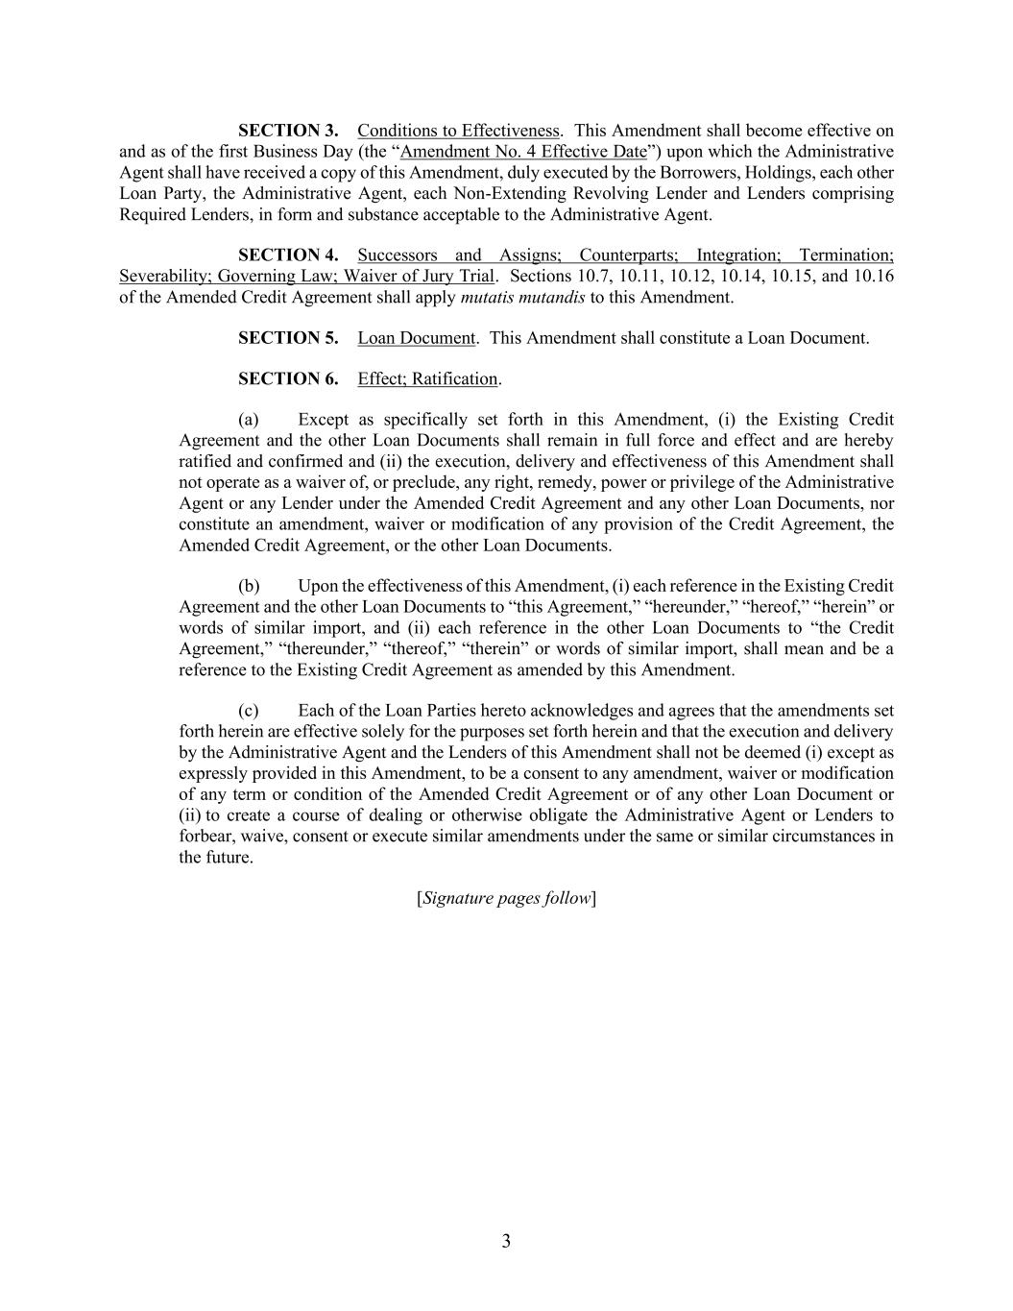
3 SECTION 3. Conditions to Effectiveness. This Amendment shall become effective on and as of the first Business Day (the “Amendment No. 4 Effective Date”) upon which the Administrative Agent shall have received a copy of this Amendment, duly executed by the Borrowers, Holdings, each other Loan Party, the Administrative Agent, each Non-Extending Revolving Lender and Lenders comprising Required Lenders, in form and substance acceptable to the Administrative Agent. SECTION 4. Successors and Assigns; Counterparts; Integration; Termination; Severability; Governing Law; Waiver of Jury Trial. Sections 10.7, 10.11, 10.12, 10.14, 10.15, and 10.16 of the Amended Credit Agreement shall apply mutatis mutandis to this Amendment. SECTION 5. Loan Document. This Amendment shall constitute a Loan Document. SECTION 6. Effect; Ratification. (a) Except as specifically set forth in this Amendment, (i) the Existing Credit Agreement and the other Loan Documents shall remain in full force and effect and are hereby ratified and confirmed and (ii) the execution, delivery and effectiveness of this Amendment shall not operate as a waiver of, or preclude, any right, remedy, power or privilege of the Administrative Agent or any Lender under the Amended Credit Agreement and any other Loan Documents, nor constitute an amendment, waiver or modification of any provision of the Credit Agreement, the Amended Credit Agreement, or the other Loan Documents. (b) Upon the effectiveness of this Amendment, (i) each reference in the Existing Credit Agreement and the other Loan Documents to “this Agreement,” “hereunder,” “hereof,” “herein” or words of similar import, and (ii) each reference in the other Loan Documents to “the Credit Agreement,” “thereunder,” “thereof,” “therein” or words of similar import, shall mean and be a reference to the Existing Credit Agreement as amended by this Amendment. (c) Each of the Loan Parties hereto acknowledges and agrees that the amendments set forth herein are effective solely for the purposes set forth herein and that the execution and delivery by the Administrative Agent and the Lenders of this Amendment shall not be deemed (i) except as expressly provided in this Amendment, to be a consent to any amendment, waiver or modification of any term or condition of the Amended Credit Agreement or of any other Loan Document or (ii) to create a course of dealing or otherwise obligate the Administrative Agent or Lenders to forbear, waive, consent or execute similar amendments under the same or similar circumstances in the future. [Signature pages follow]

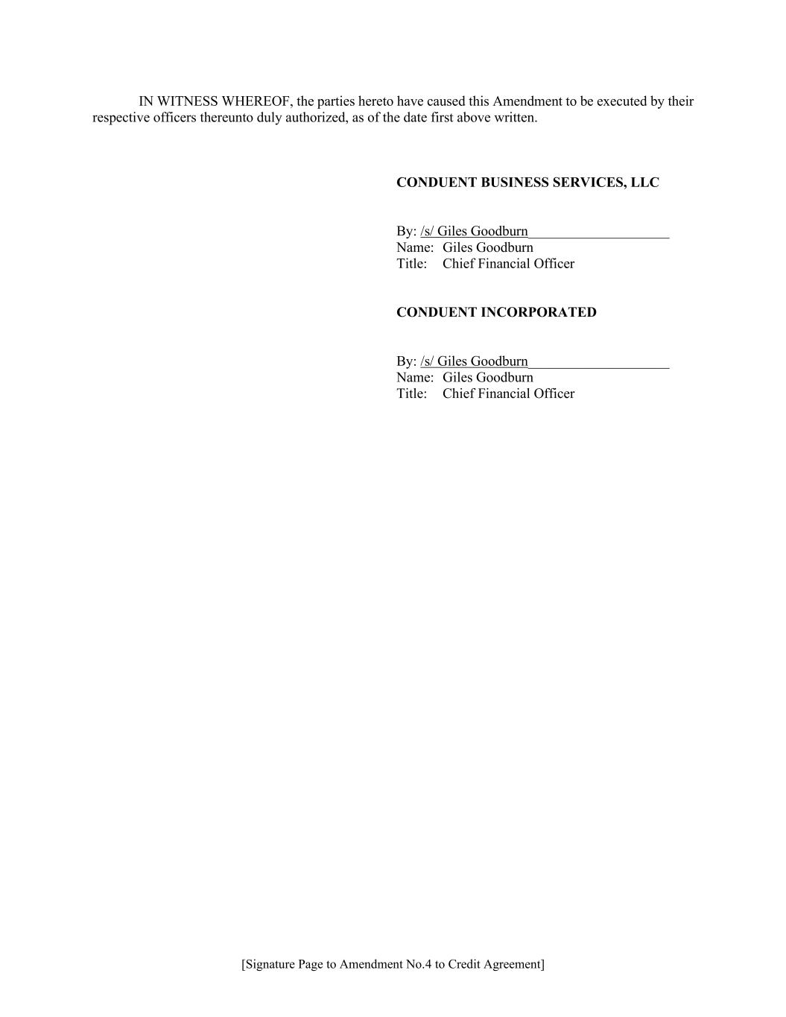
[Signature Page to Amendment No.4 to Credit Agreement] IN WITNESS WHEREOF, the parties hereto have caused this Amendment to be executed by their respective officers thereunto duly authorized, as of the date first above written. CONDUENT BUSINESS SERVICES, LLC By: /s/ Giles Goodburn____________________ Name: Giles Goodburn Title: Chief Financial Officer CONDUENT INCORPORATED By: /s/ Giles Goodburn____________________ Name: Giles Goodburn Title: Chief Financial Officer

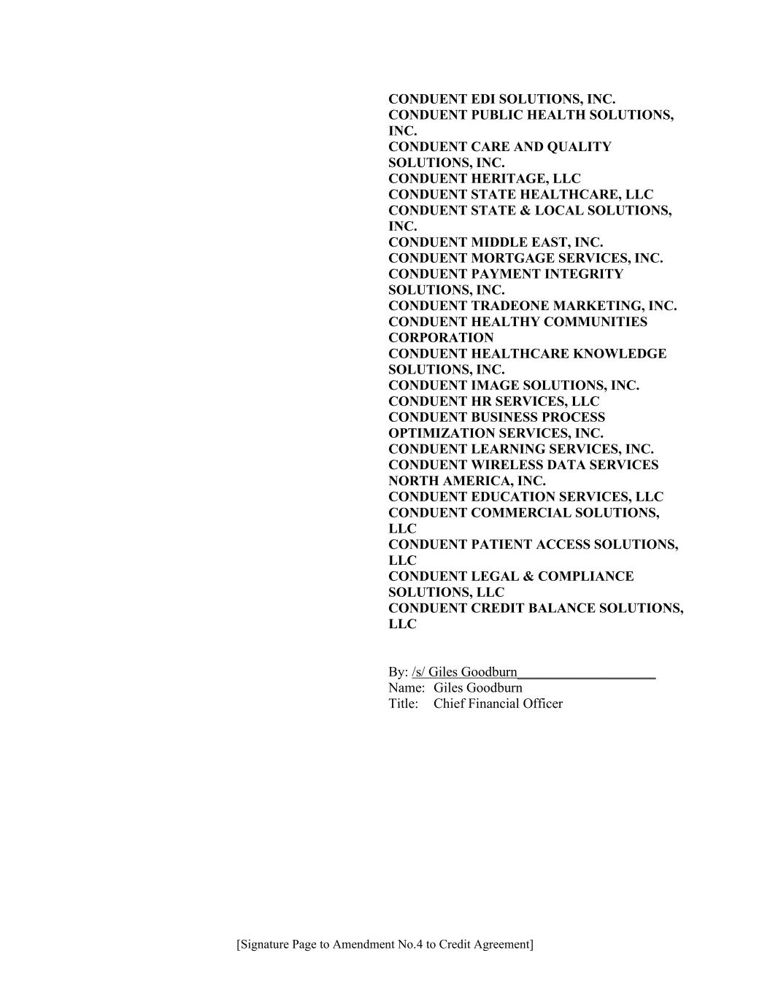
[Signature Page to Amendment No.4 to Credit Agreement] CONDUENT EDI SOLUTIONS, INC. CONDUENT PUBLIC HEALTH SOLUTIONS, INC. CONDUENT CARE AND QUALITY SOLUTIONS, INC. CONDUENT HERITAGE, LLC CONDUENT STATE HEALTHCARE, LLC CONDUENT STATE & LOCAL SOLUTIONS, INC. CONDUENT MIDDLE EAST, INC. CONDUENT MORTGAGE SERVICES, INC. CONDUENT PAYMENT INTEGRITY SOLUTIONS, INC. CONDUENT TRADEONE MARKETING, INC. CONDUENT HEALTHY COMMUNITIES CORPORATION CONDUENT HEALTHCARE KNOWLEDGE SOLUTIONS, INC. CONDUENT IMAGE SOLUTIONS, INC. CONDUENT HR SERVICES, LLC CONDUENT BUSINESS PROCESS OPTIMIZATION SERVICES, INC. CONDUENT LEARNING SERVICES, INC. CONDUENT WIRELESS DATA SERVICES NORTH AMERICA, INC. CONDUENT EDUCATION SERVICES, LLC CONDUENT COMMERCIAL SOLUTIONS, LLC CONDUENT PATIENT ACCESS SOLUTIONS, LLC CONDUENT LEGAL & COMPLIANCE SOLUTIONS, LLC CONDUENT CREDIT BALANCE SOLUTIONS, LLC By: /s/ Giles Goodburn____________________ Name: Giles Goodburn Title: Chief Financial Officer

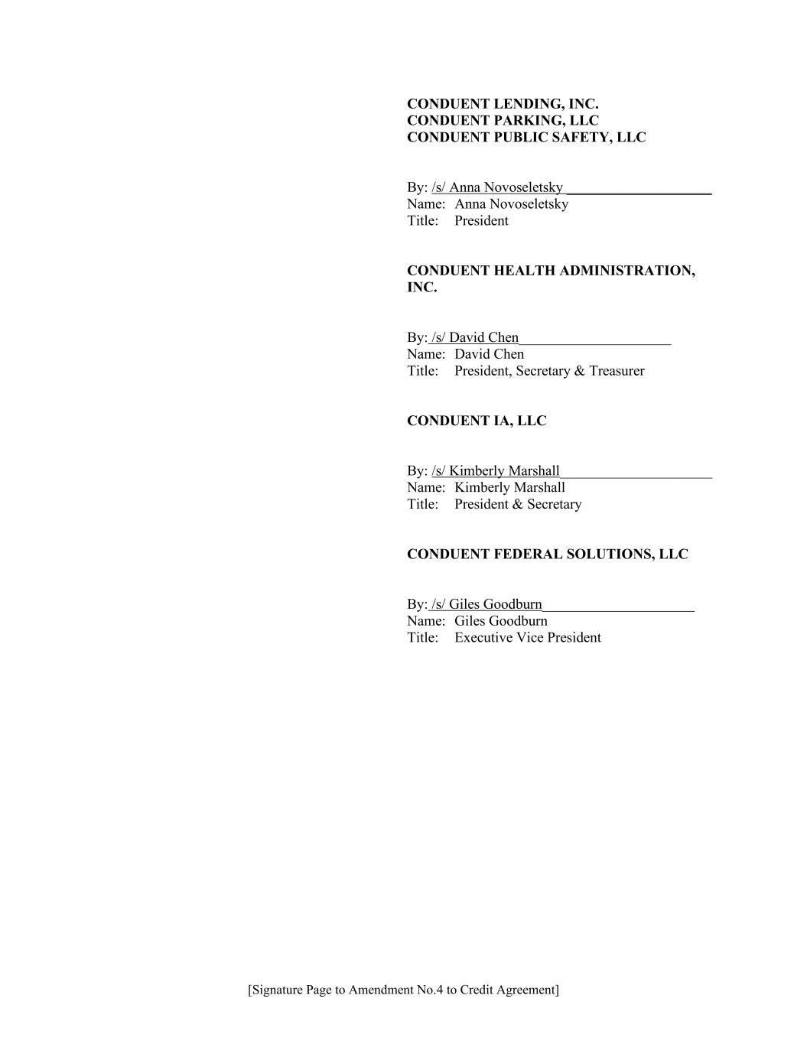
[Signature Page to Amendment No.4 to Credit Agreement] CONDUENT LENDING, INC. CONDUENT PARKING, LLC CONDUENT PUBLIC SAFETY, LLC By: /s/ Anna Novoseletsky ____________________ Name: Anna Novoseletsky Title: President CONDUENT HEALTH ADMINISTRATION, INC. By: /s/ David Chen_____________________ Name: David Chen Title: President, Secretary & Treasurer CONDUENT IA, LLC By: /s/ Kimberly Marshall_____________________ Name: Kimberly Marshall Title: President & Secretary CONDUENT FEDERAL SOLUTIONS, LLC By: /s/ Giles Goodburn_____________________ Name: Giles Goodburn Title: Executive Vice President

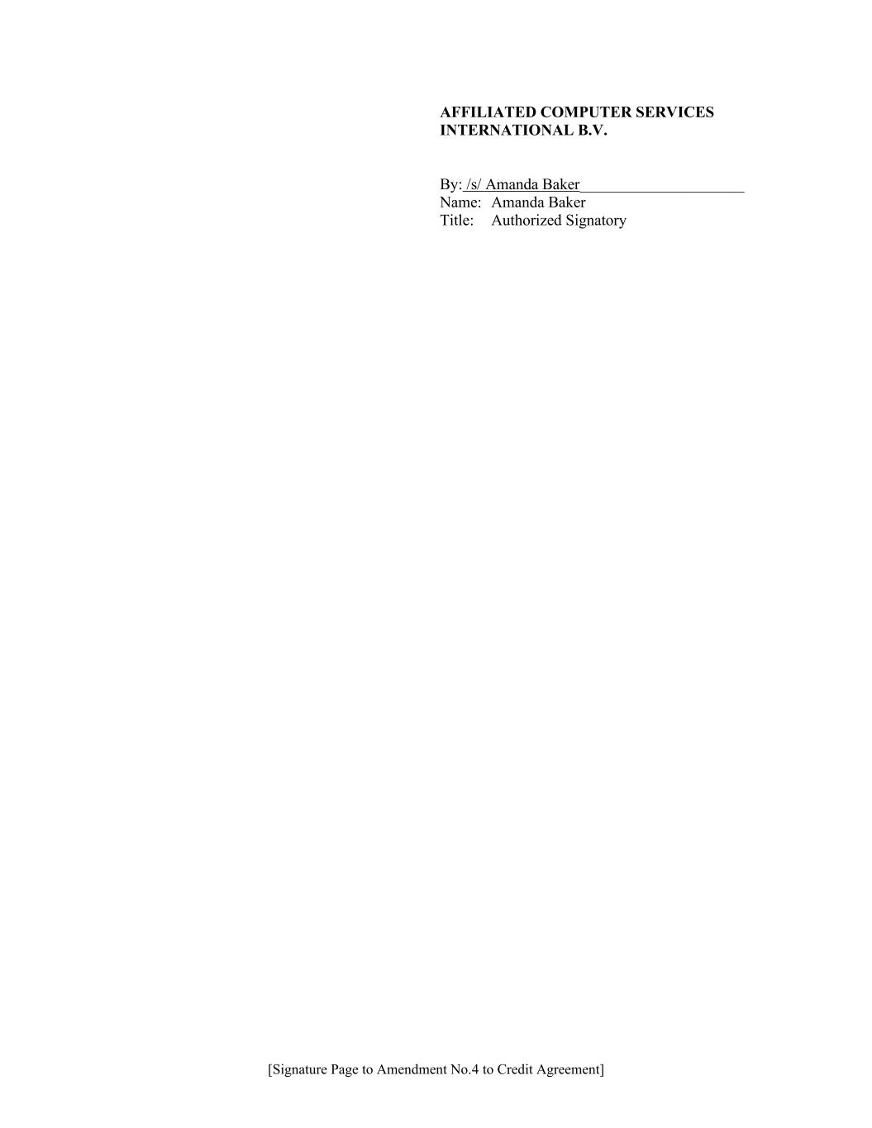
[Signature Page to Amendment No.4 to Credit Agreement] AFFILIATED COMPUTER SERVICES INTERNATIONAL B.V. By: /s/ Amanda Baker_____________________ Name: Amanda Baker Title: Authorized Signatory

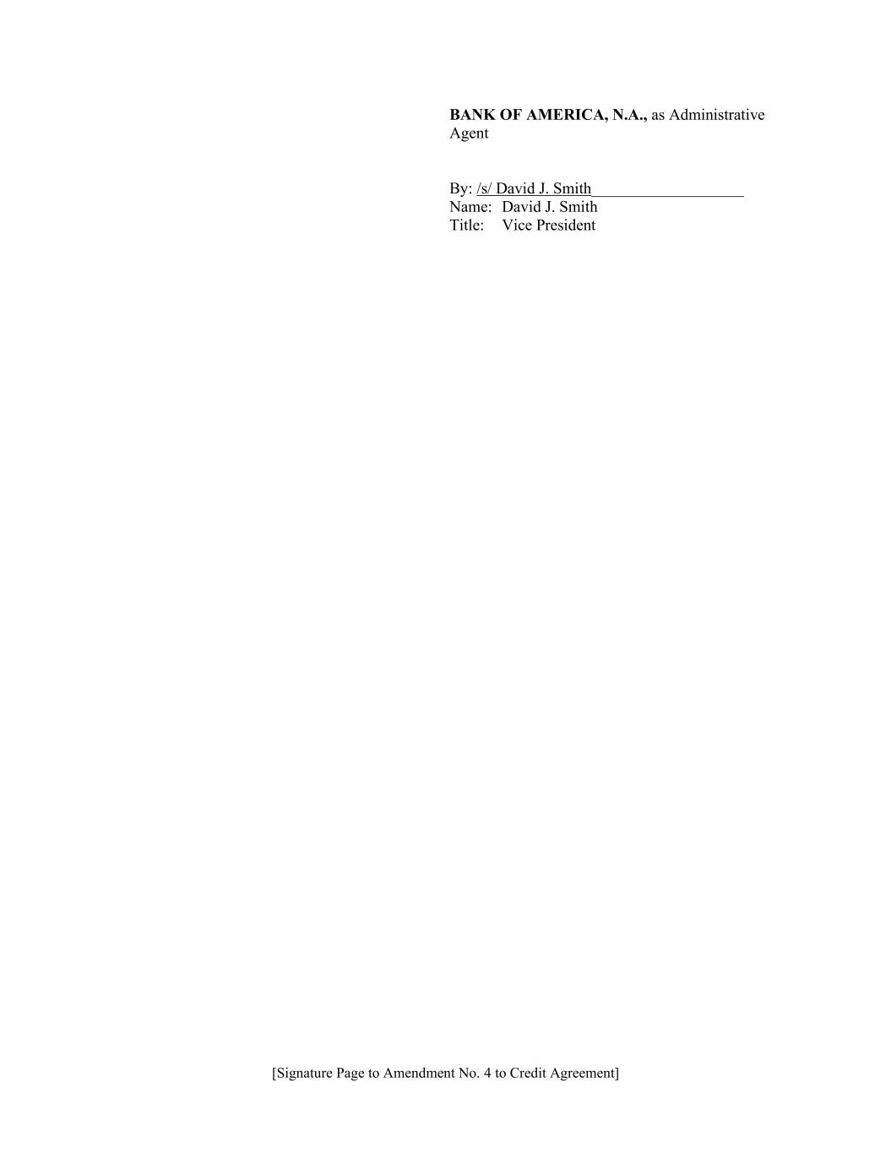
[Signature Page to Amendment No. 4 to Credit Agreement] BANK OF AMERICA, N.A., as Administrative Agent By: /s/ David J. Smith___________________ Name: David J. Smith Title: Vice President

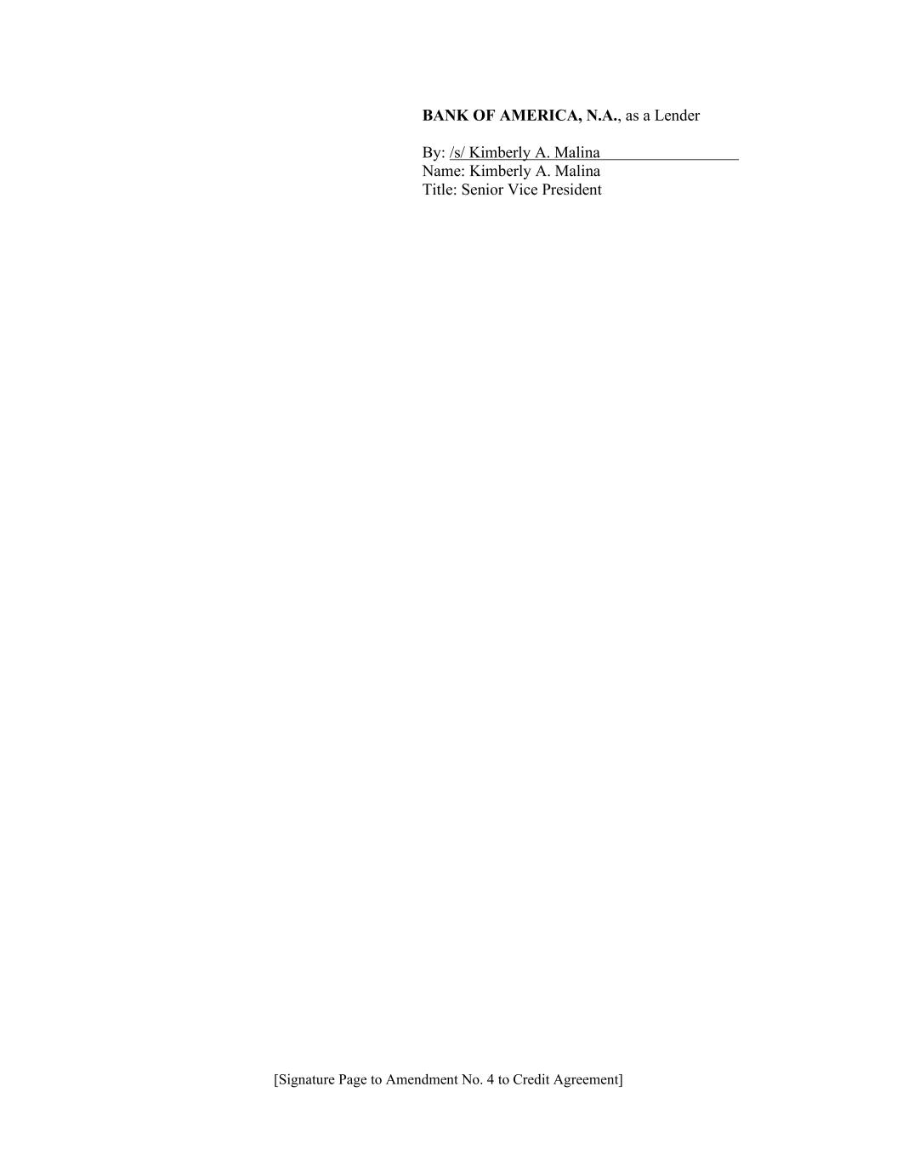
[Signature Page to Amendment No. 4 to Credit Agreement] BANK OF AMERICA, N.A., as a Lender By: /s/ Kimberly A. Malina Name: Kimberly A. Malina Title: Senior Vice President

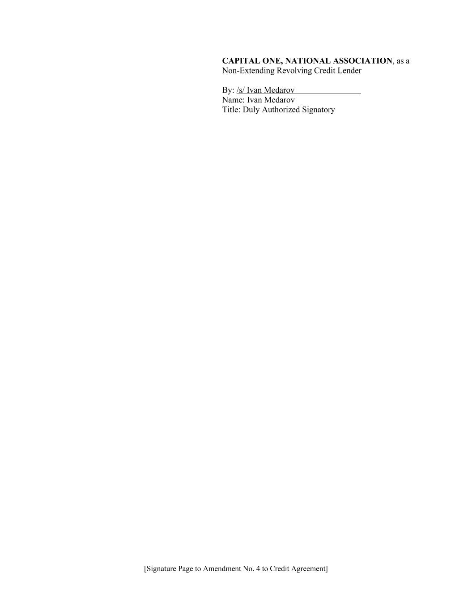
[Signature Page to Amendment No. 4 to Credit Agreement] CAPITAL ONE, NATIONAL ASSOCIATION, as a Non-Extending Revolving Credit Lender By: /s/ Ivan Medarov Name: Ivan Medarov Title: Duly Authorized Signatory

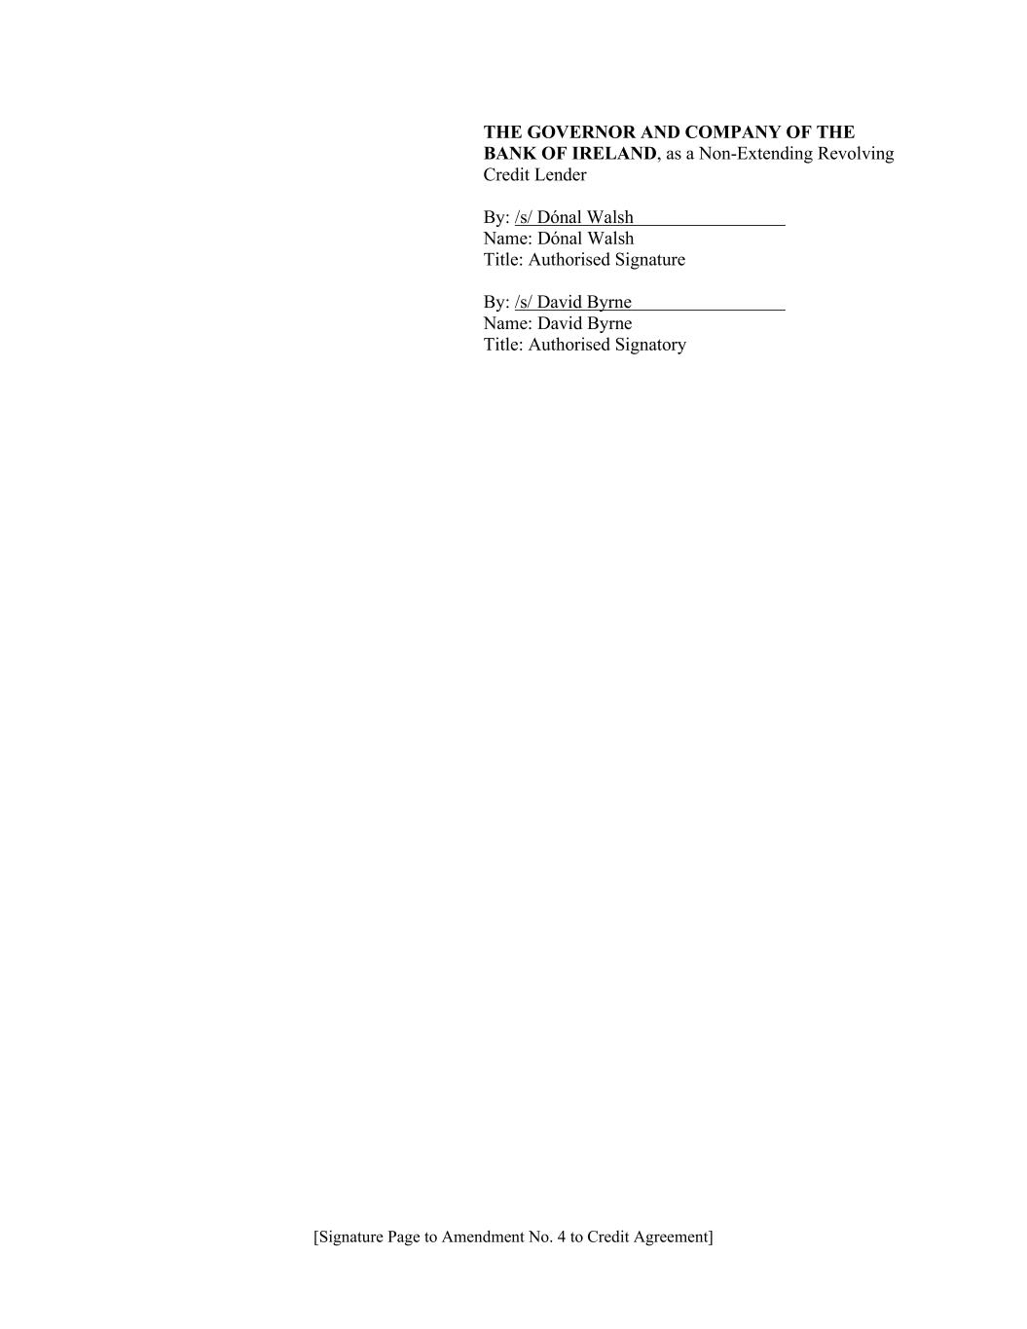
[Signature Page to Amendment No. 4 to Credit Agreement] THE GOVERNOR AND COMPANY OF THE BANK OF IRELAND, as a Non-Extending Revolving Credit Lender By: /s/ Dónal Walsh Name: Dónal Walsh Title: Authorised Signature By: /s/ David Byrne Name: David Byrne Title: Authorised Signatory

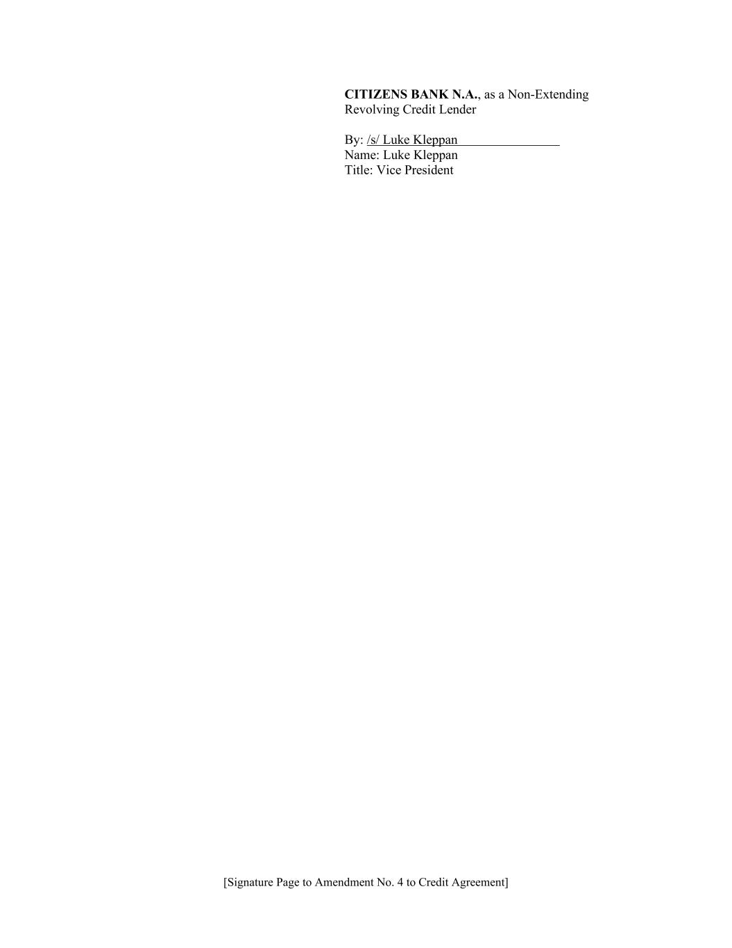
[Signature Page to Amendment No. 4 to Credit Agreement] CITIZENS BANK N.A., as a Non-Extending Revolving Credit Lender By: /s/ Luke Kleppan Name: Luke Kleppan Title: Vice President

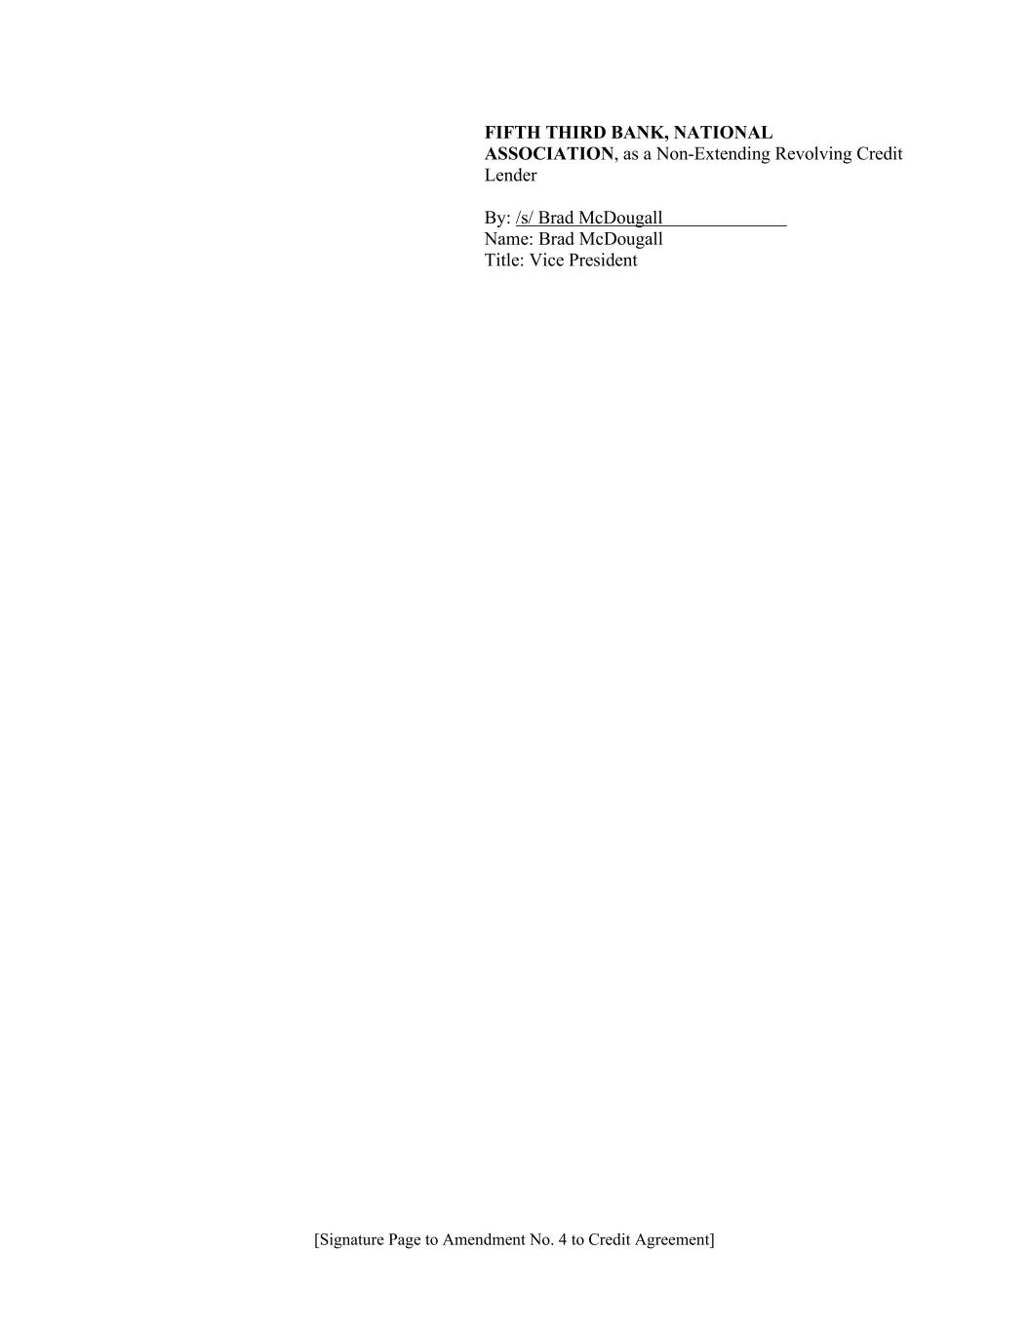
[Signature Page to Amendment No. 4 to Credit Agreement] FIFTH THIRD BANK, NATIONAL ASSOCIATION, as a Non-Extending Revolving Credit Lender By: /s/ Brad McDougall Name: Brad McDougall Title: Vice President

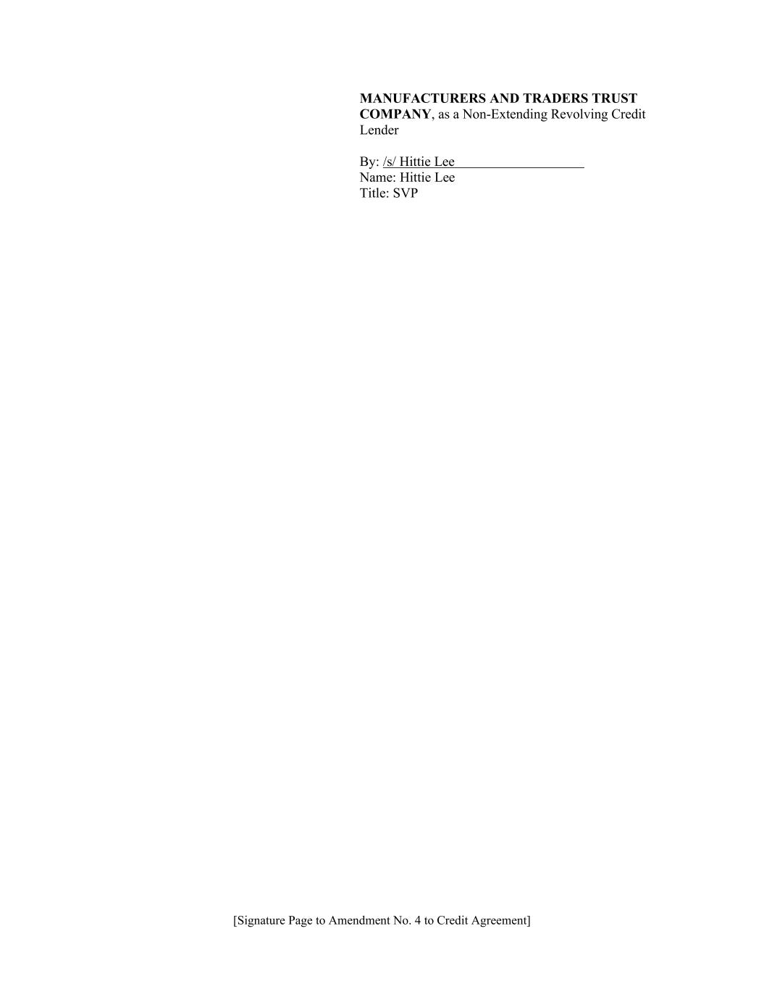
[Signature Page to Amendment No. 4 to Credit Agreement] MANUFACTURERS AND TRADERS TRUST COMPANY, as a Non-Extending Revolving Credit Lender By: /s/ Hittie Lee Name: Hittie Lee Title: SVP

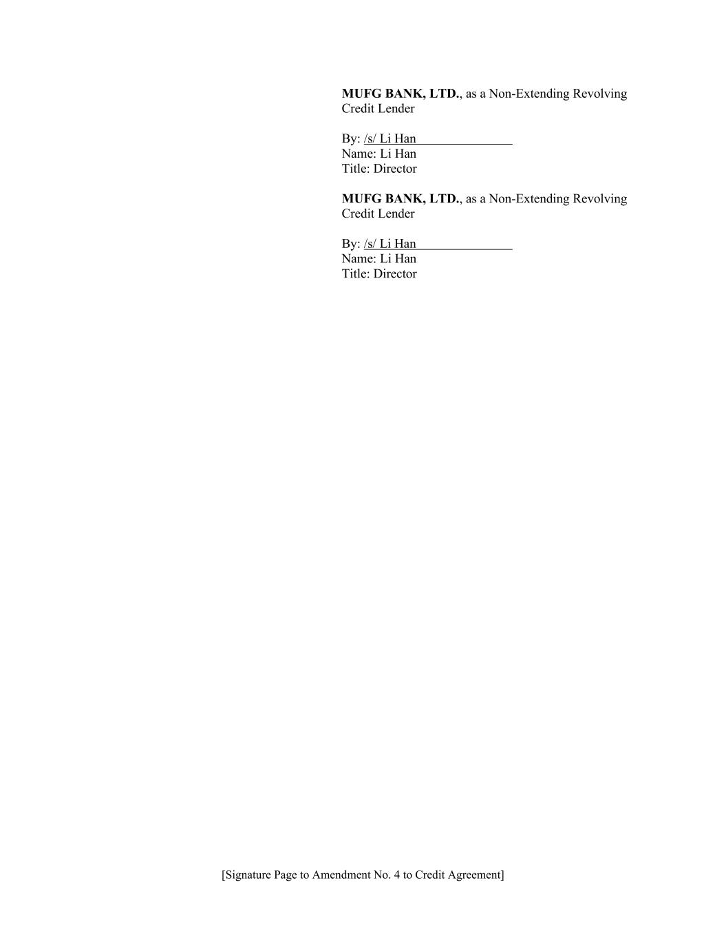
[Signature Page to Amendment No. 4 to Credit Agreement] MUFG BANK, LTD., as a Non-Extending Revolving Credit Lender By: /s/ Li Han Name: Li Han Title: Director MUFG BANK, LTD., as a Non-Extending Revolving Credit Lender By: /s/ Li Han Name: Li Han Title: Director

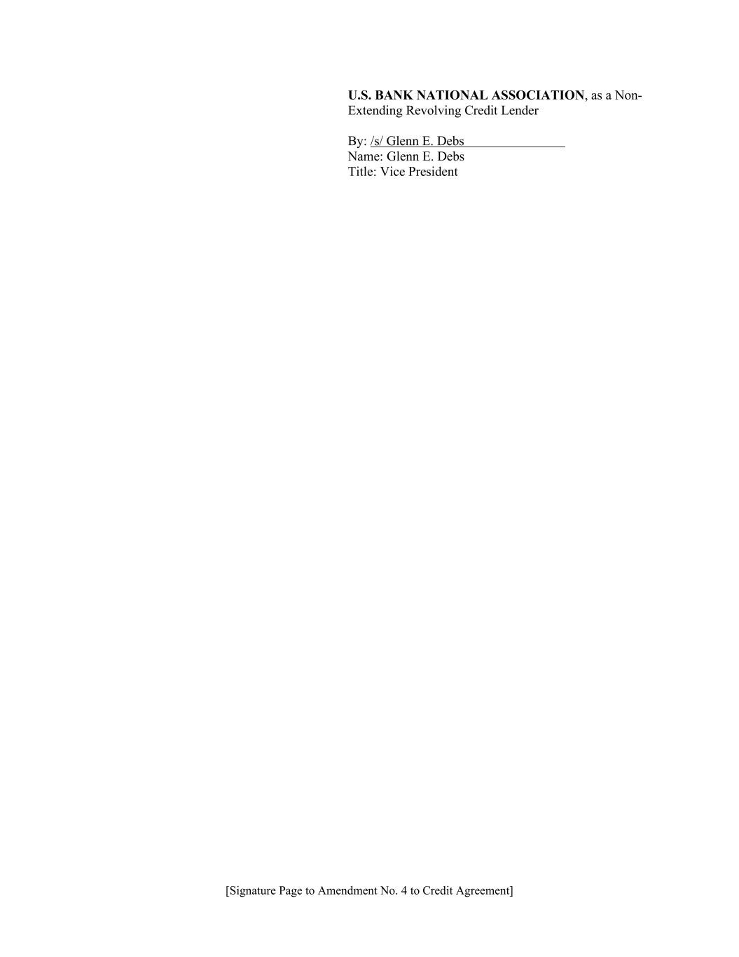
[Signature Page to Amendment No. 4 to Credit Agreement] U.S. BANK NATIONAL ASSOCIATION, as a Non- Extending Revolving Credit Lender By: /s/ Glenn E. Debs Name: Glenn E. Debs Title: Vice President

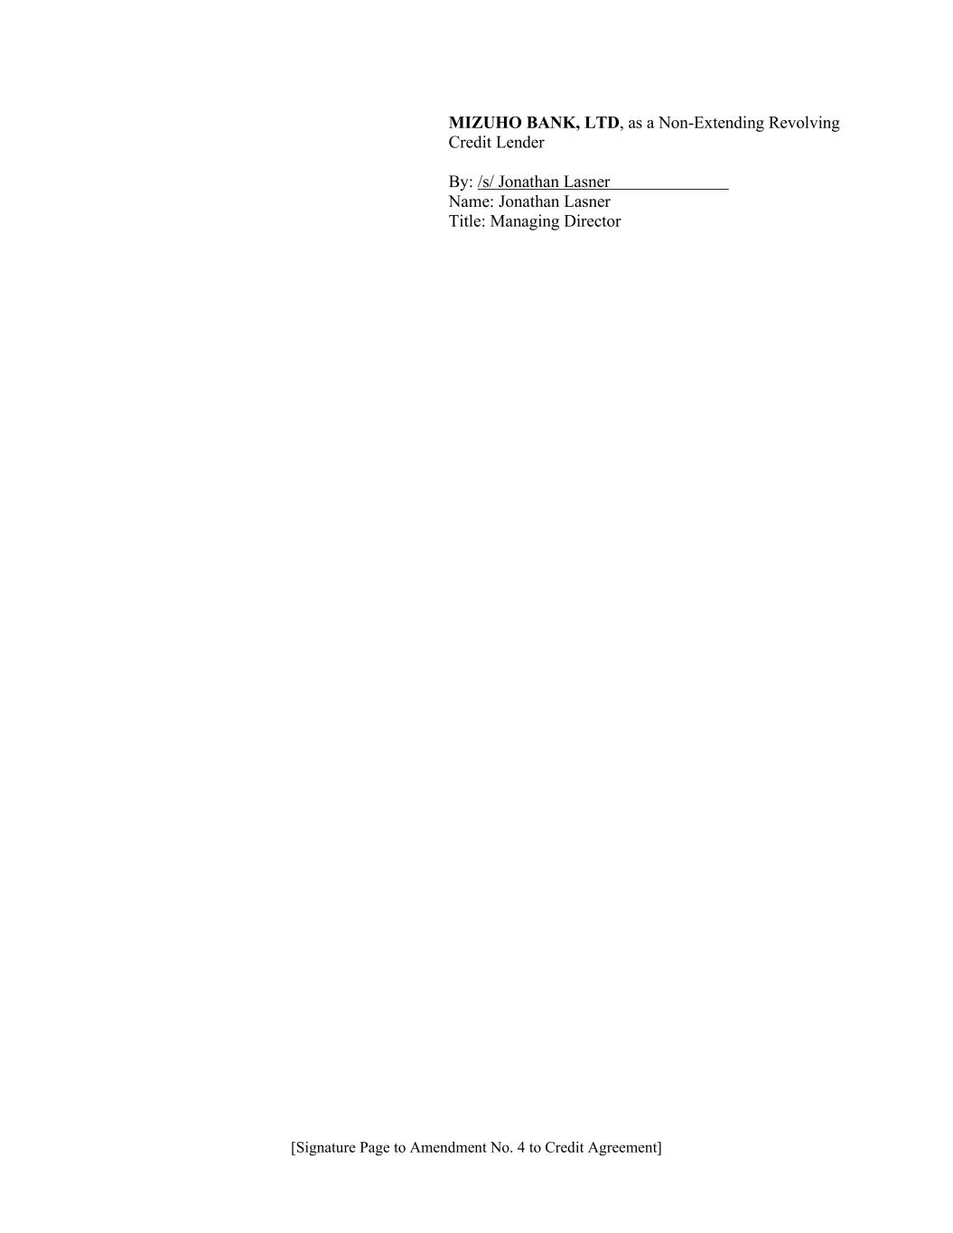
[Signature Page to Amendment No. 4 to Credit Agreement] MIZUHO BANK, LTD, as a Non-Extending Revolving Credit Lender By: /s/ Jonathan Lasner Name: Jonathan Lasner Title: Managing Director

